SONGS

Miss Polly had a dolly

Miss Polly had a dolly
Who was sick, sick, sick,
So she phoned for the doctor
To come quick, quick, quick.
The doctor came with her bag and her hat,
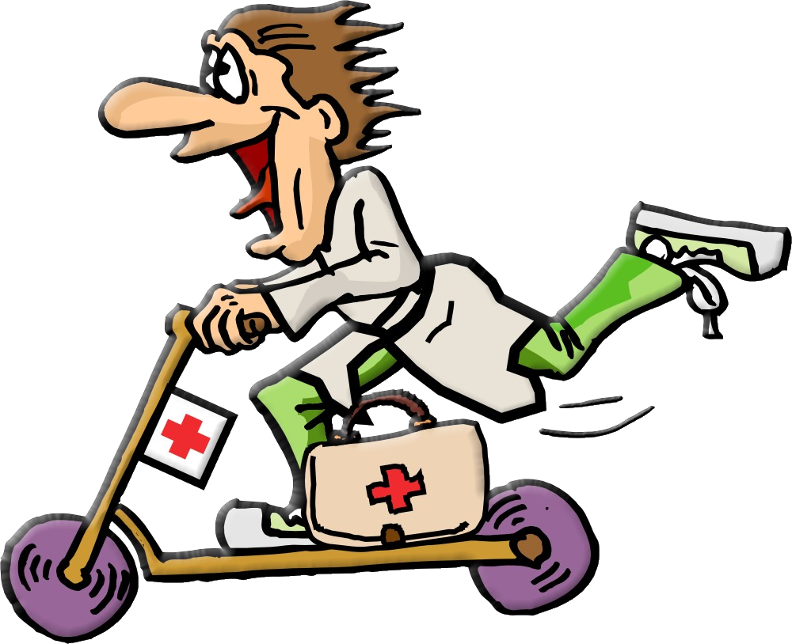
And she knocked at the door
With a rat-a-tat-tat.

She looked at the dolly
And she shook her head,
And she said, “Miss Polly, put her straight to bed”
She wrote on a paper
For a pill, pill, pill,
“I’ll be back in the morning
with my bill, bill, bill.”
(Super Songs, OUP)

Let’s make a sound

Let’s make a sound
With our body like this: clap, clap.
Let’s make a sound
With our body like this: clap, clap.
Let’s make a funny sound: one! two! three! (clap, clap)
Let’s make a sound
With our body like this: clap, clap.

Let’s make a sound
With our body like this: fiu, fiu (whistle)
Let’s make a sound
With our body like this: fiu, fiu (whistle)
Let’s make a funny sound: one! two! three! (fiu, fiu)
Let’s make a sound
With our body like this: fiu, fiu.
(Anonymous)

