PART I
Pages

1. Sequence of activities & Objectives 2
2. Activities 3-8
3. Scripts
-Story: Kipper’s Birthday 9
-Songs:
-Mary Brown 9
-Hello Song 10
-Reference Book: ‘Children Just Like Me’ (act. 5-6) 11-12
-Games from around the World 13-16
4. Hand Out 1: ‘Kipper’s Birthday’ (act. 2) 17-26
5. Hand Out 2: Class Birthday Calendar (act. 4) 27
6. Hand Out 3: Individual Birthday Calendar (act. 4) 28-35
7. Hand Out 4: World Map and Children silhouettes (act. 5) 36-38
8. Evaluation chart 39
9. Letter to parents 40-41

PART I: BIRTHDAYS
Songs: -Mary Brown, Mother Goose, OUP
-Hello Song, The Singing Kettle Video

ACTIVITIES OBJECTIVES
-1-  Planning | -2-  Story  Kipper’s Birthday  +  Build up the story | -3-  Song Book  Little Monkeys  +  Corners
-4-  Birthday Calendar | -5-  Oral Presentation:  Birthday Calendar  +  Games from the world | -6-  Games from the world

COMMENTS
1- To interact with the T when talking about birthdays.

2- To produce s written text: a Birthday Calendar.

3-. To present orally their Birthday Calendar using, at least, these expressions:
-This is my Birthday Calendar.
-My birthday is in (May).

4- To play games from around the world.

…………………………………………………………………………………………………………………………………………………………………………………………………………………………………………………………………………………………………………………………………………………………………………………………………………………………………………………………………………………………………………………………………………………………………………………………………………………………………………

ACTIVITY 1 | TIME | LANGUAGE  SKILS | INTER  ACTION | MATERIALS | DESCRIPTION | ORAL & WRITTEN PRODUCTION
Planning  SUMMARY:  Presentation of the Unit and PART I planning. | 30’ | L  S | BG | Classroom Diary | 1-. T and Ss talk about birthdays and celebrations. T elicits previous knowledge from Ss:  -Did you celebrate Christmas?  -Do you know what Ramadan is?  -When is your birthday?  -…  2- T presents PART I plan and talks about birthdays in general.  3- H (or T) writes down PART I plan on the Classroom Diary. | -Did you celebrate Christmas?  -Do you know what Ramadan is?  -When is your birthday?  PART I planning  We are going to  -listen to a story  -build up the story  -write in our Song Book  -do corner work  -make a Birthday Calendar  -present the Birthday Calendar  -play games from around the world  -sing a song

ACTIVITY 2 | TIME | LANGUAGE  SKILS | INTER  ACTION | MATERIALS | DESCRIPTION | ORAL & WRITTEN PRODUCTION
Story  Kipper’s Birthday  +  Build up the story  SUMMARY:  Ss listen to the story and in small groups build it up on their own.. | 30’ | L  R  S | BG  SG | Storybook  Hand Out 1  Glue | 1-. T shows the cover of the storybook and asks Ss if they can find the title of the book and the author.  2- All together make hypotheses about what the story might be about.  3- Ss sit comfortably in a circle and listen to the story.  4- When finishing, T asks Ss their opinion of the story, if they enjoyed it or not and if they want to listen to it again.  5- Ss get in small groups. T / H hands out a set with the pictures of the story from the Hand Out 1 to each group.  6- Ss try to sequence the pictures.  7- H hands out the a set with of the strips with the sentences and Ss try to link them with the pictures.  8- T tells the story again and Ss check their own story.  Notice:  -it’s not necessary to follow the story in the same order.  -Hand out the most difficult sentences written on the page along with the picture. | -Script of the story.  -Interaction with T and mates:  -this is page / picture number one.  -this picture goes with this sentence / words  -Finished!  -…

ACTIVITY 3 | TIME | LANGUAGE  SKILS | INTER  ACTION | MATERIALS | DESCRIPTION | ORAL & WRITTEN PRODUCTION
Song Book  Elephants have wrinkles+  Corners  SUMMARY:  Ss write in their Song Books and work in corners. | 30’ | S  L  W  L  R  W  S | BG  I  SG  BG | Individual Song Book, tape and cassette recorder (optional)  Corner materials  List of Ss in each corner | 1- T tells Ss they are going to write the lyrics of the song they have learnt in their Song Books using the T as a scribe.  2- Ss dictate the song to the T and S/he writes it down on the b/b.  3- Ss copy it in their Song Books (they don’t have to copy the whole song, just the title and two or three lines, depending on each one’s writing skills).  4- Ss go to a corner in pairs or small groups. If necessary, T or H keeps a record in order to take turns in each one.  5- T asks some Ss what they have done in the corners. | -Lyrics of the chosen song.  -What have you done in the different corners?  -I’ve read a book  -We’ve listen to a story  -We’ve played a game  -I’ve drawn a picture  -…

ACTIVITY 4 | TIME | LANGUAGE  SKILS | INTER  ACTION | MATERIALS | DESCRIPTION | ORAL & WRITTEN PRODUCTION
Birthday Calendar  SUMMARY:  T and Ss talk about their birthdays and have a look at the classroom calendar; then they make their own Birthday Calendar. | 30’ | S  L  S  W | BG  BG  I | Classroom Calendar  or Hand Out 2  Hand Out 2  Hand Out 3 | 1-. T presents a birthday calendar and Ss mark their birthdays on it. Ss can say the date of their birthdays in Basque/Spanish and T repeats them in English.  2- Ss learn a rhyme about months to help them with pronunciation.  3- H hands out one of the two options for Ss to make their own Birthday Calendar:  A: one page Calendar (Hand Out 2 in A3). Ss fold it in two, write the title ‘MY BIRTHDAY CALENDAR’ and decorate the cover.  B: a page by page Calendar (Hand Out 3). Ss decorate the cover. Punch two holes at the closed end of it, thread pieces of yarn through the holes and tie bows at the top.  (T can rub out the name of the months and/or days of the week, in both options, for Ss to fill them in their Calendars)  4- Ss mark their own birthdays on their Calendars.  5- Ss take it home and mark their Mum’s, Dad’s, sister’s… birthdays on it. They have to bring it back for the next session.  Suggestion: stickers can be used to mark the birthdays; then draw the code used at the top of the calendar. | -My birthday is in May.  -My birthday is on May 16th.  -When’s your birthday?

ACTIVITY 5 | TIME | LANGUAGE  SKILS | INTER  ACTION | MATERIALS | DESCRIPTION | ORAL & WRITTEN PRODUCTION
Oral Presentation:  Birthday Calendar  +  Games from the world  SUMMARY:  Ss present their Birthday Calendar to the rest of the class and play games from around the world. | 5’  10’  15 | S  L  R  S  L | BG  BG | Ss’ Birthday Calendars  Hand Out 4  World Map  Reference books: ‘Children just Like Me’ and ‘Celebrations’  List of games | 1- Ss present their Calendar to the rest of the class (4 or 5 Ss every session).  2- H hands out colour silhouettes of children (Hand Out 4), one from each continent, taken from the reference books ‘Children just Like Me’ and ‘Celebrations’.  3- Ss get information from the reference books about the countries those children come from and their age.  4- Ss, with T’s help, pin those silhouettes on the world map (if there is one in the classroom, use it; if not use the one in Hand Out 4).  5- T and Ss play the games those children play in their countries. | -This is my Birthday Calendar.  -Mum’s birthday is in May.  -Dad’s birthday is on May 16th.  -…  -Thank you very much for listening.  -Rules of games.

ACTIVITY 6 | TIME | LANGUAGE  SKILS | INTER  ACTION | MATERIALS | DESCRIPTION | ORAL & WRITTEN PRODUCTION
Games from the world  SUMMARY:  T and Ss play games from around the world. | 30’ | S  L | BG  I | List of games  Video or audio tape, cassette recorder or camera | 1- T and Ss play different games from around the world, chosing them from the list.  2- T can record the Ss in a video. | -Rules of the games.

STORY: Kipper’s Birthday

1- It was Kipper’s birthday.
2- Kipper wanted a party.
3- Everyone wanted to come.
4- Biff put up balloons.
5- Mum made a cake.
6- Dad took a sandwich.
7- ‘Stop it’ said Mum.
8- Everyone came to the party.
9- Dad wanted to play a game.
10- But Kipper put the television on.
11- ‘Oh, no!’ said Mum, ‘What a mess!’
12- The children played with the bubbles.
13- ‘What a good party!’ everyone said.

SONGS:

Mary Brown, Mother Goose, OUP

Mary Brown was born today,
Born today, born today.
Mary’s ten years old today,
Happy birthday!

We know who was born today,
Born today, born today.
We know you were born today,
Happy birthday!

Happy birthday Mary Brown,
Mary Brown, Mary Brown.
Happy birthday Mary Brown,
Happy birthday!

Hello Song, The singing Kettle Video

Hello, Hello, Hello, Hi, Hi, Hi.
Hello, Hello, Hello, Hi.
Hello, Hello, Hello, Hi, Hi, Hi.
Hello, Hello, Hello, Hi.

Yes, we’re all going on a World Tour and we’re going to visit lots of different countries. So, we’ll have to learn to say ‘Hello’ in lots of languages.
Let’s try French, and for us they say ‘Bonjour’.
You say ‘Bonjour’, ‘Bonjour’, ‘Bonjour’.
And in Italy they say ‘Bonjorno’. Altogether, ‘Bonjorno’, ‘Bonjorno’, ‘Bonjorno’.
And, of course, when we go away we’re saying ‘Hello, Hello, Hello’.

Hello, Hello, Hello, Hi, Hi, Hi.
Hello, Hello, Hello, Hi.
Hello, Hello, Hello, Hi, Hi, Hi.
Hello, Hello, Hello, Hi.

Hello, Hello, Hello, Hello, Hello, Hello, Hello.
Hi, Hi, Hi, Hi, Hi, Hi, Hi.
REFERENCE BOOK: ‘Children Just Like Me’

Celina (pag. 14)

Celina Tembé is nine years old and lives in the Amazon Rainforest of Brazil, South America. Celina is a Tembé Indian, and her father is the head of her village. Celina’s family farms. They grow most of the food they need, and sell what is left. Her father and brother also fish in the river, and sometimes kill alligators to eat. Celina’s village is very close to the Equator, so the weather is always worm, and day and night are the same length. In this part of Brazil it rains every day.

‘I’m called Celina Tembé, because I am a Tembé Indian. I have just started to learn Tembé, which is our own language. I like living by the river –I want to live here for the rest of my live. I love the forest, and it makes me sad when people chop down the trees. Sometimes at night the forest scares me, because the Matim lives there. The Matim is a huge animal that grown-ups say is imaginary. I’ve never seen it, but I know it’s there because I hear it whistling. I’m very scared of the Matim’.

David (pag. 25)

David, age twelve, from England.

Bakang (pag. 37)

Bakang Gabankalafe is eight years old. She lives with her family in a village called Tshabong in Botswana, southern Africa. Bakang has lived in the village all her life. It is a remote region, on the edge of the Kalahari Desert. The days are hot, dry and dusty, and nights can be very cold.

‘My name means ‘Praise’. When I grow up, I want to be a nurse. I would like to get married and live in a big house, and I want two children, a boy and a girl. Every day I go with my mother to fetch water. On the way I watch out for camels because they frighten me’.

Daisuke (pag. 53)

Daisuke Tashita is ten years old and lives near the town of Ogawa, in Japan. Daisuke’s family runs an organic farm, growing crops and raising animals in ways that do not harm the enviroment. For example, Daisuke’s parents never use chemical fertilizers or pesticides on their crops. The family even produces its own electricity, using the gas given off by animal manure, called biogas, to power a generator.

‘This is how I write my name. I was very tiny when I was born, and my parents wished that I would grow up to be big and healthy. So they called me Daisuke –Dai means ‘Big’. When I grow up, I want to be a scientist and study dinosaur fossils. I love dinosaurs. Not long ago my grandmother took me to see the dinosaur exhibition at the Tokio National Museum. It was the most exciting thing that I have ever done. I would love to visit the dinosaur museums in the United States. I have read all about them in my dinosaur books’.
Meena (pag. 56)

Meena is seven years old and lives in New Delhi, the capital city of India. She was born in the state of Rajasthan, to the west of New Delhi, in a village called Masalpur. This region is very dry, and Meena and her family had to leave their village because there wasn’t enough rain for their crops to grow. They now live and work on a construction site in the city, where a factory is being built.

‘This is how I write my name, Meena. It means ‘fish’. My dream is to go back to my village. I liked living there because our house was built of stone. I don’t like the building site because there are no trees an it is dirty. In our village, you can pick berries from the trees, but here in the city you have to pay for them. My favourite animals are cats. I don’t like dogs, because they might eat me up. When I grow up, I want to be a labourer, like Ma’.

Ngawaiata (pag. 74)

Ngawaiata Evans is nine years old and lives in the far north of New Zealand, in a village called Whatuwhiwhi. Ngawaiata’s mother is a Maori, and her father’s ancestors emigrated to New Zealand from Wales. It is a Maori tradition for children to be brought up by their grandparents, and Ngawaiata, together with two of her cousins, lives with her grandmother I a house by the sea. Many of the peoples who live in the village are Ngawaiata’s relatives. Her parents live in the nearby town of Kaitaia.

‘Ngawaiata is the Maori word for psalms. My family usually calls me ‘Bab’, which is short for Baby, as I am the smallest. I came to live with Nanna because I am half Maori, and I wanted to find about that part of me. New Zealand is a nce place to live, and I love it here by the beach. In a town you can’t do very much, but here I am never bored. I can go walkabout, play on the rocks, climb the trees, or go for a swim. When I grow up, I want to be a nurse, because then I could help my Mum, Dad and Nanna if they became sick’.

Dion (pag. 76)

Dion is five years old and lives in Western Australia. Dion is an Aboriginal Australian. The Aboriginal people were the Australia’s first inhabitants, and they have lived there for more than 40,000 years. Dion’s family lives in an Aboriginal community called Bidyadanga. People from five different Aboriginal groups live in Bidyadanga, and they each speak their own language, as well as English. Dion’s family belongs to the Nyangumarta people. Rosita is Dion’s big sister.
GAMES FROM AROUND THE WORLD

1- WHAT TIME IS IT MR WOLF? from Europe

You will need:
-a mask

How to play:
One S is Mr Wolf. Mr Wolf walks slowly. The rest of Ss walk behind him/her and shout ‘What time is it Mr Wolf?’ Mr Wolf turns around quickly and shouts ‘One o’clock!’. Ss must stop. If Mr Wolf sees somebody moving, he sends him/her back. Mr Wolf turns around and walks again. Ss ask the same questions again and again to get nearer to Mr Wolf. When Mr Wolf answers ‘Dinner time!’ he runs after the players and tries to tag one of them. The one he tags becomes Mr Wolf and the game starts again.

2- FIVE STONES JACKS from India.

Games with Jacks are played in countries all over the world. Traditionally, players used knucklebones of sheep for playing pieces. In India, children play a version of Jacks called PACHETA. Since India is a hot country, Pacheta is played outside on dry ground using small stones. This is a game for two or more players.

You will need:
Colour paint, varnish, paintbrush, pencil, saucer, glass of water, 5 small flat stones.

Making the pieces:
-Choose five small stones and clean them. Carefully mark a shape on each stone and then paint them in different colours.
-Carefully varnish each stone to protect the paint on the stones. Leave the stones to dry fully before using them in the game.

How to play:
-Take all five stones in the palm of your hand. With your hand in front of you, throw the stones up about 15 cm in the air.
-As the stones are coming down, try to catch them on the back of your hand. Keep your fingers together so that the stones don’t slip through.
-Throw the stones from the back of your hand into your palm. The player who has caught the most stones starts the game.
-Scatter the stones on the ground. Throw one stone in the air, pick up a stone from the ground and catch the thrown stone with the same hand.
-Repeat until you have picked up all the stones. Then scatter the stones, throw one in the air and pick up the remaining stones in pairs.
-Then pick up three stones, and four stones. If you miss, the other player has to go. You start from where you finished when you have a new turn.
-Make an arch with your forefinger and thumb. Scatter the stones, throw one up and tap one stone through the arch. Repeat for each stone. Then do pairs, threes and fours.
-To finish the game, throw up a stone and scoop up the other stones.

3- PIN THE TAIL ON THE DONKEY from Australia.

This game can be played by any number of players.

You will need:
A picture of a donkey with no tail, sticky tape and several cut out tails that are either numbered or coloured, one for each player.

How to play:
-The picture of the donkey is hung on the wall.
-Each player gets one paper tail with tape attached to the top.
-The player is blindfolded and spun around several times and then faced in the direction of the donkey.
-The player tries to walk towards it and pins the tail closest to the donkey’s behind.
-This is repeated by all the players.
-The winner is the player who places the tail closest to the right spot. The prize is something like a block of chocolate.

4- PAPER, SCISSORS, STONE from Japan.

This is a fast-moving hand game from Japan, originally called JAN KEN PON, meaning paper, sword, fist. The aim of this game for two is for each player to beat the other in a quick show of hands. Intricate designs made with paper and scissors are part of Japan’s ancient culture and the art of origami paper folding originated there. Japanese children still dress up in the traditional costume called the Kimono for special occasions.

No material needed

How to play:
-Two players sit opposite each other.
-Both players clench a fist and chant JAN, KEN, PON.
-On the word PON, both players display a hand in one of these three positions:
-a clenched fist represents a stone.
-two fingers represent scissors.
-a flat hand represents paper.
-Scoring:
-Stone and scissors: stone wins, as stone blunts scissors.
-Paper and stone: paper wins, as paper wraps stone.
-Scissors and paper: scissors win, as scissors cut paper.
-Symbols the same: that’s a draw.

5- THE WARRIOR GAME from New Zealand.

This is a game that comes from New Zealand called HEI TAMA TU TAMA. It’s a game for two players who must move quickly in order to win the game. The Maoris from New Zealand thought that hand and arm games were good practice for warriors, helping them develop quick reactions.

No material needed.
How to play:
-Two players stand with their hands on their hips. One is the defender and the other is the challenger.
-The defender calls out ONE HEI TAMA TU TAMA.
-On the last word, both players display one of the four arm positions shown below.
-If both players choose the same position, the defender wins a point and continues calling.
-If they choose different positions, neither scores and the challenger calls the next round.
-After winning a point, the defender starts the next round by calling TWO HEI TAMA TU TAMA.
-The first player to reach TEN HEI TAMA TU TAMA wins the game.
-The scoring moves on only when a point is won.
-A point can only be scored by the defender calling a round.

Arms positions:

6- HOOP AND DART from North America.

Native Americans played many games to improve their hunting skills. Hoop and Dart was invented to practise throwing spears. This version for two people can be played on any smooth area of ground. Native Americans also added beads and feathers to the hoops to make Dreamcatchers. Bad dreams were caught in the net and destroyed by the sun, while good dreams slid down the feathers to the sleepers.

You will need.
A hoop and a soft ball.

How to play:
-One player takes the hoop and the other one takes the soft ball.
-The first player rolls the hoop along the ground while the second player tries to shoot the ball through the hoop.
-Each player has five shoots.

7- CATTLE STOCKADE from Africa.

Here is a game played by children in Botswana, a country in Africa. The name of the game comes from the 2.5 million cattle farmed in the country which are a very important source of food. Cattle Stockade is a rowdy game for six or more players that can be played indoors or outdoors. Farmers in Botswana allow their herds of cattle to roam and graze the grasslands. The cattle are rounded up into stockades when they need to be branded or sold.

No material needed.

How to play:
-Players choose one person to be the bull.
-The remaining players link hands and form a fence or stockade. To form a strong stockade, players should link hands tightly.
-The bull tries to escape from the stockade by crawling under or leaping over the arms of the players.
-The stockade try to stop the bull escaping, without letting go of each other’s hand. Bend down to prevent the bull from crawling under the stockade.
-Once the bull has escaped, s/he can join the stockade and choose another player to be the bull.

-A large group of players can make the game more challenging by adding more cattle to the stockade.

8- LIMBO from the West Indies.

An energetic game for any number of players, Limbo can be played inside, outside, in the garden, or on a beach. Turn on some lively music and take turns in passing as low as possible under the bar. Limbo dancing is a very popular and traditional form of dance from the Caribbean Islands, West Indies. Limbo dancers from the Caribbean can pass underneath a bar as low as 15 cm off the ground, displaying amazing levels of flexibility and balance.

You will need:
A wooden or plastic bar.

How to play:
-The aim is for each player to take turns at passing under a bar, moving forwards but leaning over backwards from the knees and moves with a shuffling step under a horizontal bar.
-When every player has passed under the crossbar, lower it another level.
-A player is out when s/he touches or knocks the crossbar off the limbo stand.

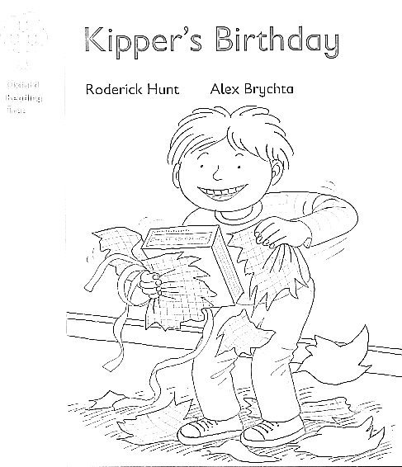

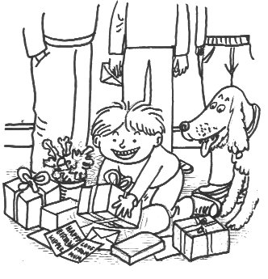

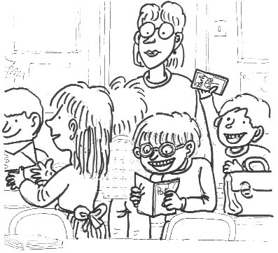

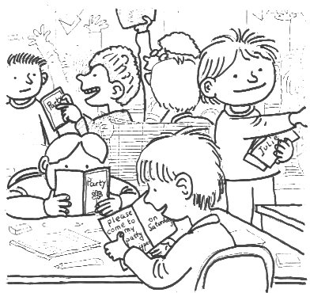

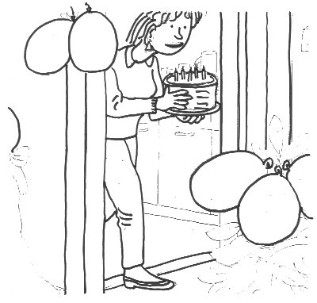

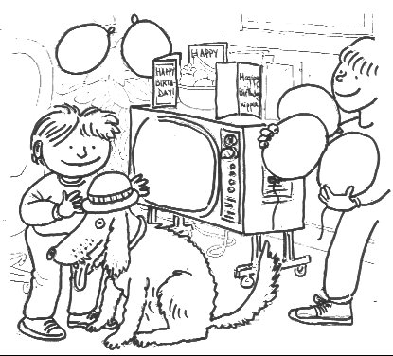

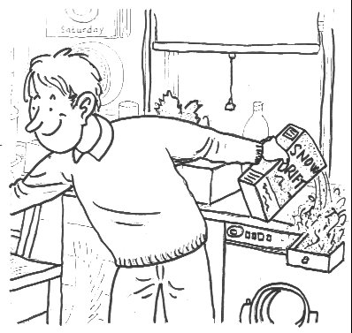

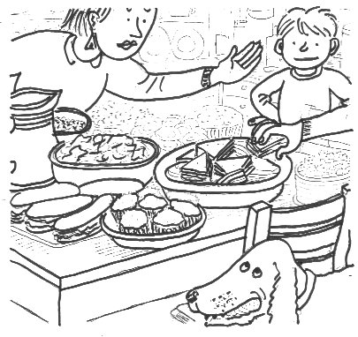

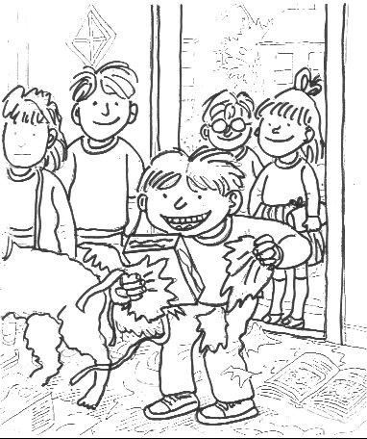

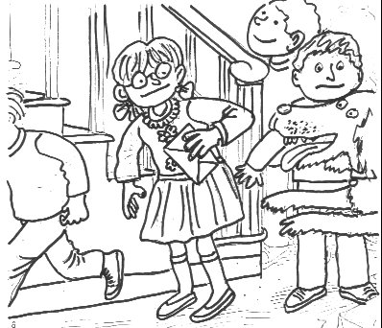
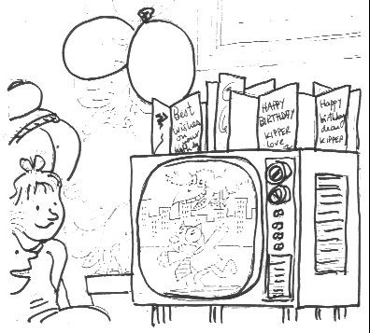

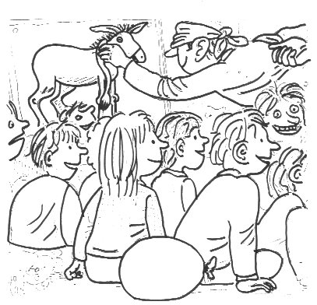

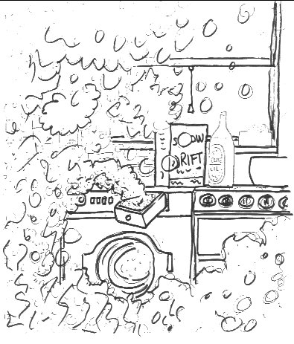
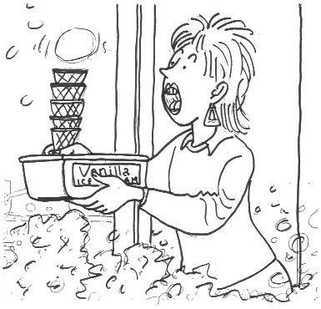

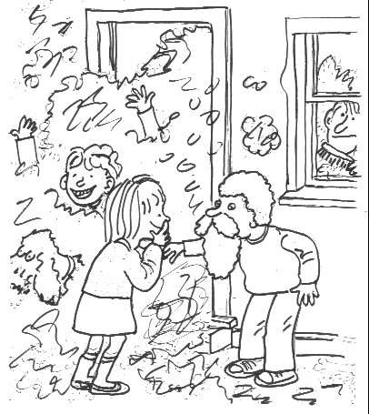
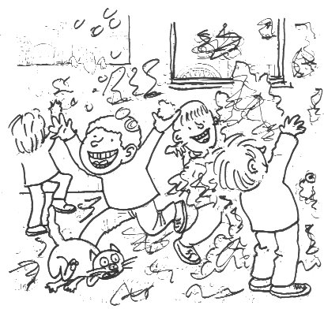
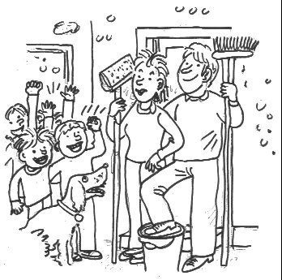
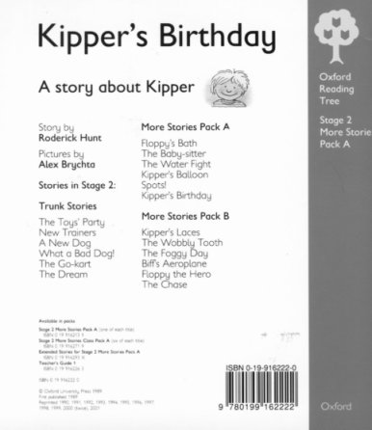

But Kipper put the television on.

The children played with the bubbles.

Kipper wanted a party.

Everyone wanted to come.

Biff put up balloons.

Mum made a cake.

Dad took a sandwich.
‘Oh no!,’ said Mum, ‘What a mess!’

‘What a good party!’ everyone said.

Dad wanted to play a game.

‘Stop it,’ said Mum.

Everyone came to the party.

It was Kipper’s birthday.

Mon | Tue | Wed | Thu | Fri | Sat | Sun
1 | 2 | 3 | 4 | 5 | 6 | 7
8 | 9 | 10 | 11 | 12 | 13 | 14
15 | 16 | 17 | 18 | 19 | 20 | 21
22 | 23 | 24 | 25 | 26 | 27 | 28
29 | 30 | 31
Mon | Tue | Wed | Thu | Fri | Sat | Sun
 |  |  |  |  | 1 | 2
3 | 4 | 5 | 6 | 7 | 8 | 9
10 | 11 | 12 | 13 | 14 | 15 | 16
17 | 18 | 19 | 20 | 21 | 22 | 23
24 | 25 | 26 | 27 | 28 | 29 | 30
Mon | Tue | Wed | Thu | Fri | Sat | Sun
 |  |  |  | 1 | 2 | 3
4 | 5 | 6 | 7 | 8 | 9 | 10
11 | 12 | 13 | 14 | 15 | 16 | 17
18 | 19 | 20 | 21 | 22 | 23 | 24
25 | 26 | 27 | 28 | 29 | 30 | 31
Mon | Tue | Wed | Thu | Fri | Sat | Sun
 | 1 | 2 | 3 | 4 | 5 | 6
7 | 8 | 9 | 10 | 11 | 12 | 13
14 | 15 | 16 | 17 | 18 | 19 | 20
21 | 22 | 23 | 24 | 25 | 26 | 27
28 | 29 | 30 | 31
Mon | Tue | Wed | Thu | Fri | Sat | Sun
 | 1 | 2 | 3 | 4 | 5 | 6
7 | 8 | 9 | 10 | 11 | 12 | 13
14 | 15 | 16 | 17 | 18 | 19 | 20
21 | 22 | 23 | 24 | 25 | 26 | 27
28 | 29 | 30
Mon | Tue | Wed | Thu | Fri | Sat | Sun
 |  |  |  |  | 1 | 2
3 | 4 | 5 | 6 | 7 | 8 | 9
10 | 11 | 12 | 13 | 14 | 15 | 16
17 | 18 | 19 | 20 | 21 | 22 | 23
24  31 | 25 | 26 | 27 | 28 | 29 | 30
Mon | Tue | Wed | Thu | Fri | Sat | Sun
 |  | 1 | 2 | 3 | 4 | 5
6 | 7 | 8 | 9 | 10 | 11 | 12
13 | 14 | 15 | 16 | 17 | 18 | 19
20 | 21 | 22 | 23 | 24 | 25 | 26
27 | 29 | 29 | 30 | 31
Mon | Tue | Wed | Thu | Fri | Sat | Sun
 |  |  |  |  |  | 1
2 | 3 | 4 | 5 | 6 | 7 | 8
9 | 10 | 11 | 12 | 13 | 14 | 15
16 | 17 | 18 | 19 | 20 | 21 | 22
23  30 | 24 | 25 | 26 | 27 | 28 | 29
Mon | Tue | Wed | Thu | Fri | Sat | Sun
 |  |  |  |  | 1 | 2
3 | 4 | 5 | 6 | 7 | 8 | 9
10 | 11 | 12 | 13 | 14 | 15 | 16
17 | 18 | 19 | 20 | 21 | 22 | 23
24 | 25 | 26 | 27 | 28
Mon | Tue | Wed | Thu | Fri | Sat | Sun
 |  |  | 1 | 2 | 3 | 4
5 | 6 | 7 | 8 | 9 | 10 | 11
12 | 13 | 14 | 15 | 16 | 17 | 18
19 | 20 | 21 | 22 | 23 | 24 | 25
26 | 27 | 28 | 29 | 30 | 31
Mon | Tue | Wed | Thu | Fri | Sat | Sun
1 | 2 | 3 | 4 | 5 | 6 | 7
8 | 9 | 10 | 11 | 12 | 13 | 14
15 | 16 | 17 | 18 | 19 | 20 | 21
22 | 23 | 24 | 25 | 26 | 27 | 28
29 | 30
Mon | Tue | Wed | Thu | Fri | Sat | Sun
 |  | 1 | 2 | 3 | 4 | 5
6 | 7 | 8 | 9 | 10 | 11 | 12
13 | 14 | 15 | 16 | 17 | 18 | 19
20 | 21 | 22 | 23 | 24 | 25 | 26
27 | 28 | 29 | 30 | 31
 |  | 1 | 2 | 3 | 4 | 5
6 | 7 | 8 | 9 | 10 | 11 | 12
13 | 14 | 15 | 16 | 17 | 18 | 19
20 | 21 | 22 | 23 | 24 | 25 | 26
27 | 28 | 29 | 30 | 31

 |  |  |  |  | 1 | 2
3 | 4 | 5 | 6 | 7 | 8 | 9
10 | 11 | 12 | 13 | 14 | 15 | 16
17 | 18 | 19 | 20 | 21 | 22 | 23
24 | 25 | 26 | 27 | 28
 |  |  |  |  | 1 | 2
3 | 4 | 5 | 6 | 7 | 8 | 9
10 | 11 | 12 | 13 | 14 | 15 | 16
17 | 18 | 19 | 20 | 21 | 22 | 23
24  31 | 25 | 26 | 27 | 28 | 29 | 30

 | 1 | 2 | 3 | 4 | 5 | 6
7 | 8 | 9 | 10 | 11 | 12 | 13
14 | 15 | 16 | 17 | 18 | 19 | 20
21 | 22 | 23 | 24 | 25 | 26 | 27
28 | 29 | 30

 |  |  | 1 | 2 | 3 | 4
5 | 6 | 7 | 8 | 9 | 10 | 11
12 | 13 | 14 | 15 | 16 | 17 | 18
19 | 20 | 21 | 22 | 23 | 24 | 25
26 | 27 | 28 | 29 | 30 | 31
 |  |  |  |  |  | 1
2 | 3 | 4 | 5 | 6 | 7 | 8
9 | 10 | 11 | 12 | 13 | 14 | 15
16 | 17 | 18 | 19 | 20 | 21 | 22
23  30 | 24 | 25 | 26 | 27 | 28 | 29

 | 1 | 2 | 3 | 4 | 5 | 6
7 | 8 | 9 | 10 | 11 | 12 | 13
14 | 15 | 16 | 17 | 18 | 19 | 20
21 | 22 | 23 | 24 | 25 | 26 | 27
28 | 29 | 30 | 31

 |  |  |  | 1 | 2 | 3
4 | 5 | 6 | 7 | 8 | 9 | 10
11 | 12 | 13 | 14 | 15 | 16 | 17
18 | 19 | 20 | 21 | 22 | 23 | 24
25 | 26 | 27 | 28 | 29 | 30 | 31

1 | 2 | 3 | 4 | 5 | 6 | 7
8 | 9 | 10 | 11 | 12 | 13 | 14
15 | 16 | 17 | 18 | 19 | 20 | 21
22 | 23 | 24 | 25 | 26 | 27 | 28
29 | 30
 |  | 1 | 2 | 3 | 4 | 5
6 | 7 | 8 | 9 | 10 | 11 | 12
13 | 14 | 15 | 16 | 17 | 18 | 19
20 | 21 | 22 | 23 | 24 | 25 | 26
27 | 28 | 29 | 30 | 31

 |  |  |  |  | 1 | 2
3 | 4 | 5 | 6 | 7 | 8 | 9
10 | 11 | 12 | 13 | 14 | 15 | 16
17 | 18 | 19 | 20 | 21 | 22 | 23
24 | 25 | 26 | 27 | 28 | 29 | 30

1 | 2 | 3 | 4 | 5 | 6 | 7
8 | 9 | 10 | 11 | 12 | 13 | 14
15 | 16 | 17 | 18 | 19 | 20 | 21
22 | 23 | 24 | 25 | 26 | 27 | 28
29 | 30 | 31

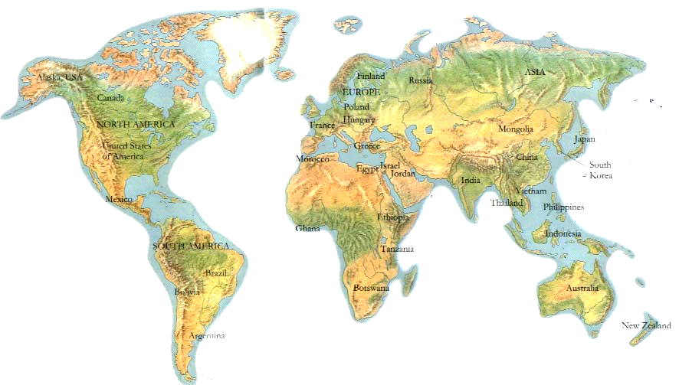
NGAWAIATA LIVES IN
NEW ZEALAND

CELINA LIVES IN
BRAZIL

DAISUKE LIVES IN
JAPAN

BAKANG LIVES IN
BOSTWANA
DION LIVES IN
AUSTRALIA

MEENA LIVES IN
INDIA

DAVID LIVES IN
ENGLAND

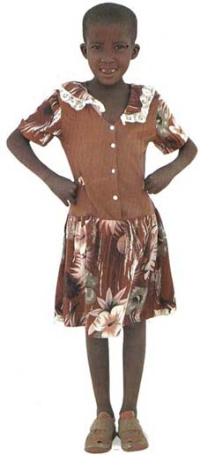
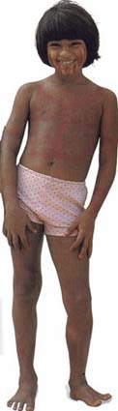
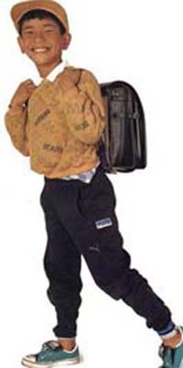
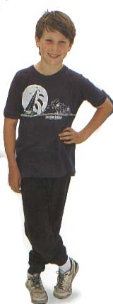
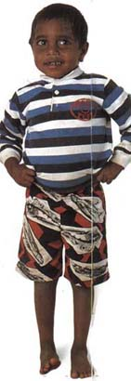
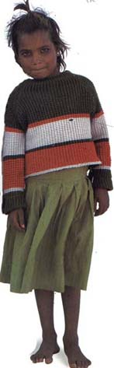
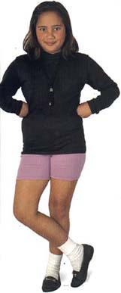

NAME | Interaction with T/S | Written texts  (Birthday calendar) | Oral Production  (Birthday calendar) | Oral Production  (Playing games) | Attitude
1-
2-
3-
4-
5-
6-
7-
8-
9-
10-
11-
12-
13-
14-
15-
16-
17-
18-
19-
20-
21-
22-
23-
24-
25-

Guraso agurgarriok:

Hona hemen hurrengo asteetan ingeleseko saioetan landuko dugun 2. unitatearen ildoa.
Informazio hau lagungarria izango delakoan, agur bero bat.
Ingeleseko irakasleria

Ezaugarriak

Unitate honetan urtebetetzeak eta jaiak landuko dira. Abiapuntua urtebetetzea izango da, umeengandik hurbilena delako, eta poliki poliki herriko jaiak, ihauteriak eta munduan zehar ospatzen diren jaiak landuko dira.

1. ATALA: ekintzak

-Urtebetetze eta ospakizunei buruz hitz egingo da, eta lehen atal honetan egingo diren ekintza nagusienak plan orrian idatziko dira.

-Ipuin bat landuko da.

-Kanta Liburuarekin jarraituko da, aurreko unitateko azken atalean landutako kanta baten esaldi batzuk idatziko dira.

-Txokoetan lan desberdinak egingo dira. Bukatzen denean ekintza honekin, esparru horietan egindakoa adierazi beharko da.

-Gelarako egutegi bat egingo da, bertan guztien urtebetetzeak idatziko dira.

-Banakako egutegi bat egingo da, non senideen eta lagunen urtebetetzeak markatuko dira. Bukatzean, gelako besteei aurkeztu beharko da.

-Beste herri batzuren jokoak landuko dira.
Estimados padres y madres:

Os presentamos el contenido de la 2ª unidad a trabajar durante las próximas semanas.
Esperando que esta información os sea de utilidad, os saludamos atentamente.
El profesorado de Inglés

Características

-En esta unidad se trabajarán los cumpleaños y las celebraciones. El cumpleaños será el punto de partida, al ser algo cercano al niño-a para pasar poco a poco a las fiestas del pueblo, carnavales y celebraciones en otros lugares del mundo.

1ª PARTE: actividades

-Hablarán sobre cumpleaños y celebraciones y escribirán las actividades principales que se van a realizar en la hoja del plan.

-Se trabajará un cuento.

-Se continuará con el Libro de Canciones, escribiendo algunos párrafos de la canción trabajada en la última parte de la unidad anterior.

-En rincones se trabajará en diversas actividades, al finalizar las mismas se dará cuenta de lo realizado en las mismas.

-Se hará un calendario de clase, donde se marcarán los cumpleaños de todos-as.

-Se harán calendarios individuales donde marcarán los cumpleaños familiares y de amigos-as. El mismo será presentado al resto de la clase.

-Se practicarán juegos de otros lugares del mundo.

STORY: Kipper’s Birthday

1- It was Kipper’s birthday.
2- Kipper wanted a party.
3- Everyone wanted to come.
4- Biff put up balloons.
5- Mum made a cake.
6- Dad took a sandwich.
7- ‘Stop it’ said Mum.
8- Everyone came to the party.
9- Dad wanted to play a game.
10- But Kipper put the television on.
11- ‘Oh, no!’ said Mum, ‘What a mess!’
12- The children played with the bubbles.
13- ‘What a good party!’ everyone said.

SONG:

Mary Brown, Mother Goose, OUP

Mary Brown was born today,
Born today, born today.
Mary’s ten years old today,
Happy birthday!

We know who was born today,
Born today, born today.
We know you were born today,
Happy birthday!

Happy birthday Mary Brown,
Mary Brown, Mary Brown.
Happy birthday Mary Brown,
Happy birthday!

