PART III
Pages

1. Sequence of activities & Objectives 2
2. Activities 3-8
3. Scripts
-Song: ‘Bean Bag Rock’ 9
4. Hand Out 1: B&W Celebration Poster (act. 14) 10-12
5. Hand Out 2: Colour Celebration Poster (act. 14) 13-14
6. Hand Out 3: Booklet, instructive texts (act. 16-17) 15-16
7. Evaluation chart 17
8. Letter to parents 18-19

PART III: OUR CELEBRATIONS
Song: ‘Bean Bag Rock’, Action Songs, Tumble Tots Video

ACTIVITIES OBJECTIVES
-13-  Evaluation  +  Planning | -14-  Celebrations Poster | -15-  Song Book  Carnival
-16-  Booklet  +  Corners | -17-  Booklet  +  Corners | -12-  Oral Presentation:  Booklet
1- To interact with the T when talking about our Celebrations.

2- To produce two written texts: a group poster and a bookltet.

3-. To be able to do corner work autonomously.

4- To present orally their booklet using, at least, these expressions: This is my favourite Celebrations booklet. Christmas in December, Carnival in February, ….
COMMENTS

…………………………………………………………………………………………………………………………………………………………………………………………………………………………………………………………………………………………………………………………………………………………………………………………………………………………………………………………………………………………………………………………………………………………………………………………………………………………………………

ACTIVITY 13 | TIME | LANGUAGE  SKILS | INTER  ACTION | MATERIALS | DESCRIPTION | ORAL & WRITTEN PRODUCTION
Evaluation  +  Planning  SUMMARY:  T and Ss evaluate PART II and plan PART III. | 30’ | L  S  W  L  S | BG  BG  I | Classroom Diary  Piece of paper per child | 1- T and Ss have a look at the plan of PART II and H ticks the activities that have been done.  2- T asks Ss to write down the name / number of the best activity for them on a small piece of paper (Ss shouldn’t imitate leaders’ opinion).  3- H collects all the papers, writes down the answers on the b/b, counts the final results and copies them on the diary, next to each activity.  4- T presents the plan for PART III writting it on the b/b. T and Ss talks about celebrations in our community.  5- H (or T) writes down PART III planning on the Classroom Diary. | -Did we listen to a story?  -Did we do corner work?  -Did we write in our Song Book?  -Did we make a Fancy Dress costume?  -Did we have a carnival party?  -Did we sing a song?  -Which has been the best activity for you?  -I liked…  -The one we / I liked best was…  -Our / my best activity was…  PART III planning  We are going to  -make a poster  -write in our Song Book  -make a booklet  -present our booklet  -do corner work  -sing a song

ACTIVITY 14 | TIME | LANGUAGE  SKILS | INTER  ACTION | MATERIALS | DESCRIPTION | ORAL & WRITTEN PRODUCTION
Celebrations Poster  SUMMARY:  T talks about seasons and months of the year along with the celebrations that took place in the community; then Ss make a Celebration Poster. | 30’ | L  R  S  W | BG  SG  BG | Hand Out 14b (colour)  Hand Out 14a (B&W)  Cardboard and felt pens | 1- T and Ss talk about seasons/months of the year and the changes in nature and our everyday life.  2- Meanwhile they place the labels and pictures on the poster (Hand Out 14).  3- Talk about events that take place in the local area.  4- Ss, in small groups, make drawings (or choose pictures) about these events, and write how they are called (San Fermin,…).  5- Pictures and their names are place on the cardboard, taking into account the season they are celebrated (Summer,…).  6- All together talk about the poster. | -Look at the seasons of the year.  -Look at the months of the year.  -What do we celebrate in Autumn?  -San Fausto. Leaves fall from trees because it’s Autumn!.  -And what’s the weather like in Summer?  -It’s hot and sunny. We go to the beach!  -Interaction with T and mates:  -What events do we celebrate?  -Draw pictures about these events, please!  -Do you understand the meaning of these words?  -Let’s stick the pictures on the cardboards!  -…

ACTIVITY 15 | TIME | LANGUAGE  SKILS | INTER  ACTION | MATERIALS | DESCRIPTION | ORAL & WRITTEN PRODUCTION
Song Book  Carnival  SUMMARY:  Ss write in their Song Books. | 30’ | S  L  W | I  BG  I | Individual Song Book, tape and cassette recorder (optional) | 1- T tells Ss they are going to write the lyrics of the song they have learnt in their Song books using the T as a scribe.  2- Ss dictate the song to the T and S/he writes it down on the b/b.  3- Ss copy it in their Song Books (they don’t have to copy the whole song, just the title and two or three lines, depending on each one’s writing skills). | -Lyrics of the song.

ACTIVITY 16 | TIME | LANGUAGE  SKILS | INTER  ACTION | MATERIALS | DESCRIPTION | ORAL & WRITTEN PRODUCTION
Booklet:  My favourite Celebrations  +  Corners  SUMMARY:  Ss make a booklet about their favourite Celebrations and then work in corners. | 30’ | R  W  L  R  W  S | I  SG  BG | Hand Out 3,  3 A4 size papers per child, classroom material  Corner materials  List of Ss in each corner | 1- Ss choose 3 events from the Celebrations Posters.  2- On one page they write the name of the event and the season or month it takes place.  3- On the next page they make a drawing about it.  4- T interacts with a group of Ss while the others are working in the corners.  5- Ss go to a corner in pairs or small groups. If necessary, T or H keeps a record in order to take turns in each one.  6- T asks some Ss what they have done in the corners. | -These is my favourite Celebration bookltet. Christmas in December, Carnival in February, …  -What have you done in the different corners?  -I’ve read a book  -We’ve listened to a story  -We’ve played a game  -I’ve drawn a picture  -…

ACTIVITY 17 | TIME | LANGUAGE  SKILS | INTER  ACTION | MATERIALS | DESCRIPTION | ORAL & WRITTEN PRODUCTION
Booklet:  My favourite Celebrations  +  Corners  SUMMARY:  Ss make a booklet about their favourite Celebrations and then work in corners. | 30’ | R  W  L  R  W  S | I  SG  BG | Hand out,  3 A4 size papers per child, classroom material  Corner materials  List of Ss in each corner | 1- Ss choose 3 events from the Celebration Posters.  2- On one page they write the name of the event and the season or month it takes place.  3- On the next page they make a drawing about it.  4- T interacts with a group of Ss while the others are working in the corners.  5- Ss go to a corner in pairs or small groups. If necessary, T or H keeps a record in order to take turns in each one.  6- T asks some Ss what they have done in the corners. | -These is my favourite Celebration bookltet. Christmas in December, Carnival in February, …  -What have you done in the different corners?  -I’ve read a book  -We’ve listened to a story  -We’ve played a game  -I’ve drawn a picture  -…

ACTIVITY 18 | TIME | LANGUAGE  SKILS | INTER  ACTION | MATERIALS | DESCRIPTION | ORAL & WRITTEN PRODUCTION
Oral Presentation:  Booklet  SUMMARY:  Ss present their booklets orally | 30’ | S  L | BG | Ss booklets | 1- Ss individually or in pairs present their booklets to the rest of the classroom mates.  2- If the group is too big, Ss are set in groups of 6-8, so that the T can evaluate the oral and written production of each S. Meanwhile the rest of the Ss can work in different corners | -These is my favourite Celebration bookltet: Christmas in December, Carnival in February, …

SONG: ‘Bean Bag Rock’, Action Songs, Tumble TotsVideo

Shake, shake, shake your bean bag (bis)
Everybody come on shake your bean bag
Shake your bean bag, don’t let it drop
Let’s all do the bean bag rock.

Hold the bean bag on your head
Hold the bean bag on your knees
Hold the bean bag on your tummy
And wiggle around if you please
If you please.

Hold the bean bag way down low
Hold it high in the air and don’t you let it go
Now shake and wriggle ‘cos you’re doing
The bean bag rock.

Shake, shake, shake your bean bag (bis)
Everybody come on shake your bean bag
Shake your bean bag, don’t let it drop
Let’s all do the bean bag rock.

Hold the bean bag on your elbow
Hold the bean bag on your toes
Hold the bean bag on your ear
And let me see you wiggle your nose
Wiggle your nose.

Hold the bean bag way down low
Hold it high in the air and don’t you let it go
Now shake and wriggle ‘cos you’re doing
The bean bag rock.

Shake, shake, shake your bean bag (bis)
Come on, come on, shake your bean bag
Shake, shake, shake your bean bag
Stop! It’s called the bean bag rock..

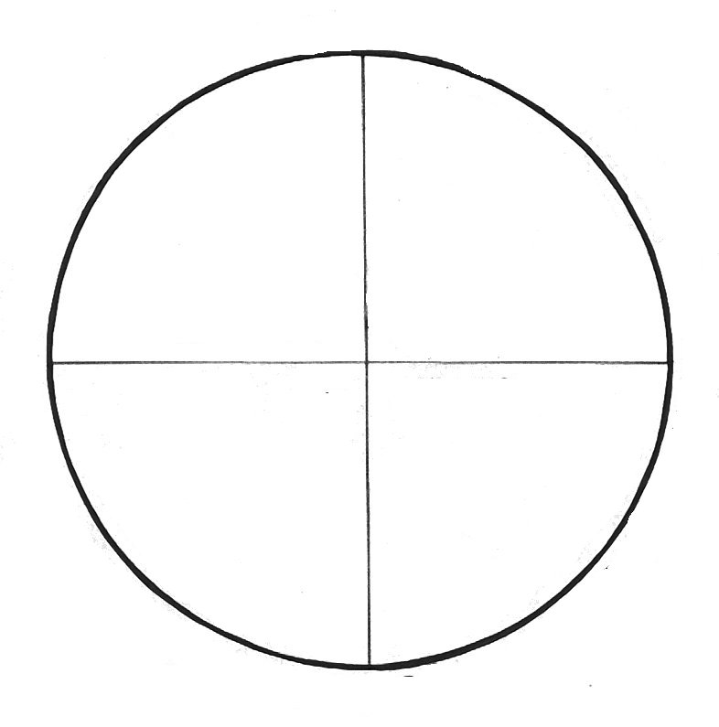

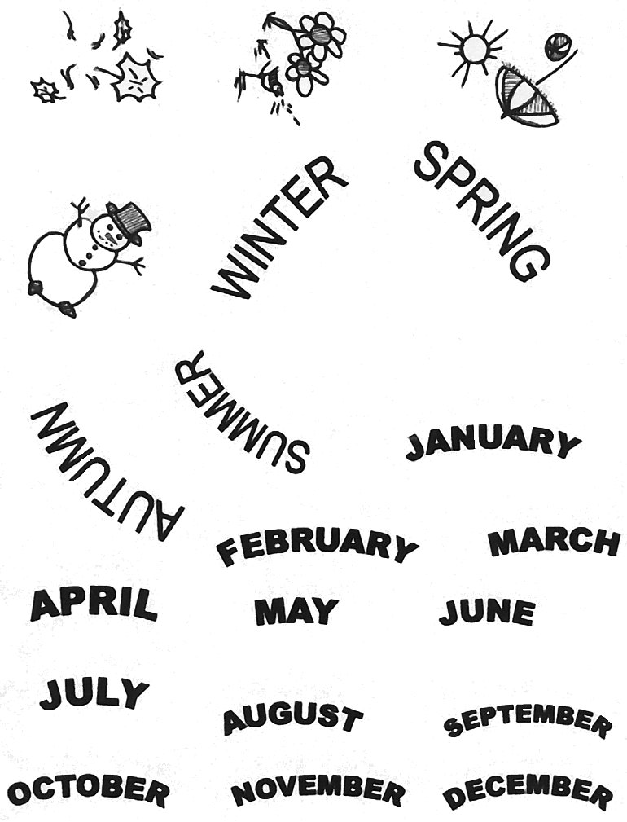
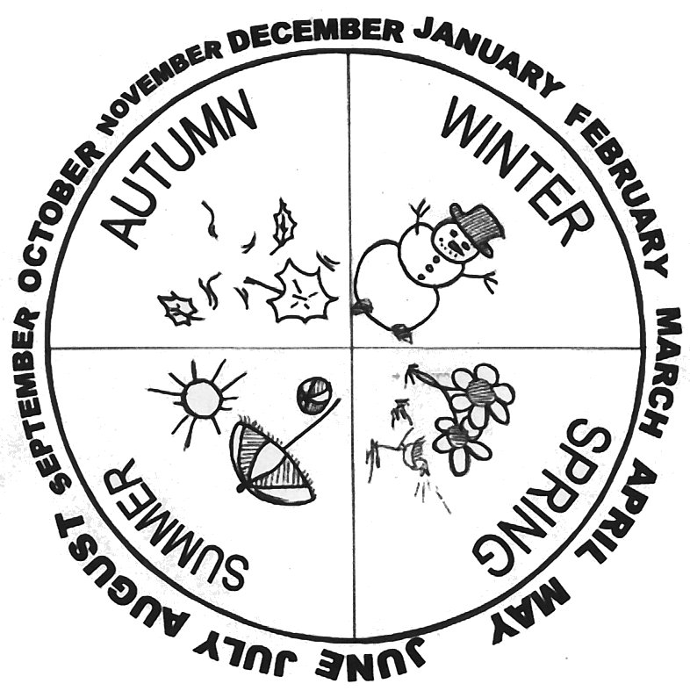
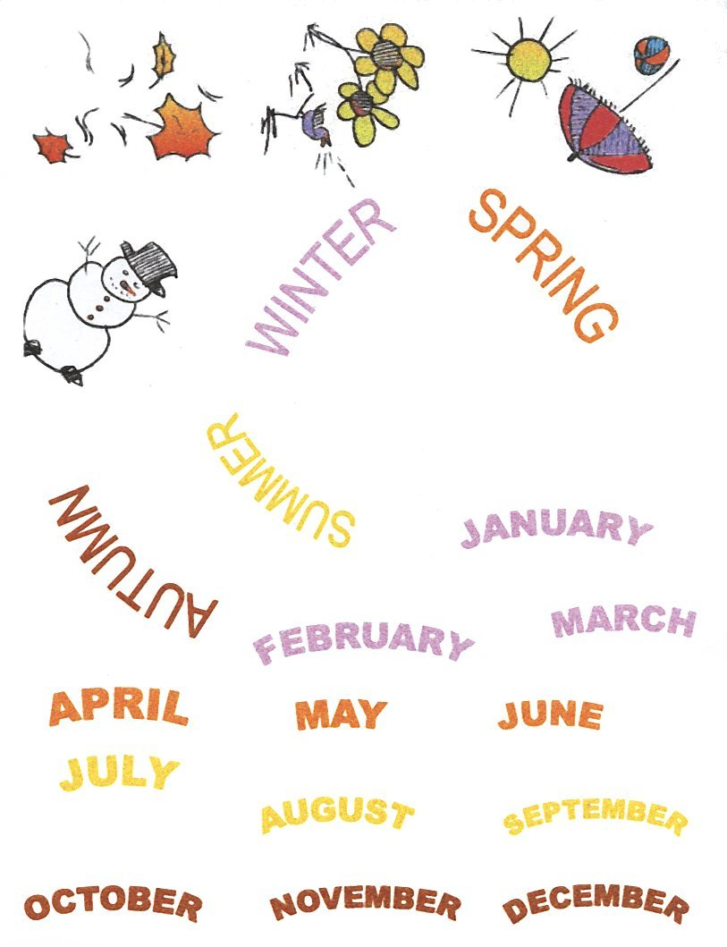
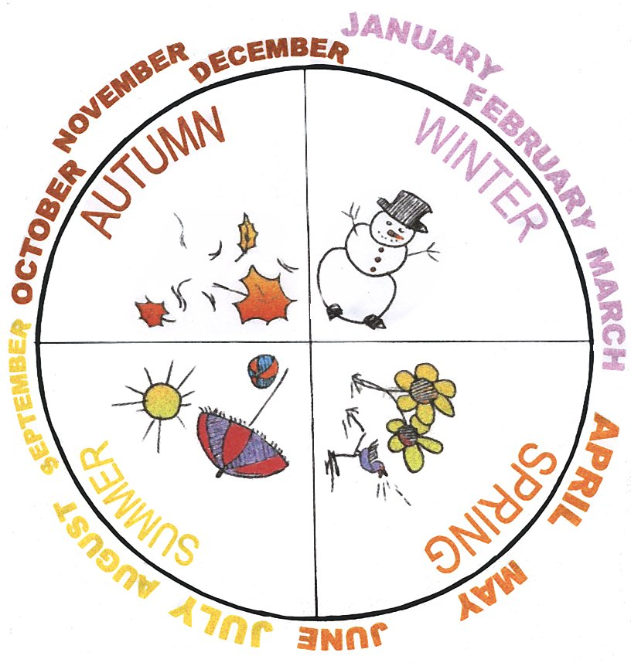

BOOKLET: INSTRUCTIVE TEXT

1ST TAKE 3 SHEETS OF PAPER AND STAPLE THEM TOGETHER.

=

2ND WRITE: CELEBRATIONS ON THE COVER.

CELEBRATIONS

BY:……

3RD WRITE: MY FAVOURITE CELEBRATIONS ARE... ON THE FIRST PAGE.

MY
FAVOURITE
CELEBRATIONS
ARE...

4TH CHOOSE 3 CELEBRATIONS YOU LIKE MOST, DRAW A PICTURE FOR EACH ONE AND WRITE THEIR NAMES ON THE NEXT PAGE.

1 2 3

MY
BIRTHDAY
IS IN
DECEMBER.


.
.

5TH WRITE: HAVE FUN!! ON THE LAST PAGE.

HAVE
FUN!!

6TH WRITE: SCHOOL YEAR 2002-03 ON THE BACK.

SCHOOL
YEAR

2002-03

7TH SHARE IT WITH YOUR PARTNERS AND TEACHERS.

8TH TAKE IT HOME AND SHOW IT WITH YOUR FAMILY!!

NAME | Interaction with T/Ss | Written texts  Poster | Written texts  Booklet | Oral production  Booklet presentation | Attitude
1-
2-
3-
4-
5-
6-
7-
8-
9-
10-
11-
12-
13-
14-
15-
16-
17-
18-
19-
20-
21-
22-
23-
24-
25

Guraso agurgarriok:

Hona hemen hurrengo asteetan ingeleseko saioetan unitatearen 3. atalean landuko dugun edukien ildoa.
Informazio hau lagungarria izango delakoan, agur bero bat.
Ingeleseko irakasleria

3. ATALA: ekintzak

-Bigarren ataleko ekintzak ebaluatuko dira, eta atal honetako ekintzak plan orrian idatziko dira.

-Gure inguruko jai eta ospakizunei buruz hitz egingo da: izena, garaia, ezaugarriak... Ondoren, taldeka, informazioa poster batetan bilduko da.

-Kanta Liburuarekin jarraituko da, aurreko atalean landutako kanta baten esaldi batzuk idatziko dira.

-Ikasle bakoitzak bere gustoko ospakizunei buruzko liburuxka bat egingo du. Amaitzean ikaskideei aurkezkuko zaie.

-Txokoetan lan desberdinak egingo dira. Bukatzen denean ekintza honekin, esparru horietan egindakoa adierazi beharko da.

-Kanta bat landuko da.

Estimados padres y madres:

Os presentamos el contenido de la 3ª parte de la unidad que trabajaremos durante las próximas semanas.
Esperando que esta información os sea de utilidad, os saludamos atentamente.
El profesorado de Inglés

3ª PARTE: actividades

-Se evaluarán las actividades de la 2ª parte y se escribirán las actividades a realizar durante la 3ª parte en la hoja del plan.

-Se hablará sobre las fiestas y celebraciones de nuestro entorno: nombre, fecha, características... A continuación, en grupos, se recogerá esta información en un poster.

-Se continuará con el Libro de Canciones, escribiendo algunos párrafos de la canción trabajada en la 2ª parte de la unidad.

-Cada alumno-a recogerá sus celebraciones más sentidas en un librillo. Al finalizar, se presentará al resto de compañeros-as.

-En rincones se trabajará en diversas actividades, al finalizar las mismas se dará cuenta de lo realizado en las mismas.

-Se trabajará una canción.

SONG: ‘Bean Bag Rock’, Action Songs, Tumble TotsVideo

Shake, shake, shake your bean bag (bis)
Everybody come on shake your bean bag
Shake your bean bag, don’t let it drop
Let’s all do the bean bag rock.

Hold the bean bag on your head
Hold the bean bag on your knees
Hold the bean bag on your tummy
And wiggle around if you please
If you please.

Hold the bean bag way down low
Hold it high in the air and don’t you let it go
Now shake and wriggle ‘cos you’re doing
The bean bag rock.

Shake, shake, shake your bean bag (bis)
Everybody come on shake your bean bag
Shake your bean bag, don’t let it drop
Let’s all do the bean bag rock.

Hold the bean bag on your elbow
Hold the bean bag on your toes
Hold the bean bag on your ear
And let me see you wiggle your nose
Wiggle your nose.

Hold the bean bag way down low
Hold it high in the air and don’t you let it go
Now shake and wriggle ‘cos you’re doing
The bean bag rock.

Shake, shake, shake your bean bag (bis)
Come on, come on, shake your bean bag
Shake, shake, shake your bean bag
Stop! It’s called the bean bag rock..

