PART IV
Pages

1. Sequence of activities & Objectives 2
2. Activities 3-8
3. Scripts
-Song: ‘Hokey Cokey’ 9-10
-Dance: ‘Circle’ 10
-Reference Book: ‘Celebrations’ 11-13
4. Hand Out 1 (act. 20) 14
5. Hand Out 2 (optional B&W) 15
6. Hand Out 3 (act. 20, option A) 16
7. Hand Out 4 (act. 20, option B) 17
8. Hand Out 5 (act. 20, option C) 18
9. Hand Out 6 (act. 20, options B-C) 19
10. Evaluation chart 20
11. Letter to parents 21-23

PART IV: WILD ANIMALS II
Song: ‘Hokey Cokey’, The Singing Kettle Video)
Dance: ‘Circle’, Music Box, Longman

ACTIVITIES OBJECTIVES
-19-  Evaluation  +  Planning | -20-  Festival Mobile | -21-  Song Book  Bean Bag Rock
-22-  Dance  Circle | -23-  Dance  Circle | -24-  Corners

COMMENTS
1- To interact with the T when talking about celebrations around the World.

2- To make a festival mobile.

3- To learn a dance.

4- To be able to do corner work autonomously.

……………………………………………………………………………………………………………………………………………………………………………………………………………………………………………………………………………………………………………………………………………………………………………………………………………………………………………………………………………………………………………………………………………………………………………………………………………………………………………………………………………………………………………………………………………………………………………………………………

ACTIVITY 19 | TIME | LANGUAGE  SKILS | INTER  ACTION | MATERIALS | DESCRIPTION | ORAL & WRITTEN PRODUCTION
Evaluation  +  Planning  SUMMARY:  T and Ss evaluate PART III and plan PART IV. | 30’ | L  S  W  L  S | BG  BG  I | Classroom Diary  Piece of paper per child | 1- T and Ss have a look at the plan of PART III and H ticks the activities that have been done.  2- T asks Ss to write down the name / number of the best activity for them in a small piece of paper (Ss shouldn’t imitate leaders’ opinion).  3- H collects all the papers, writes down the answers on the b/b, counts the final results and copies them on the diary, next to each activity.  4- T presents the plan for PART IV writting it on the b/b.  5- H (or T) writes down PART IV plan on the Classroom Diary. | -Did we make a poster?  -Did we write in our Song Book?  -Did we make a booklet?  -Did we present our booklets?  -Did we do corner work?  -Did we sing a song?  -Which has been the best activity for you?  -I liked…  -The one we / I liked best was…  -Our / my best activity was…  PART IV planning  We are going to  -make a festival mobile  -write in our Song Book  -learn a dance  -sing a song  -work in corners

ACTIVITY 20 | TIME | LANGUAGE  SKILS | INTER  ACTION | MATERIALS | DESCRIPTION | ORAL & WRITTEN PRODUCTION
Festival Mobile  SUMMARY:  T and Ss talk about festivals around the World and make a festival mobile. | 10’  20’ | S  L  L  L  R  S | BG  l  SG  I/P | Reference Book: ‘Celebrations’  Hand Out 1  Celebrations script  Hand Outs 3, 4, 5 and 6  Classroom material, string | 1-.T and Ss talk about festivals around the World. T shows them the reference book ‘Celebrations?.  2- H gives out cards (Hand Out 1, colour) with the names of some festivals and pictures for them to match, using the reference book.  3- T gives them information about the selected festivals.  4- Ss pin the matched cards on the World Map used in Part I of this Unit. T helps them if necessary.  5- For the Festival Mobile there are different options (individually):  A- (Hand Out 3) Ss cut out the spiral, along it they write down the name of some celebrations and draw pictures about them. Then, staple a string to the head of the resulting ‘snake’.  B- (Hand Outs 4 & 6) Ss cut out the spiral, hang the names of the celebrations and the pictures along it. Then, staple a string to the head of the resulting ‘snake’.  C- (Hand Outs 5 & 6) Ss use different colours to separate the celebrations written in the word-chain. Then hang the corresponding picture from the snake. Staple a string to the head of the resulting ‘snake’. | -Do you remember any festival in our community?  -People from other parts of the World celebrate the same/different festivals: Carnival, Chinese New Year…  -Let’s match these festivals with the pictures!  -Celebrations script.  -We are going to make a festival mobile.  -Which are your favourite festivals?  -Which festival you like best?  -I like …. best.  -My favourite festivals are…  -…  -Instructions for handicraft

ACTIVITY 21 | TIME | LANGUAGE  SKILS | INTER  ACTION | MATERIALS | DESCRIPTION | ORAL & WRITTEN PRODUCTION
Song Book  Bean Bag Rock  SUMMARY:  Ss write in their Song Books. | 30’ | S  L  W | BG  I | Individual Song Book, tape and cassette recorder (optional) | 1- T tells Ss they are going to write the lyrics of the song they have learnt in their Song Books using the T as a scribe.  2- Ss dictate the song to the T and S/he writes it down on the b/b.  3- Ss copy it in their Song Books (they don’t have to copy the whole song, just the title and two or three lines, depending on each one’s writing skills). | -Lyrics of the song.

ACTIVITY 22 | TIME | LANGUAGE  SKILS | INTER  ACTION | MATERIALS | DESCRIPTION | ORAL & WRITTEN PRODUCTION
Dance  Circle  SUMMARY:  Ss learn a dance. | 30’ | S  L | BG | Audio tape, cassette recorder | 1- T tells Ss they are going to learn a dance. They talk about dancing (if they are learning any Basque dances…).  2- T and Ss listen to the song a couple of times.  3- Hold hands in a circle and follow the movements according to the lyrics of the song.  Suggestions:  -T and H can perform the dance beforehand.  -Ss play instruction games (Simon says…) to get familiar with the vocabulary and expressions used in the dance.  -The dance can be used as the song to be learnt during this fortnight. | -Lyrics of the song.  -Do you like dancing?  -Do you know any Basque dance’  -Let’s dance!.  -Now, let’s practice this dance!  -Listen to the song!  -Come on everybody, form a circle and hold hands.

ACTIVITY 23 | TIME | LANGUAGE  SKILS | INTER  ACTION | MATERIALS | DESCRIPTION | ORAL & WRITTEN PRODUCTION
Dance  Circle  SUMMARY:  Ss learn a dance. | 30’ | S  L | BG | Audio tape, cassette recorder | 1- Ss practice the dance again.  2- T can record the session on a video.  3- The dance can be performed in front of another class.  4- Ss can watch their own performance on the video and evaluate it.  Suggestions:  -Ss play instruction games (Simon says…) to get familiar with the vocabulary and expressions used in the dance.  -The dance can be used as the song to be learnt during this fortnight. | -Lyrics of the song.  -Let’s practice the dance again!  -Listen to the song!  -Come on everybody, form a circle and hold hands.  -Did you like the dance?  -Let’s see the video!  -How did we do it?  -We did it very well!  -…

ACTIVITY 24 | TIME | LANGUAGE  SKILS | INTER  ACTION | MATERIALS | DESCRIPTION | ORAL & WRITTEN PRODUCTION
Corners  SUMMARY:  Ss work in corners. | 30’ | L  R  W  S | SG  BG | Corner materials  List of Ss in each corner | 1- Ss go to a corner in pairs or small groups. If necessary, T or H keeps a record in order to take turns in each one.  2- T asks some Ss what they have done in the corners. | -What have you done in the different corners?  -I’ve read a book  -We’ve listen to a story  -We’ve played a game  -I’ve drawn a picture  -…

SONG: Hokey Cokey, The Singing Kettle Video

Good evening boys and girls.
Welcome to the Singing Kettle Party.
What party would be complete without the Hokey Cokey?
Start with your right hand; put it in and shake it all about!
Everybody sing:
You put your right hand in, your right hand out,
In, out, in, out, shake it all about.
You do the Hokey Cokey and you turn around,
That’s what it’s all about.
Sing:
Oh, Hokey Hokey Cokey
Oh, Hokey Hokey Cokey
Oh, Hokey Hokey Cokey
That’s what it’s all about.

Let’s try your left hand this time:
You put your left hand in, your left hand out,
In, out, in, out, shake it all about.
You do the Hokey Cokey and you turn around,
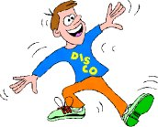
That’s what it’s all about.

Oh, Hokey Hokey Cokey
Oh, Hokey Hokey Cokey
Oh, Hokey Hokey Cokey
That’s what it’s all about.

Try your right ear this time:
You put your right ear in, your right ear out,
In, out, in, out, shake it all about.
You do the Hokey Cokey and you turn around,
That’s what it’s all about.

Oh, Hokey Hokey Cokey
Oh, Hokey Hokey Cokey
Oh, Hokey Hokey Cokey
That’s what it’s all about.

Try your left ear:
You put your left ear in, your left ear out,
In, out, in, out, shake it all about.
You do the Hokey Cokey and you turn around,
That’s what it’s all about.

Oh, Hokey Hokey Cokey
Oh, Hokey Hokey Cokey
Oh, Hokey Hokey Cokey
That’s what it’s all about.

Put in your whole head this time:
You put your whole head in, your whole head out,
In, out, in, out, shake it all about.
You do the Hokey Cokey and you turn around,
That’s what it’s all about.

Oh, Hokey Hokey Cokey
Oh, Hokey Hokey Cokey
Oh, Hokey Hokey Cokey
That’s what it’s all about.

Oh, Hokey Hokey Cokey
Oh, Hokey Hokey Cokey
Oh, Hokey Hokey Cokey
That’s what it’s all about.

DANCE: ‘Circle’, Music Box, Longman

Come along and join our circle,
Put out your hands and make a circle.
Step to the right and sing,
Step to the right and sing, sing, sing.

Now make pairs with arms crossed over,
Make up a pair with arms crossed over.
Now all together swing,
Now all together swing, swing, swing.

Now in your pairs skip to the centre,
Try to keep your circle tight.
Now link your arms behind each other,
Always keep your circle tight.

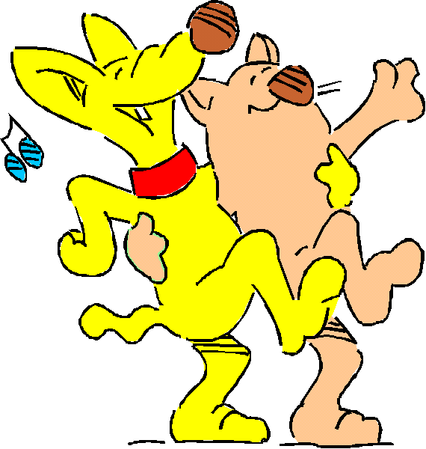

REFERENCE BOOK: ‘Celebrations’

Chinese New Year (pag. 8-9)

Man Po is nine years old and lives in Hong Kong. She is looking forward to Chinese New Year, one of the world’s most colourful celebrations. Chinese New Year starts on the first day of the Chinese calendar, usually in February. It lasts for 15 days and marks the start of the new Year. For many families, it is a time for feasting and visiting relatives and friends, but in the heart of the city, a spectacular procession takes place. The celebrations are based on bringing luck, health, happiness and wealth throughout the coming year. Chinese families clean their houses thoroughly to rid them of the last year’s bad luck before the celebrations begin.

Carnival (pag. 10-11)

Three days before Ash Wednesday in Lent, one of the world’s most spectacular Carnivals takes place in Rio de Janeiro, Brazil. Twelve-year-old Janaina is Queen of the Drummers in the Carnival’s flamboyant Samba School Parade. Fourteen schools, each with over 3,000 performers, spend the entire year creating elaborate costumes and majestic floats for this magnificent festival. Thousands of people come to watch the colourful procession of performers dancing down one of the Rio’s grand avenues, to the rhythmic Brazilian music, Samba.

‘My name is Janaina. I belong to the Mangueir do Amanha Samba School. I live close by, in a favela (shanty town). I have been a Samba dancer in the Carnival sice I was five years old. My favourite part of the Carnival is when I am dancing down the avenue. I feel more than happy, I feel amazed that the Carnival is so big. When it is all over, I just have to think that next year there’s another one’.

N’cwala (pag. 12-13)

M’Sangombe is a ten-year-old Ngoni warrior from the Eastern Province in Zambia. This year he was chosen to dance at the N’cwala ceremony, which is held each February to celebrate the harvest. The festival is based on the Ngoni tradition of offering the Paramount Ngoni chief the first produce of the year. Twelve local chiefs from the Eastern Province travel with their finest dancers to the village of Mutenguleni, where the ceremony takes place. Each group dances before the Paramount chief, and he elects one group as the best warrior dancers.

‘This is the first time that I have danced in the N’cwala. I am the youngest person in my group. All my friends have stayed in the village. On the bus journey to the N’cwala I was very excited. The Chief of my village was also on the bus. I am not afraid of him, but I respect him because he is a Chief. If I had the chance to be a Chief, I would be excited and happy. I would look after the people in my Chiefdom’.

Eid ul-Fitr (pag. 36-37)

Dalia is eleven years old and lives in Jordan. Dalia and her family are Muslims. Each year during the ninth lunar month, called Ramadan, Muslims avoid food and drink between sunrise and sunset. They celebrate the end of this period of fasting with Eid ul-Fitr, a joyous festival of feasting that lasts for three days. At Eid, Muslims eat celebratory meals, give food to the poor, visit relations and friends, and exchange gifts and cards.

‘This is th Arabic word Eid ul-Fitr, which means ‘breaking of the fast’. For the month of Ramadan, we don’t eat or drink anything between sunrise and sunset. Ramadan ends on the morning after we have seen the new moon in the sky, and this is the first day of Eid. We get up before sunrise, have a bath, and put on new clothes. Then we go to the mosque and pray until the sun has risen. After that, we go home and eat what we want for breakfast. I think that everyone feels very happy at Eid’.

Trung Thu (pag. 40-41)

Van is twelve years old and lives in Vietnam. Each year, on the 15th day of the eighth lunar month, she joins hordes of other children who go out into the streets with glowing lanterns to enjoy Trung Thu. This mid-autumn festival celebrates the beauty of the moon, which is brighter and whiter than at any other time of the year. The festival involves a family gathering where parents spoil their children with treats and tasty moon cakes.

‘On Trung Thu, the moon looks like a yellow ball, full and beautiful. My mother buys me moon cakes and I arrange them on a tray with some fruit. We eat these on the terrace. Then I put a candle inside my star lantern, light it, and go outside to meet my friends and follow the processions through the streets’.

Hallowe’en (pag. 42-43)

Alex is ten years old and lives in Canada. This year, his neighbour Megan has invited him to a party to celebrate Hallowe’en. Hallowe’en is an ancient festival that takes place on the last night of October, when it was once believed that witches and spirits returned to Earth. Children have great fun decorating their houses and dressing up in different disguises. As night falls, they go from door to door, frightening their neighbours and saying ‘trick or treat’.

‘This is a scaring time of year. My neighbour Megan is having a Hallowe’en party. I am going as the Giant Hamster from Goosebumps book. He is ugly with big teeth and has grown huge and evil after eating some Monster Blood. At Megan’s party we’ll play my favourite game, which is apple bobbing. When we go trick or treating, people always give us treats. My favourite treats are suckers’.

Diwali (pag. 50-51)

Eleven-year-old Sonu lives in northern India. Each Autumn, just before the new moon, when the sky is at its darkest, Sonu celebrates Diwali, the magnificient festival of lights. Houses all over India twinkle with tiny lights from clay lamps called diye (singular diya), which are lit to welcame the Hindu god Rama. On this day thousands of years ago, Rama returned to reclaim his kingdom after 14 years in exile. People also light diye in the hope that Lakshmi, the goddess of prosperity, will visit their homes. Diwali lasts for two days –on the second night, families pray and feast and set off fireworks to ward off evil.

‘The word Diwali comes from the Hindi word Deepavali, which I have written here. Deepavali means ‘row of lights’. Today is Diwali and it is also my birthday, which is very lucky. On Diwali, we wear clean clothes or new clothes. In the evening we pray to Lakshmi and then we touch our elders’
feet to show our respect for them. We offer sweets to Lakshmi, and after the prayers, we share sweets among ourselves’.

Hanukkah (pag. 52-53)

Seven-year-old Isabel comes from New York City, USA. She and her family are Jewish and each year, on the 25th day of the Jewish month of Kislev (usually around December), they celebrate Hanukkah, the festival of lights. Hanukkah lasts for eight days and features an eight-branched candlestick, which the Jews use to remind them of the miracle that happened when the Temple of Jerusalem was re-captured and cleansed, more than 2,000 years ago.

‘At Hanukkah, we light candles in our hanukkiya. Actually we have two –one that I made from clay, and the other, real one, which is golden. Last night I watched a tape about Hanukkah and the other day, I called my Dad’s Mom, who told me the story behind it. Hanukkah is one of my favourite festivals. I like making little cards for my Mom and Dad with ‘Happy Hanukkah’ on them, and I also make my own dreidls out of some paper, tape and a pencil. Most of all, I love eating the latkes that my Mom makes’.

Christmas (pag. 56-57)

Nine-year-old Maria lives in Stuttgart, Germany. Her favourite celebrations are her birthday and Christmas –a Christian festival to mark the birth of Jesus Christ. On 24 December, which is Christmas Eve, Maria, her sister and children throughout Germany go to Church. They believe that while they are there, Christkind (baby Christ) visits their homes to deliver gifts. Every German household has a green fir tree at Christmas. Maria decorates her tree with glittering hearts.

‘This is how I write Christmas is German. Christmas is to celebrate the birth of Jesus Christ. His mother was called Mary, just like me! I have written a letter to Christkind, and I will leave it in the sitting room. This year, our Christmas tree is a really nice one. Last year we had a very prickly tree, but this one keeps all its needles’.

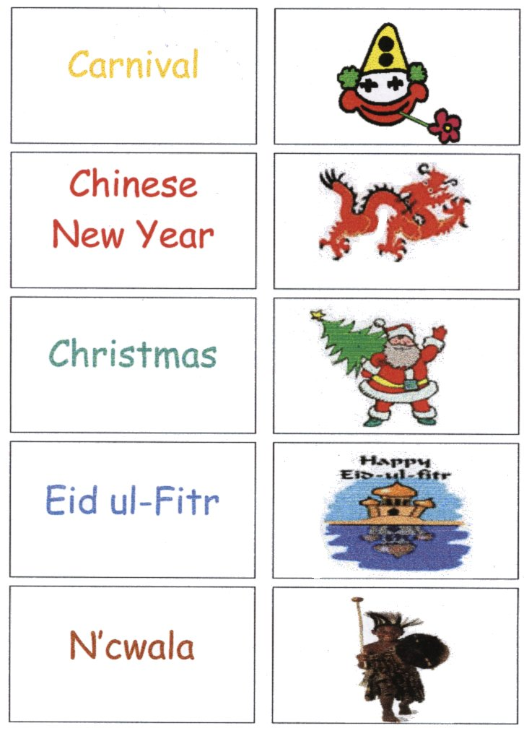

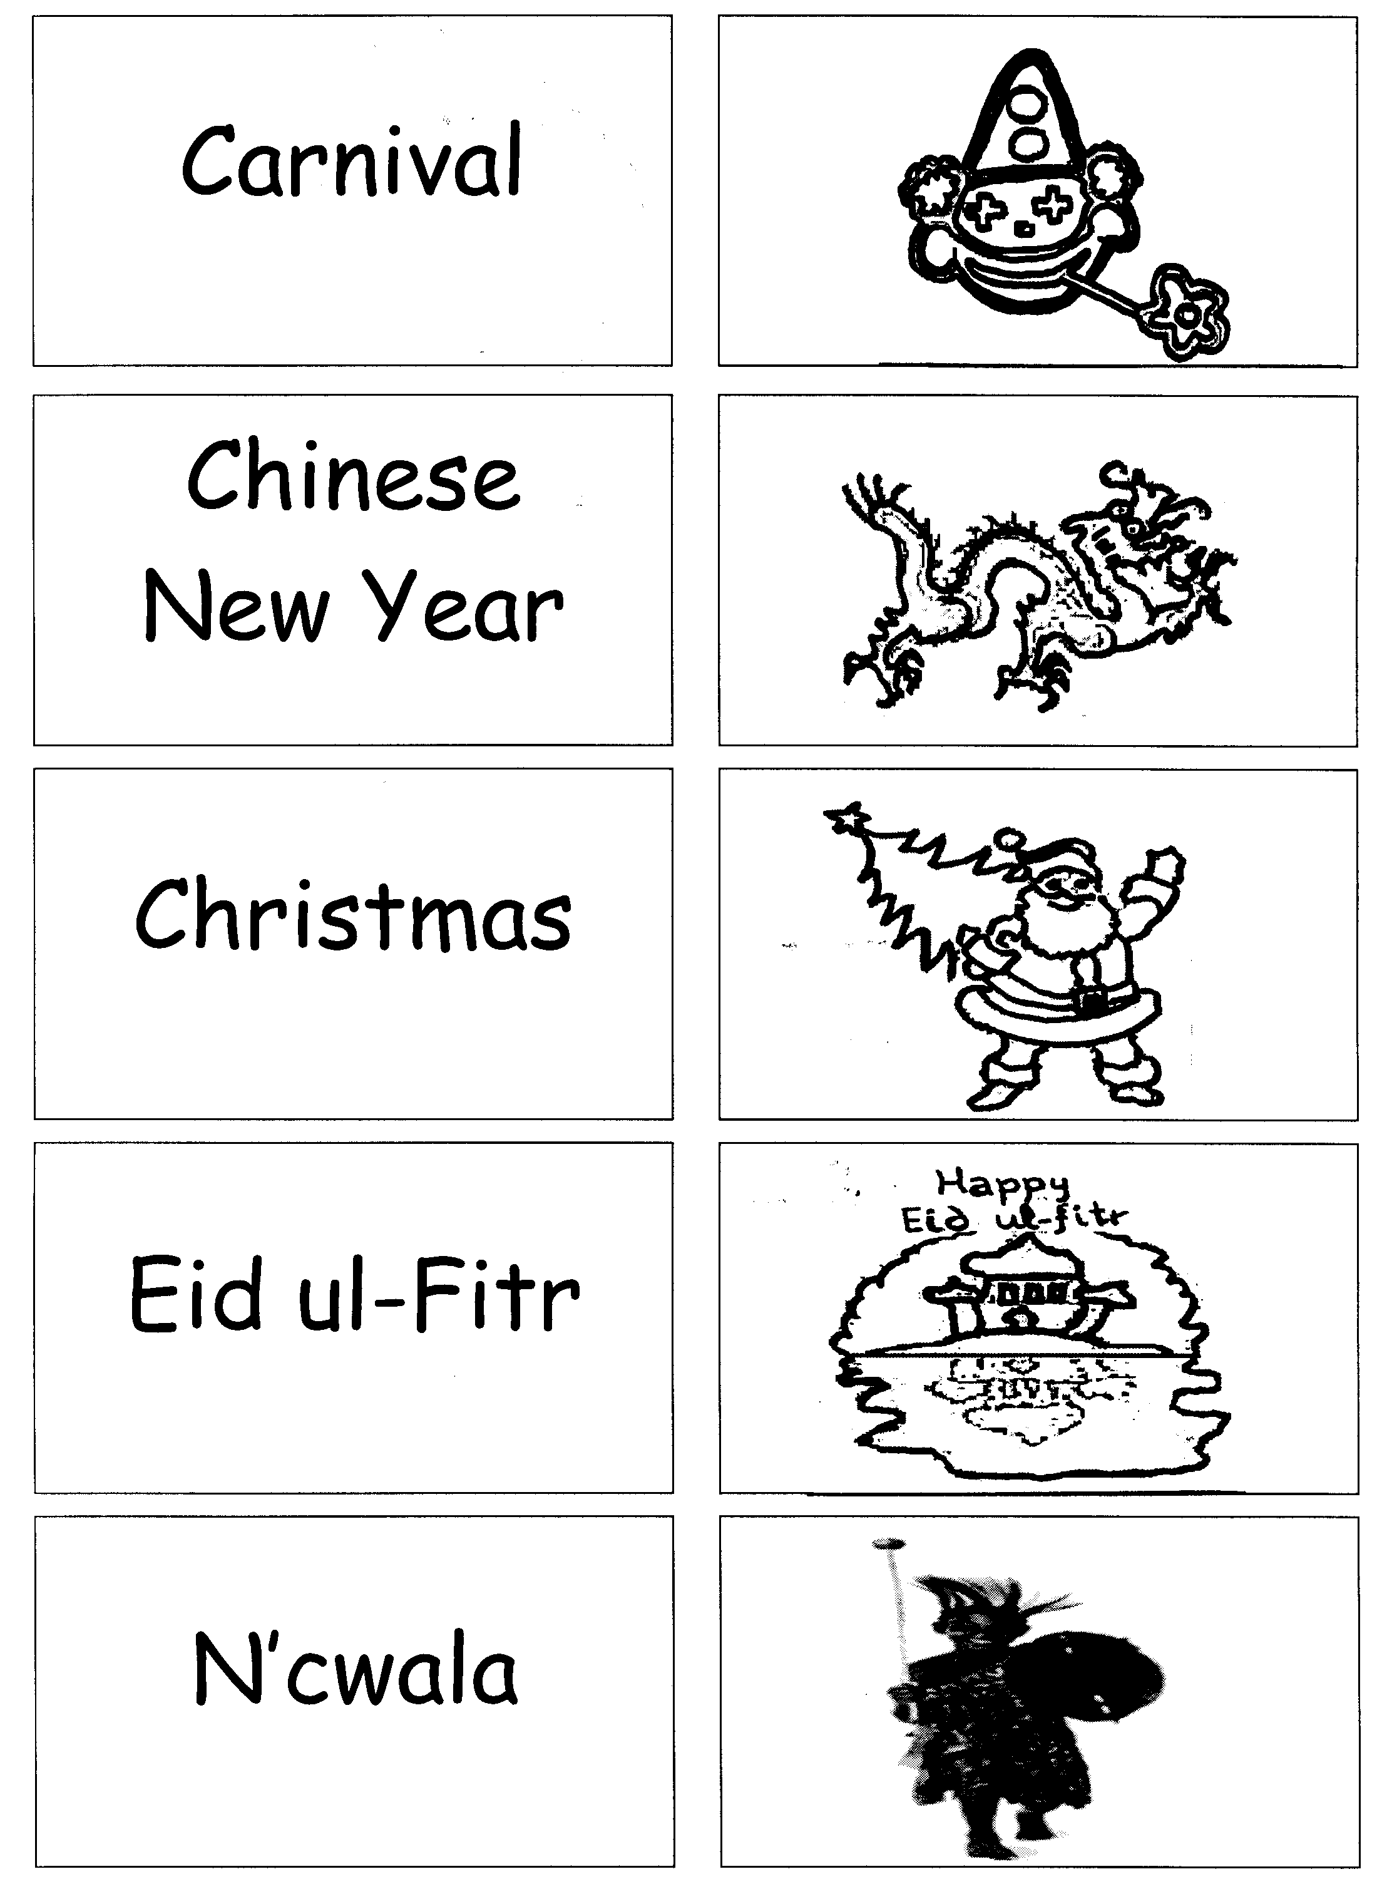
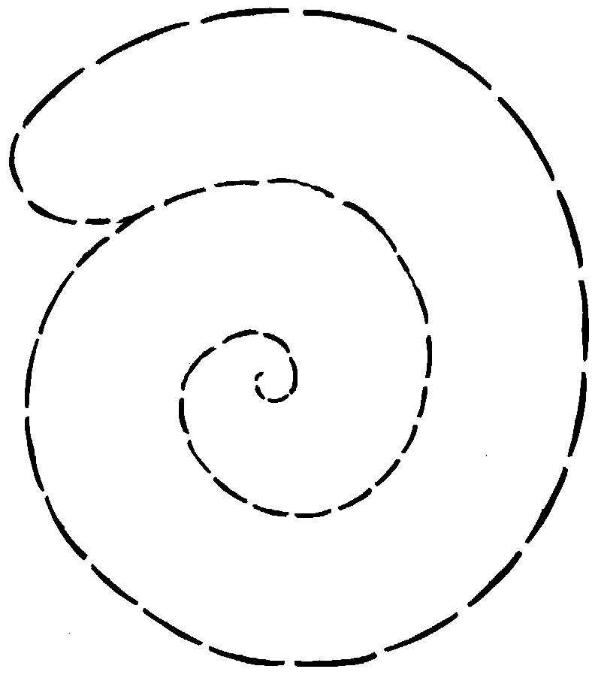

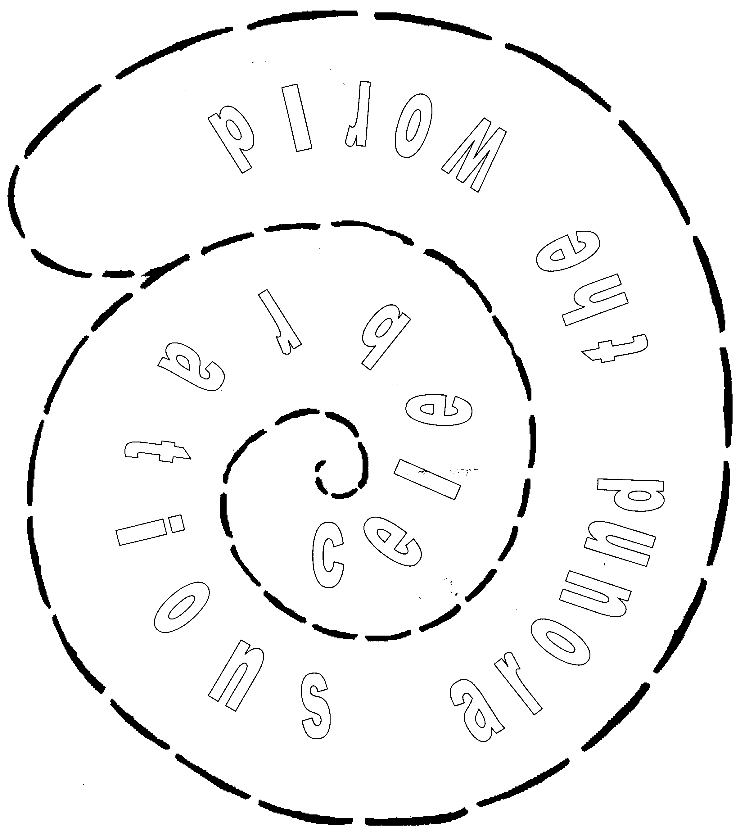
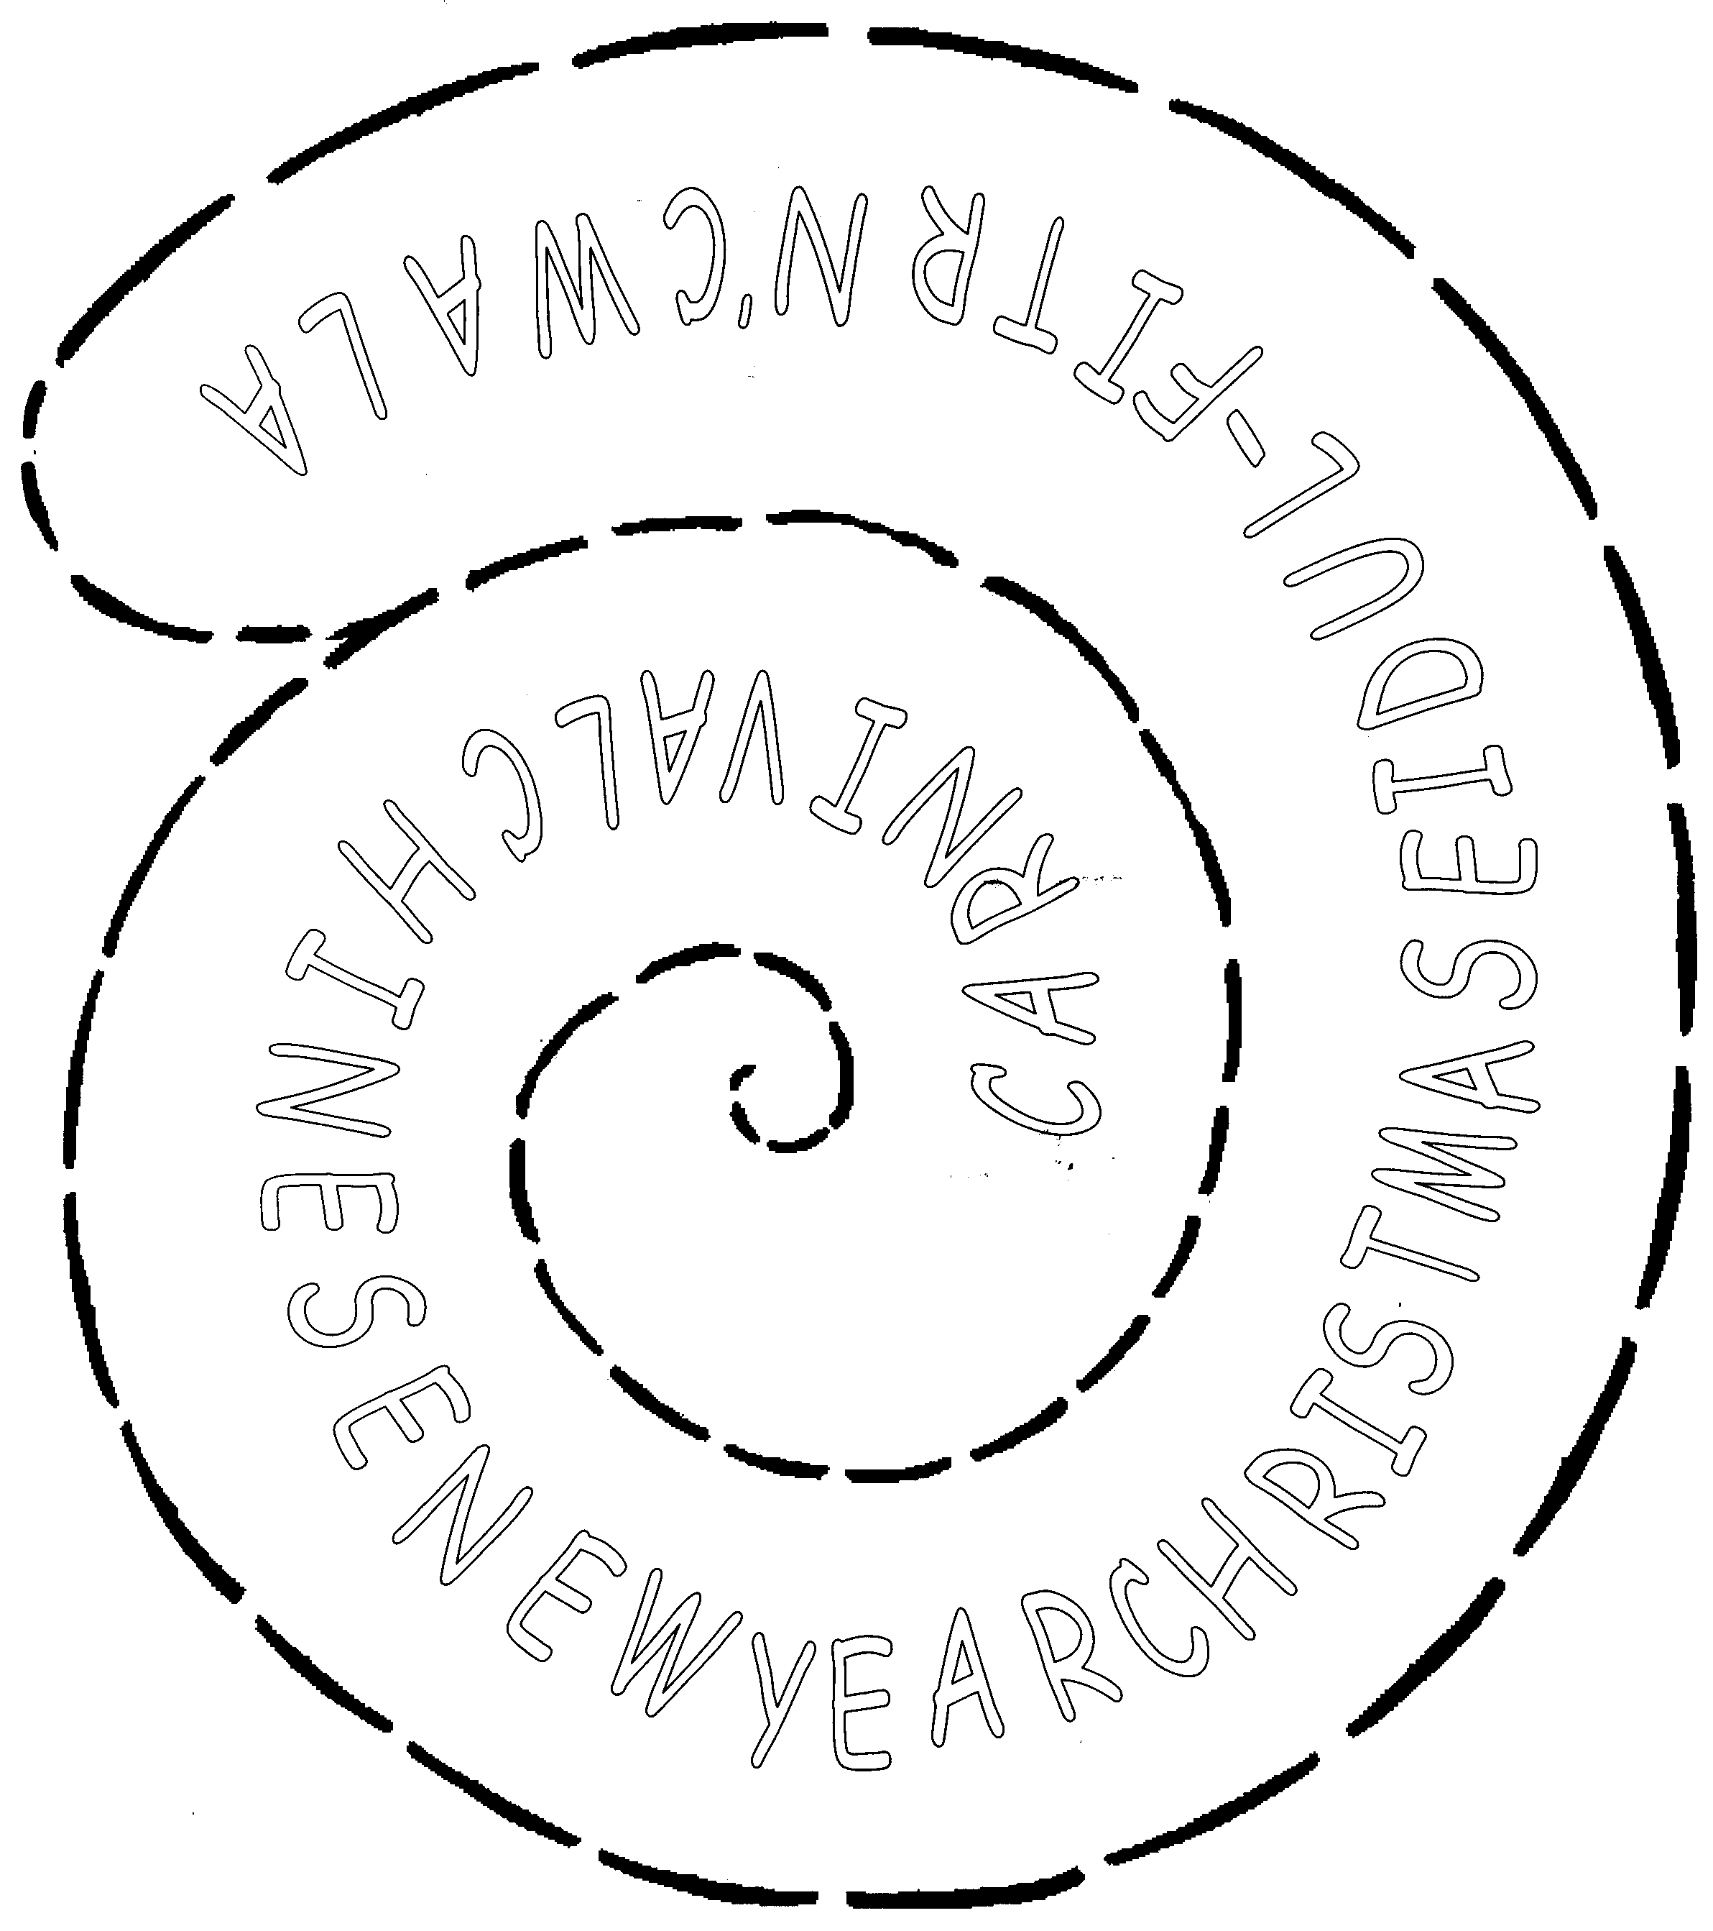

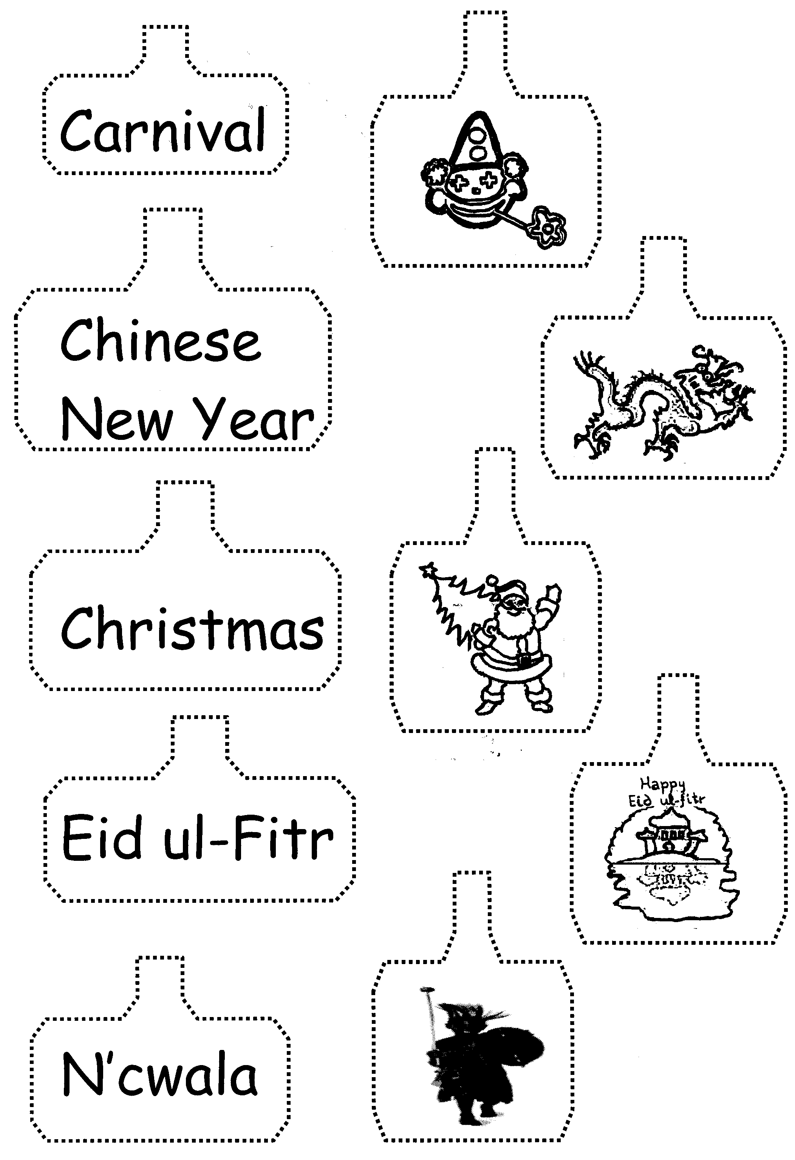

NAME | Interaction with T/Ss | Festival mobile | Dance | Attitude
1-
2-
3-
4-
5-
6-
7-
8-
9-
10-
11-
12-
13-
14-
15-
16-
17-
18-
19-
20-
21-
22-
23-
24-
25

Guraso agurgarriok:

Hona hemen hurrengo asteetan ingeleseko saioetan unitatearen 4. atalean landuko dugun edukien ildoa.
Informazio hau lagungarria izango delakoan, agur bero bat.
Ingeleseko irakasleria

4. ATALA: ekintzak

-Hirugarren ataleko ekintzak ebaluatuko dira, eta atal honetako ekintzak plan orrian idatziko dira.

-Munduan zehar jai eta ospakizunei buruz hitz egingo da: izena, non ospatzen den, ... Gelako entziklope-dien laguntzaz, txartelen bidez mapa batetan kokatu ahal izango dira.

-Bzkoitzak zintziligarri bat egingo du gaiari buruz.

-Kanta Liburuarekin jarraituko da, aurreko atalean landutako kanta baten esaldi batzuk idatziko dira

-Txokoetan lan desberdinak egingo dira. Bukatzen denean ekintza honekin, esparru horietan egindakoa adierazi beharko da.

-Kanta bat landuko da.

-Dantza bat landuko da.

Estimados padres y madres:

Os presentamos el contenido de la 4ª parte de la unidad que trabajaremos durante las próximas semanas.
Esperando que esta información os sea de utilidad, os saludamos atentamente.
El profesorado de Inglés

4ª PARTE: actividades

-Se evaluarán las actividades de la 3ª parte y se escribirán las actividades a realizar durante la 4ª parte en la hoja del plan.

-Se hablará sobre celebraciones en diversas partes del mundo: nombre, lugar... Con la ayuda de enciclopedias, las situaremos físicamente en el mapa por medio de tarjetas.

-Individualmete se hará un móvil sobre el tema.

-Se continuará con el Libro de Can-ciones, escribiendo algunos párrafos de la canción trabajada en la parte anterior.

-En rincones se trabajará en diversas actividades, al finalizar las mismas se dará cuenta de lo realizado en las mismas.

-Se trabajará una canción.

-Se trabajará un baile.

SONG: ‘Hokey Cokey’, The Singing Kettle Video

Good evening boys and girls.
Welcome to the Singing Kettle Party.
What party would be complete without the Hokey Cokey?
Start with your right hand; put it in and shake it all about!
Everybody sing:
You put your right hand in, your right hand out,
In, out, in, out, shake it all about.
You do the Hokey Cokey and you turn around,
That’s what it’s all about.
Sing:
Oh, Hokey Hokey Cokey
Oh, Hokey Hokey Cokey
Oh, Hokey Hokey Cokey
That’s what it’s all about.

Let’s try your left hand this time:
You put your left hand in, your left hand out,
In, out, in, out, shake it all about.
You do the Hokey Cokey and you turn around,
That’s what it’s all about.

Oh, Hokey Hokey Cokey
Oh, Hokey Hokey Cokey
Oh, Hokey Hokey Cokey
That’s what it’s all about.

Try your right ear this time:
You put your right ear in, your right ear out,
In, out, in, out, shake it all about.
You do the Hokey Cokey and you turn around,
That’s what it’s all about.

Oh, Hokey Hokey Cokey
Oh, Hokey Hokey Cokey
Oh, Hokey Hokey Cokey
That’s what it’s all about.

Try your left ear:
You put your left ear in, your left ear out,
In, out, in, out, shake it all about.
You do the Hokey Cokey and you turn around,
That’s what it’s all about.

Oh, Hokey Hokey Cokey
Oh, Hokey Hokey Cokey
Oh, Hokey Hokey Cokey
That’s what it’s all about.

Put in your whole head this time:
You put your whole head in, your whole head out,
In, out, in, out, shake it all about.
You do the Hokey Cokey and you turn around,
That’s what it’s all about.

Oh, Hokey Hokey Cokey
Oh, Hokey Hokey Cokey
Oh, Hokey Hokey Cokey
That’s what it’s all about.

Oh, Hokey Hokey Cokey
Oh, Hokey Hokey Cokey
Oh, Hokey Hokey Cokey
That’s what it’s all about.

DANCE: ‘Circle’, Music Box, Longman

Come along and join our circle,
Put out your hands and make a circle.
Step to the right and sing,
Step to the right and sing, sing, sing.

Now make pairs with arms crossed over,
Make up a pair with arms crossed over.
Now all together swing,
Now all together swing, swing, swing.

Now in your pairs skip to the centre,
Try to keep your circle tight.
Now link your arms behind each other,
Always keep your circle tight.

