PART I
Pages

1. Sequence of activities & Objectives 2
2. Activities 3-8
3. Scripts
-Story: The Three Little Pigs 9
-Story with silhouettes 10
-Story for the performance 11-12
-Teacher’s tool for the performance 13-14
-Songs: 15
-Who’s Afraid of Big Black Spiders
-Who’s Afraid of the Big Bad Wolf
4. Colour silhouettes (act. 3) 16-22
5. Black & White silhouettes 23-24
6. Masks (act. 4) 25-27
7. Evaluation chart 28
8. Letter to parents 29-31

PART I: MY HOME
Songs: ‘Who’s Afraid of Big Black Spiders’, Music Box, Longman
‘Who’s Afraid of the Big Bad Wolf’, Disney Video

ACTIVITIES OBJECTIVES
-1-  Planning | -2-  Story  The Three Little Pigs  +  Corners | -3-  Story with silhouettes  The Three Little Pigs  +  Masks
-4-  Rehearsal  +  Video viewing | -5-  Performance | -6-  Song Book  Mexican Bean Bag Dance

COMMENTS
1- To interact with the T when talking about homes.

2- To listen to a story.

3-. To perform a role in the play The Three Little Pigs, using linguistic and non linguistic resources.

4- To show a positive attitude towards the performance.

…………………………………………………………………………………………………………………………………………………………………………………………………………………………………………………………………………………………………………………………………………………………………………………………………………………………………………………………………………………………………………………………………………………………………………………………………………………………………………

ACTIVITY 1 | TIME | LANGUAGE  SKILS | INTER  ACTION | MATERIALS | DESCRIPTION | ORAL & WRITTEN PRODUCTION
Planning  SUMMARY:  Presentation of the Unit and PART I planning. | 30’ | L  S  W | BG  I | Classroom Diary  Photos of different types of houses | 1-. T and Ss talk about homes and the community.  2- T elicits previous knowledge from Ss:  -Where do you live?  -Is it a flat, house…?  -…  3- T can bring photos of different types of houses.  4- T presents PART I plan and talks about houses in general.  5- H (or T) writes down PART I plan on the Classroom Diary. | -We are going to talk about houses.  -This is my home.  -Where do you live?  -I live in a flat / house…  -…  PART I planning  We are going to  -listen to a story  -do corner work  -make masks  -perform a play  -write in our Song Book  -sing a song

ACTIVITY 2 | TIME | LANGUAGE  SKILS | INTER  ACTION | MATERIALS | DESCRIPTION | ORAL & WRITTEN PRODUCTION
Story  The Three Little Pigs  +  Corners  SUMMARY:  Ss listen to the story and then work in corners. | 30’ | L  S  L  R  W | BG  SG  BG | Storybook  Corner materials  List of Ss in each corner | 1- T talks about the picture that appears on the front page of the storybook and asks Ss who the writer (and the illustrator) is.  2- All together make hypotheses about what the story might be about.  3- Ss sit comfortably in a circle and listen to the story.  4- When finishing, T asks Ss their opinion of the story, if they enjoyed it or not and if they want to listen to it again.  5- Ss go to a corner in pairs or small groups. If necessary, T or H keeps a record in order to take turns in each one.  6- T asks some Ss what they have done in the corners. | -Script of the story.  -What have you done in the different corners?  -I’ve read a book  -We’ve listened to a story  -We’ve played a game  -I’ve drawn a picture  -…

ACTIVITY 3 | TIME | LANGUAGE  SKILS | INTER  ACTION | MATERIALS | DESCRIPTION | ORAL & WRITTEN PRODUCTION
Story with silhouettes  The Three Little Pigs  +  Masks  SUMMARY:  Ss listen to the story, choose a role for the play and make a mask. | 10’  20’ | L  S  S  W | BG  I | Story with Silhouettes b/b  Masks  Classroom material | 1- Draw a house on the b/b. Place Mother Pig and the three pigs by it.  2- Draw a path and along it straw, sticks and bricks.  3- T tells the story using silhouettes.  4- When telling the story, place the silhouettes in the corresponding place.  Ss can take part while telling the story.  5- Ss choose a mask for the performance.  6- Ss cut out and colour the masks. | -Adapted version for telling the story with silhouettes.  -Choose a mask, please!  -Hand me the scissors, please!  -Who’s got elastic bands?  -Finished!  -…

ACTIVITY 4 | TIME | LANGUAGE  SKILS | INTER  ACTION | MATERIALS | DESCRIPTION | ORAL & WRITTEN PRODUCTION
Rehearsal  +  Video viewing  SUMMARY:  Ss rehearse the performance and see the video tape of The Three Little Pigs. | 20’  10’ | L  S  L | BG  SG  BG | Masks  Story for the performance  Dramatizing hints  Video tape | 1-. Ss rehearse the story (see dramatizing hints). They will decide when to perform the role by heart.  2- T can hand out a tape with the adapted version for the performance to the Ss that want to work on it at home.  3- Ss sit comfortably and see the video tape of The Three Little Pigs. | -Script of the play.  -Let’s enjoy a video!

ACTIVITY 5 | TIME | LANGUAGE  SKILS | INTER  ACTION | MATERIALS | DESCRIPTION | ORAL & WRITTEN PRODUCTION
Performance  SUMMARY:  Ss perform the story and T records the performance. | 30’ | S | BG | Masks  Evaluation chart | 1-. Ss perform the story in front of another group. T, or classroom T, records the performance.  2- When finishing, T asks the audience their opinion about it.  3- T can use the video recording for evaluating the use of linguistic and non linguistic resources of each S, using the evaluation chart. | -Script of the story.

ACTIVITY 6 | TIME | LANGUAGE  SKILS | INTER  ACTION | MATERIALS | DESCRIPTION | ORAL & WRITTEN PRODUCTION
Song Book  Mexican Bean Bag Dance  SUMMARY:  Ss write in their Song Books. | 30’ | S  L  W | BG  I | Individual Song Book, tape and cassette recorder (optional) | 1- T tells Ss they are going to write the lyrics of the song they have learnt in their Song Books using the T as a scribe.  2- Ss dictate the song to the T and S/he writes it down on the b/b.  3- Ss copy it in their Song Books (they don’t have to copy the whole song, just the title and two or three lines, depending on each one’s writing skills). | -Lyrics of the song.

STORY: ‘The Three Little Pigs’, Macmillan

- The three little pigs liked living at home although the house was small. But when new babies came along there just wasn’t room for them all.

- “It’s time we left”, the piggies said, “and built homes of our own”. And as they kissed their mum goodbye, she said: “Be sure to phone”.

- The pigs set off, and in the field they saw a heap of straw. “I’ll build my house of that”, said one. “Straw’s nice and quick, I’m sure”.

- The second pig looked all around and spied a nearby wood. “I’ll build my house of sticks”, he squeaked. “Sticks are really good”.

- “To build a house”, the third pig said, “I know the thing to choose. Not straw or sticks, but solid bricks. Yes, they’re the things to use”.
And carefully he laid his bricks one by one by one. He built four walls and then the roof. At last his work was done.

- Now close by was another house and a big bad wolf lived there. His fridge was very empty. His cupboards were quite bare.
The wolf had eaten all the food (that’s why he was so big ). “I fancy something else”, he said. “And what I’d like is pig!”

- He went to see his neighbour in his nice new house of straw. But the piggy saw him coming, ran inside and locked the door.
Said wolf, “If you don’t let me in, then I shall huff and puff and blow your house down”. Which he did. And one puff was enough!

- The piggy just escaped in time, and ran round to his brother. And when the wolf knocked on the door they clung onto each other.
They shouted, “Wolfie, go away!” He blew. (They thought he might). The house of sticks came tumbling down. The wolf snarled, “Serves you right!”

- He chased the piggies down the lane, and would have caught them, but … their brother shouted, “In here, quick!”. Then slammed the front door shut.
“Now I’ve got you”, laughed the wolf. “It won’t take very long to blow this little house down, too!” But this time he was wrong.

- No matter how he huffed and puffed. The wolf just couldn’t make this house fall down. The walls stood firm. They didn’t even shake.

- “I don’t give up that easily”, the sly wolf growled. “Oh no. I’ll climb onto the roof and down the chimney I shall go!”

- “Coming to get you”, called the wolf, “Whether you’re ready or not”. He slithered down the chimney and landed in a pot…
… Which was full of salty water, onions, carrots, too. The piggies cheered, Hip, hip, hooray! The wolf is in a stew!”

STORY with silhouettes: ‘The Three Little Pigs’

1- Once upon a time there was a mother pig who had three little pigs. The three little pigs grew so big that one day their mother said to them: "You are very big so you must go and build houses for yourselves. But take care that the wolf does not catch you!”.

2- The three little pigs set off. Soon they saw some straw in a field and the little pig said: “I’ll build my house of straw!”. So he built himself a house of straw. He was very happy with his house. The other two little pigs went on along the road but soon they saw some sticks and the second little pig said: “I’ll build my house of sticks!”. So the second little pig built himself a house of sticks. He was also very happy with his house. The third little pig walked on, along the road, by himself. Soon he saw some bricks and he stopped and said: “I’ll build my house of bricks”. So the third little pig built himself a house of bricks. The third little pig was very very happy with his house.

3- One day the wolf came along the road. He came to the house of straw, knocked on the door and said: “Little pig, little pig, let me come in!”. “No, no!”, said the little pig. “By the hair of my chinny chin chin, I will not let you in!”. “Then I’ll huff and I’ll puff and I’ll blow your house in!” said the wolf. So he huffed and he puffed and the house of straw fell down but the little pig managed to escape in time and ran along the road to his brother’s house.

4- Then the wolf walked further along the road and came to the house of sticks. When the two little pigs saw the wolf coming, they ran inside the house and shut the door. The wolf knocked on the door and said, “Little pigs, little pigs, let me come in!”. “No, no!”, said the second little pig. “By the hair of my chinny chin chin, I will not let you in!”. “Then I’ll huff and I’ll puff and I’ll blow your house in!”, said the wolf. So he huffed and he puffed and he huffed and he puffed. And the house of sticks fell down but the two little pigs managed to escape in time and ran along the road to their brother’s house.

5- So the wolf walked further along the road and came to the house of bricks. When the three little pigs saw the wolf coming, they ran inside the house and shut the door. The wolf knocked on the door and said, “Little pigs, little pigs, let me come in!”. “No, no!”, said the little pig. “By the hair of my chinny chin chin, I will not let you in!”. “Then I’ll huff and I’ll puff and I’ll blow your house in!”, said the wolf. So he huffed and he puffed and he huffed and he puffed. But the house of bricks did not fall down!

6- The wolf was very angry. He said, “Little pigs, I am going to eat you up! I am going to climb down your chimney and get you!”. The three little pigs were very frightened but they said nothing. Then the third little pig put a big pot of water on the fire, to boil. The wolf climbed on to the roof. Then he began to come down the chimney. The little pig took the lid off the pot. Into the pot fell the wolf, with a big splash.

7- And that was the end of the big bad wolf.
STORY for the performance: ‘The Three Little Pigs’

SCENE 1

MOTHER PIG: YOU MUST GO AND BUILD HOUSES FOR YOURSELVES. BE CAREFUL OF THE WOLF!

THE THREE LITTLE PIGS: YES, MUM.

SCENE 2

THE THREE LITTLE PIGS (singing): WHO’S AFRAID OF THE BIG BAD WOLF! THE BIG BAD WOLF! THE BIG BAD WOLF! WHO’S AFRAID OF THE BIG BAD WOLF! La, la ,la, la, la!

THE FIRST LITTLE PIG: OH! STRAW! I’LL MAKE MY HOUSE OF STRAW.

SCENE 3

THE SECOND AND THE THIRD LITTLE PIGS (singing): WHO’S AFRAID OF THE BIG BAD WOLF! THE BIG BAD WOLF! THE BIG BAD WOLF! WHO’S AFRAID OF THE BIG BAD WOLF! La, la ,la, la, la!

THE SECOND LITTLE PIG: OH! STICKS! I’LL MAKE MY HOUSE OF STICKS.

SCENE 4

THE THIRD LITTLE PIG (singing): WHO’S AFRAID OF THE BIG BAD WOLF! THE BIG BAD WOLF! THE BIG BAD WOLF! WHO’S AFRAID OF THE BIG BAD WOLF! La, la ,la, la, la!

THE THIRD LITTLE PIG: OH! BRICKS! I’LL MAKE MY HOUSE OF BRICKS.

SCENE 5

WOLF: OPEN THE DOOR AND LET ME IN!

THE FIRST LITTLE PIG: NOT BY THE HAIR OF MY CHINNY CHIN CHIN.

WOLF: I’LL HUFF AND I’LL PUFF AND I’LL BLOW YOUR HOUSE IN.

SCENE 6

WOLF: PLEASE, OPEN THE DOOR AND LET ME IN.

THE SECOND LITTLE PIG: NOT BY THE HAIR OF MY CHINNY CHIN CHIN.

WOLF: I’LL HUFF AND I’LL PUFF AND I’LL BLOW YOUR HOUSE IN.

SCENE 7

WOLF: PLEASE, OPEN THE DOOR AND LET ME IN.

THE THIRD LITTLE PIG: NOT BY THE HAIR OF MY CHINNY CHIN CHIN. GO AWAY!

WOLF: I’LL HUFF AND I’LL PUFF AND I’LL BLOW YOUR HOUSE IN!

SCENE 8

WOLF: I’LL GET YOU! (splash)

THE THREE LITTLE PIGS (singing): WHO’S AFRAID OF THE BIG BAD WOLF! THE BIG BAD WOLF! THE BIG BAD WOLF! WHO’S AFRAID OF THE BIG BAD WOLF! La, la ,la, la, la!

TEACHER’S TOOL FOR THE PERFORMANCE

Scene number | Script | Mime / gesture / Actions | Class setting | Masks / drawings / clothes / others?
1 | Mother Pig: You must go and build houses for yourselves. Be careful with the wolf!  The Three Little Pigs: Yes, Mum.
2 | The Three Little Pigs: Who’s afraid of the big bad wolf! the big bad wolf! the big bad wolf! Who’s afraid of the big bad wolf! La, la la la la! (singing)  The First Little Pig: Oh! Straw! I’ll make my house of straw.
3 | The Second and the Third Little Pigs: Who’s afraid of the big bad wolf! the big bad wolf! the big bad wolf! Who’s afraid of the big bad wolf! La, la la la la!  (singing)  The Second Little Pig: Oh! Sticks! I’ll make my house of sticks.
4 | The Third Little Pig: Who’s afraid of the big bad wolf! the big bad wolf! the big bad wolf! Who’s afraid of the big bad wolf! La, la la la la! (singing)  The Third Little Pig: Oh! Bricks! I’ll make my house of bricks.
5 | Wolf: Open the door and let me in!  First Little Pig: Not by the hair of my chinny chin chin.  Wolf: I’ll huff and I’ll puff and I’ll blow your house down.
6 | Wolf: Please, open the door and let me in.  Second Little Pig: Not by the hair of my chinny chin chin.  Wolf: I’ll huff and I’ll puff and I’ll blow your house down.
7 | Wolf: Please, open the door and let me in.  Third Little Pig: Not by the hair of my chinny chin chin. Go away!  Wolf:, I’ll huff and I’ll puff and I’ll blow your house down!
8 | Wolf: I’ll get you! (splash)  The Three Little Pigs: Who’s afraid of the big bad wolf! the big bad wolf! the big bad wolf! Who’s afraid of the big bad wolf! La, la la la la! (singing)

SONGS:

‘Who’s Afraid of Big Black Spiders?, Music Box, Longman

Who’s afraid of big black spiders
Big black spiders
Big black spiders

Who’s afraid of big black spiders
Me, me, me ,me, me!

I’m not afraid of big black spiders
Big black spiders
Big black spiders
I’m not afraid of big black spiders
No, no, no, not me!

‘Who’s Afraid of the Big Bad Wolf?, Disney Video

Who’s afraid of the big bad wolf
The big bad wolf
The big bad wolf
Who’s afraid of the big bad wolf
Tra La La La La!

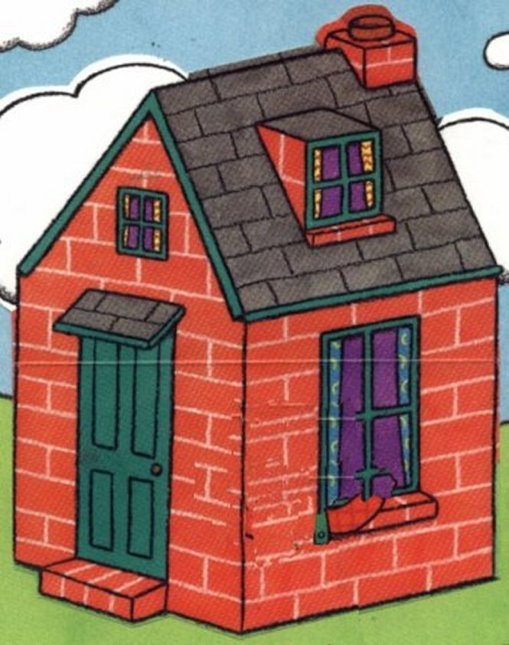
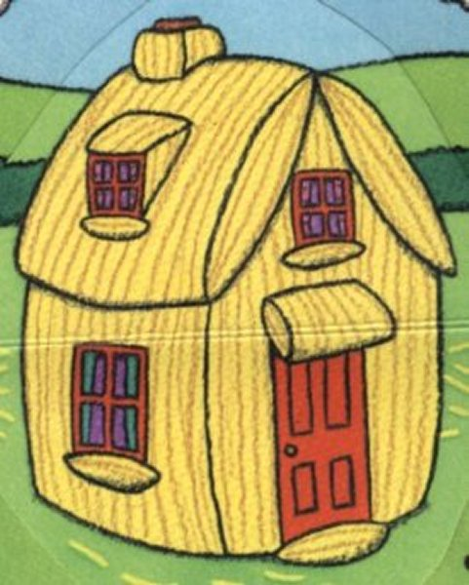
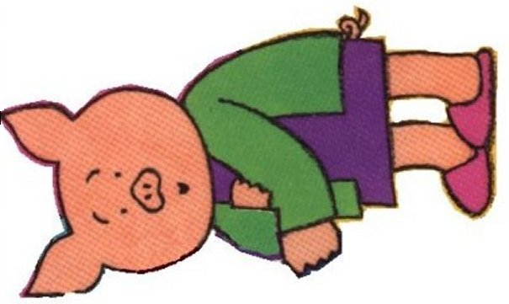
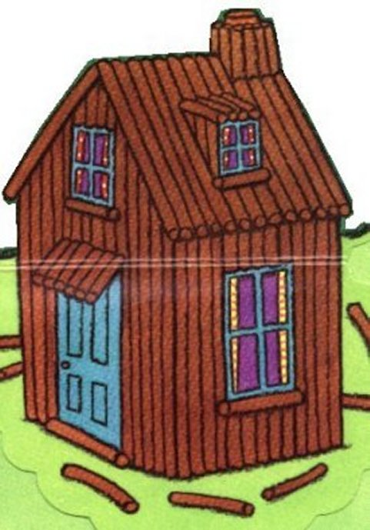
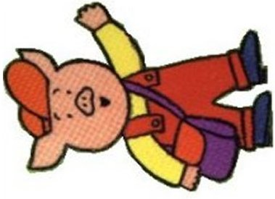
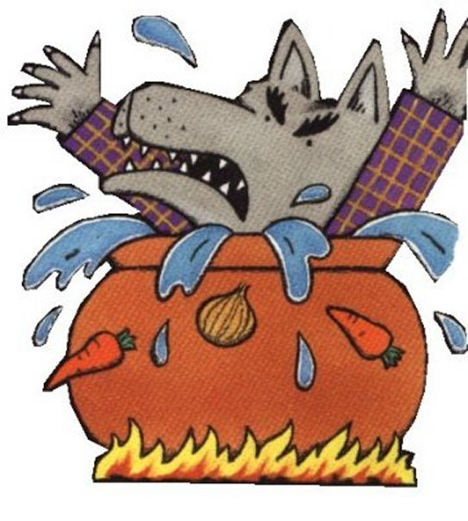
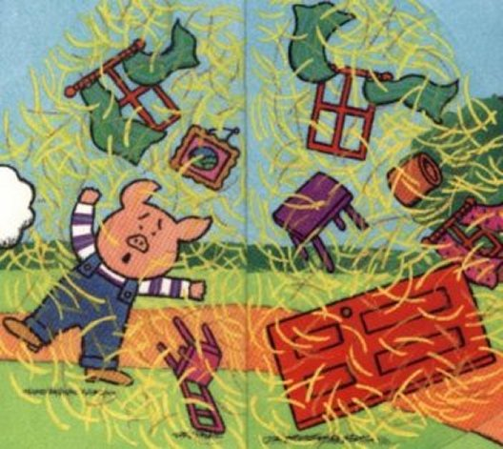
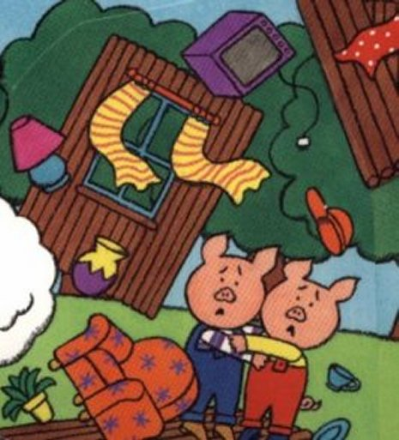
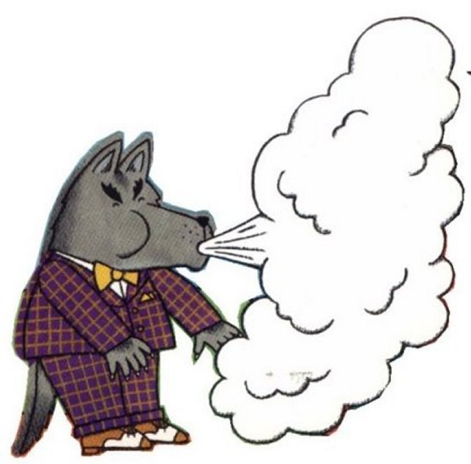
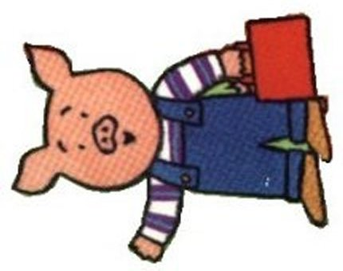
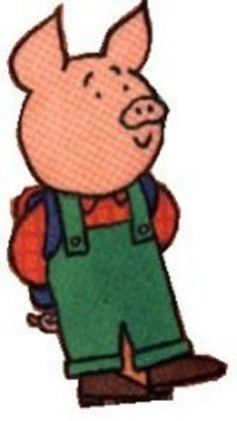
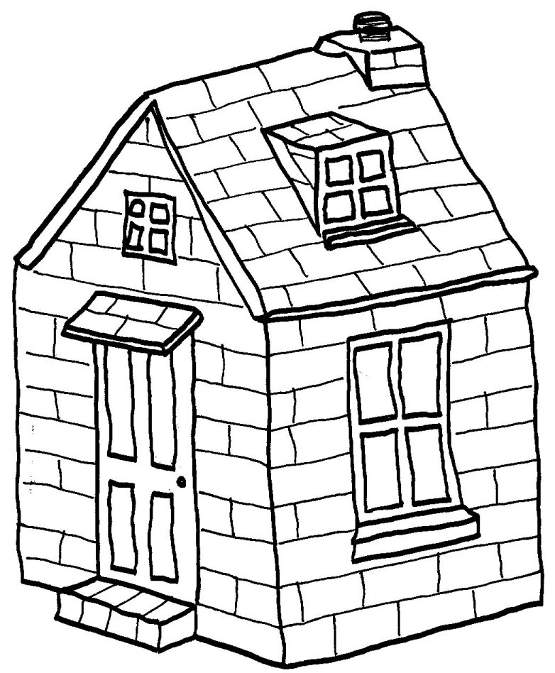
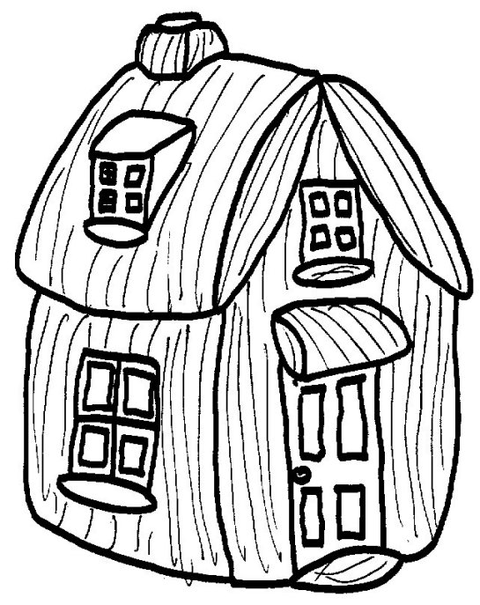
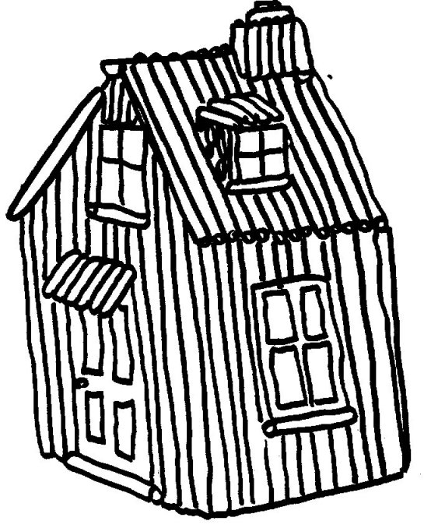
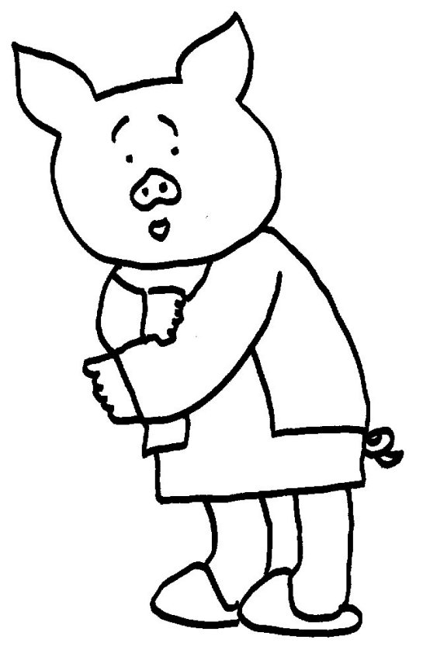
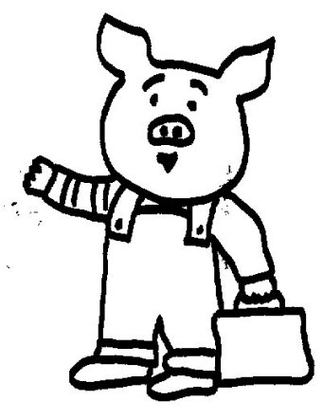
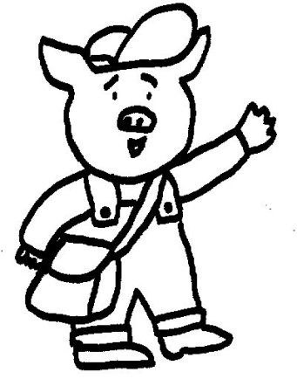
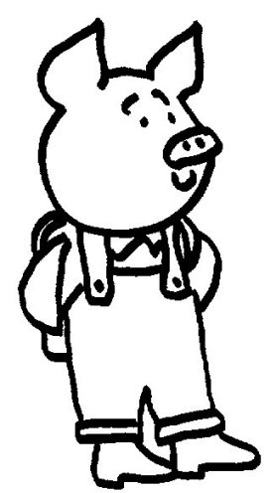
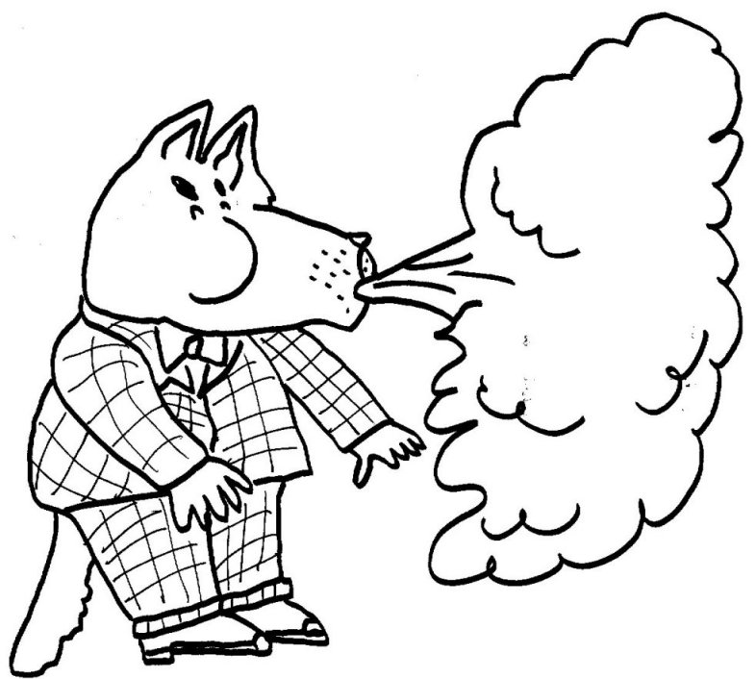
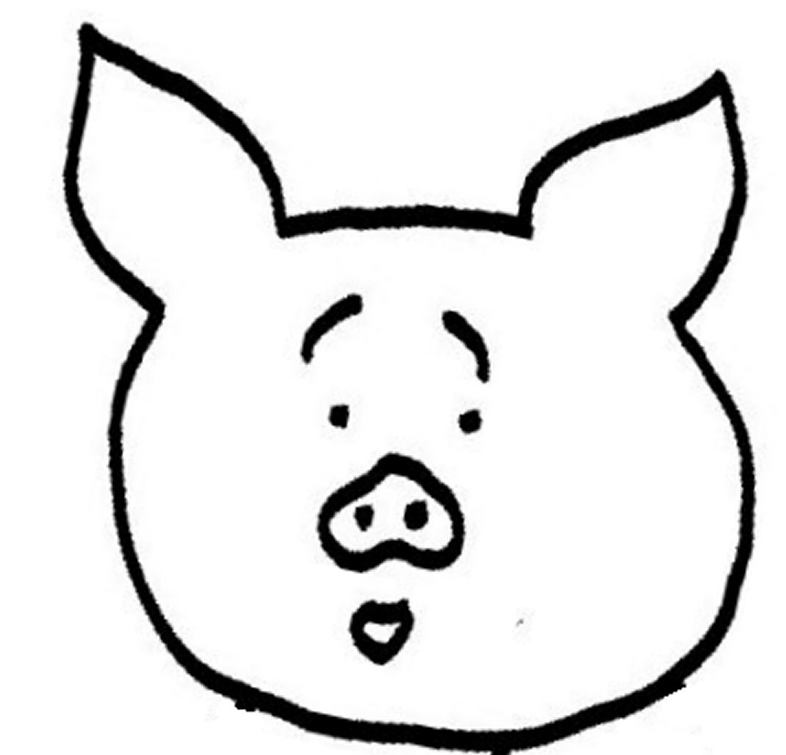
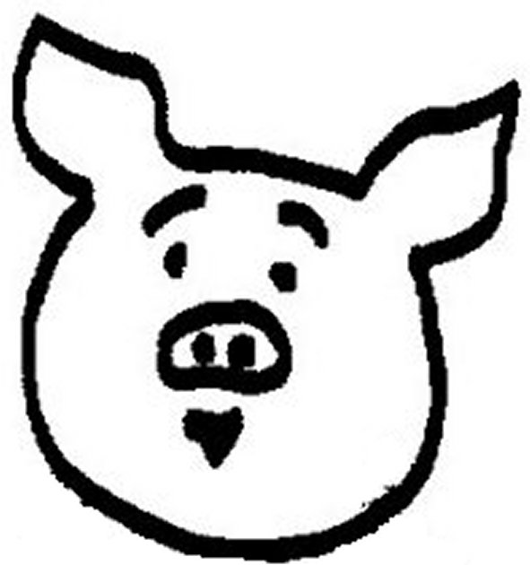
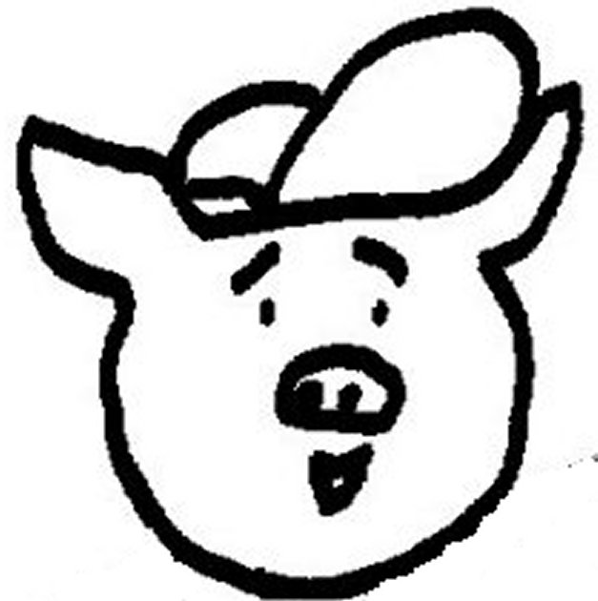
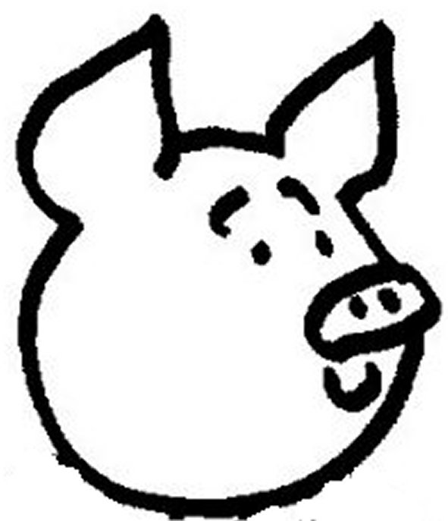
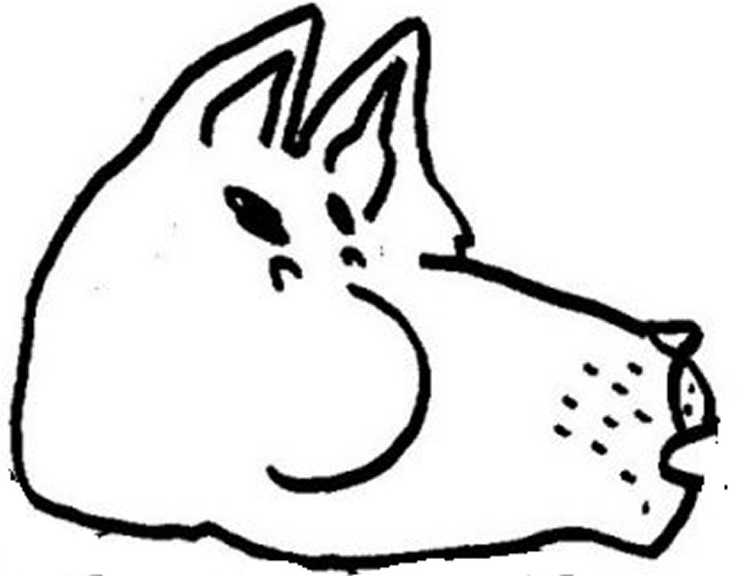

NAME | Interaction with T/S | Written text  Song Book | Oral Production  Performance | Non linguistic resources (perf) | Attitude
1-
2-
3-
4-
5-
6-
7-
8-
9-
10-
11-
12-
13-
14-
15-
16-
17-
18-
19-
20-
21-
22-
23-
24-
25-

Guraso agurgarriok:

Hona hemen hurrengo asteetan ingeleseko saioetan landuko dugun 3. unitatearen ildoa.
Informazio hau lagungarria izango delakoan, agur bero bat.
Ingeleseko irakasleria

Ezaugarriak

Unitate honetan etxeak, herriak eta hiriak landuko dira. Abiapuntua etxea izango da, umeengandik hurbilena delako, eta poliki poliki auzoa, herria edo hiria landuko dira.

1. ATALA: ekintzak

-Beraien komunitateari buruz hitz egingo da, eta lehen atal honetan egingo diren ekintza nagusienak plan orrian idatziko dira.

-Ipuin bat landuko da.

-Ipuina antzeztu egingo da.

-Kanta Liburuarekin jarraituko da, aurreko unitateko azken atalean landutako kanta baten esaldi batzuk idatziko dira.

-Txokoetan lan desberdinak egingo dira. Bukatzen denean ekintza honekin, esparru horietan egindakoa adierazi beharko da.

-Kanta bat landuko da.
Estimados padres y madres:

Os presentamos el contenido de la 3ª unidad a trabajar durante las próximas semanas.
Esperando que esta información os sea de utilidad, os saludamos atentamente.
El profesorado de Inglés

Características

-En esta unidad se trabajarán la casa, el pueblo y la ciudad. La casa será el punto de partida, al ser algo cercano al niño-a para pasar poco a poco al barrio, el pueblo y/o la ciudad.

1ª PARTE: actividades

-Hablarán sobre su comunidad y escribirán las actividades principales que se van a realizar en la hoja del plan.

-Se trabajará un cuento.

-Se representará el cuento trabajado.

-Se continuará con el Libro de Canciones, escribiendo algunos párrafos de la canción trabajada en la última parte de la unidad anterior.

-En rincones se trabajará en diversas actividades, al finalizar las mismas se dará cuenta de lo realizado en las mismas.

-Se trabajará una canción.

STORY: ‘The Three Little Pigs’, Macmillan

1- The three little pigs liked living at home although the house was small. But when new babies came along there just wasn’t room for them all.

2- “It’s time we left”, the piggies said, “and built homes of our own”. And as they kissed their mum goodbye, she said: “Be sure to phone”.

3- The pigs set off, and in the field they saw a heap of straw. “I’ll build my house of that”, said one. “Straw’s nice and quick, I’m sure”.

4- The second pig looked all around and spied a nearby wood. “I’ll build my house of sticks”, he squeaked. “Sticks are really good”.

5- “To build a house”, the third pig said, “I know the thing to choose. Not straw or sticks, but solid bricks. Yes, they’re the things to use”.
And carefully he laid his bricks one by one by one. He built four walls and then the roof. At last his work was done.

6- Now close by was another house and a big bad wolf lived there. His fridge was very empty. His cupboards were quite bare.
The wolf had eaten all the food (that’s why he was so big ). “I fancy something else”, he said. “And what I’d like is pig!”

7- He went to see his neighbour in his nice new house of straw. But the piggy saw him coming, ran inside and locked the door.
Said wolf, “If you don’t let me in, then I shall huff and puff and blow your house down”. Which he did. And one puff was enough!

8- The piggy just escaped in time, and ran round to his brother. And when the wolf knocked on the door they clung onto each other.
They shouted, “Wolfie, go away!” He blew. (They thought he might). The house of sticks came tumbling down. The wolf snarled, “Serves you right!”

9- He chased the piggies down the lane, and would have caught them, but … their brother shouted, “In here, quick!”. Then slammed the front door shut.
“Now I’ve got you”, laughed the wolf. “It won’t take very long to blow this little house down, too!” But this time he was wrong.

10- No matter how he huffed and puffed. The wolf just couldn’t make this house fall down. The walls stood firm. They didn’t even shake.

11- “I don’t give up that easily”, the sly wolf growled. “Oh no. I’ll climb onto the roof and down the chimney I shall go!”

12- “Coming to get you”, called the wolf, “Whether you’re ready or not”. He slithered down the chimney and landed in a pot…
… Which was full of salty water, onions, carrots, too. The piggies cheered, Hip, hip, hooray! The wolf is in a stew!”.

SONGS:

‘Who’s Afraid of Big Black Spiders?, Music Box, Longman

Who’s afraid of big black spiders
Big black spiders
Big black spiders

Who’s afraid of big black spiders
Me, me, me ,me, me!

I’m not afraid of big black spiders
Big black spiders
Big black spiders
I’m not afraid of big black spiders
No, no, no, not me!

‘Who’s Afraid of the Big Bad Wolf?, Disney Video

Who’s afraid of the big bad wolf
The big bad wolf
The big bad wolf
Who’s afraid of the big bad wolf
Tra La La La La!

