PART II
Pages

1. Sequence of activities & Objectives 2
2. Activities 3-8
3. Scripts
-Song: ‘A spider in the Bathroom’ 9
-List of Rhymes: 9-11
-Games 12
4. Hand Out 1: Shops’ names (act. 9) 13-23
5. Hand Out 2: Index Cards (act. 10) 24-25
6. Evaluation chart 26
7. Letter to parents 27-28

PART II: MY STREET
Song: ‘A Spider in the Bathroom’, Music Box, Longman
Rhyme: List of rhymes.

ACTIVITIES OBJECTIVES
-7-  Evaluation  +  Planning | -8-  Song Book  Who’s Afraid of the Big Bad Wolf | -9-  Index Cards
-10-  Street wall map I | -11-  Street wall map II | -12-  Game
1- To interact with the T when talking about neighbourhood.

2- To encourage children’s curiosity about their neighbourhood while making Street Index Cards.

3-. To make observations about their neighbourhood.

4- To use fine motor skills.
COMMENTS

…………………………………………………………………………………………………………………………………………………………………………………………………………………………………………………………………………………………………………………………………………………………………………………………………………………………………………………………………………………………………………………………………………………………………………………………………………………………………………

ACTIVITY 7 | TIME | LANGUAGE  SKILS | INTER  ACTION | MATERIALS | DESCRIPTION | ORAL & WRITTEN PRODUCTION
Evaluation  +  Planning  SUMMARY:  T and Ss evaluate PART I and plan PART II. | 30’ | L  S  W  L  S | BG  BG  I | Classroom Diary  Piece of paper per child  B/b  Classroom Diary | 1-. T and Ss have a look at the plan of PART I and H ticks the activities that have been done.  2- T asks Ss to write down the name / number of the best activity for them on a small piece of paper (Ss shouldn’t imitate leaders’ opinion).  3- H collects all the papers, writes down the answers on the b/b, counts the final results and copies them on the diary, next to each activity.  4- T presents the plan for PART II and talks about streets and their elements with the Ss.  5- H (or T) writes down PART II plan on the Classroom Diary. | -Did we listen to a story?  -Did we do corner work?  -Did we make masks?  -Did we perform a play?  -Did we write in our Song Book?  -Did we sing a song?  -Which has been the best activity for you?  -The one we/I liked best was…  -Our/My favourite activity was…  PART II planning  We are going to  -make index cards  -make a wall map  -play a game  -write in the Song Book  -sing a song  -say a rhyme

ACTIVITY 8 | TIME | LANGUAGE  SKILS | INTER  ACTION | MATERIALS | DESCRIPTION | ORAL & WRITTEN PRODUCTION
Song Book:  Who’s Afraid of the Big Bad Wolf?  SUMMARY:  Ss write in their Song Books. | 15’ | S  W | BG | Individual Song Book, tape and cassette recorder | 1-. T tells Ss they are going to write the lyrics of the song Who’s Afraid of Big Black Spiders in their Song Books using the T as a scribe.  2- Ss dictate the song to the T and s/he writes it down on the b/b.  3- Ss copy it (or part of it) in their Song Books. | -Lyrics of the song.

ACTIVITY 9 | TIME | LANGUAGE  SKILS | INTER  ACTION | MATERIALS | DESCRIPTION | ORAL & WRITTEN PRODUCTION
Index Cards  SUMMARY:  Ss make street index cards. | 30’ | L  S  W | BG  SG  I  P | Picture Dictionaries  Hand Out 1  Hand Out 2  Classroom material. | 1- T elicits Ss’ previours knowledge about shops, buildings, elements they can find in their streets.  2- As they name, T writes them on the b/b along with a drawing –or uses Hand Out 1- to make sense.  3- H hands out Picture Dictionaries (or photocopies) for Ss to choose a shop or bulding.  4- H gives out Hand Out 2 to each S. S/he cuts out a shape from them and draws the chosen shop/building and then writes its name. Faster Ss can make more than one index card.  5- Some Ss can design different street elements (cars, people, benches…).  6- When they finish H collects all the index cards for next session.  Note:  If the group is large, some of the Ss could design the street on a big wrapping paper. | -I live in .... Street.  -There are many/some shops in my street: the butcher’, the bakary,...  -What can we buy in the bakery?  -That’s it! Some bread.  -Anything else?  -Have a look at your Hand Outs!  -We’re going to draw a shop/building.  -Write its name on it.  -When finishing, H will collet them all.

ACTIVITY 10 | TIME | LANGUAGE  SKILS | INTER  ACTION | MATERIALS | DESCRIPTION | ORAL & WRITTEN PRODUCTION
Street wall map I  SUMMARY:  Ss make street wall map. | 30’ | L  S  W | BG  SG  I  P | Wrapping paper  Index Cards  Classroom material.  Picture Dictionaries | 1- Gather the Ss together and get them design a map of their neighbourhood or the Main Street.  2-. Some of them can draw the streets on the wrapping paper, while others, working in pairs or individually, can draw the different elements (pedestrian crossings, traffic lights, street lamps, roundabouts, speed bumps, street lights..).  3- Ss stick the index cards with the shops/buildings done in the former activity.  4- Ss add (if they fill like) characters to the display (people, postman, the baker, cars... | -What did we do in the previous session?  -I made a sweet shop / bookshop / bakery...  -Now we’re going to design our Main Street / neighbourhood.  -We’ll draw it on this wrapping paper.  -We need the different elements we find in the street: street lamps, traffic lights, pedestrian crossings, parks,...  -So divide in groups and let’s start working!  -Add your houses / buildings to the picture.  -...

ACTIVITY 11 | TIME | LANGUAGE  SKILS | INTER  ACTION | MATERIALS | DESCRIPTION | ORAL & WRITTEN PRODUCTION
Street wall map II  SUMMARY:  Ss make a street wall map. | 30’ | L  S  W  S  L | BG  SG  I  P  BG | Wrapping paper  Index Cards  Classroom material.  Picture Dictionaries | 1- Ss continue with the activity.  2-. When finishing let the whole class talk about the work done.  3- T and Ss can talk about other kinds of communities,: a big city, a town, a village, living in the countryside...  4- The work can be displayed in the corridors of the school. | -Let’s go on with the Street Wall Map.  -Today, we can add...  -Oh! The Baker’s next to the Sweet Shop! Good!  -What a beautiful park!  -Should we add some street lamps?  -What about some benches over there?  -...  -We live in a village, but how big cities look like?  -There are very tall buildings, big commercial centres,...  -Let’s display the Street Wall Map in the corridor!  -...

ACTIVITY 12 | TIME | LANGUAGE  SKILS | INTER  ACTION | MATERIALS | DESCRIPTION | ORAL & WRITTEN PRODUCTION
Game  SUMMARY:  T and Ss play a game. | 30’ | S  L | BG | Game script  Video camera. | 1- T and Ss play a game.  2- T can record the session on a video. | -Let’s play a game!  -Listen to the instructions!  -Are they clear?  -Was it fun?  -…

SONG: ‘A Spider in the Bathroom’, Music Box, Longman

There’s a spider in the bathroom
There’s a snail in the hall
And I can see a centipede climbing up the wall!
There’s a bee in the bedroom
There’s an ant in the hall
I’m standing in the kitchen
And I’m not afraid at all!

There’s a spider in the garden
There’s a snail in my bed
There’s a green and yellow centipede
On my slice of bread!
There’s a bee in the bedroom
There’s an ant in the hall
I’m standing in the kitchen
And I’m not afraid at all!

RHYMES:

a. ‘Traffic Lights’

The red at the top
Tells us to STOP!
The green below
Tells us to GO!
The yellow in the middle
Tells us to WAIT!
Please don’t worry
You don’t be LATE!

Betty Silkunas

b. ‘Traffic Lights’

The red light means STOP (stand still)
The green light means GO (walk forward)
The yellow light mean CAUTION (walk in place)
This your should KNOW.

Betty Silkunas
c. ‘There was a Little House’

There was a little green house
And in the little green house
There was a little brown house
And in the little brown house
There was a little yellow house
And in the little yellow house
There was a little white house
And in the little white house
There was a little heart

Adapted Traditional

d. ‘I will make a Little House’

I will make a little house (form roof shape with fingers)
Where two playmates come to hide (bend thumbs under roof)
When I peek in at the door (peek under roof)
They quickly run outside (pop thumbs back out)

Adapted Traditional

e. ‘Two Little Houses’

Two little houses, closed up tight. (close fists)
Let’s open the windows, and let in some light. (open fists)

Adapted Traditional

f. ‘Where do we live?’

A squirrel lives in a tree (form tree shape with hands)
A snail lives in a shell (cover fists with opposite hand)
A bear lives in a cave (make fists with thumb inside)
It suits her very well.

A fish lives in a fishbowl (form circle with hands)
A bird lives in a nest (cup hands together)
Mathew lives in a house (make roof above head with arms) / (any name can be used)
He thinks his home is best.

Elizabeth Mckinnon
g. ‘Around the Block’

Let’s go walking (walk)
Around the block.
We will keep on walking,
Then we’ll stop. (stop)

Let’s go driving (pretend to drive a car)
Around the block.
We will keep on driving,
Then we’ll stop. (stop)

Jean Warren

h. ‘Stop, Look and Listen’

Stop, look and listen (do actions as rhyme indicates)
Before you cross the street.
Firts use your eyes and ears,
Then use your feet.

Adapted Traditional

GAMES:

a. Traffic Lights

A game for four or more players. One player is chosen to be IT and shouts out an instruction. The last player to do the action is out. Players can also be out if they do the wrong action.

Instructions:

-RED (means stand still)
-GREEN (means run around)
-CRASH (means lie flat)
-BRIDGE (means make an arch on the ground)

b. Red Light, Green Light

A game for four or more players. One player is chosen to be the Traffic Light and stands out in the front with his/her back to everyone. When the Traffic Light says ‘Green ight’, everyone creeps forward to try to touch the light. The Traffic Light the shouts ‘Red light’ and spins around. If anyone is seen moving, s/he has to go back and start again.

HAND OUT 1

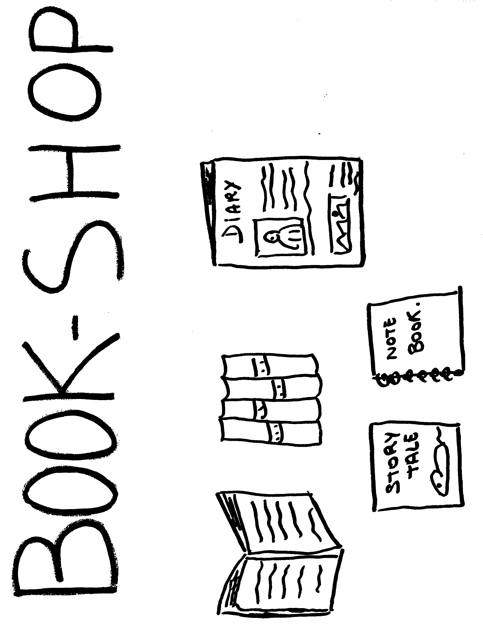
HAND OUT 1

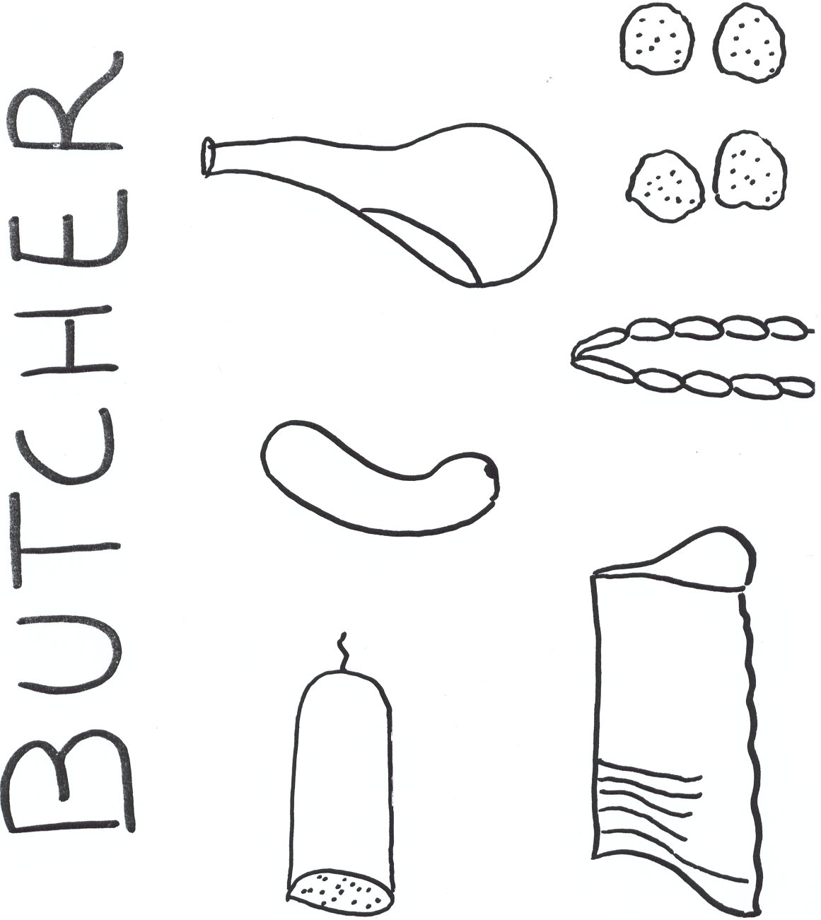

HAND OUT 1
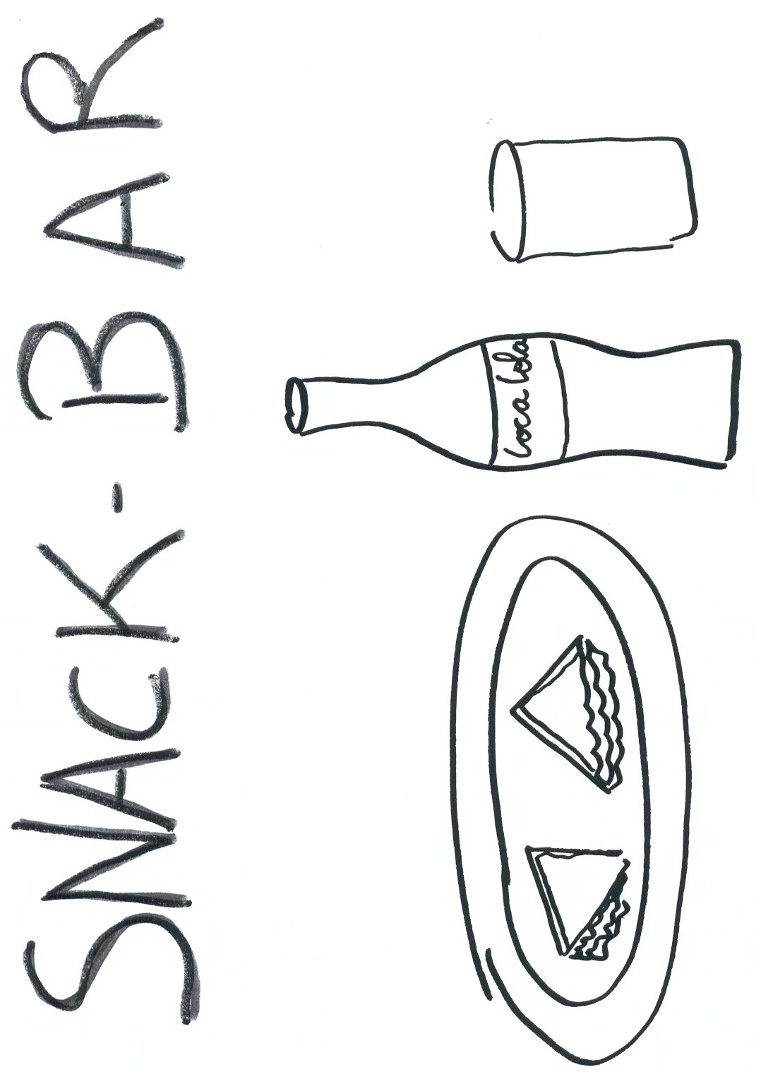

HAND OUT 1

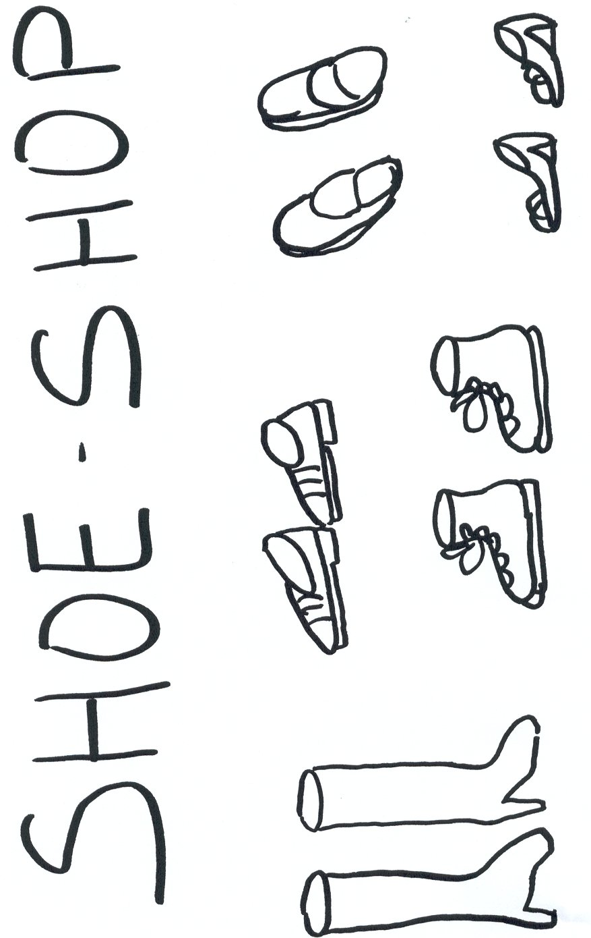
HAND OUT 1
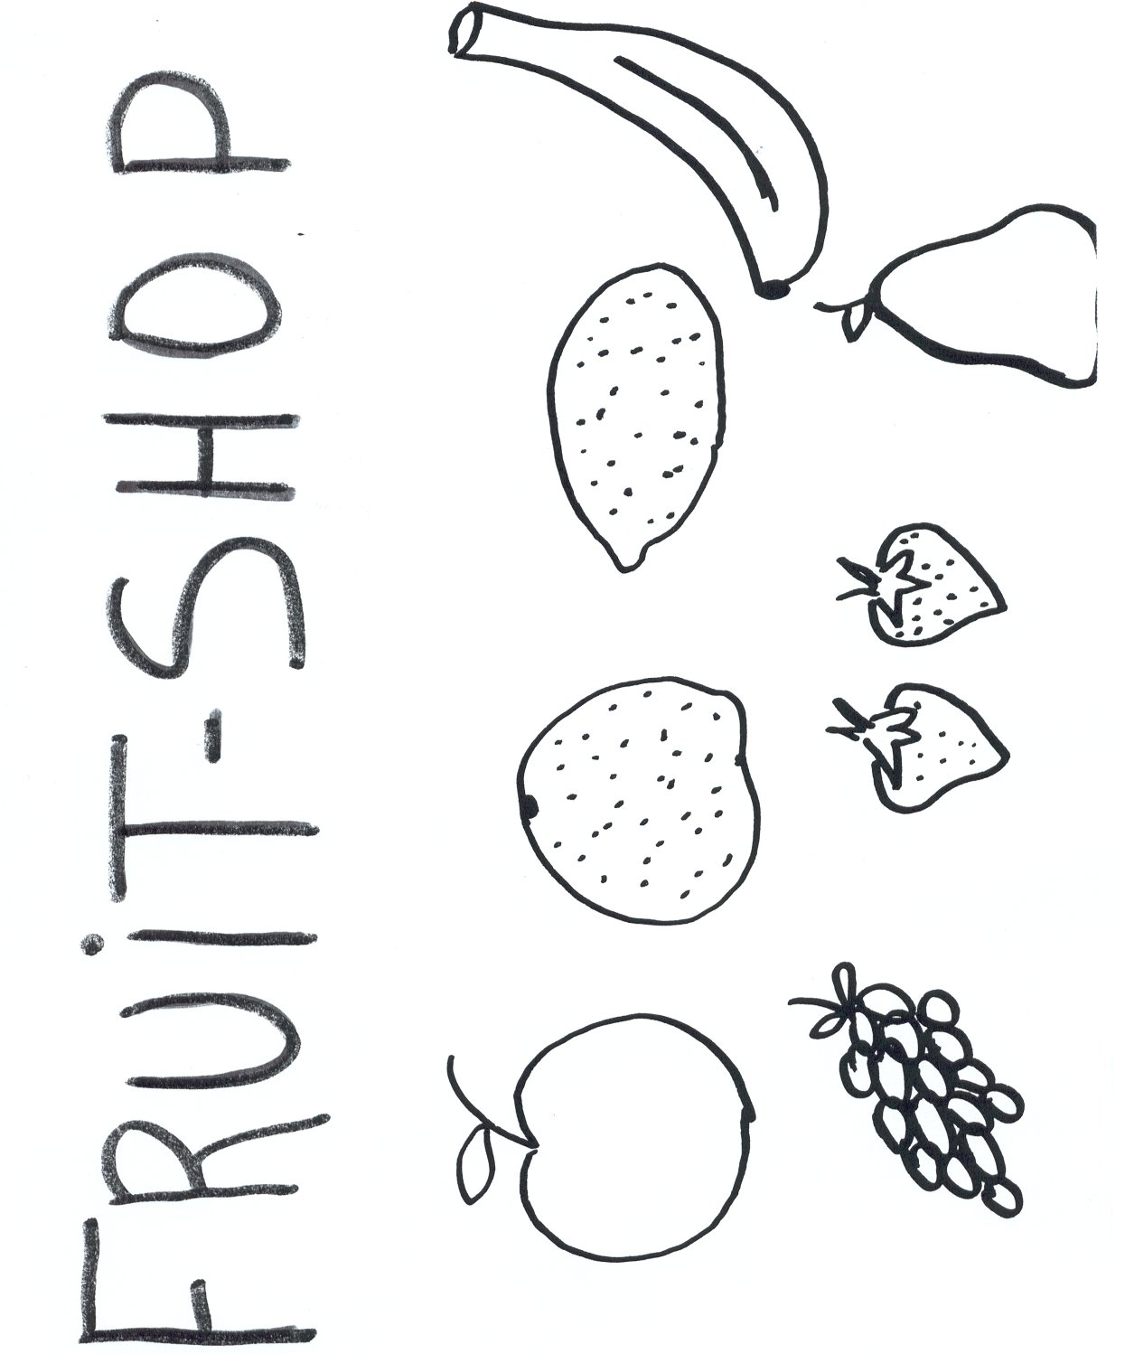

HAND OUT 1
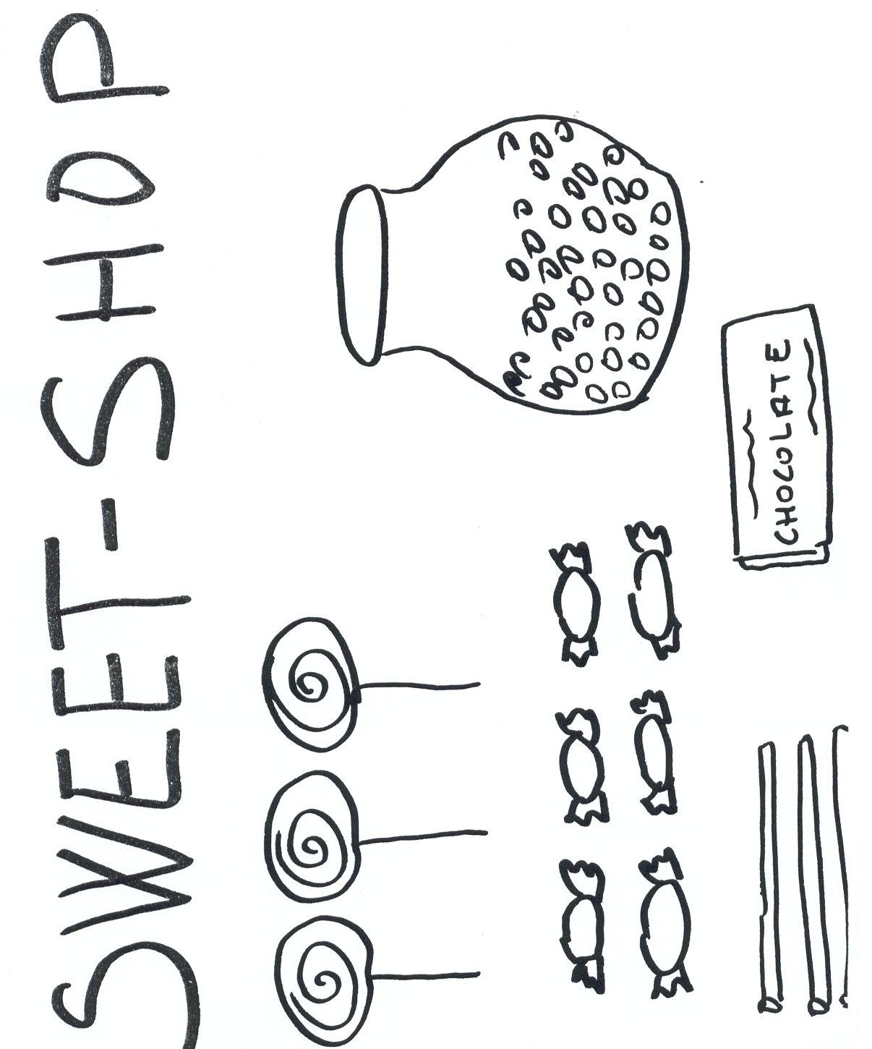

HAND OUT 1
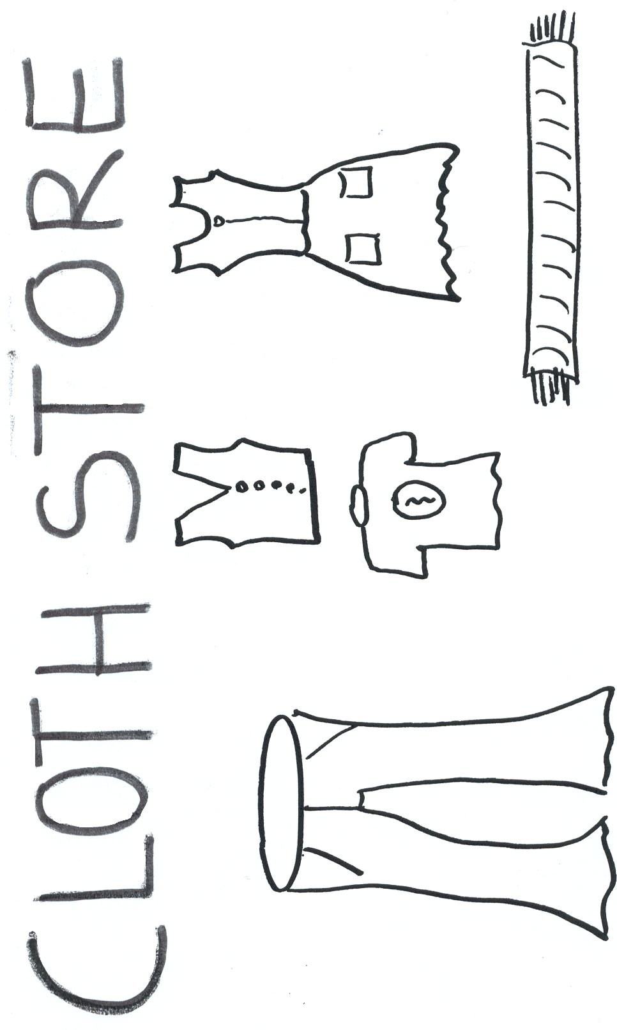

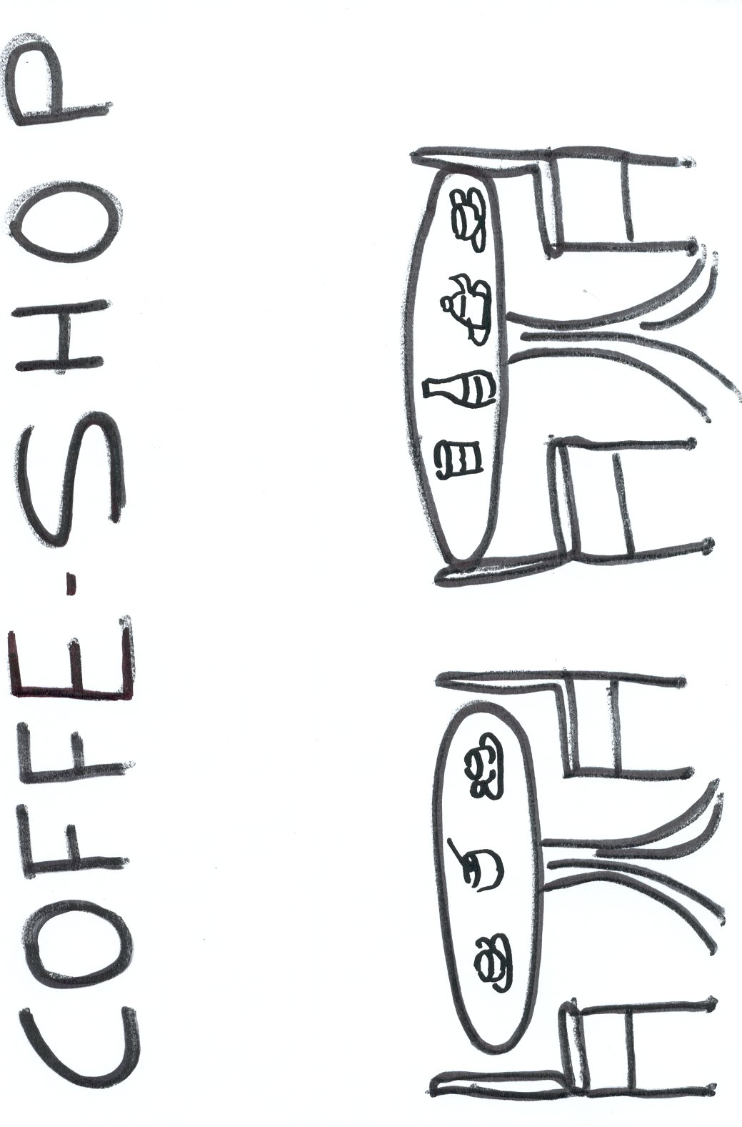
HAND OUT 1

HAND OUT 1
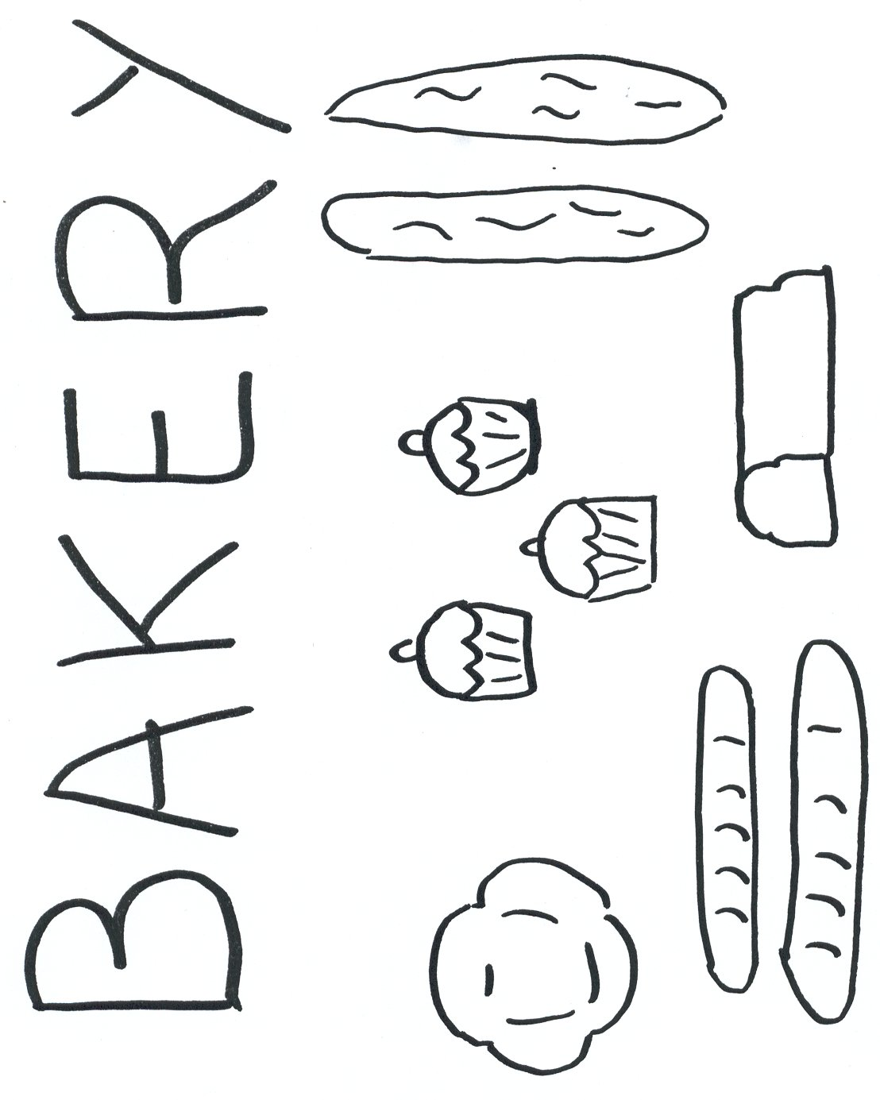

HAND OUT 1
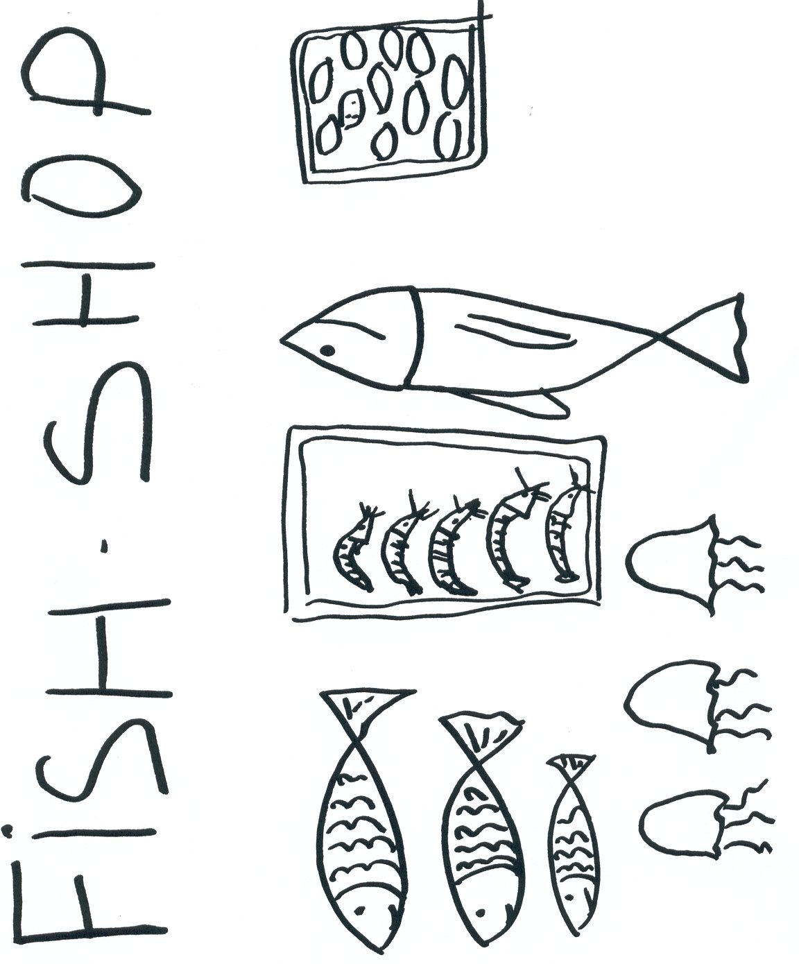

HAND OUT 1


HAND OUT 2
Ss draw their own block of flats / house / shop / building...

HAND OUT 2

NAME | Interaction with T/S | Written text  Song Book | Written text  Index Cards | Oral Production | Attitude
1-
2-
3-
4-
5-
6-
7-
8-
9-
10-
11-
12-
13-
14-
15-
16-
17-
18-
19-
20-
21-
22-
23-
24-
25-

Guraso agurgarriok:

Hona hemen hurrengo asteetan ingeleseko saioetan unitatearen 2. atalean landuko dugun edukien ildoa.
Informazio hau lagungarria izango delakoan, agur bero bat.
Ingeleseko irakasleria

2. ATALA: ekintzak

-Lehenengo ataleko ekintzak ebaluatuko dira, gure kale eta auzoari buruz hitz egingo da eta atal honetako ekintzak plan orrian idatziko dira.

-Txarteletan dendak eta eraikinak marraztuko dira. Informazioa gelako laguntza liburuetatik hartuko da.

-Kale edo auzo baten hormairudia egingo da. Bertan hainbat elementu azalduko dira: semaforoak, zebra bideak, parkeak... Hormairudi honi aurreko ekintzan egindako txartekalak erantsiko zaie.

-Joku bat landuko da.

-Kanta Liburuarekin jarraituko da, aurreko unitateko azken atalean landutako kanta baten esaldi batzuk idatziko dira.

-Kanta bat landuko da.

-Errima bat landuko da.
Estimados padres y madres:

Os presentamos el contenido de la 2ª parte de la unidad que trabajaremos durante las próximas semanas.
Esperando que esta información os sea de utilidad, os saludamos atentamente.
El profesorado de Inglés

2ª PARTE: actividades

-Se evaluarán las actividades de la 1ª parte, se hablará sobre la calle y el barrio y se escribirán las actividades a realizar durante la 2ª parte en la hoja del plan.
-Se dibujarán tiendas y edificios en tarjetas. Se recogerá información en libros de consulta de clase.

-Se realizará un mural sobre una calle o el barrio. En el mismo se reflejarán elementos de la calle: semáforos, pasos de cebra, parques... Se añadirán las tarjetas elaboradas en la actividad anterior.

-Se trabajará un juego.

-Se continuará con el Libro de Canciones, escribiendo algunos párrafos de la canción trabajada en la última parte de la unidad anterior.

-Se trabajará una canción.

-Se trabajará una rima.

SONG: ‘A Spider in the Bathroom’, Music Box, Longman

There’s a spider in the bathroom
There’s a snail in the hall
And I can see a centipede climbing up the wall!
There’s a bee in the bedroom
There’s an ant in the hall
I’m standing in the kitchen
And I’m not afraid at all!

There’s a spider in the garden
There’s a snail in my bed
There’s a green and yellow centipede
On my slice of bread!
There’s a bee in the bedroom
There’s an ant in the hall
I’m standing in the kitchen
And I’m not afraid at all!

