3
INEBI

Lehen Hezkuntzako Ingelesa Edukien Bitartez
Inglés a través de Contenidos en Educación Primaria
A Content & Language Integrated Learning Sequence for Primary Education

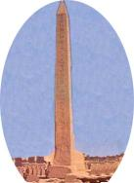
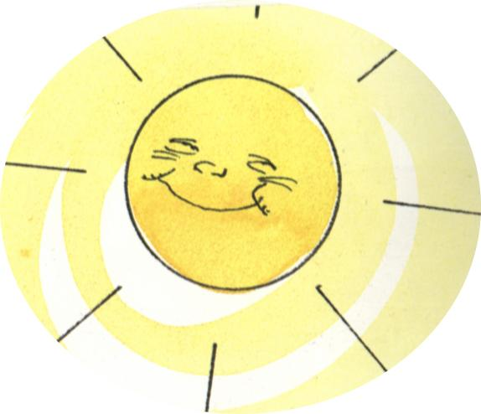
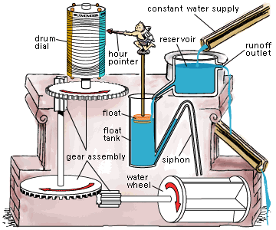
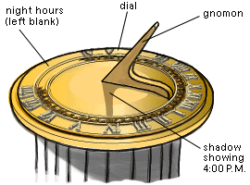
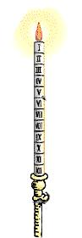
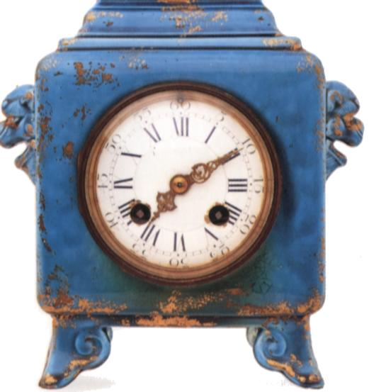
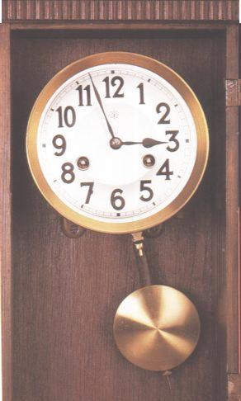

Unit 2

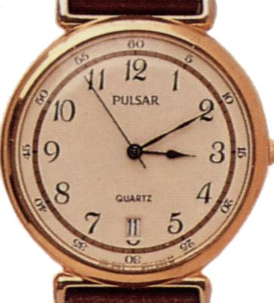

Exploring

Time

CONTENTS

Introduction

 | Page
1.1. Introduction and description |  | 3-4
1.2. Objectives |  | 4-5
1.3 Parts of the Unit |  | 6
1.4. Assessment and Evaluation |  | 6-8

Summary of activities

2.1. Part I: Mouse tells the Time | 9
2.2. Part II: A World of Clocks | 9-10
2.3. Part III: A Day in my life | 10-11

General activities

3.1. Reading | 11
3.2. Diary | 11-12
3.3. Sing and Say | 12-13
3.4. Corners | 13
3.5. Teachers’ Resources Bank | 13-14
3.6. ICT | 14

Appendix

4.1. Mind Map | 14-19
4.2. Audio Cover | 20

- Bibliography, resources and useful websites

5.1. Material for the Unit | 21
5.2. Useful Internet Sites | 21-22

1. Introduction

1.1. Introduction and description

This unit deals with the topic of Time. It focuses on how to tell the time, different devices to measure time through History and daily/weekly routines. As well as in previous units they Ss will learn new songs, listen to stories, perform a play, play different games, etc. As final products, all the students are expected to make a clock exhibition, a Chinese Lantern and a booklet.
The unit has 3 parts, each one with a set of possible activities to carry out.
Cross-curricular contents of the unit:

LITERATURE

- Stories: ‘Mouse Tells the Time’, ‘Elephant’s Diary’
- Drama: ‘Mouse Tells the Time’
- Songs: ‘It’s Time to Go to School’, ‘Hickory, Dickory, Dock’, ‘This Is the Way…’

SCIENCE

- Measuring time: seconds, minutes, hours, days, weeks.
- Recording and comparing data.
- Time in everyday routines: timetables.

HISTORY

- Clocks through History.
- Chronological order: timeline.

MATHS

- Numbers.
- Operating with numbers.

ARTS

- Decorating own diary.
- Making a clock.
- Making a Chinese Lantern.
- Making a booklet.

1.2. Objectives

Chart 1 (page 5) shows the basic communicative language objectives, the attitudinal objectives and the content objectives, all taken from the National Curriculum Reform Blueprint (DCB-OCD) for Primary Education.

LEVEL: P3 | UNIT II: EXPLORING TIME |  | CHART 1: Objectives
Objectives |  | Concepts |  | Procedures | Attitudes
BASIC COMMUNICATIVE LANGUAGE OBJECTIVES  - To understand oral and written narrative, expository and instructive texts.  - To give opinions (likes, dislikes and preferences) orally, when talking about the activities carried out in the unit.  - To give oral information on tasks done and tasks to do.  - To ask for information about the language they need to carry out the activities.  - To tell the news (either related to general topics or to their own personal experience).  - To interact in English with T and peers.  - To write the lyrics of songs and other simple texts.  - To dramatize a story.  ATTITUDINAL OBJECTIVES  - To develop autonomous learning strategies.  - To be aware of the communicative value of English as a language.  - To take part actively in individual tasks as well as in group work.  - To develop awareness about the value of games.  - To be aware of the use of recycling material.  CONTENT OBJECTIVES: TIME  - To understand simple oral and written texts related to time.  - To memorize songs and rhymes related to the unit.  - To tell the time.  - To produce simple oral and written texts related to time.  - To be aware of different ways to measure time through History.  - To sequence events.  - To use simple devices to measure time.  - To represent, interpret and express personal experiences and routines related to time. |  | - Instructions, stories and descriptions.  - I liked, I enjoyed, most, least... In my opinion…  - We went, played, read, wrote…, We’re going to…  - What does… mean? How do you say?  - Yesterday, this morning (past tense).  - Poetic texts: “It’s Time to Go to School”, “Hickory Dickory Dock”, “This Is the Way”.  - Narrative text: “Mouse Tells the Time”.  2.4. Co-operation, fairness…  - Stories, reference books related to time.  - Lyrics of the songs and rhymes.  - What time is it? / It’s …. o’clock, a quarter past, half past, a quarter to / …. past ... / … to ….  - Expressions with routines related to time (time, days of the week, …).  - Sundial, sunglass, water clock, candle clock, pendulum clock, watch, … .  - The 1st oldest clock was; the 2nd oldest clock was…; and finally… .  - Digital and analogical watch, clocks, timers, stopwatch, … .  - Actions, time, days of the week, … . |  | - Searching for and interpreting information in reference books.  - Writing:  - Making hypotheses on spelling.  - Checking spelling.  - Copying and/or writing simple texts.  - Following some dramatizing hints: intonation, pronunciation, speaking to an audience, stage movements, learning the scripts by heart.  - Recording own work in a diary. Working in corners.  - Using English in context when interacting with T and peers.  - Collecting and using recycling material for the activity.  - Producing a booklet/poster about an ideal day.  - Listening to and reading different texts  - Matching, comparing and representing data on timelines.  - Using different devices to measure the time needed to do certain tasks.  -Carrying out tasks to calculate time.  -Consulting reference books.  -Recording data.  -Reporting tasks carried out.  -Using appropriate vocabulary when interpreting and reporting information.  - Using different codes (numbers, colours and icons). | - Keeping folders and diaries tidy.  - Interacting in English with T and peers.  - Participating actively in all the class activities, co-operating with peers.  - Co-operating and developing fair play in games.  - Showing interest in different ways of measuring time.  - Appreciating the importance of precise instruments to measure time.  - Incorporating expressions of time to everyday language.

1.3. Parts of the Unit

Part I: Mouse tells the Time
In this part students will work on the storybook ‘Mouse tells the Time’. There will be a performance. The reading activity will deal with different ways of measuring time.
Part II: A World of Clocks
In this part students will analyse ways that people came up with to measure Time. They will design and make a clock while they do several tasks using different devices and then play simple games to practise telling the time.
Part III: A Day in my life
In this part Ss will talk about daily/weekly routines and make a Chinese Lantern. They will also make booklet about their ideal day.

1.4. Assessment and Evaluation

There are several tools designed to help teachers assess their work and to evaluate students’ progress.
Chart 2 (page 7) shows hints for students’ evaluation: what, how, and when to evaluate, as well as which tool can be for the purpose.
Chart 3 (page 8) is a very useful tool, where the routines followed by each student throughout the unit can be recorded.
Each part has its own evaluation chart to record language, content and attitudinal objectives that each student has achieved.
It is highly recommended to use these tools systematically, every day, every week or/and every fortnight, so that the information that teachers need to evaluate his or her Ss can be recorded properly to ensure reliability.
LEVEL: P 3 | UNIT 2: EXPLORING TIME | CHART 2: Hints for Evaluation
INDICATORS
WHAT |  |  | HOW | TOOL |  | WHEN
- Follows T’s instructions / shows understanding of stories by participation.  - (1.7) Tells and/or writes the activities s/he liked best/least. Makes hypotheses and gives opinions.  - Says what s/he did (yesterday, last 2 weeks, in corners) and what we are going to do (today, next two weeks).  - Asks for language needed.  - Tells a piece of news.  - (2.2) Interacts in English with T and peers in specific situations.  - Writes simple texts.  - Acts out with good intonation and pronunciation; speaks to an audience and moves around the stage.  - Records own work in the diary (planning and assessments, activities done, new words...) and keeps materials tidy.  - (1.4) Participates actively (includes asking for language).  - Co-operates and shows fair play in games.  - Suggests and uses recycling material for the clock craft.  - Follows procedure for reading. Obtains information from simple expository, narrative and descriptive texts.  - Sings the songs and recites the rhymes of the unit.  - Tells the time.  - Produces simple oral and written simple texts related to time.  - Recognizes different devices to measure time through History.  - Puts events in order on a timeline.  - Uses different devices to measure time.  - Records data graphically and interprets bar charts on daily routines. Exchanges information (orally) about time. |  |  | Observation  Revising diaries / Interviewing  Observation  Observation  Revising class diary / Observation  Observation  Revising diaries, folders, booklets, S&S books  Observation MAIN ACT. (rehearsals and performance)  Revising diaries, folders  Interviewing  Observation MAIN ACT  Observation MAIN ACT  Observation MAIN ACT / Clock design  Observation MAIN ACT  Revising diaries, folders  Observation MAIN ACT  Observation MAIN ACT  Revising folders  Observation MAIN ACT / Diaries / Folders  Observation MAIN ACT  Observation MAIN ACT / Final products  Observation MAIN ACT  Observation MAIN ACT / Final products | Register  Diary/Ind. or group interview  Register  Register  Class diary/Register  Register  Diaries, folders, booklets, S&S books  Register/Video recording  Diaries, folders, group interview  Register  Register  Register / Craft  Register/Diary/Folder  Register  Register/Folder  Register / Diaries / Folder  Register  Register / Final products  Register  Register / Final products |  | One student (any but helper) each day  4 Ss per class a week/All Ss working on their own  When S is Helper  One student per day  Fortnightly  One student per day  4 Ss per class a week  4 Ss during rehearsal and performance  When analysing video recording  4 Ss per class a week  All Ss working on their own  All Ss working on their own  A small group when playing games  All Ss working in groups  1/4 Ss per activity  4 Ss per class a week  1/4 Ss per activity  1/4 Ss per activity  4 Ss per class a week  1/4 Ss per activity  4 Ss per class a week  1/4 Ss per activity  1/4 Ss per activity  4 Ss per class a week  1/2 pairs per activity  1/4 Ss per day  1/4 Ss per activity  4 Ss per class a week
Numbers in brackets stand for the objectives

CHART 3: Routines Register
CLASS: |  | HELPER |  |  | UNDER-  STANDS |  |  | ATTITUDE |  |  |  |  |  | NEWS |  |  | DIARY-FOLDER |  |  | OTHER ROUTINES
 |  | - Says what we did and what we’re going to do  - Unit mind map  - Others |  |  | - Follows teacher’s instructions |  |  | - Pays Attention  - Asks for language  - Participates  - Collaborates |  |  | - Interacts in English with Teacher  - (Interacts in English with Peers) |  |  | - Tells a Piece of News |  |  | - Writes the acts. best/least liked  - Records own work  - Keeps materials tidy
Name | Date | Yes | With help | No | Yes | With help | No | 1 | 2 | 3 | 1 | 2 | 3 | Yes | With help | No | Yes | With help | No | Yes | With help | No

2. Summary of activities

2.1. Part I: Mouse tells the Time

Act. 1: Planning
T and Ss outline the whole term’s plan and set Part I planning.
Act. 2: Song
Ss listen and sing the song, ‘It’s Time to Go to School’.
Act. 3: Story Telling
Ss listen to a story and choose the characters for the performance.
Act. 4: Rehearsal
Ss work on the performance script and rehearse it.
Act. 5: Sing & Say
Ss write the corresponding song in their Sing & Say book.
Act. 6: Reading
T and Ss analyse different methods to tell the time.
Act. 7: Corners
Ss work in corners.
Act. 8: Performance
Ss perform the story in front of an audience.
Act. 9: Evaluation
Ss give their opinion of the activities done in PART I and review what they have learnt.

2.2. Part II: A World of Clocks

Act. 10: Planning
T and Ss talk about the unit and Ss write down the planning of PART II.

Act. 11: Clocks through History
T and Ss analyse different ways to tell the time from Prehistoric Times to ModernAges.

Act. 12: Making a Clock
Ss, in groups, design and make a clock using recycling material.
Act. 13: Sing & Say
Ss write the corresponding song in their Sing & Say book.
Act.14: Funtime
Ss do different tasks, using different devices to measure time.
Act. 15: Song
Ss listen and sing the song, ‘Hickory, Dickory Dock’.
Act. 16: What time is it?
Ss play different games to practice telling the time in English.
Act. 17: Corners
Ss work in corners.
Act. 18: Clock Exhibition
Each group presents their clock to the rest of the class and place it in the exhibition.

Act. 19: Evaluation
Ss give their opinion of the activities done in PART II and review what they have learnt.

2.3. Part III: A Day in My Life

Act. 20: Planning
T and Ss talk about the unit and Ss write down the planning of PART III.

Act. 21: Song
Ss listen and sing a song.

Act. 22: Story Telling
Ss listen to a story.

Act. 23: My timetable
T and Ss interact about daily routines and make a Chinese Lantern.
Act. 24: Sing & Say
Ss write the corresponding song in their Sing & Say book.
Act. 25: Playing with Time
Ss play different games to practise telling the time in English.
Act. 26: Booklet
Ss make a booklet about their ideal day.
Act. 27: Corners
Ss work in corners.
Act. 28: Evaluation
Ss give their opinion of the activities done in PART III and review what they have learnt.

3. General Activities

3.1. Reading

In this unit there are two activities especially designed to help students understand written texts: Activity 6, ‘Mouse tells the Time’ and Activity 11, ‘Clocks through History’. Before Ss actually start reading the text, T elicits previous knowledge about the topic, asks questions about the title, the writer and the organisation of the book and talks about the information shown in the pictures. T reads the text aloud to establish sight-sound correspondence while Ss follow in their texts or handouts. T explains difficult words referring to pictures and/or using mime and gestures. Key words may be underlined. Then Ss read the text on their own and do the task proposed (filling in a chart and matching paragraphs and pictures).

3.2. Diary

In Primary 3 we introduce a change in the procedure to work with the diary because our aim is to foster writing. Therefore, we propose two types of diaries to be implemented in the classroom. On the one hand, we intend to maintain the classroom diary as it was and, on the other hand, each student will start writing his/her own diary.
The contents of the individual diary for this Second Stage are as follows:
- Planning (a list of the different activities to be carried out).
- Self-assessment about the individual effort and participation can be included using the following sentences: I’ve participated in this activity; It’s been easy/difficult for me; I’ve made an effort…This can also be done for the classroom diary reflecting the group’s opinion: We think it has been/was an easy/difficult activity for us…
- Opinions regarding likes and dislikes about the activities either individually or in group: I liked…, I didn’t like… We liked a lot this activity.
- An account of his/her own learning. It can be discussed in group what has been learnt but every student should write in his/her own diary what is true for his/her individual case: I’ve learnt this vocabulary about the Time: o’clock, quarter past, … ; This activity can be used as a means of self-assessment asking students not to copy it from anywhere.
- Vocabulary, songs, rhymes, tongue twisters, etc. other than the ones written in the “Sing & Say book” can be written in the diary.
- Any other material in English not related to the main topic but relevant for the individual student can be included in his/her diary.
As in previous years, at the end of every unit the contents of the diary can be discussed and a review of the unit can be done in group either using the classroom diary or the individual ones.

3.3. Sing & Say

Ss are going to keep a record of all the songs they will learn during the school year in a special booklet called Sing & Say. After listening to the song, Ss in pairs or in a small group will write the beginning of the song on scrap paper the way they think it is. Afterwards, while T writes this first verse on the b/b, Ss will check their written production. T and Ss will follow the same procedure with the rest of the song. Finally Ss will copy the lyrics in their Sing & Say book.
Once this activity has ended T and Ss will work on pronunciation. T will write words taken from the lyrics and invite Ss to pronounce them. Then T will write some other words which have the same sound so that Ss should try and transfer the sounds from the previous words to the new ones (short and long vowel sounds, consonant clusters, …).
Finally, Ss will learn and practise a tongue-twister. It helps children develop greater phonemic awareness in fun, meaningful ways, to achieve the full effect of a tongue twister Ss should try to repeat it several times, as quickly as possible, without stumbling or mispronouncing.

3.4. Corners

Corner work promotes learner autonomy because Ss can choose the activities they prefer and work at their own pace and, at the same time it fosters cooperative learning since some of those activities must be done in pairs or in groups. In this unit some sessions are devoted to do corner work. T will decide which corners will be organised according to the materials and the facilities available in the school: computer corner, craft corner, reading corner, listening corner, board games corner, pending tasks corner (see the Document for English Language in Primary Education). In Part III some appendices (Appendix_25A, Appendix_25B and Appendix_25C) contain picture cards and word cards for students to play Snap, Pelmanism, Domino or Happy Families while they practise language related to Time.

3.5. Teachers’ Resource Bank

- ‘How do you know what Time it is?’, A. Whitman & Company
(ISBN 0807579394)
- ‘Time and Seasons’, Kingfisher (ISBN 0753454718)

3.6. ICT

Some advice and suggestions to integrate ICT in this unit:
- Typing. Good habits are essential and they will help our students in the future.

- Word Processing. Several tasks can be done with or without this tool.

- World Wide Web. Ss may find information and pictures on the Internet, as well as play some on-line games; some interesting websites are mentioned in the “Useful Web Sites” section of this document.

4. Appendix

4.1. Unit Mind Map

A Mind Map is a way of organizing an area of information. It is typically an organic multi-coloured chart laid out on a large sheet of paper. It contains words and drawings that are connected in various ways. A Mind Map can be used for keeping notes, or for developing a concept, or for getting an overview of an activity. Mind Maps use and stimulate the visual abilities of the mind. If represented visually, a bigger subject can be understood and remembered much more efficiently. Mind Maps are an example of Radiant Thinking. A central idea branches off into many different directions. The branches themselves branch off into finer details or associations. Radiant Thinking is both Creative and Organized. Like a tree.
The Unit Mind Map will give Ss an overview of what they have been doing. It will hold information in a format that Ss will find easy to remember and quick to review. The Unit Mind Map can commence being done with the evaluation of Part I and finish at the end of the unit or as a revision of the different activities that have been carried out.
Start from the centre of the page and work out. Make the centre a clear and strong visual image that depicts the general theme of the map. Create sub-centers for sub-themes. Use arrows, icons or other visual aids to show links between different elements. Remember that anything that stands out on the page will stand out in Ss’ mind.

TIME
Reading task
Planning
I
Evaluation
Song
It’s Time to Go to School’

Story Telling
Mouse tells the Time

Corners
Rehearsal
Sing & Say
Stand Up, Sit Down

Performance
Clocks Through History
Planning
II
Evaluation
Song
Hickory Dickory Dock
Making a Toy
Corners
Funtime
Sing & Say
It’s Time to Go to School’

What Time is it?
Clock Exhibition
24-Hour Timetable
Planning
III
Evaluation
Song
This is the Way
Story Telling
Elephant Diary
Corners
Playing with Time
Sing & Say
Hickory Dickory Dock
Booklet
My Ideal Day
4.2. Audio cover

Track 1. Unit 1, Part II. Story: “At the Doctor’s” (Performance).
Track 2. Unit 1. Part I. Pronunciation awareness.
Track 3. Unit 1. Part I. Tongue Twisters.
Track 4. Unit 1. Part II. Pronunciation awareness.
Track 5. Unit 1.Part II. Tongue Twister.
Track 6. Unit 1. Part III. Pronunciation awareness.
Track 7. Unit 1.Part III. Tongue Twister.

Track 8. Unit 2. Part I. Story: “Mouse tells the Time”.

Track 9. Unit 2. Part I. Performance: “Mouse tells the Time”.
Track 10. Unit 2. Part I. Pronunciation awareness.
Track 11. Unit 2. Part I. Tongue Twister.
Track 12. Unit 2. Part II. Song. “Hickory Dickory Dock”.
Track 13. Unit 2. Part II. Pronunciation awareness.
Track 14. Unit 2. Part II. Tongue Twister.

Track 15. Unit 2. Part III. Story: “Elephant Diary”.
Track 16. Unit 2. Part III. Song. “This is the way”.
Track 17. Unit 2. Part III. Pronunciation awareness.
Track 18. Unit 2. Part III. Tongue Twister.
Track 19. Optional Book. History: It´s science! Time.

Track 20. Optional Book. History: Readabout. Time and Clocks.

Primary 3
AUDIO

UNIT 2:
EXPLORING TIME

5. Bibliography, resources and useful websites

5.1. Material for the Unit

STORIES

  - Mouse tells the Time: Pavilion Children’s Books (ISBN 1843650002)
  - Elephant Diary, Oxford Literacy Web Non-Fiction, big book
(ISBN 0199155704)

REFERENCE MATERIALS

- First Time Book, DK , (ISBN 0751363073)
- Tell me what the time is. Whiz Kids. Book House(ISBN 01904194079)
- Time and Clocks, Franklin Watts, ( ISBN 0749652756)
- Time: It’s Science, Franklin Watts , (ISBN 0749642785)

5.2. Useful Internet Sites

http://physics.nist.gov/GenInt/Time/time.html
The Evolution of Time. Measurement through the Ages. This website provides some Web resources about the measurement of time.
http://www.cln.org/themes_index.html
This site contains Rhymes about Clocks and Telling Time
http://www.enchantedlearning.com/rhymes/topics/time.shtml
This website has printable worksheets.
http://www.edhelper.com/Time.htm
http://www.lessonplanspage.com/PEWhatTimeIsItMrFoxGameK4.htm
This website is dedicated to Mathematics: Problem Solving
http://www.rhlschool.com/math6n12.htm
http://www.rhlschool.com/math6n14.htm
This website has seven lessons and ten online interactive activities about using clocks and calendars to measure time in addition to understanding seasons. Lessons include complete plans and printable activity pages.
http://sln.fi.edu/time/Journey/JustInTime/contents.html
This site provides you with worksheets.
http://www.learningpage.com/free_pages/menu_basics/time.html
This website provides students with information about sundials and shows them how they work.
Http://liftoff.msfc.nasa.gov/Academy/Earth/Sundial/Sundial.html
In this website Students examine the calendar systems used by the Japanese, Hebrew, Islamic, and Chinese cultures, and discover what exact day January 1, 2000 is on other calendars
http://www.proteacher.com/cgi-bin/outsidesite.cgi?external=http://www.pbs.org/teachersource/mathline/concepts/y2k/activity2.shtm&original=http://www.proteacher.com/090092.shtml&title=Calendars
A printable worksheet about the days and their sequence
http://www.proteacher.com/cgi-bin/outsidesite.cgi?external=http://www.onlineworksheets.org/weekday.htm&original=http://www.proteacher.com/090092.shtml&title=Learn%20the%20Days%20of%20the%20Week
A printable worksheet about months and their sequence.
http://www.proteacher.com/cgi-bin/outsidesite.cgi?external=http://www.onlineworksheets.org/months.htm&original=http://www.proteacher.com/090092.shtml&title=Learn%20the%20Months%20of%20the%20Year
Suggested lesson ideas
http://www.proteacher.com/cgi-bin/outsidesite.cgi?external=http://mathcentral.uregina.ca/RR/database/RR.09.96/danylczuk2.html#3.%20%20Time%20-%20Suggested%20Lesson%20Ideas&original=http://www.proteacher.com/090092.shtml&title=Time
This website provides teachers with information about Time
http://www.arcytech.org/java/clock/index.html
This website has information provided by 6th Grade students from Montgomery Village Middle School about Time.
http://www.mcps.k12.md.us/schools/mvms/instruct/time_lesson1.html
This website provides teachers with information about the history of Timekeeping.
http://www.elytradesign.com/ari/html/quartzclock.htm

