3
INEBI

Lehen Hezkuntzako Ingelesa Edukien Bitartez
Inglés a través de Contenidos en Educación Primaria
A Content & Language Integrated Learning Sequence for Primary Education

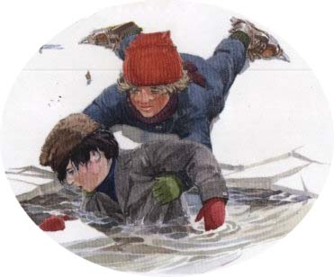
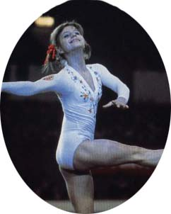
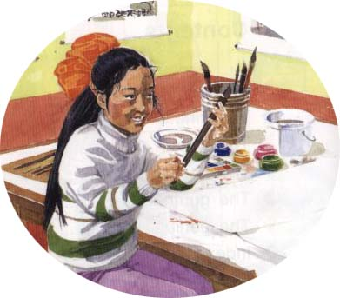
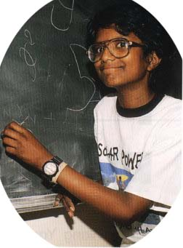
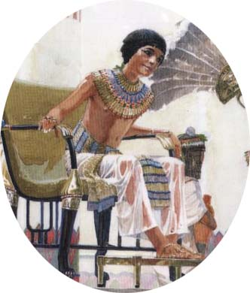
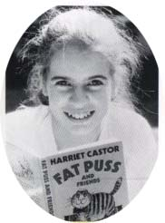

Unit 3

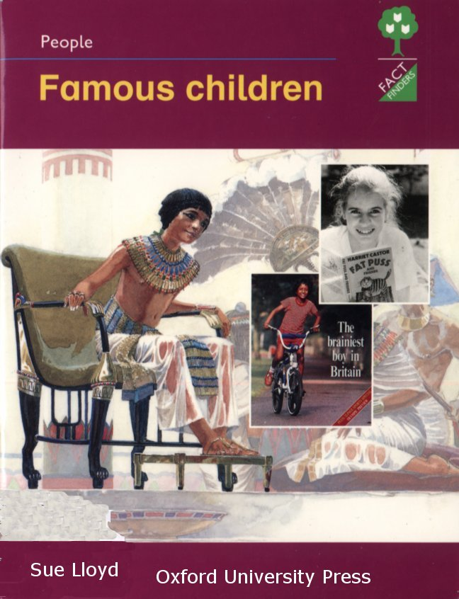

Famous

Children

CONTENTS

Introduction

 | Page
1.1. Introduction and description |  | 3-4
1.2. Objectives |  | 4-5
1.3 Parts of the Unit |  | 6
1.4. Assessment and Evaluation |  | 6-8

Summary of activities

2.1. Part I: Continents and Oceans | 9
2.2. Part II: Beautiful Bananas | 9-10
2.3. Part III: My Life Film | 10-11

General activities

3.1. Reading | 11
3.2. Diary | 11-12
3.3. Sing and Say | 12-13
3.4. Corners | 13
3.5. Teachers’ Resources Bank | 13-14
3.6. ICT | 14

Appendix

4.1. Mind Map | 14-19
4.2. Audio Cover | 20

- Bibliography, resources and useful websites

5.1. Material for the Unit | 21
5.2. Useful Internet Sites | 21-22

1. Introduction

1.1. Introduction and description

This unit deals with the topic of Famous Children. It focuses on our Planet Earth, and on children from different parts of the world, highlighting the names of the continents, oceans, countries… At the same time students (Ss) will analyse biographies of some famous children. As well as in previous units Ss will learn new songs, listen to stories, perform a play, play different games, etc. As final products, all Ss are expected to make a globe, a booklet and a film strip.
The unit has 3 parts, each one with a set of possible activities to carry out.

Cross-curricular contents of the unit:

LITERATURE

- Stories: ‘Beautiful Bananas’
- Biographies: ‘Famous Children’
- Drama: ‘Beautiful Bananas’
- Songs: ‘Oceans’ ‘Continents’, ‘Hello Song’, ‘My Bonnie Lies Over the Ocean’

GEOGRAPHY

- The Earth consists of land and water (continents, countries, oceans and seas).
- A map is the graphic representation of the Earth on a plan. It gives us information about where a place is, the name of the place and how big it is.
- A globe represents the planet Earth.
- The Olympic flag represents the continents.

ARTS

- Decorating own diary.
- Making a globe.
- Making a booklet.
- Designing ‘My Life Film’.

1.2. Objectives

Chart 1 (page 5) shows the basic communicative language objectives, the attitudinal objectives and the content objectives, all taken from the National Curriculum Reform Blueprint (DCB-OCD) for Primary Education.
In addition to the specific objectives of this unit, it would be advisable to consolidate the objectives from units 1 and 2, improving vocabulary.

LEVEL: P3 | UNIT III: FAMOUS CHILDREN |  | CHART 1: Objectives
Objectives |  | Concepts |  | Procedures | Attitudes
BASIC COMMUNICATIVE LANGUAGE OBJECTIVES  - To understand oral and written narrative, expository and instructive texts.  - To give opinions (likes, dislikes and preferences) orally, when talking about the activities carried out in the unit.  - To give oral information on tasks done and tasks to do.  - To ask for information about the language they need to carry out the activities.  - To tell the news (either related to general topics or to their own personal experience).  - To interact in English with T and peers.  - To write the lyrics of songs and other simple texts.  - To dramatize a story.  ATTITUDINAL OBJECTIVES  - To develop autonomous learning strategies.  - To be aware of the communicative value of English as a language.  - To take part actively in individual tasks as well as in group work.  - To develop awareness about the value of games.  CONTENT OBJECTIVES: THE EARTH & AUTOBIOGRAPHY  - To understand simple oral and written texts related to real and fiction characters and events.  - To memorize songs and rhymes related to the unit.  - To produce simple oral and written texts related to themselves and to real and fiction characters and events.  - To identify and locate different physical elements and cartographic codes.  - To be aware of the meaning of the Olympic Flag. |  | - Instructions, stories and descriptions.  - I liked, I enjoyed, most, least..., I think, in my opinion…  - We went, played, read, wrote…, We’re going to…  - What does… mean? How do you say?  - Yesterday, this morning (past tense).  - Poetic texts: “This Is the Way”, “Continents”, “Oceans”, “Hello Song”  - Narrative text: “Beautiful Bananas”.  2.4. Co-operation, fairness…  - Stories, reference books related to children, atlas…  - Lyrics of the songs and tongue twisters.  - Autobiography: I’m…(name), I’m … years old, I was born in…, my father/mother is a …, I’ve got … brother/sisters, when I was … (age) I … (action)…  - Continents, countries, oceans, seas… The globe, world map |  | - Searching for and interpreting information in reference books.  - Writing:  - Making hypotheses on spelling.  - Checking spelling.  - Copying and/or writing simple texts.  - Following some dramatizing hints: intonation, pronunciation, speaking to an audience, stage movements, learning the scripts by heart.  - Recording own work, opinions, self-assessment… in a diary. Working in corners.  - Using English in context when interacting with T and peers.  3.1. Using reading strategies to obtain main information from the text:  - Eliciting previous knowledge.  - Making hypothesis and predictions.  - Scanning, looking for key words.  - Listening and reading with the teacher’s help to understand meaning (mimics, explanations, underlining some words…).  - Individual reading.  3..3.a. Developing writing strategies:  - Listening to and reading different texts.  - Producing a booklet about a known story.  - Classifying information.  - Comparing structures.  - Writing their own autobiography on a film strip.  3..3.b. Presenting their film strips orally.  - Map reading.  - Relating the Olympic rings to the world map. | - Keeping folders and diaries tidy.  - Interacting in English with T and peers.  - Participating actively in all the class activities, co-operating with peers.  - Co-operating and developing fair play in games.  - Showing interest in getting to know children from all over the world.

1.3. Parts of the Unit

Part I: Continents and Oceans
In this part Ss will work on different ways to represent our planet Earth: maps, globes… they give us information about where a place is, the name of the place and how big it is.
Part II: Beautiful Bananas
In this part Ss will work on the storybook ‘Beautiful Bananas’. There will be a performance and Ss will retell the story by means of a booklet.
Part III: My Life Film
In this part Ss will read biographies of famous children and build up a mind map. They will tranfer the information found in a biography to an autotobiography. They will also describe their own life by means of a film strip.

1.4. Assessment and Evaluation

There are several tools designed to help teachers assess their work and to evaluate students’ progress.
Chart 2 (page 7) shows hints for students’ evaluation: what, how, and when to evaluate, as well as which tool can be for the purpose.
Chart 3 (page 8) is a very useful tool, where the routines followed by each student throughout the unit can be recorded.
Each part has its own evaluation chart to record language, content and attitudinal objectives that each student has achieved.
It is highly recommended to use these tools systematically, every day, every week or/and every fortnight, so that the information that teachers need to evaluate his or her Ss can be recorded properly to ensure reliability.
LEVEL: P 3 | UNIT 3: FAMOUS CHILDREN | CHART 2: Hints for Evaluation
INDICATORS
WHAT |  |  | HOW | TOOL |  | WHEN
- Follows T’s instructions / shows understanding of stories by participation.  - (1.7) Tells and/or writes the activities s/he liked best/least. Makes hypotheses and gives opinions.  - Says what s/he did (yesterday, last 2 weeks, in corners) and what we are going to do (today, next two weeks).  - Asks for language needed.  - Tells a piece of news.  - (2.2) Interacts in English with T and peers in specific situations.  - Writes simple texts.  - Acts out with good intonation and pronunciation; speaks to an audience and moves around the stage.  - Records own work in the diary (planning and assessments, activities done, new words...) and keeps materials tidy.  - (1.4) Participates actively (includes asking for language).  - Co-operates and shows fair play in games.  - Follows procedure for reading. Obtains information from simple expository and narrative texts.  - Sings the songs and says tongue twisters of the unit.  - Produces simple oral and written simple texts related to himself and to other real/fiction characters and events.  - Identifies and interprets the globe. Identifies and locates different places on a world map.  - Relates each ring colour in the Olympic flag to a continent. |  |  | Observation  Revising diaries / Interviewing  Observation  Observation  Revising class diary / Observation  Observation  Revising diaries, folders, booklets, S&S books  Observation MAIN ACT. (rehearsals and performance)  Revising diaries, folders  Interviewing  Observation MAIN ACT  Observation MAIN ACT  Observation MAIN ACT  Observation MAIN ACT  Observation MAIN ACT / Final products  Observation MAIN ACT / Final products  Revising folders/Diary  Observation MAIN ACT | Register  Diary/Individual or group interview  Register  Register  Class diary/Register  Register  Diaries, folders, booklets, S&S books  Register/Video recording  Diaries, folders, group interview  Register  Register  Register / Final products  Register  Register / Final products  Register / Diaries / Folder  Register / Final products |  | One student (any but helper) each day  4 Ss per class a week/All Ss working on their own  When S is Helper  One student per day  Fortnightly  One student per day  4 Ss per class a week  4 Ss during rehearsal and performance  When analysing video recording  4 Ss per class a week  All Ss working on their own  All Ss working on their own  A small group when playing games  All Ss working in groups  1/4 Ss per activity  4 Ss per class a week  1/4 Ss per activity  4 Ss per class a week  1/4 Ss per activity  4 Ss per class a week  1/4 Ss per activity  4 Ss per class a week
Numbers in brackets stand for the objectives

CHART 3: Routines Register
CLASS: |  | HELPER |  |  | UNDER-  STANDS |  |  | ATTITUDE |  |  |  |  |  | NEWS |  |  | DIARY-FOLDER |  |  | OTHER ROUTINES
 |  | - Says what we did and what we’re going to do  - Unit mind map  - Others |  |  | - Follows teacher’s instructions |  |  | - Pays Attention  - Asks for language  - Participates  - Collaborates |  |  | - Interacts in English with Teacher  - (Interacts in English with Peers) |  |  | - Tells a Piece of News |  |  | - Writes the acts. best/least liked  - Records own work  - Keeps materials tidy
Name | Date | Yes | With help | No | Yes | With help | No | 1 | 2 | 3 | 1 | 2 | 3 | Yes | With help | No | Yes | With help | No | Yes | With help | No

2. Summary of activities

2.1. Part I: Continents and Oceans

Act. 1: Planning
T and Ss outline the whole term’s plan and set Part I planning.
Act. 2: The Earth
Ss learn the Earth consists of land and water (continents, countries, oceans and seas).

Act. 3: World Map
Ss complete a world map with the information they have studied the previous day: continents, countries, oceans and seas.

Act. 4: Sing & Say
Ss write the corresponding song in their Sing & Say book.
Act. 5: Globe
Ss make an Earth globe.
Act. 6: Song: ‘Oceans’ or ‘Continents’
Ss listen and sing the song.
Act. 7: Corners
Ss work in corners.
Act. 8: Olympic Flag
Ss link continents with the Olympic flag and talk about where and when the last Olympic Games took place.

Act. 9: Evaluation
Ss give their opinion of the activities done in PART I and review what they have learnt.

2.2. Part II:

Act. 10: Planning
T and Ss talk about the unit and Ss write down the planning of PART II.

Act. 11: Song: ‘Hello’
Ss listen and sing ‘Hello Song’.
Act. 12: Story Telling ‘Beautiful Bananas’’
Ss listen to the story ‘Beautiful Bananas’ and choose the characters for the performance.

Act. 13: Rehearsal ‘Beautiful Bananas’’
Ss work on the performance script and rehearse it.
Act.14: Sing & Say
Ss write the corresponding song in their Sing & Say book.
Act. 15: Booklet
Ss make their own booklet based on the story.
Act. 16: Corners
Ss work in corners.
Act. 17: Performance: ‘Beautiful Bananas’’
Ss perform the story in front of an audience.
Act. 18: Evaluation
Ss give their opinion of the activities done in PART II and review what they have learnt.

2.3. Part III:

Act. 19: Planning
T and Ss talk about the unit and Ss write down the planning of PART III.

Act. 20: Song: ‘My Bonie Lies Over the Ocean’
Ss listen and sing a song.

Act. 21: Reading: ‘Famous Children’
T and Ss read ‘Famous Children’ to make clear the comprehension of the book.

Act. 22: Mind Map
Ss fill in a mind map with pictures and main information, according to the text.

Act. 23: Sing & Say
Ss write the corresponding song in their Sing & Say book.
Act. 24: Autobiography
T & Ss read some autobiographies to find out main information and complete a chart.

Act. 25: My Life Film
Ss write their own autobiographies arranged in a film strip.
Act. 26: Corners
Ss work in corners.
Act. 27: Evaluation
Ss give their opinion of the activities done in PART III and review what they have learnt.

3. General Activities

3.1. Reading

In this unit there are three activities especially designed to help Ss understand written texts: Activity 1, ‘Children just like me’, Activity 12, ‘Beautiful Bananas’ and Activity 21, ‘Famous Children’. Before Ss actually start reading the text, T elicits previous knowledge about the topic, asks questions about the title, the writer and the organisation of the book and talks about the information shown in the pictures. T reads the text aloud to establish sight-sound correspondence while Ss follow in their texts or handouts. T explains difficult words referring to pictures and/or using mime and gestures. Key words may be underlined. Then Ss read the text on their own and do the task proposed (filling in a chart and matching paragraphs and pictures).

3.2. Diary

In Primary 3 we introduce a change in the procedure to work with the diary because our aim is to foster writing. Therefore, we propose two types of diaries to be implemented in the classroom. On the one hand, we intend to maintain the classroom diary as it was and, on the other hand, each student will start writing his/her own diary.
The contents of the individual diary for this Second Stage are as follows:
- Planning (a list of the different activities to be carried out).
- Self-assessment about the individual effort and participation can be included using the following sentences: I’ve participated in this activity; It’s been easy/difficult for me; I’ve made an effort…This can also be done for the classroom diary reflecting the group’s opinion: We think it has been/was an easy/difficult activity for us…
- Opinions regarding likes and dislikes about the activities either individually or in group: I liked…, I didn’t like… We liked a lot this activity.
- An account of his/her own learning. It can be discussed in group what has been learnt but every student should write in his/her own diary what is true for his/her individual case: I’ve learnt this vocabulary about Continents: America, Europe, Asia… This activity can be used as a means of self-assessment asking students not to copy it from anywhere.
- Vocabulary, songs, rhymes, tongue twisters, etc. other than the ones written in the “Sing & Say book” can be written in the diary.
- Any other material in English not related to the main topic but relevant for the individual student can be included in his/her diary.
As in previous years, at the end of every unit the contents of the diary can be discussed and a review of the unit can be done in group either using the classroom diary or the individual ones.

3.3. Sing & Say

Ss are going to keep a record of all the songs they will learn during the school year in a special booklet called Sing & Say. After listening to the song, Ss in pairs or in a small group will write the beginning of the song on scrap paper the way they think it is. Afterwards, while T writes this first verse on the b/b, Ss will check their written production. T and Ss will follow the same procedure with the rest of the song. Finally Ss will copy the lyrics in their Sing & Say book.
Once this activity has ended T and Ss will work on pronunciation. T will write words taken from the lyrics and invite Ss to pronounce them. Then T will write some other words which have the same sound so that Ss should try and transfer the sounds from the previous words to the new ones (short and long vowel sounds, consonant clusters…).
Finally, Ss will learn and practise a tongue-twister. It helps children develop greater phonemic awareness in fun, meaningful ways, to achieve the full effect of a tongue twister Ss should try to repeat it several times, as quickly as possible, without stumbling or mispronouncing.

3.4. Corners

Corner work promotes learner autonomy because Ss can choose the activities they prefer and work at their own pace and, at the same time it fosters cooperative learning since some of those activities must be done in pairs or in groups. In this unit some sessions are devoted to do corner work. T will decide which corners will be organised according to the materials and the facilities available in the school: computer corner, craft corner, reading corner, listening corner, board games corner, pending tasks corner (see the Document for English Language in Primary Education).

3.5. Teachers’ Resource Bank

- A life like mine, DK, ISBN: 0751339822
- Foundation Atlas, Heinemann, ISBN 043535017X
- Geography KS1, Scholastic, IBBN 0 590 53400 9
- Geography KS2: Places, Scholastic, ISBN 0 590 53401 7
- Geography KS2: Themes, Scholastic, ISBN 0 590 53408 4

3.6. ICT

Some advice and suggestions to integrate ICT in this unit:
- Typing. Good habits are essential and they will help our students in the future.

- Word Processing. Several tasks can be done with or without this tool.

- World Wide Web. Ss may find information and pictures on the Internet, as well as play some on-line games; some interesting websites are mentioned in the “Useful Web Sites” section of this document.

4. Appendix

4.1. Unit Mind Map

A Mind Map is a way of organizing an area of information. It is typically an organic multi-coloured chart laid out on a large sheet of paper. It contains words and drawings that are connected in various ways. A Mind Map can be used for keeping notes, or for developing a concept, or for getting an overview of an activity. Mind Maps use and stimulate the visual abilities of the mind. If represented visually, a bigger subject can be understood and remembered much more efficiently. Mind Maps are an example of Radiant Thinking. A central idea branches off into many different directions. The branches themselves branch off into finer details or associations. Radiant Thinking is both Creative and Organized. Like a tree.
The Unit Mind Map will give Ss an overview of what they have been doing. It will hold information in a format that Ss will find easy to remember and quick to review. The Unit Mind Map can commence being done with the evaluation of Part I and finish at the end of the unit or as a revision of the different activities that have been carried out.
Start from the centre of the page and work out. Make the centre a clear and strong visual image that depicts the general theme of the map. Create sub-centers for sub-themes. Use arrows, icons or other visual aids to show links between different elements. Remember that anything that stands out on the page will stand out in Ss’ mind.

FAMOUS
CHILDREN
The Earth
Planning
I
Evaluation
Song
‘Oceans’
‘Continents’

Corners
Sing & Say
‘Stand Up, Sit Down’

Globe
Olympic Flag
World Map
Story Telling
‘Beautiful Bananas’
Rehearsal
‘Beautiful Bananas’
Performance
‘Beautiful Bananas’

Booklet
Planning
II
Evaluation
Song
‘Hello Song’
Corners
Sing & Say
‘Oceans’
‘Continents’

My Life Film
Planning
III
Evaluation
Song
‘My Bonnie Lies Over the Ocean’
Reading
‘Famous Children’
Corners
Mind Map
Sing & Say
‘Hello Song’
Autobiography
4.2. Audio cover

Track 01. Unit 3. Part I. Geographical glossary.
Track 02. Unit 3. Part I. Pronunciation awareness.
Track 03. Unit 3. Part I. Tongue Twister.
Track 04. Unit 3. Part I. Olympic flag.
Track 05. Unit 3. Part I. Song: ‘Oceans’.
Track 06. Unit 3. Part I. Song: ‘Continents’.
Track 07. Unit 3. Part II. Song: ‘Hello’.

Track 08. Unit 3. Part II. Story: ‘Beautiful bananas’.

Track 09. Unit 3. Part II. Story: ‘Beautiful bananas’ (Performance).
Track 10. Unit 3. Part II. Pronunciation awareness.
Track 11. Unit 3. Part II. Tongue Twister.
Track 12. Unit 3. Part II. Children just like me. Celina, pg. 14.
Track 13. Unit 3. Part II. Children just like me. Ari, pg. 26.
Track 14. Unit 3. Part II. Children just like me. Bakang, pg. 37.

Track 15. Unit 3. Part II. Children just like me. Daisuke, pg. 53.
Track 16. Unit 3. Part II. Children just like me. Meena, pg. 56.
Track 17. Unit 3. Part II. Children just like me. Ngwaita, pg. 74.
Track 18. Unit 3. Part II. Children just like me. Dion, pg. 76.
Track 19. Unit 3. Part III. Story. ‘Famous children’. Fact finders.
Track 20. Unit 3. Part III. Pronunciation awareness.

Track 21. Unit 3. Part III. Tongue Twister.

Primary 3
AUDIO

UNIT 3:
FAMOUS CHILDREN

5. Bibliography, resources and useful websites

5.1. Material for the Unit

stories

  - Beautiful Bananas: OUP (ISBN 0192725521)
    - People: Famous Children, More Unit B, Oxford Reading Tree Fact Finders, ISBN 019916942X

reference materials

- Interfact Atlas Two-Can Publishing Ltd (ISBN 1854346970 )
- Children just like me. DK ISBN 0751353272

maps
  - Peters World Map ISBN: 0 7217 0933 8
  - Inflatable Globe (40 cm) Globes UK ISBN: N231160016

OPTIONAL MATERIAL

movies
  - Lilo & Stitch, DISNEY
    - DVD ASIN: B000063W2O
    - VHS ASIN: B000063W2N
  - Jungle Book, DISNEY ( not available)
  - Mulan, DISNEY
  - DVD
  - Pocahontas DISNEY
  - DVD ASIN: B00005LDBM
  - VHS ASIN: B00004L8J6
CD-ROM
  - BECOME A WORLD EXPLORER
Dorling Kindersley Ltd ISBN: B00004UCNQ

5.2. Useful Internet Sites

http://www.edhelper.com/Geographical_Terms.htm Introductory Geography Vocabulary (Grades 2-4).

http://www.childrensatlas.com/ Atlas online. In this atlas you can explore the world using the fantastic maps and graphics.

http://www.dltk-kids.com/world/index.htm Crafts for Kids: Countries & Cultures Activities.

http://hum.amu.edu.pl/~zbzw/glob/glob1.htm The great earth gallery.

http://members.aol.com/bowermanb/maps.html Map sites.

http://yourchildlearns.com/owlmouse.htm Learn geography with free educational map puzzles.

http://www.lizardpoint.com/fun/geoquiz/worldquiz.html Test your Geography Knowledge.

http://worldatlas.com/aatlas/imagec.htm Information.

http://www.ri.net/schools/Central_Falls/v/218/t7con.html Explore the seven continents.

http://games.funschool.com/game.php?g=1125&s=0&category=61&level=0 Games.

http://www.enchantedlearning.com/geography/continents/ Geography.

http://members.shaw.ca/henriksent/continents.htm Lyrics.

http://www.fcps.k12.va.us/FoxMillES/contoceans.html Continents of the Earth: Fox Mill Elementary School.

http://alpha.lsb.syr.edu/projects/we_are/3rd/3rd.html World Communities.

http://www.ri.net/schools/Central_Falls/v/218/t7con.html The seven continents of the world are listed. Each continent links to another web page to include interesting facts about life on that particular continent. Students will learn about the animals, famous locations, and the people.

www.enchantedlearning.com/geography/continents/quiz.shtml This web site provides teachers with the opportunity of copying a worksheet for non-commercial use and using it to teach about the locations of the continents and oceans. Students will answer questions and colour the world. Click on geography to have a collection of geography pages, printouts, and activities. Click on oceans to learn all about Earth's oceans.

www.etc.sccoe.org/i98/ii98Units/SocStd/Continental/text/Contin1.html#assess This web site is created by teachers for teachers to use when teaching about the continents. Objectives are given, lessons, and an evaluation rubric is found on this site. Teachers can use this web site to incorporate new ideas for teaching about the continents. The lessons are fun ways students can remember the continents and their locations.

http://www.graphicmaps.com/aatlas/world.htm An excellent site for students to find information about the continents on Earth. Students click on a continent at the top of the page to find out more facts about the continent. Things such as the countries are listed, current time, flags, atlases, and guides are among the many interesting facts found on this site. The map will show students the location of each continent, country and city. Teachers will be able to print out an outline of the countries or states on each continent. Students can email their questions about geography to this web site. Sources are listed on this site to verify the information read.

http://wizard.hprtec.org/builder/worksheet.php3?ID=20367 Read the directions then play the game.

http://ofcn.org/cyber.serv/academy/ace/soc/cecsst/cecsst121.html The student will become familiar with major land masses of the world.

http://www.LittleExplorers.com/classroom/quiz/continents.shtml Use the Little Explorers online picture dictionary and your classroom wall map to answer these 20 questions about continents. Students will use research skills to learn a variety of facts about continents and to match the facts with the name of the continent. Objective: Locate and identify the equator, continents, oceans, and large islands on a map and globe.

http://www.nationalgeographic.com/geospy Continent Game (easy).

http://www.lizardpoint.com/fun/geoquiz/worldquiz.html How many continents are there in the world?

http://geography.about.com/science/geography/library/maps/blrindex.htm? World Atlas: Countries Organized by Continent and Region.

http://www.enchantedlearning.com/geography/label/labelcontinents.shtml Label Continents Map Printout.
http://www.enchantedlearning.com/geography/label/labeloceans.shtml Label Oceans Map Printout.

http://surfnetkids.com/games/geography-sc.htm Puzzles.

http://www.ipl.org/youth/cquest/ From the Internet Public Library you can travel to each continent to find our more about it.

http://www.ri.net/schools/Central_Falls/v/216/sevcontn/sevcont.html The student can choose one of the seven continents to research.

http://www.afn.org/~afn11300/fun.html These are some beautiful photos from the various continents.

http://www.petersmap.com/page2.html A more in depth answer about what the seven continents are as well as a world map. Nice way to view their locations on the map. This site is more appropriate for grades 3 and up.

http://www.fcps.k12.va.us/NewingtonForestES/Gradepages/continents/continents.htm A nice resource site that allows children to explore and learn about the seven continents. Also provides printable world maps for both students and teachers.

