Track 01. U1 PART 1: “The water cycle”
Track 02 U1 PART 1: “My Bonnie lies over the ocean”
Track 03 U1 PART 2: “Yellow submarine”
Track 04 U1 PART 3: “ A sailor went to sea”
Track 05 U2 PART 1: “Family album chant”
Track 06 U2 PART 1>“Family album chant” only music
Track 07 U2 PART 2: “Everybody”
Track 08 U2 PART 2: “There’s a monkey sitting in my family tree”
Track 09 U2 PART 3: “My grandfather’s clock”
Track 10 U3 PART 1: “The buildings rap”
Track 11 U3 PART 2: “London bridge is falling down”
Track 12 U3 PART 3: “Humpty Dumpy”
Track 13 U3 PART 3: “Where’s the Parthenon?”

Primary 4




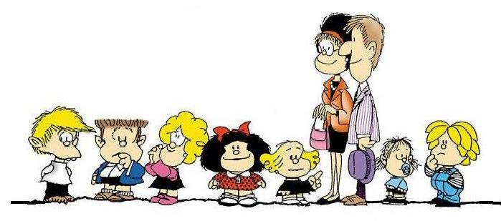

Songs

