

Lehen Hezkuntzako Ingelesa Edukien Bitartez
Inglés a través de Contenidos en Educación Primaria
A Content & Language Integrated Learning Sequence for
Primary Education

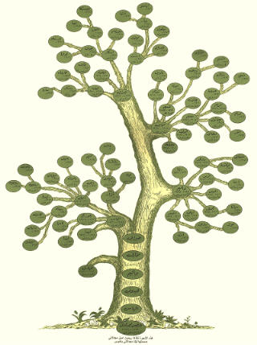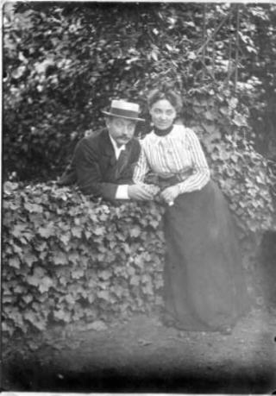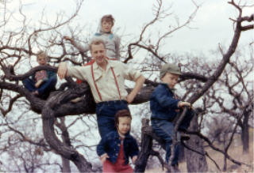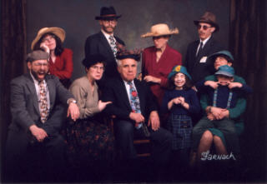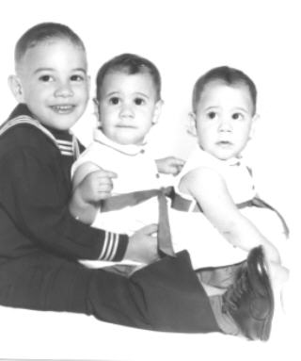

Unit 2

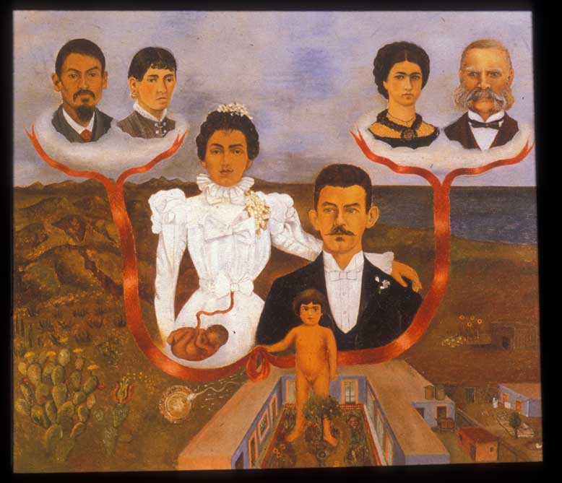

My Family Tree

CONTENTS

Introduction

 | Pages
1.1. Introduction and description |  | 3-4
1.2. Objectives |  | 4-5
1.3 Parts of the Unit |  | 6
1.4. Assessment and Evaluation |  | 6-8

Summary of activities

2.1. Part I: All Kinds of Families | 9
2.2. Part II: My Family Tree | 9-10
2.3. Part III: Now and Then | 10-11

General activities

3.1. Reading | 11
3.2. Diary | 11
3.3. Sing and Say | 12-13
3.4. Corners | 13-14
3.5. Games | 14-15
3.6 Video | 15
3.6. ICT | 16

Appendix

4.1. Mind Map | 16-20
4.2. Audio Cover | 21

- Bibliography, resources and useful websites

5.1. Material for the Unit | 22
5.2. Useful Internet Sites | 22-23

1. Introduction

1.1. Introduction and description

The contents presented in this unit are related to families and everyday life in recent history. It focuses on the idea of family diversity and the differences between the kind of world the children’s parents and grandparents knew when young and the one we have today.
This unit has three main sequences of activities: All Kinds of Families, My Family Tree, Now and Then.
It also contains extra reading activities, songs, games, ideas for learning stations…
Furthermore, some suggestions to supplement this unit are stated in this introduction.
Cross-curricular contents of the unit:
LITERATURE
- Stories: ‘The Grandad Tree’, ‘All Kinds of Families’
- Drama: ‘All Kinds of Families’
- Songs: ‘Family Album Chant’, ‘There’s a Monkey Sitting in my Family Tree’, ‘My Grandfather’s Clock’ and famous songs like some of the ones suggested in this document.
- Poems: Haiku writing and reading.

HISTORY
- Ss investigate about everyday life in the second half of the last century through a survey to relatives.

MATHS
- Ss represent survey results in bar graphs.

ARTS
- Decorating own diary.
- Designing a family scrapbook.

1.2. Objectives

Chart 1 (page 5) shows the basic communicative language objectives, the attitudinal objectives and the content objectives, all taken from the National Curriculum Reform Blueprint (DCB-OCD) for Primary Education.

LEVEL: P4 | UNIT 2: MY FAMILY TREE |  | CHART 1: Objectives
Objectives |  | Concepts |  | Procedures | Attitudes
BASIC COMMUNICATIVE LANGUAGE OBJECTIVES  - To understand oral and written narrative, expository and instructive texts.  - To give opinions (likes, dislikes and preferences), ask for information and talk about what they have learnt, when recalling the activities carried out in the unit.  - To give oral information on tasks done and tasks to do.  - To ask for information about the language they need to carry out the activities.  - To tell the news (either related to general topics or to their own personal experience about the theme in the unit).  - To interact in English with T and peers in very contextualised situations.  - To write the lyrics of songs and other simple texts.  - To dramatize sketches.  ATTITUDINAL OBJECTIVES  - To develop autonomous learning strategies and awareness of learning process.  - To be aware of the communicative value of English as a language.  - To take part actively in individual tasks as well as in group work.  CONTENT OBJECTIVES: MY FAMILY TREE  - To understand simple oral and written texts related to family and daily-life facts.  - To memorize songs and tongue twisters related to the unit.  - To produce simple oral and written texts related to family and daily-life facts.  - To classify family relationships.  - To make a scrapbook about their own family.  - To collect and record information.  - To analyse similarities and differences in life style through different generations. |  | - Instructions, stories and descriptions.  - I liked, I enjoyed, most, least..., I think, in my opinion, What...? When...? Where...? Who?…  - We went, played, read, wrote…, We’re going to…  - What does… mean? How do you say? How do you spell?  - Yesterday, this morning (past tense)…  - Poetic texts: ‘Family Album Chant’, ‘Everybody’, ‘There’s a Monkey Sitting in my Family Tree’, ‘My Grandfather’s Clock’, haikus, songs from second half of 20th century…  - Narrative text: ‘The Grandad Tree’  - Stories, reference books related to family and History (Fact Finders, History time lines…), atlas…  - Lyrics of the songs and tongue twisters.  - Expository texts and slogans. Specific language: family members, vocabulary to describe people, telephone numbers, addresses, dates, time, days of the week, months, likes and dislikes, hobbies, school, transports, food, communication… My family is very big, I don’t have any, cousin, My aunt lives in… This is my dad …, His/her favourite food is... S/he got up at seven, S/he’s afraid of spiders, She’s been to …, I like him/her because …  - Family members.  - (see 3.3)  - Questionnaires (language structures related to personal information).  - Bar charts, graphs and texts. |  | - Searching for and interpreting information in reference books.  - Writing:  - Making hypotheses on spelling.  - Linking oral and written forms of some words.  - Checking spelling.  - Copying and/or writing simple texts.  - Following some dramatizing hints: intonation, pronunciation, speaking to an audience, stage movements, learning the scripts by heart.  - Recording own work, opinions, self-assessment… in a diary. Working in corners.  - Using English in context when interacting with T and peers.  3.1. Using reading strategies to obtain main information from the text:  - Eliciting previous knowledge.  - Making hypotheses and predictions.  - Scanning, looking for key words.  - Listening and reading with teacher’s help to understand meaning (mimics, explanations, underlining some words…).  - Individual reading.  3.3.a. Developing writing strategies:  - Listening to and reading different texts.  - Classifying information.  - Comparing structures.  - Writing captions for pictures or small texts with information related to pictures.  3.3.b. Producing comprehensible output when presenting their products orally (booklet, scrapbook, graphs…).  - Using classifying patterns such as family trees.  - Recording data through questionnaires and organising information. Making hypotheses, writing captions, relating relatives to historical facts in time…  - Asking for and recording information (questionnaires), reading and writing it in their scrapbook.  - Interpreting and representing data graphically: working in groups, drawing bar charts and explaining the results to their peers. | - Keeping folders and diaries tidy.  - Interacting in English with T and peers.  - Participating actively in all the class activities, co-operating with peers.  3.5. Showing interest in their own history and in other family groups.

1.3. Parts of the Unit

Part I: All Kinds of Families
This sequence includes reading activities and a performance based on “All Kinds of Families” book (Fact Finders, OUP). It aims to help Ss become aware of the diversity of family compositions we can find in our society, while developing reading strategies.
Part II: My Family Tree
In this part the Ss are proposed to start building their own family scrapbooks and collect in it a series of pictures and texts related to some people in their families.
Part III: Now and Then
The Ss will carry out a survey among some members of their families (parents and grandparents’ generations), they will translate, organize and report on the data collected. It aims to show some differences between everyday life nowadays and in the last century.

1.4. Assessment and Evaluation

There are several tools designed to help teachers assess their work and to evaluate Ss’ progress.
Chart 2 (page 7) shows hints for Ss’ evaluation: what, how, and when to evaluate, as well as which tool can be for the purpose.
Chart 3 (page 8) is a very useful tool, where the routines followed by each student throughout the unit can be recorded.
Each part has its own evaluation chart to record language, content and attitudinal objectives that each S has achieved.
It is highly recommended to use these tools systematically, every day, every week or/and every fortnight, so that the information that teachers need to evaluate his or her Ss can be recorded properly to ensure reliability.
LEVEL: P 4 | UNIT 2: MY FAMILY TREE | CHART 2: Hints for Evaluation
INDICATORS
WHAT |  |  | HOW | TOOL |  | WHEN
- Follows T’s (or text) instructions / shows understanding of stories by participation. T checks speakers and listeners’ understanding through questions.  - (1.7) Tells and/or writes the activities s/he liked best/least. Makes hypotheses and gives opinions. Says what s/he has learnt.  - Says what s/he did (yesterday, last 2 weeks, in corners) and what we are going to do (today, next two weeks).  - Asks for language needed.  - Tells a piece of news.  - (2.2) Interacts in English with T and peers in specific situations.  - Writes comprehensible short texts. Writes the lyrics of the song and checks.  - Acts out with good intonation and pronunciation; speaks to an audience and moves around the stage.  - Records own work in the diary (planning and assessments, activities done, new words...), works autonomously in corners and keeps materials tidy.  - (1.4) Participates actively (includes asking for language).  - Follows procedure for reading. Obtains information from simple expository and narrative texts.  - Sings the songs and says tongue twisters of the unit.  - Produces simple oral and written simple texts related to family and daily-life facts. Presents their reports (family tree, scrapbook, graphs) orally.  - Makes a family tree.  - Makes a scrapbook. Writes about him/herself and about somebody in his/her family.  - Collects and selects information. Presents it to his/her partners.  - Recognizes similarities and differences between the past and now. |  |  | Observation  Revising diaries / Interviewing  Observation  Observation  Revising class diary / Observation  Observation  Revising diaries, folders, booklets, S&S books  Observation MAIN ACT. (rehearsals and performance)  Revising diaries, folders  Interviewing  Observation MAIN ACT  Observation MAIN ACT  Observation MAIN ACT  Observation MAIN ACT / Scrapbook / Revising folders or diaries  Observation MAIN ACT / Scrapbook/ Revising folders/Diary  Observation MAIN ACT / Scrapbook/ Revising folders/Diary  Observation MAIN ACT / Final products (questionnaires, scrapbook, graphs)/Revising folders/Diary  Observation MAIN ACT / Final products (questionnaires, graphs, scrapbook)/Revising folders/Diary | Register  Diary/Individual or group interview  Register  Register  Class diary/Register  Register  Diaries, folders, booklets, S&S books  Register/Video recording  Diaries, folders, group interview  Register  Register / Final products  Register  Register / Final products (scrapbook)  Register / Diaries / Folder / Final products  Register / Final products  Register / Final products  Register / Final products |  | One student (any but helper) each day  4 Ss per class a week/All Ss working on their own  When S is Helper  One student per day  Fortnightly/when relevant news appears.  One student per day  4 Ss per class a week  4 Ss during rehearsal and performance  When analysing video recording  4 Ss per class a week  All Ss working on their own  All Ss working on their own  All Ss working in groups  1/4 Ss per activity  4 Ss per class a week  1/4 Ss per activity  4 Ss per class a week  1/4 Ss per activity  4 Ss per class a week  1/4 Ss per activity  4 Ss per class a week  1/4 Ss per activity  4 Ss per class a week  1/4 Ss per activity  4 Ss per class a week
Numbers in brackets stand for the objectives

CHART 3: Routines Register
CLASS: |  | HELPER |  |  | UNDER-  STANDS |  |  | ATTITUDE |  |  |  |  |  | NEWS |  |  | DIARY-FOLDER |  |  | OTHER ROUTINES
 |  | - Says what we did and what we’re going to do  - Unit mind map  - Others |  |  | - Follows teacher’s instructions |  |  | - Pays Attention  - Asks for language  - Participates  - Collaborates |  |  | - Interacts in English with Teacher  - (Interacts in English with Peers) |  |  | - Tells a Piece of News |  |  | - Writes the acts. best/least liked  - Records own work  - Keeps materials tidy
Name | Date | Yes | With help | No | Yes | With help | No | 1 | 2 | 3 | 1 | 2 | 3 | Yes | With help | No | Yes | With help | No | Yes | With help | No

2. Summary of activities

2.1. Part I: All Kinds of Families

Act. 1: Planning
The T tells a story to introduce the topic. T and Ss outline the plan for the whole term and set Part I planning.
Act. 2: Song: ‘Family Album Chant’
Ss listen and sing the song.
Act. 3: Reading: ‘All Kinds of Families’
Ss read a book and work on key vocabulary and pronunciation.
Act. 4: Mind Map: ‘All Kinds of Families’
Ss match pictures and texts to organize the contents of the book in a kind of mind map display.
Act. 5: Sing & Say: ‘A Sailor Went to Sea’
Ss write the corresponding song in their Sing & Say book.
Act. 6: Rehearsal: ‘All Kinds of Families’
Ss work on the performance script and rehearse it.
Act. 7: Corners.
Ss work at different learning centres.
Act. 8: Performance: ‘All Kinds of Families’
Ss perform the story in front of an audience.
Act. 9: Evaluation
Ss give their opinion of the activities done in PART I and review what they have learnt.

2.2. Part II: My Family Tree

Act. 10: Planning
T and Ss talk about families and Ss write down the planning of PART II.
Act. 11: Song: ‘There’s a Monkey Sitting in my Family Tree’
Ss listen to the song and sing it later on.
Act. 12: Designing my scrapbook.
Ss design their own scrapbook after seeing different models.
Act. 13: All about me
Ss write about themselves.
Act.14: Sing & Say: ‘Family Album Chant’
Ss write the corresponding song in their Sing & Say book.
Act. 15: My family tree
Ss create their own family tree.
Act. 16: Corners
Ss work in corners.
Act. 17: People in my family.
Ss write about one or two family members.
Act. 18: Evaluation
Ss give their opinion of the activities done in PART II and review what they have learnt.

2.3. Part III: Now and Then

Act. 19: Planning
T and Ss talk about everyday objects used by grandparents, parents and themselves. Ss write down the planning of PART III.
Act. 20: Song: ‘My Grandfather’s Clock’
Ss listen and sing a song.

Act. 21: Survey: ‘Life when parents and grandparents were young’
Ss translate and organize data about everyday life before and now.

Act. 22: Writing a Report: ‘Life when parents and grandparents were young’
Ss write a short text extracting information from their surveys.
Act. 23: Sing & Say: ‘There’s a Monkey Sitting in my Family Tree’
Ss write the song they sang in the last part of Unit 1 in their Sing & Say book.

Act. 24: Comparing data: ‘Life when parents and grandparents were young’
Ss share data from their surveys and represent them in a graph.
Act. 25: Corners.

Ss work in corners.

Act. 26: Presentation of Scrapbook: ‘My Family Scrapbook’
Ss present part of their scrapbook to peers individually.
Act. 27: Evaluation
Ss give their opinion of the activities done in PART III and review what they have learnt.

3. General Activities

3.1. Reading

The main reading activities in this unit are the following:
- All Kinds of Families (Fact Finders, OUP) and drama script (main reading skill: thorough reading to understand a text and reading out).
- Other titles in the Fact Finders collection: When Gran Was a Child, I Came to Britain from Jamaica, I Live in France, Getting Ready for Eid, Christian Family Festivals, When Grandad Was at School (main reading skill: general understanding).

3.2. Diary

As it was stated in the introduction to Unit 1: Water II, two types of diaries are still proposed: a classroom diary and individual notebooks where each S will keep a series of drafts, texts, planning and evaluation activities, comments on preferences, likes and dislikes, self-assessment, new vocabulary…
As in previous years, at the end of every unit the contents of the diary can be discussed and revision can be done in group either using the classroom diary or the individual ones.

3.3. Sing & Say

Songs
Singing along well-known songs (or easier lyrics with popular tunes) is good practice to exercise reading speed, identification of written and oral forms of words, comprehension of general meaning of texts and pronunciation.

As it was proposed in P3, Ss will keep a record of songs by building their individual Sing & Say books. The procedure is the following:
- Ss learn a song (or part of it) by heart.
- They are asked to write a verse (or more) as they think it should be written.
- They copy, stick or just look up the lyrics and check their original text with the correct one.

We propose to work on the following songs:
- A chant for children: “Family Album Chant” (Longman Children’s Dictionary)
- A song for children: “There’s a Monkey Sitting in my Family Tree”.
- A popular song related to time and relatives: “My Grandfather’s Clock”.
- Modern songs that have been hits in the last decades. “Everyone” by the Backstreet Boys contains some words related to family and can be used as an alternative to children’s songs.
Other suggestions:
  - Rock Around the Clock. Bill Haley and The Comets.
  - What a Wonderful World. Louis Amstrong.
  - Let’s Twist Again. Chubby Checker
  - The Twist. Chubby Checker.
  - Twist and Shout. Beatles.
  - Yellow Submarine. Beatles.
  - Hello, Goodbye. Beatles.
  - Barbie Girl. Aqua.
  - Wannabe. Spice Girls.
  - We Will Rock You. Queen.
  - Rivers of Babylon. Boney M.
  - Everybody. Backstreet Boys.
  - Born in the USA. Bruce Springsteen.
  - 2-4-6-8 Motorway. Tom Robinson.
  - Ground Zero. Elliott Murphy
  - Cotton-Eye Joe. Rednex.
  - Agadoo. The Chart of the Flops.
  - The Banana Boat Song. Harry Belafonte.
  - Doodah. Cartoons.
  - The Locomotion Song. Atomic Kitten.
  - Superman.
  - Witch Doctor. Cartoons.
  - Jump in the Line. Harry Belafonte.
  - Qué será, será. Doris Day.

Pronunciation awareness
T and Ss will work on pronunciation. T will write words taken from the lyrics of the song and invite Ss to pronounce them. Then T will write some other words which have the same sound so that Ss should try and transfer the sounds from the previous words to the new ones.
Rhymes & Tongue Twisters
Nursery rhymes and tongue twisters are good for practising memory, intonation and pronunciation.
Ss will learn and practise a tongue-twister. It helps children develop greater phonemic awareness in fun, meaningful ways, to achieve the full effect of a tongue twister Ss should try to repeat it several times, as quickly as possible, without stumbling or mispronouncing.

3.4. Corners

Corner work promotes learner autonomy because Ss can choose the activities they prefer and work at their own pace and, at the same time it fosters cooperative learning since some of those activities must be done in pairs or in groups. In this unit some sessions are devoted to do corner work. T will decide which corners will be organized according to the materials and the facilities available in the school: computer corner, craft corner, reading corner, listening corner, board games corner, pending tasks corner (see the Document for English Language in Primary Education).

3.5. Games

These are some ideas of simple games that can be used as warmers or round-off activities. Their aim is to help the teacher introduce the tasks, draw the Ss’ attention before dealing with one of the main activities proposed for the unit, or just give an end to the lesson in a whole group fun activity.
- “MY GRANDMOTHER HAD A PARTY”
The players sit in a circle or semicircle and a sentence chain is started in this way:
S1: “My grandmother had a party and invited Uncle Peter”.
S2: “My grandmother had a party and invited Uncle Peter and Cousin Rose”.
S3: “My grandmother had a party and invited Uncle Peter, Cousin Rose and Sister Mary”
New family members are added until some student can’t remember everything and a new “party” is commented.
- “FRUIT SALAD”
Ss are sitting in a circle. The T assigns one of five family categories to each child. (e.g. father, mother, uncle, cousin, aunt). Then, the T or some S calls out one, two, three, four or all the categories in the following way:
T: “I want my mother, uncle and aunt to come home”
The children who belong to the mentioned groups stand up and try to sit in a different chair from the one they had.
- “FATHER JOHNNY IS COMING TO STAY”
Four or five volunteers stand in front of the rest of the class. Example of dialogue:
S1: “Father Johnny (or Mother Maggie/Uncle Jimmy...) is coming to stay”.
S2: “What is he like?”
S1: “He’s got a mouth like this” (twisting mouth in an amusing way).
S2: (Turning to S3) “What is he like?”
S3: “He’s got a mouth like this (repeating gesture) and a nose like this (adding a new amusing gesture)”
The players try to make the others smile by making funny faces, but the ones who smile or laugh are out and new players join the game.
- “WHO IS WHO”
All the children stand in a circle. One player thinks of a person in the group. The other players ask him or her questions like this:
S1: ”Is it a girl?”
S2: “No, he is a boy” (all the girls sit down).
S3: “Has he got blue eyes?”
S2: “Yes, he has” (all the boys with brown or green eyes sit down).
The game ends when only a person is left and S2 admits that he or she was the one S2 thought of.

3.6. Video

Excerpts from some feature films can be used for motivation and oral understanding. Suggestions:
- “The Sound of Music”
- “The Parent trap”

History documentaries can also be very useful to illustrate some key moments in the History of the 20th century.

3.7. ICT (Information and Communication Technologies)

Some suggestions to integrate ICT in this unit:
- CD-ROM. Children’s encyclopaedias and other educational software can be useful to get information and work on language.
- Wordbird’s World Land (Longman): “Families”.
- World Wide Web. Ss may find information and pictures on the Internet, as well as play some on-line games; some interesting websites are mentioned in the “Useful Web Sites” section of this document.

4. Appendix

4.1. Unit Mind Map

The Unit Mind Map will intends to give the Ss an overview of what they have been doing. It will hold information in a format that Ss will find easy to remember and quick to review. The Unit Mind Map can commence being done with the evaluation of Part I and finish at the end of the unit or as a revision of the different activities that have been carried out.
Procedure:
- Start from the centre of the page and work out.
- Make the centre a clear and strong visual image that depicts the general theme of the map.
- Create sub-centres for sub-themes.
- Use arrows, icons or other visual aids to show links between different elements.
- Remember that anything that stands out on the page will stand out in Ss’ mind.

MY FAMILY TREE
Planning
I
Evaluation
Song
‘Family Album Chant’
Corners
Sing & Say
‘A Sailor Went to Sea’
Reading
‘All Kinds of Families’

Rehearsal
‘All Kinds of Families’
Performance
‘All Kinds of Families’
Mind Map
‘All Kinds of Families’

People in my family
My family tree
Designing my scrapbook
All about me
Planning
II
Evaluation
Song
’There’s a Monkey Sitting in my Family Tree’
Corners
Sing & Say
‘Family Album Chant’
Writing a report
‘Life now and then’
Planning
III
Evaluation
Song
‘My Grandfather’s Clock’
Survey
‘Life now and then’
Corners
Presentation of Scrapbook
‘My Family Scrapbook’

Sing & Say
‘There’s a Monkey Sitting in my Family Tree’
Comparing data
‘Life now and then’’

4.2. Audio Covers

Track 01. Part 1. Story: ‘The Grandad Tree’
Track 02. Part 1. Fact Finders/Families: ‘All Kinds of Families’
Track 03. Part 1. Performance: ‘The Smith Family’
Track 04. Part 1. Performance: ‘The Bolt Family’
Track 05. Part 1. Performance: ‘The Akram Family’
Track 06. Part 1. Performance: ‘The Grant Family’
Track 07. Part 1. Performance: ‘The Potter Family’
Track 08. Part 1. Performance: ‘The Baker Family’
Track 09. Part 1. Language awareness
Track 10. Part 1. Tongue Twister
Track 11. Part 2. Song: ‘There’s a Monkey Sitting in my Family Tree’
Track 12. Part 2. Language awareness
Track 13. Part 2. Tongue Twister
Track 14. Part 3. Song: ‘My Grandfather’s Clock’
Track 15. Part 3. Language awareness
Track 16. Part 3. Tongue Twister
Track 17. Fact Finders/Families: ‘Christian Family Festivals’
Track 18. Fact Finders/Families: ‘Getting Ready for Eid’
Track 19. Fact Finders/Families: ‘I Came to Britain from Jamaica’
Track 20. Fact Finders/Families: ‘I Live in France’
Track 21. Fact Finders/Families: ‘When Gran Was a Child’
Track 22. Fact Finders/Schools: ‘When Grandad Was at School’
Track 23. Fact Finders/Schools: ‘Schools Around the World’
Track 24. Fact Finders/Schools: ‘Special Kinds of Schools’
Track 25. Fact Finders/Schools: ‘Make a Model of Your School’
Track 26. Fact Finders/Schools: ‘Who Works at Your School’
Track 27. Fact Finders/Schools: ‘A Day in the Life of a Teacher’

Primary 4
AUDIO

UNIT 2:
MY FAMILY
TREE

5. Bibliography, resources and useful websites

5.1. Material for the Unit

Story
-The Granddad Tree, Trish Cooke, Walker Books. (ISBN: 0744578752)

Reading packs
-Families: Unit B pack, Oxford Reading Tree (ISBN 019916642-0)
-Schools: More Unit C, Oxford Reading Tree (ISBN 019916950-0)

Reference books
-Oxford First Dictionary, P/b OUP (ISBN 0-19910848X)
-Oxford Very First Dictionary, P/b OUP (ISBN 0-199111197)
-Oxford First Rhyming Dictionary, P/b OUP (ISBN 0-199109249)
-Oxford First Thesaurus, P/b OUP (ISBN 0-199107289)
-Timelines of World History, Usborne ( ISBN 0746041039)

OPTIONAL MATERIAL

Reference books
-What's my Family Tree?, Mick Manning, Franklin Watts (ISBN: 0749656646)
-Families are Different, Nina Pellegrini,Holiday House,(ISBN: 0-823408876)

DVDs
-The parent trap (Tú a Londres y yo a California), Buena Vista Home Entertainment (ASIN: B00004CYS9)
-The sound of music (Sonrisas y lágrimas), 20th Century Fox Home Entertainment (ASIN: B0001WHYEC)

5.2. Useful Internet Sites

http://www.dltk-kids.com/crafts/miscellaneous/families.htm
A website on Family Crafts and Colouring

http://www.preschoolrainbow.org/family-theme.htm
A Preschool Theme :Me, My Family and Friends

http://www.dltk-bible.com/genesis/families/my_family_tree.htm
In this web page children can build a family tree

http://www.atozteacherstuff.com/pages/370.shtml
In this web page you can find pages for the family book

http://esl.about.com/library/vocabulary/blwordgroups_family.htm
Children can learn vocabulary about family

http://www.mansioningles.com/vocabulario02.htm
Children can learn and listen to vocabulary about family.

http://a4esl.org/q/f/z/zz85bem.htm
Children can practise vocabulary about family

http://www.better-english.com/vocabulary/relations.htm
Children can practise vocabulary about family

http://endrino.cnice.mecd.es/%7Ejgol0025/
Children can learn and listen to vocabulary about family

http://www.activityvillage.co.uk/family_printables.htm
Family Printables

http://www.englishbanana.com/wordsearch/games60.html
Wordsearch: Find 20 words to describe different members of the family

www.scrapbookscrapbook.com/FamilyTree/familytree.html
Some pictures to give ideas of family tree displays.

http://www.billybear4kids.com/story/personalized/scrapbook/CountryBears/scrapbook.html
Program for making scrapbooks.

