Famous
Buildings
Facts

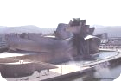
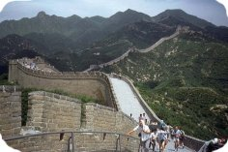
The Euskalduna
Bilbao

It is built at the site of the old Euskalduna shipyards.
The Guggenheim
Bilbao

The outside titanium walls of the building look like fish scales.
The Great Wall
China

It is 2.000 years old.
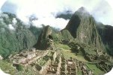
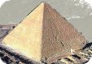
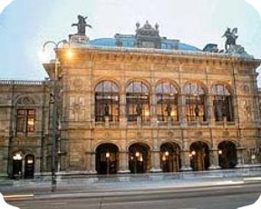
Machu Picchu
(Peru)
The blocks fit perfectly together without mortar. The joints are so tight that even the thinnest of knife blades can’t be forced between the stones.
The Great Pyramid
Egypt

It is 2.000 years old.
The Opera House
Vienna
The initial reception of their architectural concept was so negative that both architects died. Nowadays is ranked as one of the leading houses of the world.
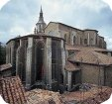
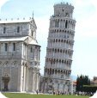
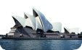
The Old Cathedral
Gasteiz
Excavations have revealed that before this stone cathedral was built on the hill where the city was started, a wooden church was built.
The Leaning Tower
Pisa

It was designed to be vertical and started to lean during its construction.
The Opera House
Sydney

Utzon, the architect, had the idea of building the roofs when he was pealing an orange.
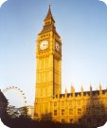
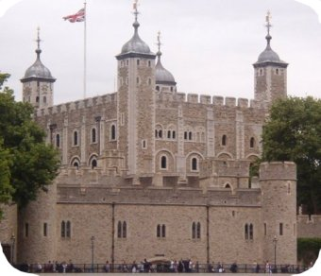
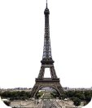
Big Ben
London
The bells rang across London for the first time on 31st May 1859, and Parliament had a special sitting to decide on a suitable name. Sir Benjamin Hall, known as "Big Ben", rose and gave a long speech on the subject. When, Sir Benjamin sank back into his seat, a wag shouted out: "Why not call him Big Ben and have done with it?" ; Big Ben had been named.
The Tower of London
England
In 1078 William of Normandy, King of England, order this tower to be built as ‘a symbol of his power, a fortress for his defence and a prison for his enemies’.
The Eiffel Tower
Paris

It is the most visited place in the world.
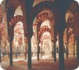
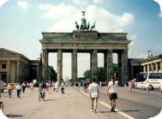
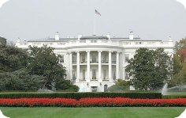
The Mosque
Cordoba

The prayer hall, 23.400 square meters, is filled with almost 500 slender columns and superimposed striped arches.
The Brandenburg Gate
Berlin

It is perforated by five passengers ways, the central one being reserved for carriages of royalty.
The White House
Washington
During the 1812 War the invading British armies burned it. James Hoban rebuilt it according to the original design, but this time the sandstone walls were painted white. In 1902, President Roosevelt made the name official.
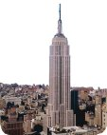
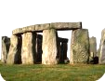
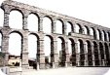
The Empire State Building
New York
It was built in one year. It has gone down in history as being one of the fastest buildings of its proportions constructed (436 m high, 365 tonnes weight, 73 elevators…).
Stonehenge
England
One legend says that it was brought by a tribe of giants from Africa to Ireland, and from there flown by the wizard Merlin across the sea.
The Roman Aqueduct
Segovia

It stands without the use of mortar or cement. Its 20.400 stone blocks are held together by gravity.
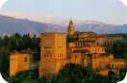
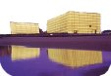
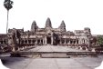
The Alhambra
Granada
It exists since the 9th Century but was declare a national monument in 1870.
The Kursaal
Donostia
Moneo, the architect, says he conceived it as ‘two gigantic rocks stranded at the mouth of the river, forming part of the landscape rather than belonging to the city’.
The Angkor Wat Temple
Cambodia
It’s the world’s largest religious centre, it’s central tower is over 64 m high. How were the huge rocks carried up to the top will probably remain a mystery forever.
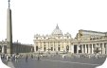
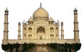
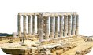
St. Peter’s Basilica
Rome
St. Peter preached his faith in Rome and established his Episcopal chair, whose successors, the bishops of Rome, have been accounted in all ages.
The Taj Mahal
India
The Shah Jehan ordered to kill the architect’s wife, for him to feel what he felt at his wife’s death and to create something gorgeous for her sake.
The Temple of Poseidon
Greece
The statue of Poseidon, a Greek god, was 5 metres high and the only remaining part of it is a foot which is 70 cm long.
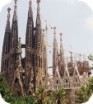
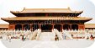
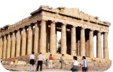
The Sagrada Familia
Barcelona
It is the unfinished masterpiece of Barcelona’s most celebrated architect Antonio Gaudí.
The Forbidden City
Beijing
It was completed in 1420 during the Ming Dynasty. It was the home of 24 emperors of the Ming and Ching dynasties.
The Parthenon
Athens

The steps were 508 mm high.
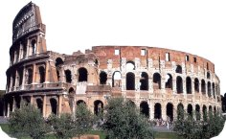
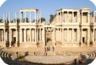
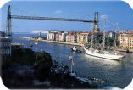
The Coliseum
Rome
It was designed to hold 50.000 spectators. It had 80 entrances so crowds could arrive and leave easily and quickly.
The Roman Theatre
Merida
The theatre can accommodate up to 6.000 people.
The Hanging Bridge
Bizkaia

First transporter bridge in the world.
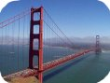
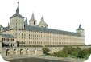
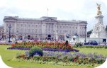
The Golden Gate
San Francisco
The bridge is commonly known as ‘The Bridge that couldn’t be built’, because before its completion in 1937, it was considered impossible to build, due to persistently foggy weather, 60-mile-per-hour and strong ocean currents.
The Escorial
Madrid
Philip II won the battle of San Quintin on the day of San Lorenzo. He wanted to show gratitude to this saint by building a monastery in his honour.
Buckingham Palace
London
The Changing of the Guard takes place daily during the summer (and every other day after the summer) in the forecourt of the Palace at 11:30 a.m.
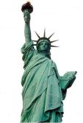
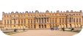
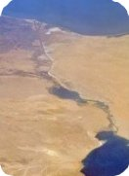
The Statue of Liberty
New York
It is the symbol of America to most people, but it was conceived a an expression of French republican ideals.
The Versailles Palace
Paris
Its fabulous gardens and park are almost as spectacular as the castle. Nowadays about eight million visitors discover this architectural and cultural masterpiece every year.
The Suez Canal
Egypt
The canal stretches over 100 miles from Port Said and the Mediterranean Sea to Suez and the Red Sea.

