Famous
Buildings
Facts

Index
Index | Page
- The Euskalduna in Bilbao | 3
- The Guggenheim in Bilbao | 3
- The Great Wall of China | 3
- Machu Picchu in Peru | 3
- The Great Pyramid in Egypt | 3
- The Opera House in Vienna | 3
- The Old Cathedral in Gasteiz | 4
- The Leaning Tower of Pisa in Italy | 4
- The Sydney Opera House in Australia | 4
- Big Ben and The Houses of Parliament in London | 4
- The Tower of London | 4
- The Eiffel Tower in Paris | 5
- The Mosque in Cordoba | 5
- The Brandenburg Gate in Berlin | 5
- The White House in Washington | 5
- The Empire State Building in New York | 5
- Stonehenge in England | 5
- The Roman Aqueduct in Segovia | 6
- The Alhambra in Granada | 6
- The Kursaal in Donostia | 6
- The Angkor Wat Temple in Cambodia | 6
- St. Peter’s Basilica in Rome | 6
- The Taj Mahal in Agra, India | 6
- The Temple of Poseidon in Greece | 7
- The Sagrada Familia in Barcelona | 7
- The Forbidden City in Beijing, China | 7
- The Parthenon in Athens | 7
- The Coliseum in Rome | 7
- The Roman Theatre in Merida | 7
- The Hanging Bridge in Bizkaia | 7
- The Golden Gate in San Francisco | 8
- The Escorial in Madrid | 8
- Buckingham Palace in London | 8
- The Statue of Liberty in New York | 8
- The Versailles Palace in Paris | 8
- The Suez Canal | 8


- The Euskalduna in Bilbao
It is built at the site of the old Euskalduna shipyards.

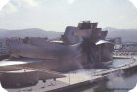
- The Guggenheim in Bilbao
The outside titanium walls of the building look like fish scales.

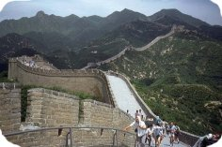
- The Great Wall of China

It is 2.000 years old.

- Machu Picchu
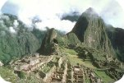
The blocks fit perfectly together without mortar. The joints are so tight that even the thinnest of knife blades can’t be forced between the stones.

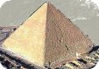
- The Great Pyramid
It is estimated to contain 2.300.000 blocks of stone. The smallest weighs 3 tons and the heaviest more than 70 tons.

- The Opera House in Vienna
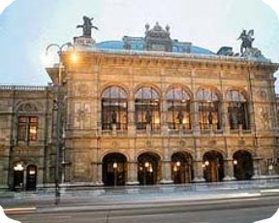
The initial reception of their architectural concept was so negative that both architects died. Nowadays is ranked as one of the leading houses of the world.

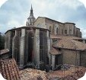
- The Old Cathedral in Gasteiz
Excavations have revealed that before this stone cathedral was built on the hill where the city was started, a wooden church was built.

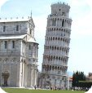
- The Leaning Tower of Pisa

It was designed to be vertical and started to lean during its construction.

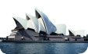
- The Sydney Opera House
Utzon, the architect, had the idea of building the roofs when he was pealing an orange.

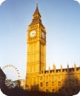
- Big Ben and The Houses of Parliament in London
The bells rang across London for the first time on 31st May 1859, and Parliament had a special sitting to decide on a suitable name. Sir Benjamin Hall, known affectionately in the House as "Big Ben", rose and gave an impressively long speech on the subject. When, Sir Benjamin sank back into his seat, a wag in the chamber shouted out: "Why not call him Big Ben and have done with it?" The house erupted in laughter; Big Ben had been named.
- The Tower of London
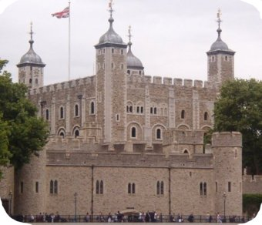
In 1078 William of Normandy, King of England, order this tower to be built as ‘a symbol of his power, a fortress for his defence and a prison for his enemies’.

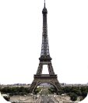
- The Eiffel Tower in Paris

It is the most visited place in the world.

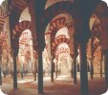
- The Mosque in Cordoba
The prayer hall, 23.400 square meters, is filled with almost 500 slender columns and superimposed striped arches.

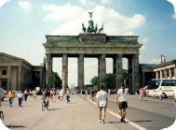
- The Brandenburg Gate
It is perforated by five passengers ways, the central one being reserved for carriages of royalty.

- The White House in Washington

During the 1812 War the invading British armies burned it. James Hoban rebuilt it according to the original design, but this time the sandstone walls were painted white. In 1902, President Roosevelt made the name official.
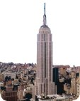
- The Empire State Building
It was built in one year. It has gone down in history as being one of the fastest buildings of its proportions constructed (436 m high, 365 tonnes weight, 73 elevators…).

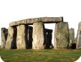
- Stonehenge
One legend says that it was brought by a tribe of giants from Africa to Ireland, and from there flown by the wizard Merlin across the sea.

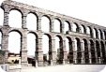
- The Roman Aqueduct in Segovia
It stands without the use of mortar or cement. Its 20.400 stone blocks are held together by gravity.

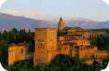
- The Alhambra in Granada
It exists since the 9th Century but was declare a national monument in 1870.

- The Kursaal in Donostia
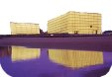
Moneo, the architect, says he conceived it as ‘two gigantic rocks stranded at the mouth of the river, forming part of the landscape rather than belonging to the city’.
- The Angkor Wat Temple
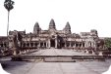
It’s the world’s largest religious centre, it’s central tower is over 64 m high. How were the huge rocks carried up to the top will probably remain a mystery forever.
- St. Peter’s Basilica in Rome
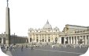
St. Peter preached his faith in Rome and established his Episcopal chair, whose successors, the bishops of Rome, have been accounted in all ages.
- The Taj Mahal

The Shah Jehan ordered to kill the architect’s wife, for him to feel what he felt at his wife’s death and to create something gorgeous for her sake.

- The Temple of Poseidon
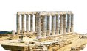
The statue of Poseidon, a Greek god, was 5 metres high and the only remaining part of it is a foot which is 70 cm long.
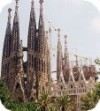
- The Sagrada Familia in Barcelona
It is the unfinished masterpiece of Barcelona’s most celebrated architect Antonio Gaudí.
- The Forbidden City in Beijing

It was completed in 1420 during the Ming Dynasty. It was the home of 24 emperors of the Ming and Ching dynasties.
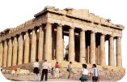
- The Parthenon in Athens

The steps were 508 mm high.

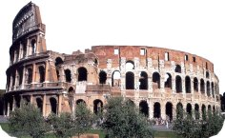
- The Coliseum in Rome
It was designed to hold 50.000 spectators. It had 80 entrances so crowds could arrive and leave easily and quickly.

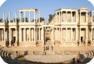
- The Roman Theatre in Merida

The theatre can accommodate up to 6.000 people.

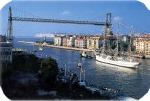
- The Hanging Bridge in Bizkaia

First transporter bridge in the world.


- The Golden Gate in San Francisco
The bridge is commonly known as ‘The Bridge that couldn’t be built’, because before its completion in 1937, it was considered impossible to build, due to persistently foggy weather, 60-mile-per-hour and strong ocean currents.
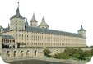
- The Escorial in Madrid
Philip II won the battle of San Quintin on the day of San Lorenzo. He wanted to show gratitude to this saint by building a monastery in his honour.

- Buckingham Palace in London
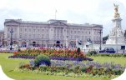
The Changing of the Guard takes place daily during the summer (and every other day after the summer) in the forecourt of the Palace at 11:30 a.m.

- The Statue of Liberty in New York

It is the symbol of America to most people, but it was conceived a an expression of French republican ideals.

- The Versailles Palace in Paris
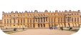
Its fabulous gardens and park are almost as spectacular as the castle. Nowadays about eight million visitors discover this architectural and cultural masterpiece every year.
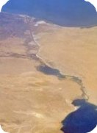
- The Suez Canal

The canal stretches over 100 miles from Port Said and the Mediterranean Sea to Suez and the Red Sea.

