SONG:
-“Kookaburra”, traditional
Kookaburra sits in the old gum tree
Merry, merry king of the bush is he
Laugh, Kookaburra! Laugh, Kookaburra!
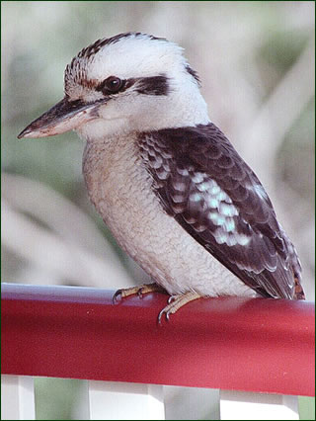
Gay your life must be!
Kookaburra sits in the old gum tree
Eating all the gum drops he can see
Stop, Kookaburra! Stop, Kookaburra!
Leave some there for me!
Kookaburra sits in the old gum tree
Counting all the monkeys he can see
Stop, Kookaburra! Stop, Kookaburra!
That's not a monkey that's me
Kookaburra sits on a rusty nail
Gets a boo-boo in his tail
Cry, Kookaburra! Cry, kookaburra!
Oh, how life can be!

(Back to the first verse)

Kookaburra sits in the old gum tree
Merry, merry king of the bush is he
Laugh, Kookaburra! Laugh, Kookaburra!
Gay your life must be!

Laugh, Kookaburra! Laugh, Kookaburra!
Gay your life must be!
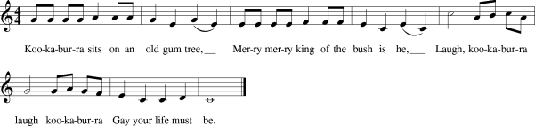
Score:

