SONG:
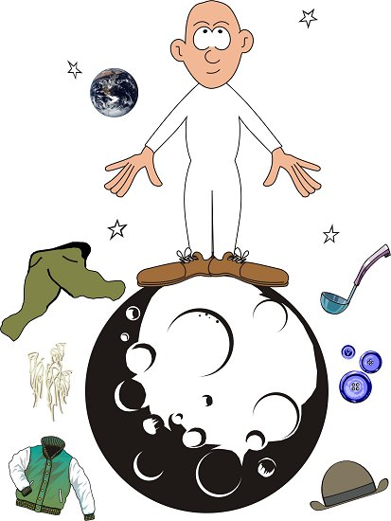
-“Aiken Drum”, traditional
There was a man lived in the moon,
lived in the moon, lived in the moon,
There was a man lived in the moon,
And his name was Aiken Drum.
(Chorus)
And he played upon a ladle,
a ladle, a ladle,
And he played upon a ladle,
And his name was Aiken Drum.
And his hat was made of good cream cheese,
good cream cheese, good cream cheese,
And his hat was made of good cream cheese,
And his name was Aiken Drum.
(Chorus)
And his coat was made of good roast beef,
good roast beef, good roast beef,
And his coat was made of good roast beef,
And his name was Aiken Drum.
(Chorus)
And his buttons were made of penny loaves,
penny loaves, penny loaves,
And his buttons were made of penny loaves,
And his name was Aiken Drum.
(Chorus)
1, 2, 3, 4 and 1, 2, 3, 4
And he played….
1, 2, 3, 4, and 1, 2, 3, 4
And he played….

