COLLABORATIVE READING

A proposal for “Eric’s talking ears”. Reading puzzle

Aims:
To foster autonomous learning strategies.
To promote group work and cooperation.
To develop reading strategies in order to understand a text.
To share information and experiences.

“Eric’s talking ears” is a short story book that consists of six chapters of about 10 pages each. It’s not long if the reader understand almost everything he or she reads, but if the understanding is not enough the reading task can become boring and non-motivating. Our proposal consists of reading the book in a cooperative way, that is, each student is going to read only one chapter and work on it. After that, there will be another two tasks to carry out in the group. The final aim is to get to understand the whole story and collaboration and autonomous work are the only way to get it.

1st step: Divide the class group in five teams. Each team is going to read a chapter. As you probably have only one storybook, they could take it home and read the assigned chapter. This can be a very long process depending on the number of students.
2nd step: Each student is going to work on a different worksheet about the chapter. These worksheets main objective is to help understanding the chapter or develop reading strategies, as well as, to promote autonomous work.
3rd step: Group work about the chapter. When all the students have already read the correspondent chapter, they will meet and present their worksheets to the others. From this task they will have to prepare how to report the main information to the rest of the group.
4th step: A spokesperson from each group has to tell the rest what his/her chapter is about.
5th step: Final task suggestions: a role-play, to prepare an ear language code and use it, to invent a sign language...
Reading Puzzle
Chapter 1.

The Little Blue Book

Order the sentences to summarise chapter 1.

Eric puts on the hat and attaches elephant’s ears.
He moves the elephant’s ears but he doesn’t know what it means.
Eric has to read the book to learn animals’ ear language.
Eric and his dad are at the zoo.
The book says that animals talk with their ears.
Eric’s dad works at the zoo.
They find animals’ ears, a little blue book and a hat in a box.

Reading Puzzle
Chapter 1.

The Little Blue Book

- Draw a circle around the right answer:
- Where are Eric and his dad?
  - At the zoo.
  - At school.
  - In Eric’s room.
- What’s Eric’s dad’s job?
  - He’s a teacher.
  - He’s a zoo keeper.
  - He’s a vet.
- What is in the box?
  - A pair of elephant ears.
  - A dictionary and plastic animals.
  - Animal ears (not real ones), a book and a hat.
- What kind of book is it?
  - A storybook.
  - A book about animals.
  - A book to understand animal ear language.
- What did dad tell Eric about the things in the box?
  - It was very useful.
  - It didn’t work. It was a crazy idea.
  - He told him to throw them away.

Reading Puzzle
Chapter 1.

The Little Blue Book

- Look for the words in the left column and match them with the ones in the right column.
- cap
- waggle
- get rid of them
- puzzled
- weird
- strange
- throw them out
- confused
- move
- hat

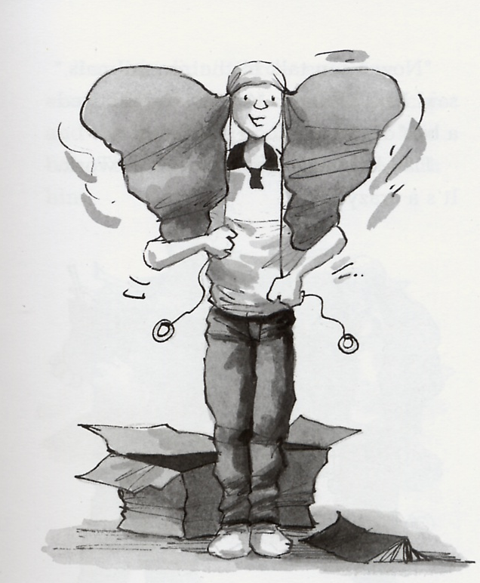

Reading Puzzle
Chapter 1.

The Little Blue Book

- Match the word with the definition.

Zoo keeper
Swimming cap
strings
Heap of them
puzzled
twitch
A thin cord made of twisted threads. It is used to tie things up.
Someone who works in a zoo feeding the animals, cleaning the cages, ...
A pile of them, a lot of them, usually in a rather untidy arrangement.
Someone who is confused
A special hat used when swimming
A quick and little movement you make with a part of your body.

Reading Puzzle
Chapter 2.

Jungle

- Order the sentences to summarise chapter 2.

Maya and Miko got very excited because Eric told them there was a jungle outside the zoo.
First, he talked to the elephants.
Then, the hyenas told jokes to Eric.
Eric secretly practised animal ear language.
It wasn’t true. It was just a park.
Finally he talked to the lion.
Afterwards, Eric talked to the gazelles.
The baby elephants ask to Eric what was outside the zoo.

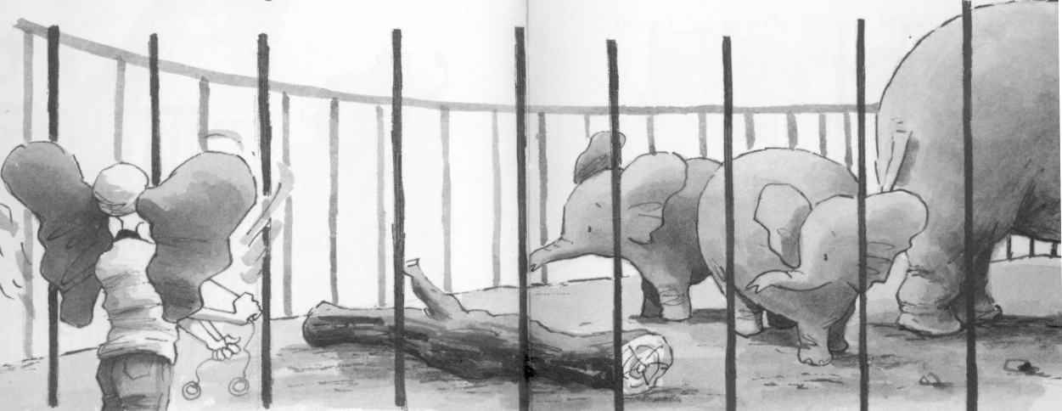

Reading Puzzle
Chapter 2.

Jungle

- Draw a circle around the right answer:

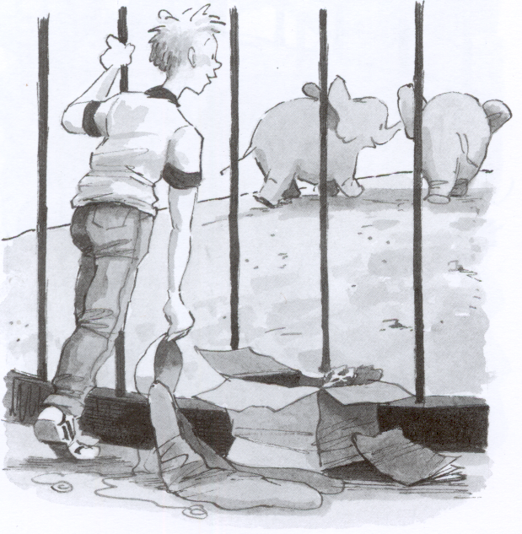

1. How long did Eric practise ear language?
a) For a whole week
b) For two hours
c) For a month
2. Why did Eric feel nervous?
a) Because animals were very big and fierce.
b) Because he had an examnation.
c) Because the lions were asleep.
3. Who did he talk to first?
a) To the giraffes.
b) To the polar bears.
c) to the elephants.
4. What were the baby elephants called?
a) Baby and Nothing.
b) Maya and Miko.
c) Eric and Dad.
5. What did Eric tell the baby elephants?
a) There was a park outside the big gates.
b) There was a forest outside the big gates.
c) There was a jungle outside the big gates.

Reading Puzzle
Chapter 2.

Jungle

- Look for the words in the left column that match with the ones in the right column.

- scary
- haughty
- fence
- wonderful
- small
- barrier
- fierce
- proud
- tiny
- fantastic, lovely

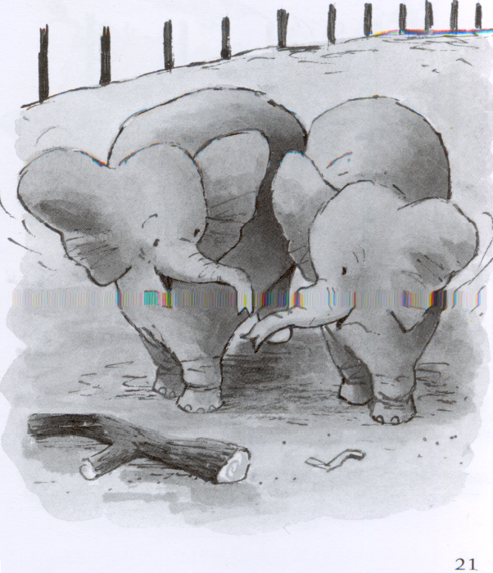

Reading Puzzle
Chapter 2.

Jungle

- Number the animals as they appear in this chapter:

Hyenas
Lion
Giraffes
Gazelles
Polar bears
Elephants

- Draw a circle around the ones Eric talked to.

