Beatles
When I'm Sixty-Four (audio)

When I get older losing my hair,
Many years from now.
Will you still be sending me a valentine
Birthday greetings bottle of wine.
If I'd been out till quarter to three
Would you lock the door,
Will you still need me, will you still feed me,
When I'm sixty-four.
You'll be older too,
And it you say the word,
I could stay with you.
I could be handy, mending a fuse
When your lights have gone.
You can knit a sweater by the fireside
Sunday mornings go for a ride,
Doing the garden, digging the weeds,
Who could ask for more.
Will you still need me, will you still feed me,
When I'm sixty-four.
Every summer we can rent a cottage,
In the Isle of Wight, if it's not too dear
We shall scrimp and save
Grandchildren on your knee
Vera Chuck & Dave
Send me a postcard, drop me a line,
Stating point of view
Indicate precisely what you mean to say
Yours sincerely, wasting away
Give me your answer, fill in a form
Mine for evermore
Will you still need me, will you still feed me,
When I'm sixty-four.
Boa Constrictor (audio)
I’m being swallowed by a boa constrictor
I’m being swallowed by a boa constrictor
I’m being swallowed by a boa constrictor
And I don’t like it very much!

Oh no, oh no, he swallowed my toe,
He swallowed my toe
Oh gee, oh gee, he’s up to my knee,
He’s up to my knee
Oh fiddle, oh fiddle, he’s reached my middle,
He’s reached my middle
Oh heck, oh heck, he’s up to my neck,
He’s up to my neck
Oh dread, oh dread, he swallowed my.... schlirppp!

I'm being swallowed by a boa constrictor
I'm being swallowed by a boa constrictor
I'm being swallowed by a boa constrictor
And I don't like it very much
Oh no (oh no) he swallowed my toe (he swallowed my toe)
Oh me (oh me) he swallowed my knee (he swallowed my knee)
Oh fiddle (oh fiddle) he's up to my middle (he's up to my middle)
Oh heck (oh heck) he swallowed my neck (he swallowed my neck)
Oh - (GULP!)

From Where the Sidewalk Ends
by Shel Silverstein
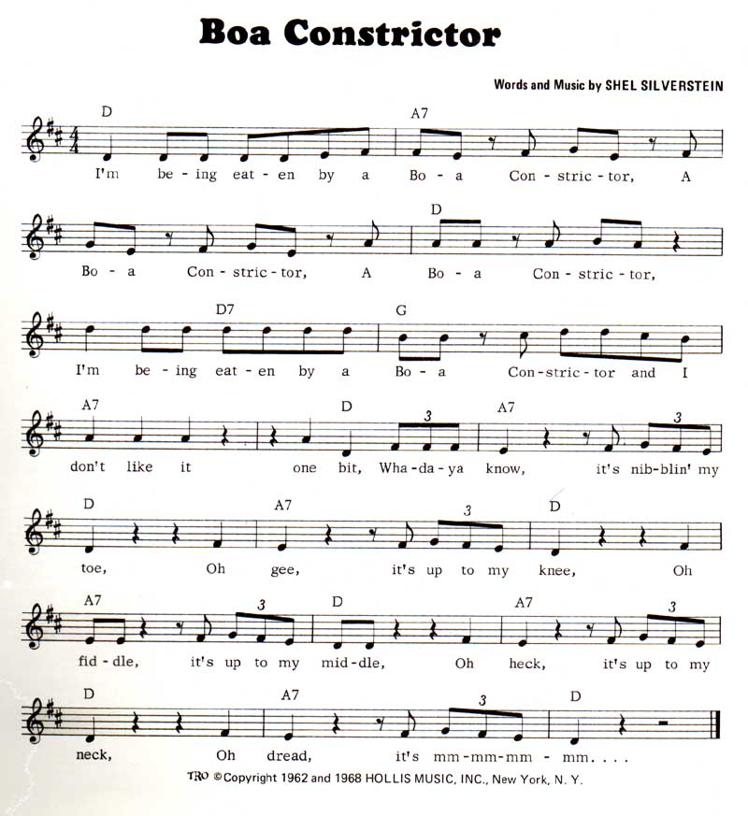
Only Sixteen (audio)

She was only sixteen, only sixteen
I loved her so
But she was too young to fall in love
And I was too young to know
We'd laugh and we'd sing
and do the little things
That made my heart glow
But she was too young to fall in love
And I was too young to know
Why did I give my heart so fast
it never will happen again
But I was a mere lad of sixteen
I've aged a year since then
She was only sixteen, only sixteen
with eyes that would glow
But she was too young to fall in love
and I was too young to know
(Then why did you give your heart so fast)
Biy, it never will happen again
(But you were a mere lad of sixteen)
Oh, I've aged a year since then
She was only sixteen, only sixteen
With eyes that would glow
But she was too young to fall in love
And I was too young to know
She was too young to fall in love
And I was too young to know.

Written by Sam Cooke, 1959
Barbara Campbell is the registered author to avoid having Specialty Records make the money for the song.
Published By: Ardmore & Beechwood Ltd.
Time: 1:54
Info: It was probably written in Lou Rawls' parents' apartment in Chicago, maybe about Rawls' stepsister Marian, who turned sixteen in 1959 (source: You Send Me book
- Peter Guralnick in the booklet for the CD Portrait Of A Legend says it was meant for Rawls' stepsister Eunice!
- The song was originally intened for a teenage actor named Steve Rowland, a friend of Ricky Nelson whose father was a B-movie director. The produced didnt like it so Sam recorded it himself (Portrait Of A Legend)
- Sam used the bridge for this song from Little things you do (Portrait Of A Legend)
Instruments:
Guitar, background vocals, drums, bass

Only Sixteen (Activity)

Before listening to the song

Read the lyrics of the song and complete the summary of the story with the words in the boxes:

love
one
friends

young
girl
boy
sixteen

love

This story happened ……….. year ago when the boy was …………. years old. He fell in ……….. with a sixteen-year-old ……….. They were good ………. but she didn’t love him.
Now the ………. thinks that she didn’t love him because she was very ……….. but a year ago he was also very young and he didn’t understand that. Now he thinks he won’t fall in ……….. so quickly .

Wonderful World (audio)
Don't know much about history
Don't know much biology
Don't know much about a science book
Don't know much about the French I took
But I do know that I love you
And I know that if you love me too
What a wonderful world this would be
Don't know much about geography
Don't know much trigonometry
Don't know much about algebra
Don't know what a slide rule is for
But I do know one and one is two
And if this one could be with you
What a wonderful world this would be
Now I don't claim, to be an A-student
But I'm trying to be
For maybe by being an A-student, baby
I could win your love for me
{repeat first two blocks)

Written by: Sam Cooke, Lou Adler, Herb Alpert
Time: 2:02
Musicians:
Bass: Adolphus Asbrook
Guitar: Cliff White
Second Vocalist: Lou Rawls
Drummer: Unknown
Engineer: Deano Lappas
Information
* Re-released for a Levi's Commercial in 1986
* Opening tune for Dutch TV Quiz 'Heraxamen'

Wonderful World (Activity)

Before listening to the song:

Read the lyrics of the song and draw a tick  in the right box. Underline the words in the song that justify your choice.

The singer is a good student | True | False
The singer is in love

The singer knows that the other person loves him too

The singer is very happy because the other person loves him too

The singer thinks that he will be very happy if the other person loves him

The singer is ready to study more to win her lover’s love

After listening to the song

Did you like the song?
------------------------------------------------------------------------------------

Write down something you have got in common with the singer

-------------------------------------------------------------------------------------

According to the song, an A-student is a very good student or a very bad one?
-------------------------------------------------------------------------------------

What are your favourite subjects?

-------------------------------------------------------------------------------------

