SENET
Number of players: 2 | Origins Egypt, 3000 BC
Time Required: 5 - 10 minutes  Objective  To be the first player to throw all his or her tokens off the board | Equipment:  1 x Senet board,  5 x Black tokens,  5 x White tokens

RULES
The Beginning:
- Play starts with an empty board. There are 10 squares across and only three squares down.
- Each player spins until one player scores a 4 or a 6, then the player enters a token on square 4 or 6 accordingly.
- Tokens enter the board at top left, follow in a zig-zag pattern towards the last square on the board, and then fall out of the board.
- A player may enter any piece waiting to enter the board, but is not required to do so if another move is possible.
Moves:
- Spinning a 6 gives an extra spin.
- Only one token is permitted to occupy a given square.
There are three special squares on the board:
1. The central 'Power and Life' square - A token that lands here is safe, temporarily, it cannot be thrown off the board.
2. The 'Good' square - landing here gives an extra throw.
3. The 'Water' square - the token is removed from the board start again, end of current turn.
- Falling off - this is only possible if the correct number is spun to remove you from the board. It gives an additional turn.

Captures:
- If a player moves a token onto a square occupied by an opponent, then the opponent’s token is removed from the board, and must be re-entered the normal way.
The End:
- The winner is the first player to get all tokens off the board.
Scoring:
- Keep a record of the number of games won/lost.
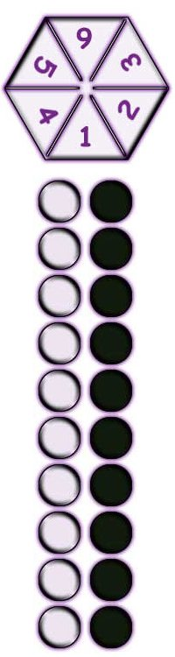
More detailed instructions for teachers.

The Beginning:
Play starts with an empty board, set the board out so that there are 10 squares across and only three squares down. Each player spins until one player scores a 4 or a 6, then the player enters a token on square 4 or 6 accordingly.
Tokens enter the board at top left, follow the hands in a zig-zag pattern progressing towards the last square on the board, and then bear off. A player may enter any piece waiting to enter the board, but is not required to do so if another move is possible.
Moves:
Spinning a 6 gives an extra spin. If a player has a legal move, it must be made. Only one token is permitted to occupy a given square.
There are three special squares on the board:
1. The central 'Power and Life' square - A token that lands here is safe, temporarily, it cannot be thrown off the board.
2. The 'Good' square - landing here gives an extra throw.
3. The 'Water' square - the token is removed from the board start again, end of current turn.
Bearing off - this only possible if the correct number is spun to remove you from the board. Once a token has completed the board it takes no further part in the game, but bearing off does qualify for an additional turn. (The 3rd square from the end indicates that a 3 is required to bear off, the next square a 2).
Captures:
If a player moves a token onto a square occupied by an opponent, then the opponents token is removed from the board, and must be re-entered the normal way.
The End:
The winner is the first player to bear off all tokens from the board.
Scoring:
Keep a record of the number of games won/lost.

