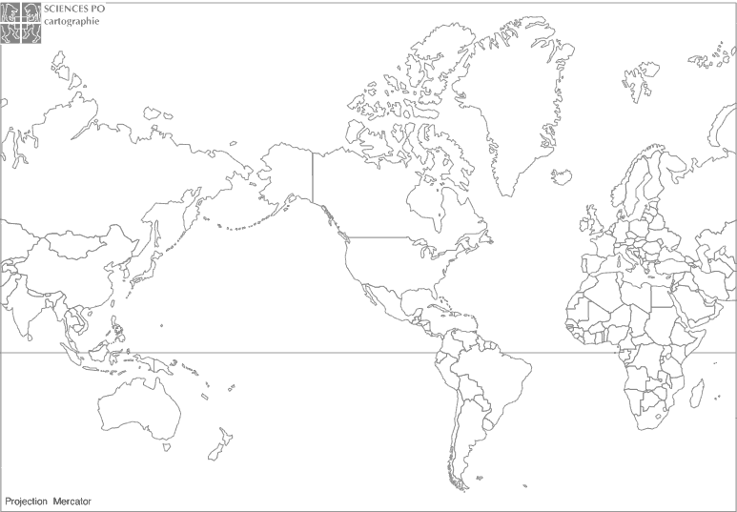
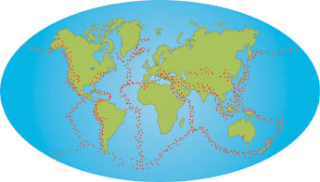
Red dots mark the places where earthquakes and volcanic eruptions are more likely to occur.

