Activity 1: Matching words and pictures

(Small group)

Match the list of words with what you think it is the most appropriate image. Check your guess with other groups.
Some pictures can be matched with different words so there might be more than one answer

Balanced diet

Stamina

Strength

Calorie

Carbohydrates

Fats

Fibre

Minerals

Proteins

Vitamins

Acne

Bacteria

Puberty

Period

Fertilisation

Sweat

Abuse

Bullying

Drug abuse

Peer pressure

Addict

Depression

Overdose

Self-esteem

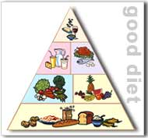
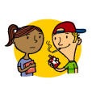
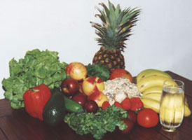
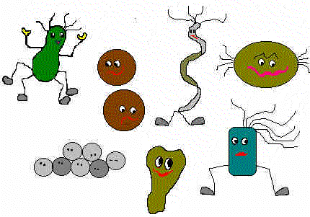
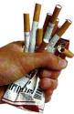

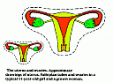
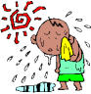

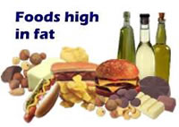
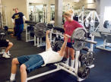
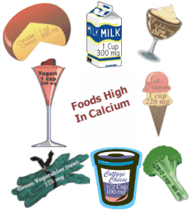
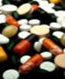
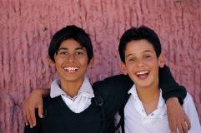
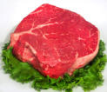
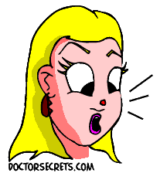
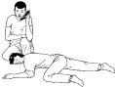

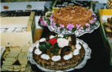
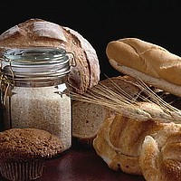
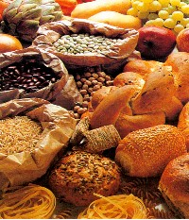
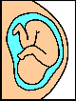
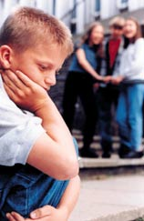
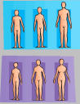
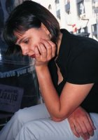
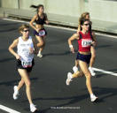

Activity 2. - INFORMATION GAP

Divide the class in 4 groups of 2 or 3 pairs each. Proceed to assign letter A and B to each member of the pair. Give each group the corresponding set of information gap handout. Work in pairs to complete the task. Then in the same group As and Bs meet to check their answers.
Then students meet in fours, so the group is formed with someone from A1, A2, A3 and A4 and some others with B1, B2, B3 and B4 and proceed to complete the whole glossary.
Notice that those in A threes will have the previous B version and vice versa.
Information gap – Pair work
SET 1 – STUDENT A
Balanced ____ | A diet that contains all the foods we need for a healthy body in the right proportions.
Strength | The amount of force ______ can produce
_________ | A measure of the energy in food. We need __ ___ a certain amount of calories per day depending on our size and level of activity.
Carbohydrates | Substances found in foods such as bread and ______, which are the body’s main source of energy
_______ | Substances that supply the body with energy and help to keep it warm
Minerals | Over __ substances, including iron and _______, needed in a person’s diet to maintain good health
Information Gap – Pair work
SET 1 – STUDENT B
Balanced diet | A diet that contains all the ____ we need for a healthy ___ in the right proportions.
Strength | The amount of force muscles can _________
Calorie | A measure of the energy in food. We need to eat a certain amount of calories ___ ____ depending on our size and level of activity.
Carbohydrates | Substances found in foods such as bread and pasta, which are the body’s main source of ________
Fats | Substances that supply the body with _____ and help to keep it warm
___________ | Over 20 substances, including iron and calcium, needed in a person’s diet to maintain _____ health

Information gap – Pair work
Set 2 – STUDENT A
___________ | Substances used by the body for growth and repair and mainly found in _______
Vitamins | Over __ substances, including vitamins B and C, needed in small amounts in a person’s diet
Acne | Masses of __, inflamed spots on the ____. Often appears during puberty
Bacteria | _________ life forms. Some are harmful to us and some keep us healthy
Fertilisation | Fusion of ____ and female sex cells from different _________ of the same species to form a new being.
Abuse | Hurting _______ by words or actions which make them feel unhappy or distressed.
Information gap – Pair work
Set 2 – STUDENT B
Proteins | _______ used by the _____ for growth and repair and mainly found in meat
__________ | Over 13 substances, including vitamins __ and __, needed in small amounts in a person’s diet
Acne | Masses of red, inflamed spots on the skin. Often appears during _______
Bacteria | Microscopic life forms. ______ are harmful to us and some keep us healthy
Fertilisation | Fusion of male and ______ sex cells from different individuals of the same species to form a _____ being.
Abuse | Hurting someone by words or actions which make them feel _________ or distressed.

Information gap – Pair work
Set 3 – STUDENT A
__________ | Bullying is something that someone does on purpose to hurt you. Sometimes it's the same thing done over and over ______, but sometimes it's a lot of small things that build up so that it _____ the way you live your life.
Drug abuse | Using ____ drugs such as cannabis, heroin or cocaine for recreational purposes.
Peer ______ | When friends the same age as us try to make us do __________ or behave in a certain way
Depression | A mental _______ when someone feels sad and uninterested in life
Overdose | When __ ____ of a drug, is taken, perhaps because is too pure. It can lead to death.
___________ | The period of a _______ life when their body is sexually maturing
Information gap – Pair work
Set 3 – STUDENT B
Bullying | Bullying is ________ that someone does on purpose to hurt ____. Sometimes it's the same thing done over and over again, but sometimes it's a lot of ____ things that build up so that it affects the way you live your life.
Drug _______ | Using illegal drugs such as cannabis, heroin or cocaine for recreational purposes.
Peer pressure | When ______ the same age as us try to make us do something or behave in a certain ____
____________ | A mental condition when someone feels sad and uninterested in life
Overdose | When too much of a drug, is taken, perhaps because is too ___. It can lead to death.
Puberty | The period of a person’s life when their _______ is sexually maturing

Information gap – Pair work
Set 4 – STUDENT A

Stamina | The ability to ________ a physical activity for a long period of time
Fibre | A substance found in _______ foods that helps the body’s ________ and intestinal movements.
Period | Shedding of the lining of the uterus, roughly every __ days if fertilisation has not occurred. Also called menstruation
Sweat | Salty ______ emitted by the skin to help lower body temperature
Addict | Someone who feels a physical or ______ need to do something, such as taking drugs
____-esteem | It is ___ we think and feel about ourselves. We are not born with self-esteem- it is something we develop as we grow older.

Information gap – Pair work
Set 4 – STUDENT B

Stamina | The ability to perform a physical activity for a long period of _____
_________ | A substance found in vegetable foods that helps the body’s digestion and ______________ movements.
_________ | Shedding of the lining of the uterus, roughly every 28 days if fertilisation has not occurred. Also called _____________
Sweat | Salty liquid emitted by the skin to help lower body ___________
Addict | Someone who feels a physical or mental need to do something, such as _______ drugs
Self-esteem | It is how we think and feel about ________. We are not born with self-esteem- it is something we develop as we grow ______.

Balanced ____ | A diet that contains all the foods we need for a healthy body in the right proportions.
Stamina | The ability to ________ a physical activity for a long period of time
Strength | The amount of force ________ can produce
_________ | A measure of the energy in food. We need __ ___ a certain amount of calories per day depending on our size and level of activity.
Carbohydrates | Substances found in foods such as bread and ______, which are the body’s main source of energy
_______ | Substances that supply the body with energy and help to keep it warm
Fibre | A substance found in _______ foods that helps the body’s ________ and intestinal movements.
Minerals | Over __ substances, including iron and _____, needed in a person’s diet to maintain good health
___________ | Substances used by the body for growth and repair and mainly found in _______
Vitamins | Over __ substances, including vitamins B and C, needed in small amounts in a person’s diet
Acne | Masses of __, inflamed spots on the ____. Often appears during puberty
Bacteria | _________ life forms. Some are harmful to us and some keep us healthy
___________ | The period of a _______ life when their body is sexually maturing
Period | Shedding of the lining of the uterus, roughly every __ days if fertilisation has not occurred. Also called menstruation
Fertilisation | Fusion of ____ and female sex cells from different _________ of the same species to form a new being.
Sweat | Salty ______ emitted by the skin to help lower body temperature
Abuse | Hurting _______ by words or actions which make them feel unhappy or distressed.
__________ | Bullying is something that someone does on purpose to hurt you. Sometimes it's the same thing done over and over _______, but sometimes it's a lot of small things that build up so that it ______ the way you live your life.
Drug abuse | Using ____ drugs such as cannabis, heroin or cocaine for recreational purposes.
Peer ______ | When friends the same age as us try to make us do __________ or behave in a certain way
Addict | Someone who feels a physical or ______ need to do something, such as taking drugs
Depression | A mental ________ when someone feels sad and uninterested in life
Overdose | When __ ____ of a drug, is taken, perhaps because is too pure. It can lead to death.
____-esteem | It is ___ we think and feel about ourselves. We are not born with self-esteem- it is something we develop as we grow older.
Find two partners with different B set numbers. Share information to complete this glossary
Find two partners with different A set numbers. Share information to complete this glossary
Balanced diet | A diet that contains all the ____ we need for a healthy ___ in the right proportions.
Stamina | The ability to perform a physical activity for a long period of _____
Strength | The amount of force muscles can _________
Calorie | A measure of the energy in food. We need to eat a certain amount of calories ___ ____ depending on our size and level of activity.
Carbohydrates | Substances found in foods such as bread and pasta, which are the body’s main source of ________
Fats | Substances that supply the body with _____ and help to keep it warm
_________ | A substance found in vegetable foods that helps the body’s digestion and __________ movements.
___________ | Over 20 substances, including iron and calcium, needed in a person’s diet to maintain _____ health
Proteins | _______ used by the _____ for growth and repair and mainly found in meat
__________ | Over 13 substances, including vitamins __ and __, needed in small amounts in a person’s diet
Acne | Masses of red, inflamed spots on the skin. Often appears during _______
Bacteria | Microscopic life forms. ______ are harmful to us and some keep us healthy
Puberty | The period of a person’s life when their _______ is sexually maturing
_________ | Shedding of the lining of the uterus, roughly every 28 days if fertilisation has not occurred. Also called _____________
Fertilisation | Fusion of male and ______ sex cells from different individuals of the same species to form a ____ being.
Sweat | Salty liquid emitted by the skin to help lower body _____________
Abuse | Hurting someone by words or actions which make them feel _________ or distressed.
Bullying | Bullying is ________ that someone does on purpose to hurt ____. Sometimes it's the same thing done over and over again, but sometimes it's a lot of ____ things that build up so that it affects the way you live your life.
Drug _______ | Using illegal drugs such as cannabis, heroin or cocaine for recreational purposes.
Peer pressure | When ______ the same age as us try to make us do something or behave in a certain ____
Addict | Someone who feels a physical or mental need to do something, such as _______ drugs
____________ | A mental condition when someone feels sad and uninterested in life
Overdose | When too much of a drug, is taken, perhaps because is too ___. It can lead to death.
Self-esteem | It is how we think and feel about _________. We are not born with self-esteem- it is something we develop as we grow ______.

Activity 3. - Glossary loop
Cut strips and give one to each student. All the strips should be distributed for the activity to work, so if there are any spare ones, give students more than one if needed.
Any student at random reads aloud slowly the definition on the right hand side box of the strip. The student who has got the word matching the definition, located in the left hand side box says it aloud and if correct, reads then the definition on the right hand side box. Proceed until the loop is completed. Do it again as revision and to correct pronunciation.

Balanced diet | It is how we think and feel about ourselves. We are not born with self-esteem- it is something we develop as we grow older.
Stamina | A diet that contains all the foods we need for a healthy body in the right proportions.
Strength | The ability to perform a physical activity for a long period of time
Calorie | The amount of force muscles can produce
Carbohydrates | A measure of the energy in food. We need to eat a certain amount of calories per day depending on our size and level of activity.
Fats | Substances found in foods such as bread and pasta, which are the body’s main source of energy
Fibre | Substances that supply the body with energy and help to keep it warm
Minerals | A substance found in vegetable foods that helps the body’s digestion and intestinal movements.
Proteins | Over 20 substances, including iron and calcium, needed in a person’s diet to maintain good health
Vitamins | Substances used by the body for growth and repair and mainly found in meat
Acne | Over 13 substances, including vitamins B and C, needed in small amounts in a person’s diet
Bacteria | Masses of red, inflamed spots on the skin. Often appears during puberty
Puberty | Microscopic life forms. Some are harmful to us and some keep us healthy
GLOSSARY LOOP
Period | The period of a person’s life when their body is sexually maturing
Fertilisation | Shedding of the lining of the uterus, roughly every 28 days if fertilisation has not occurred. Also called menstruation
Sweat | Fusion of male and female sex cells from different individuals of the same species to form a new being.
Abuse | Salty liquid emitted by the skin to help lower body temperature
Bullying | Hurting someone by words or actions which make them feel unhappy or distressed.
Drug abuse | Bullying is something that someone does on purpose to hurt you. Sometimes it's the same thing done over and over again, but sometimes it's a lot of small things that build up so that it affects the way you live your life.
Peer pressure | Using illegal drugs such as cannabis, heroin or cocaine for recreational purposes.
Addict | When friends the same age as us try to make us do something or behave in a certain way
Depression | Someone who feels a physical or mental need to do something, such as taking drugs
Overdose | A mental condition when someone feels sad and uninterested in life
Self-esteem | When too much of a drug, is taken, perhaps because is too pure. It can lead to death.

