

The Muses were the nine ancient Greek godesses who presided over the Arts and Sciences.
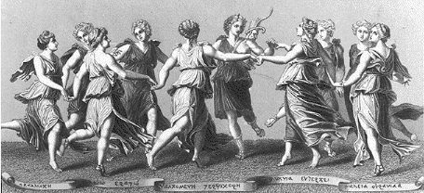

They were believed to inspire all artists, especially poets, philosophers, and musicians. The Muses were the daughters of Zeus, the supreme Greek God, and Mnemosyne, the godess of memory.
They had 9 daughters, the Muses : Calliope, Clio, Erato, Euterpe, Melpomene, Polyhymia, Terpsichore, Thalia and Urania.

The Muses were venerated throughout Greece, but more so in those areas with many water wells, springs and fountains.

The Muses sat near the throne of Zeus, king of the gods, and sang of his greatness and of the origin of the world and its inhabitants and the glorious deeds of the great heroes. From their name, Muses, words such as music, museum and mosaic are derived.

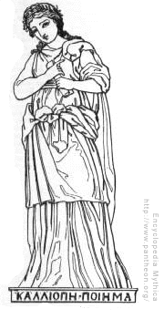
ΚΑΛΛΙΟΠΕ
(CALLIOPE)

The eldest and most distinguished of the nine Muses.
She is the Muse of eloquence and epic or heroic poetry.
Calliope , meaning “beautiful voice", is the mother of Orpheus , god of dreams, by the god Apollo.
She was the arbitress in the argument over the beautiful Adonis between Persephone and Aphrodite.
Her emblems are a stylus and wax tablets.

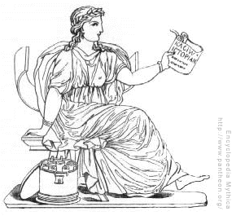
ΚΛΙΟ

(CLIO)
(CLIO)

The Muse of historical and heroic poetry.
With Pierus, the king of Macedonia, she is the mother of Hyacinth, prince of Sparta.
She was credited for introducing the Phoenician alphabet into Greece.
Her attribute is usually a parchment scroll or a set of tablets.

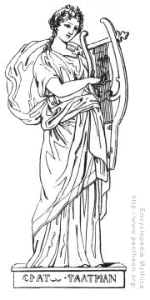
ΕΡΑΤΟ

(Erato)

The Muse of lyric poetry, particularly love and erotic poetry, and mimicry.
She is usually depicted with a lyre.

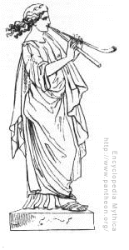

ΕΥΤΕΡΠΕ

(Euterpe)

Euterpe, from the Greek world for culture, is one of the nine Muses.

Her name means "rejoicing well" or "delight".

Euterpe is the Muse of music and lyric poetry. She is also the Muse of joy and pleasure and of flute playing and was thought to have invented the double flute, which is her attribute.

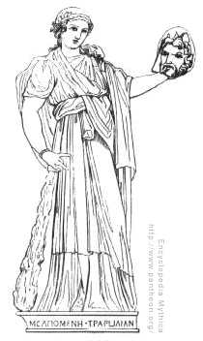
ΜΕΛΠΟΜΕΝΕ
(Melpomene)

The Muse of tragedy.

She is usually represented with a tragic mask and wearing the cothurnus (the boots traditionally worn by tragic actors).

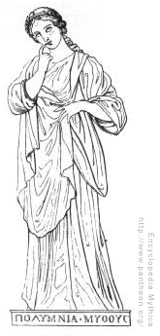
Sometimes she holds a knife or a club in one hand, and the mask in the other.
ΠΟΛΨΗΨΜΝΙΑ
(Polyhymnia)

Polyhymnia is the Greek Muse of the sacred hymn, eloquence and dance.
She is usually represented in a pensive or meditating position.
She is a serious looking woman, dressed in a long cloak and resting with an elbow on a pillar.
Sometimes she holds a finger to her mouth.

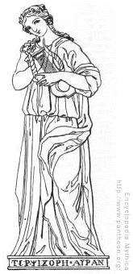
ΤΕΡΠΣΙΧΗΟΡΕ
(Terpsichore)

One of the nine Muses of ancient Greece. Terpsichore is the Muse of dancing and the dramatic chorus. Hence the word terpsichorean, pertaining to dance.

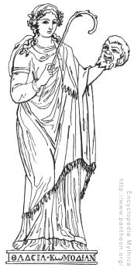
She is usually represented seated, and holding a lyre. According to some traditions, she is the mother of the Sirens with the river-god Achelous.

ΤΗΑΛΙΑ
(Thalia)

The Muse who presided over comedy and pastoral poetry.
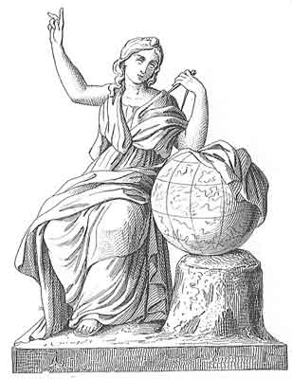
She also favored rural pursuits and is represented holding a comic mask and a shepherd's crook (her attributes).
ΥΡΑΝΙΑ
(Urania)

The Greek Muse of astronomy and astrology.
She is represented with a globe in her left hand and a peg in her right hand.
Urania is dressed in a cloak embroidered with stars and she keeps her eyes towards the sky.
Tasks

Notes for the teacher
You can exploit this materials doing different types of tasks:
1.- Reading and writing tasks
- Reading the texts and writing a modern version of the muses complete with drawings of how nowadays muses would look like
- Shadow and running dictations
- Filling the gaps activities with students A and B and erasing some words from the texts.
2.- Subject linked tasks
- The Greek alphabet: eliciting the different letters from the alphabet and trying to complete it.
- Working with the Greek text:
  - Trying to identify words from the text in Greek that have similar ones in English/Spanish or Basque (ánthrōpoi, gennioúntai , eleútheroi, logiko, pneúma)
  - Trying to infer their meaning looking at the translation
Ánthrōpoi- human beings
Gennioúntai- are born
Eleútheroi- free
Logiko-reasonable thinking, reason
Pneúma- spirit
- Which text is this?
Article 1 of the Universal Declaration of Human Rights
- Researching more about the Muses and Classical mythology in general

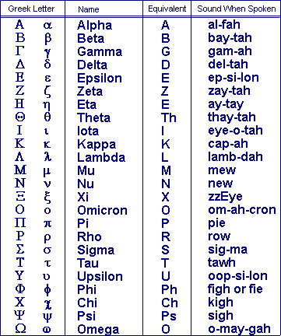
Sample text in Greek

Transliteration to our latin alphabet
Óloi oi ánthrōpoi gennioúntai eleútheroi kai ísoi stēn axioprépeia kai ta dikaimata. Eínai proikisménoi me logiko kai syneídēsē, kai ofeíloun na symperiférontai metaxý tous me pneúma adelfosýnēs.

Translation into English

All human beings are born free and equal in dignity and rights. They are endowed with reason and conscience and should act towards one another in a spirit of brotherhood.

(Article 1 of the Universal Declaration of Human Rights)

