Discovering my talents

UNIT 2

Become an artist

Evaluation Appendix


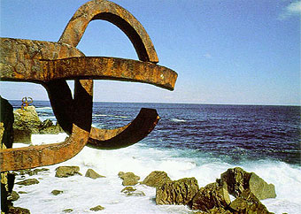
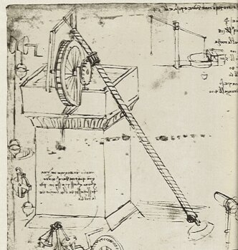
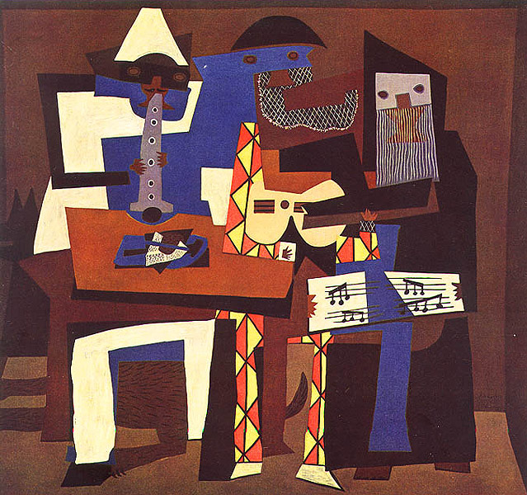

Objectives of the unit

- To understand that the concept of Art is a broad and flexible one and also an expression of human creativity and genius.

- To reflect upon and work on the features of Art and the process to create a piece of Art

- To be able to produce different types of texts, such as process descriptions, reports, and justifications as well as to be able to use techniques such as graphs and charts.

- To be able to get information from sources in English, written and audiovisual and/or on-line.

- To be able to carry out classroom interactions in English, leading to the completion of the required tasks.

- To be able to present both orally and in written form the outcomes of the final products assigned.

7.- To be able to develop critical judgment about my own and others performance.

Unit 2 Become an artist

SUBJECT, LINGUISTIC & EDUCATIONAL OBJECTIVES
SubjectObjectives: Art & Technology | Language Objectives
1.- To understand that the concept of Art is a broad and flexible one and also an expression of human creativity and genius.  Activities 1,2, 3, 4, 7,9 | 3.- To be able to produce different types of texts, such as process descriptions, reports, and justifications as well as to be able to use techniques such as graphs and charts.  Activities 1, 2,4,5,6,7,9
2.- To reflect upon and work on the features of Art and the process to create a piece of Art  Activities 2, 4,5,6,7,9 | 4.- To be able to get information from sources in English, written and audiovisual and/or on-line.  Activities 2,3,4,5,6,7,9
5.- To be able to carry out classroom interactions in English, leading to the completion of the required tasks.
Activities 1,2,3,4,5,6,7,8,9
6.- To be able to present both orally and in written form the outcomes of the final products assigned.
Activity 1,2,4,5,6,7,8,9
Attitudinal and/or educational objective
7.- To be able to develop critical judgment about my own and others performance.
Activity 7,8

Unit 3 Famous Europeans

SUBJECT & LINGUISTIC CONTENT
Subject content | Language content
General overview of the History of Art across times and continents  - Difference between Art & technology  - The creative process | - Core vocabulary: nouns, verbs & adjectives related to the topic  - Texts:  - Descriptive texts: description of an object, description of a process.  - Argumentative texts: justifying a choice  - Tenses: revision of the past tenses, the passive voice

SKILLS CONTENT
- Predicting information
- Getting the gist of both aural text and written texts
- Selecting the required information from both oral, written and audiovisual texts
- Building texts using the required language
- Transferring information from one type of text to another one
- Drawing conclusions
- To use the acquired learning in new and personal situations
- Presenting orally tasks and conclusions

Secondary 1 Europeans Unit 3 : Famous Europeans
NAME | 1. Follows teacher’s instructions | 2. Gets the gist of oral / written and audiovisual texts | 3. - Selects the required information fromriten and audiovisual texts | 4. Shares the information he/she gets. | 5. Buildis texts using the required language | 6. – Transfers information from one type of text to another one | 7. - Uses the dictionary properly. | 8. - Uses classroom interaction language appropriately. | 9.- Presents orally tasks and conclusions

OBJECTIVE:

ACTIVITIES:

CONTENT:
SUBJECT | LANGUAGE | SKILLS

SS

PERFORMANCE

SUBJECT | LANGUAGE | SKILLS

Objective achieved:
Yes Partially(minimum) No

