Discovering my talents

UNIT 2

Become an artist

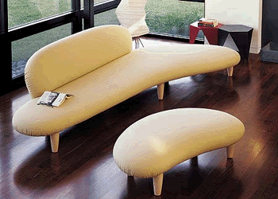
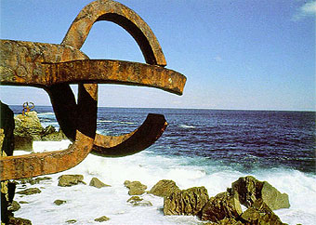
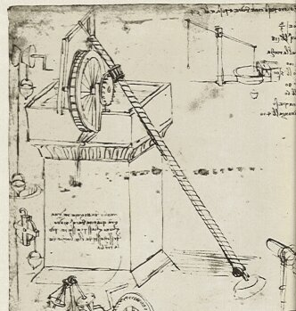
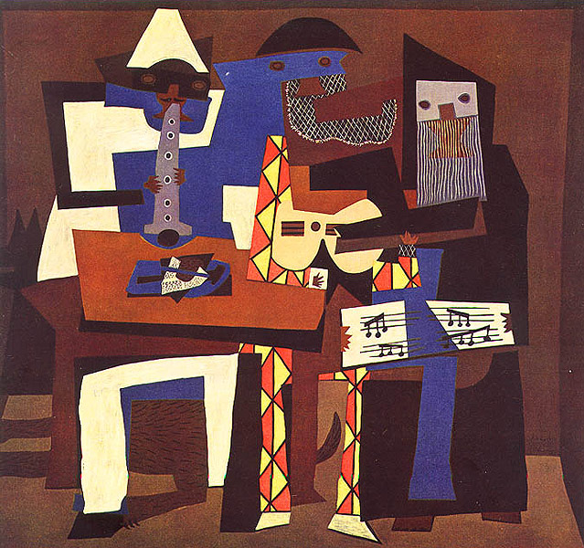

INDEX

Introduction to Unit 2

Page
About this Unit 3
General Aims and Final Products 3
Objectives 4
Map of Activities 4
List of Handouts 5
List of Appendices 6
Description of the activities 7-15

Sequence of Activities Page
Act 1: Art & Artifacts 7
Act 2: Objectography 8
Act 3: The Wrong Trousers 9
Act 4: Art, Artists & Technology 10
Act 5: The Design Process 11
Act 6: Designing your own artifact 12
Act 7: Evaluating your design 13
Act 8: Our own Art Auction 14
Act 9: My favourite piece of Art 15

Introduction

About this unit

Become an artist is a unit of sequenced activities intended to last for one term.
This unit consists of 9 separate activities, representing different stages and functions of the general learning process:
- Finding out previous knowledge about the topic
- Fostering learner motivation
- Exposing learners to new knowledge
- Researching information
- Integrating learning
Every activity comprises a series of tasks or sub-activities. These tasks and sub-tasks are not equal in depth and length and are designed to deal with the proposed subject content and language skills.
These activities are linked in a progressive sequence towards the completion of a final product, which is shared by the whole group, cooperatively accomplished and rich enough to incorporate the work and learning developed through a given period of time.
The last activity is always an individual assessment proposal where learners have to show the progress made in both subject and language content.

General Aims

- To motivate students to learn in English.
- To understand that Art is the product of human creativity and an expression of beauty.
- To reflect on issues with regard to Art:
- What is Art?
- The use of Art
- Art, Design & Technology
- To prepare students to approach research and learning in English, and to help them realise that English can be their main tool of communication in a global and multicultural world.
- To develop students’ attitudes so that they become active and autonomous towards their own school learning, both of content and language.
- To help students feel the connection and value of this learning for their own lives.

Final Products

Collective final product: Art Auction
- Exhibiting all the art works created in the class to be auctioned and bought by the learners.

Individual final product: My favourite piece of Art
A student (each one of them) has inherited a very rare and valuable piece of Art. He/she decides to donate it to the local Museum but in order to do that the students is asked to write a factual essay about it.

Objectives

- To understand that the concept of Art is a broad and flexible one and also an expression of human creativity and genius.

- To reflect upon and work on the features of Art and the process to create a piece of Art

- To be able to produce different types of texts, such as process descriptions, reports, and justifications as well as to be able to use techniques such as graphs and charts.

- To be able to get information from sources in English, written and audiovisual and/or on-line.

- To be able to carry out classroom interactions in English, leading to the completion of the required tasks.

- To be able to present both orally and in written form the outcomes of the final products assigned.

- To be able to develop critical judgment about my own and others performance.

Map of UNIT 2

This map makes reference to the stages within the general learning process:

Engagement to topic. (Previous knowledge; cognitive challenge;)

Exposure to new content. (Language & Content)
  - Research: getting and organizing information.
  - Integration of learning: outcomes, assessment, application in new contexts, etc.
2.1  “Art & Artifacts”  - Engagement on the topic | 2.2  “Objectography”  - Exposure to new content | 2.3  “Wallace & Gromit: The Wrong Trousers”  - Exposure to new content
2.4  “Art, Artists & Technology”  - Exposure to new content  - Research: getting and organizing information. | 2.5  “The Design process”  - Exposure to new content  - Research: getting and organizing information. | 2.6  “Design your own artifact”  - Exposure to new content  - Research: getting and organizing information.
2.7  “Evaluating your design”  - Integration of learning: using it in new situations | 2.8  “Our own Art Auction”  - Integration of learning: using it in new situations | 2.9  “My favourite piece of Art”  - Application of learning  - Assessment

Description of the activities
Each of the following 9 activities is described in one page, following a basic frame, which includes a brief account of the contents and the procedure. When we use the following abbreviation S2 U3 we mean Secondary 2nd year unit 3. Activities have been numbered 3.1, 3.2, … 3.9, in reference to the number of the unit (3) and to the order of the activity within the proposed sequence:

Title
Description: A very brief account of the activity
Aim: In terms of general learning, integrating linguistic contents and Geology and Earth Sciences content as well as attitudinal development.
Procedure: A series of suggested steps and tasks to carry out the activity
Materials: The basic materials needed to carry out the activity as well as some references to optional materials relevant to the topics and tasks proposed in the activity.
Linguistic skills: the skill or skills mostly targeted in the activity.
Approximate timing of the activity considering the current timetable of English (3 sessions per week).

Handouts

Handouts are materials for the students. They are crucial to carry out the activity although they can be replaced by similar materials. They are provided in easy printable and photocopiable format.
The handouts are linked to the activity they belong to, so that they are easy to identify and find. When two or more handouts are necessary to one activity, they are numbered a, b, c, etc. For example: Handout 2.1

List of Handouts for the activities in Unit 2

h.2.1.a What is this gadget?
h.2.1.b Art or Artifact?
h2.1.c Art & Artifacts
h.2.4.a Art, Artists & Technology
h.2.4.b Reading about Art
h.2.4.c History of Art in Images
h.2.4d Artistic Tasks
h.2.5.a The Design Process
h.2.5.b Planning the process
h.2.6 Making your own artifact
h.2.7.a Interview with a graphic artist
h.2.7.b Evaluating my work
h.2.8.a Our Art Auction (1)
h.2.8.b Our Art Auction (2)
h.2.8.c Our Art Auction (3)
h.2.9 My favourite piece of Art

Appendices

Appendices are directed to teachers. They provide complementary explanations regarding general procedure or some methodological aspects. Sometimes they can also contain extra materials and organizational tips. They are presented alongside the sequence in relation to concrete activities, but they will be referred to in other similar activities in the rest of the units. Consequently, they are numbered with no specific reference to any unit or activity, for example: Appendix 1, 2 etc.

List of Appendices in Unit 2

Appendix 1: Learning stations
Appendix 2: Reading proposal
Appendix 3: Working with vocabulary
Appendix 4: Reflection on language

Appendix 5: Evaluation appendix

Activity 2.1: “Art and artifacts”

Description
Ss observe 20 pieces of art and fill in a chart with the necessary info. Then each S gets the info about one of the pieces of art. Each piece is commented and students call their guesses. The S with the info gives the right info to the group.

General aim
To understand that the concept of Art is a broad and flexible one and to understand Art as an expression of human creativity and genius.

Procedure
- Step 1: All pictures (H.2.1a) are placed on the wall. Ss walk around and get the required info (H.2.1b. Individual work)
- Step 2: Ss join in small groups and compare their notes.
- Step 3: Each student is given one of the objects with the information about it. They get the information required (H.2.1c)
Step 4: (Big group) Each picture is presented. Students call their guesses and the student who’s got the item gives the real information.

Materials
Hand outs | Classroom reference/School library |  | On-line
Hand outs | Books | Multimedia | On-line
H.2.1a
H.2.1b
H2.1c

Language skills focused
Interaction. Written Production.

Timing: 1/2 periods

Activity 2.2: “Objectography”

Description
Ss find out about the history of a common everyday object and write its “biography” (Objectography). They have to complete their work with a prospective view of that object within 25 years.

General aim
- To understand that Art is the product of human creativity and an expression of beauty.
- To reflect on issues with regard to Art:
- What is Art?
- The use of Art
- Art, Design & Technology
- To prepare students to approach research and learning in English, and to help them realise that English can be their main tool of communication in a global and multicultural world.

Procedure
- Step 1: Ss in groups of three find out information about the historical development of an object.
- Step 2: They make a short description taking into account the issues of the previous activity and build a small history of the object (what is it? what is it for?, materials, other uses)
- They decide which will the development be and how it will look like, which materials it will be made of, etc in the future. They make a design and/or timeline and present it to peers, using graphic support.
Materials
Hand outs | Classroom reference/School library |  | On-line
Hand outs | Books | Multimedia | On-line
H.2.1 |  | Encarta Encyclopaedia  Britannica | http://inventors.about.com/library/bl/bl12.htm  Ancient Chinese Technology  Artifacts 20th Century Art & Design  By Kids For Kids Young Inventors and Kid's How to Invent  cbc.ca-kids-games-wordsnaps  Complexification Gallery of Computation  Communications  Education Planet - The Education Web Guide  Exhibit of Artifacts  Famous Inventions - A - History of Inventions  Great British Design Quest Digital Design Museum  History of Invention Important Historical Inventors Inventions Listings  Invent Now Hall of Fame Invention Channels  Inventions From 1000 to 1399  Inventions That Changed Our World  Inventions Through Time  Inventions  Inventors-Inventions  Inventors  MRI artifacts  DiscoverySchool.com  Scientific, Medical and Mechanical Antiques  ThinkQuest Library Inventions  Coolest Inventions of 2002  What in the World Is That - Ingenious Inventions Through History  World Almanac for Kids  World Mysteries - Strange Artifacts, Ancient Flying Machines
Language skills focused: Reading / Writing Timing: 2 periods

Activity 2.3: “The wrong trousers”

Description
Ss watch the film “The wrong trousers” and complete the activities from the student’s book ( 6 episodes)

General aim
To be able to get information from sources in English, written and audiovisual and/or on-line.

Procedure
- Step 1: Before exploiting the video section by section (6 episodes) you can offer Ss an initial global viewing.
- Step 2: Each section/episode consists of: pre-tasks, watch the section, while you watch activity and post-tasks.
- Step 3: Bear in mind Teacher’s book guidelines.

Materials
Hand outs | Classroom reference/School library |  | On-line
Hand outs | Books | Multimedia | On-line
Teacher’s book  Student’s book |  | Film: “The wrong trousers”

Language skills focused
Listening
Writing

Timing: 2 periods

Activity 2.4: “Art, Artists & Technology”

Description
Ss read an extensive file on Art and work on several reading techniques and then scan a visual file on Art across History and continents to carry out different tasks.

General aim
To understand that the concept of Art is a broad and flexible one and also an expression of human creativity and genius.
To be able to present both orally and in written form the outcomes of the final products assigned.

Procedure
- Step 1: Make individual copies of h 2. 4. a and introduce the dossier through questions addressed to the whole group: number of pages, chapters, if the know the illustrations etc. Work on Appendix 3 Working with Vocabulary.
- Step 2: Introduce the reading tasks and make sure they understand the activities( h 2. 4. b). You can use this proposal in two different ways, as classroom individual wok and as homework or both. It is also an excellent tool to evaluate your learners reading skills.
- Step 3: Then you will introduce the visual file (h.2.4.c). One copy per 3 students will be fine. Focus their attention on the way the file is organized and distribute the tasks( h.2.4.d) after reading the teaching notes.
- Step 4: Make them present orally the tasks to the rest of the class.

Materials
Hand outs | Classroom reference/School library |  | On-line
Hand outs | Books | Multimedia | On-line
h.2.4.a  h.2.4.b  h.2.4.c  h.2.4.d  Appendix 3 | Timelines of World History

Language skills focused
Listening
Writing
Reading
Spoken Interaction
Timing: 8 periods

Activity 2.5 The Design Process

Description
Students are going to create their own ‘work of art’. They are going to be given information about which the steps and features of the process are. They will take them into account before planning the object of their creation.

General aim
To reflect upon and work on the features of Art and the process to create a piece of Art

Procedure
- Step 1: Students go through the elements given, read them carefully, ask for help to the teacher if they need it and answer the questions. (h. 2.5a)
- Step 2: They complete the chart answering the different questions concerning to the reasons, features, materials, and procedure of their work.(h. 2. 5b)
- Step 3: They write a plan about what they would like to do following the script given. (h.2.5b)

Materials
Hand outs | Classroom reference/School library |  | On-line
Hand outs | Books | Multimedia | On-line
h.2.5a
h. 2.5b

Language skills focused:
Reading / writing

Timing:
2-3 sessions

Activity 2.6: Making your own artifact

Description: The students are going to tell their peers about the process of creation of their work. While they make their object they write the different steps until their task is accomplished.

General aim:

To reflect upon and work on the features of Art and the process to create a piece of Art
To be able to present both orally and in written form the outcomes of the final products assigned.

Procedure
- Step 1: They read carefully the example of the process of creation of a toy. (h.2.6)
- Step 2: Following the previous example they write a report including the list of materials and tools needed and the whole procedure until the end of the process. Then they will present it orally to their peers.

Materials
Hand outs | Classroom reference/School library |  | On-line
Hand outs | Books | Multimedia | On-line
H.2.6

Language skills focused:
Reading / writing/ speaking/ listening

Timing: 2/3 sessions

Activity 2.7 Evaluate your design

Description

Students are going to listen to an interview with a graphic artist, and then they are going to carry out some tasks in order to work on the text.
Then, and in big group situation, they are going to reflect upon the process (the task set, the description of the process, the description of your piece of art and how you evaluate your work) they have followed to create their object, in order to became aware of the importance of evaluation processes.

General aim

To be able to present both orally and in written form the outcomes of the final products assigned
To be able to develop critical judgment about my own and others performance.

Procedure
- Step 1: Students listen to an interview and carry out some tasks about it. (h.2.7a)
- Step 2: They devise their own the checklist to reflect on their work
- ( or you can provide them with it)(h.2.7.b)
- Step 3: They write an assessment reporting on the following: The task set, the description of the process, the description of your piece of art and how you evaluate your work.

Materials
Hand outs | Classroom reference/School library |  | On-line
Hand outs | Books | Multimedia | On-line
h.2.7a
h. 2.7b

Language skills focused:
Listening, reading, writing

Timing:
3 sessions

Activity 2.8: Our Art Auction

Description

Ss carry out a mock auction in which they are going to buy and sell the objects they have made throughout this unit.

General aim

To learn the basic rules of an auction and the language related to it.

Procedure

▪ Step 1: Ss prepare a list with the art objects they have made and will be offered for sale at the auction. Each student gives a number and a name to his/her object and writes his /her name beside it. (This will take no more than ten minutes so it can be done at the end of the previous session to the auction).
▪ Step 2: One student will act as the auctioneer. You can draw lots to decide on the auctioneer if no student volunteers or to decide among the students who are willing to be auctioneers. The rest of students will be bidders and sellers at different times. Each student will act as the seller once, when he/she tries to sell his/her object. Therefore, the teacher has to deliver the handouts in the following way:
- Handout 2.8.a will be given to the student acting as the auctioneer. He/she studies his/her role.
- Handouts 2.8.b and 2.8.c will be given to the rest of students. They follow the instructions given in the handouts.
▪ Step 3 : The teacher gives the list prepared in step 1 to the auctioneer and he/she places it on the table. The auctioneer follows the instructions in handout 2.8.a and the auction begins.

Materials
Hand outs | Classroom reference/School library |  | On-line
Hand outs | Books | Multimedia | On-line
H.2.8 a
H.2.8 b
H.2.8 c

Language skills focused
Listening, speaking and writing
Timing: 1 or 2 periods, depending on the number of students and therefore on the number of objects for sale.

Activity 2.9: “My favourite piece of Art”

Description
Ss draw their favourite piece of Art from the visual file on Art of from any other source and describe also justifying their choice.

General aim
To understand that the concept of Art is a broad and flexible one and also an expression of human creativity and genius.
To be able to present both orally and in written form the outcomes of the final products assigned.

Procedure
- Step 1: Distribute the handouts individually and make sure thery understand the task
- Step 2: Remind them of the fact that this is an assessment task and let them work with the notebook and the different resources available to them in the class.

Materials
Hand outs | Classroom reference/School library |  | On-line
Hand outs | Books | Multimedia | On-line
h.2.9 | Timelines of World History

Language skills focused
Listening
Writing
Reading
Spoken Interaction
Timing: 2 periods

