The 50s
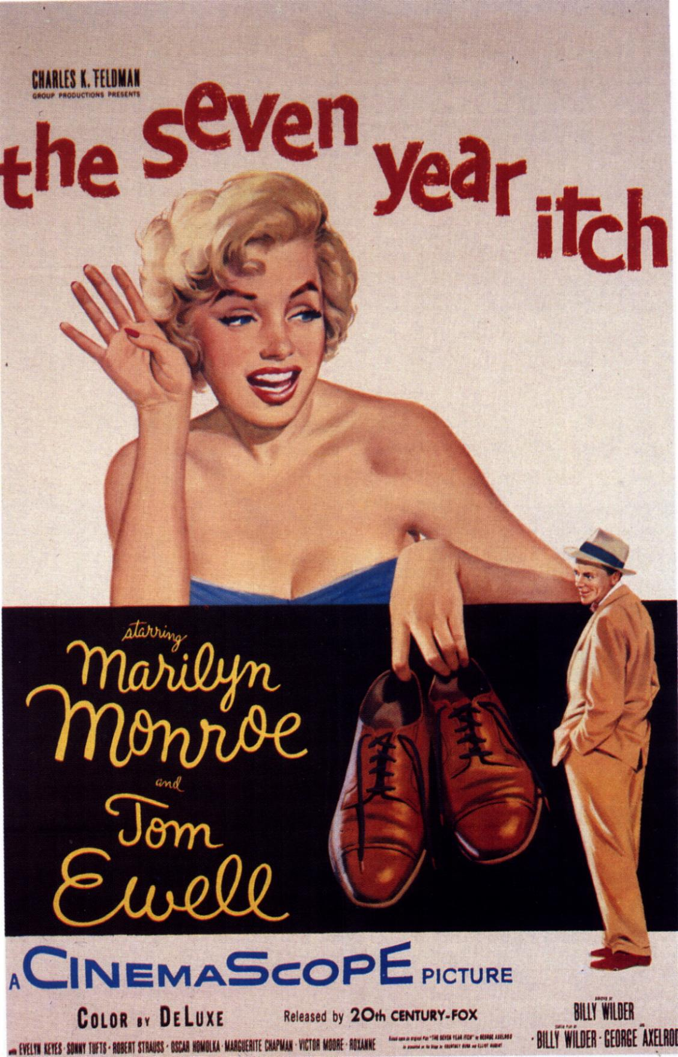
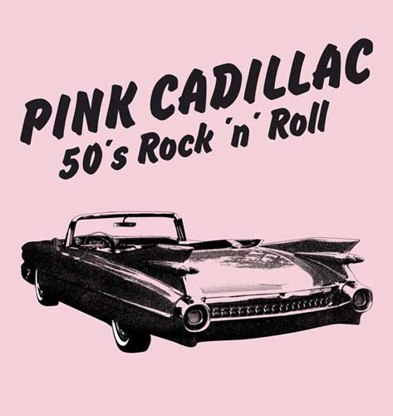
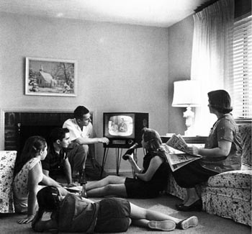
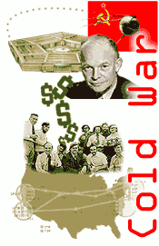

FLY ME TO THE MOON (FRANK SINATRA)
Fly me to the moon, let me play among the stars
Let me see what spring is like on a-Jupiter and Mars
In other words, hold my hand, in other words, baby, kiss me.
Fill my heart with song and let me sing for ever more
You are all I long for all I worship and adore
In other words, please be true, in other words, I love you.
Fill my heart with song, let me sing for ever more
You are all I long for all I worship and adore
In other words, please be true, in other words, in other words I love you...!

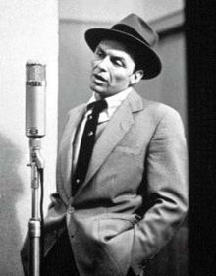

JAILHOUSE ROCK (ELVIS PRESTLEY)
The warden threw a party in the county jail, the prison band was there and they began to wail.
The band was jumpin' and the joint began to swing, you should've heard those knocked out jailbirds sing.
Let's rock, everybody, let's rock, everybody in the whole cell block was dancin' to the Jailhouse Rock.
Spider Murphy played the tenor saxophone, Little Joe was blowin' on the slide trombone.
The drummer boy from Illinois went crash, boom, bang, the whole rhythm section was the Purple Gang.
Let's rock, everybody, let's rock, everybody in the whole cell block was dancin' to the Jailhouse Rock.
Number forty-seven said to number three: "You're the cutest jailbird I ever did see.
I sure would be delighted with your company, come on and do the Jailhouse Rock with me."
Let's rock, everybody, let's rock, everybody in the whole cell block was dancin' to the Jailhouse Rock.
The sad sack was a sittin' on a block of stone way over in the corner weepin' all alone.
The warden said, "Hey, buddy, don't you be no square, if you can't find a partner use a wooden chair."
Let's rock, everybody, let's rock, everybody in the whole cell block was dancin' to the Jailhouse Rock.
Shifty Henry said to Bugs, "For Heaven's sake, no one's lookin', now's our chance to make a break."
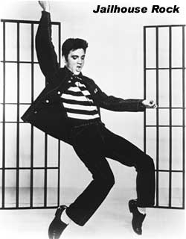
Bugsy turned to Shifty and he said, "Nix nix, I wanna stick around a while and get my kicks."
Let's rock, everybody, let's rock, everybody in the whole cell block was dancin' to the Jailhouse Rock...

FOLSOM PRISON BLUES (JOHNNY CASH)

I hear the train a comin'
it's rolling round the bend
and I ain't seen the sunshine since I don't know when,
I'm stuck in Folsom prison, and time keeps draggin' on
but that train keeps a rollin' on down to San Anton..
When I was just a baby my mama told me. Son,
always be a good boy, don't ever play with guns.
But I shot a man in Reno just to watch him die
now every time I hear that whistle I hang my head and cry.

I bet there's rich folks eating in a fancy dining car
they're probably drinkin' coffee and smoking big cigars.
Well I know I had it coming, I know I can't be free
but those people keep a movin'
and that's what tortures me...

Well if they'd free me from this prison,
if that railroad train was mine
I bet I'd move just a little further down the line
far from Folsom prison, that's where I want to stay
and I'd let that lonesome whistle blow my blues away.....

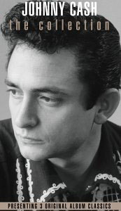

The 1950s was the decade spanning the years 1950 to 1959.

Social, cultural and political movements

- The Cold war which began at the end of the previous decade as a geopolitical , ideological and economic struggle between the Soviet Union and the United staes, intensifed.
During this time the Warsaw Pact( defense organistaion of the countries under Soviet rule and influence) and the NATO ( western democracies defense organisation) were founded.
Nuclear testing also intensified.
But tensions within the Eastern bloc also rose up leading to the Hungarian revolution in 1956 which ended with Soviet intervention.
- In 1959 Cuban revolutionaries led by Fidel castro took power in Cuba finishing Fulgencio Batista’s corrupt regime.
- The European Union was born under the name of European Common Market, on March 25 1957 by the signing of the Treaty of Rome between Italy, France, West Germany, Belgium, The Netherlands and Luxembourg.
- The first Sputnik satellite was launched in 1957.
- Television replaced radio as the dominant mass medium in industrialized countries.
- In Literature beatniks, or the beat generation, was an anti-materialistic movement whose main writers were American: Jack Kerouac, J.D. Salinger.

Music

- Traditional pop music such as the bebop era of jazz hit its peak and climaxed as early rock and roll music led by Elvis Presley was embraced by teenagers and the emerging youth culture Rock music was generally dismissed or condemned by older generations. Other prominent rock and roll musicians inclued Paul Anka, Chuck Berry, Bo Diddley, Buddy Holly, Jerry Lee Lewis and Little Richard.

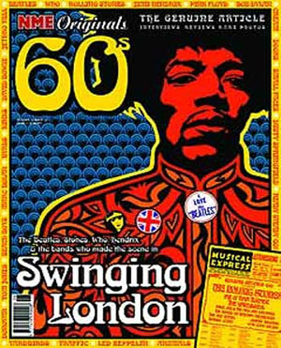
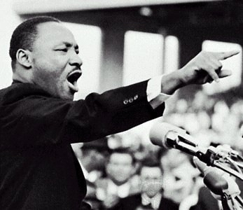

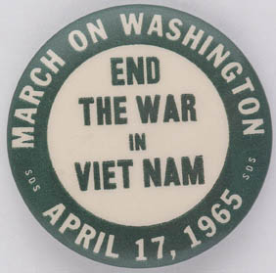
The 60s

A HARD DAY'S NIGHT (THE BEATLES)
It's been a hard day's night, and I’ve been working like a dog
It's been a hard day's night, I should be sleeping like a log
But when I get home to you I'll find the things that you do will make me feel alright
You know I work all day to get you money to buy you things
and it's worth it just to hear you say you're going to give me everything
so why on earth should I moan, 'cause when I get you alone
you know I feel ok.
When I'm home everything seems to be right, when I'm home feeling you holding me tight, tight.
So why on earth should I moan, 'cause when I get you alone you know I feel ok you know I feel alright...

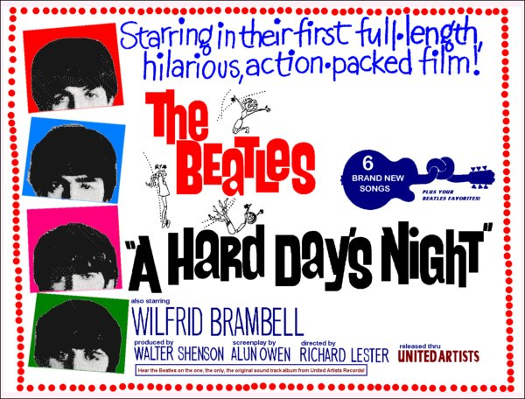

PRETTY WOMAN (Roy Orbison)
Pretty woman, walkin' down the street, pretty woman, the kind I'd like to meet
Pretty woman I don't believe you, you're not the truth, no one could look as good as you (mercy!).
Pretty woman, won't you pardon me? Pretty woman, I couldn't help but see,
Pretty woman, that you look lovely as can be, are you lonely just like me? (grrlll!!)
Pretty woman stop awhile, pretty woman talk awhile, pretty woman give your smile to me.
Pretty woman yeah, yeah, yeah, pretty woman look my way, pretty woman say you'll stay with me.
'Coz I need you, I'll treat you right, come with me baby, be mine tonight.
Pretty woman, don't walk on by, pretty woman, don't make me cry,
Pretty woman, don't walk away, hey, if that's the way it must be (OK)
I guess I'll go on home, it's late, there'll be tomorrow night, but wait, what do I see?
Is she walkin' back to me? Yeah, she's walkin' back to me! Oh, oh, pretty woman...
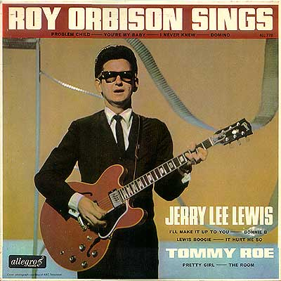

THE TIMES THERY ARE A-CHANGING (BOB DYLAN)
Come gather 'round people
Wherever you roam
And admit that the waters
Around you have grown
And accept it that soon
You'll be drenched to the bone.
If your time to you
Is worth savin'
Then you better start swimmin'
Or you'll sink like a stone
For the times they are a-changin'.
Come writers and critics
Who prophesize with your pen
And keep your eyes wide
The chance won't come again
And don't speak too soon
For the wheel's still in spin
And there's no tellin' who
That it's namin'.
For the loser now
Will be later to win
For the times they are a-changin'.
Come senators, congressmen
Please heed the call
Don't stand in the doorway
Don't block up the hall
For he that gets hurt
Will be he who has stalled
There's a battle outside
And it is ragin'.
It'll soon shake your windows
And rattle your walls
For the times they are a-changin'.
Come mothers and fathers
Throughout the land
And don't criticize
What you can't understand
Your sons and your daughters
Are beyond your command
Your old road is
Rapidly agin'.
Please get out of the new one
If you can't lend your hand
For the times they are a-changin'.
The line it is drawn
The curse it is cast
The slow one now
Will later be fast
As the present now
Will later be past
The order is
Rapidly fadin'.
And the first one now
Will later be last
For the times they are a-changin'.

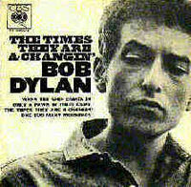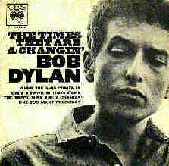

The 1960s decade refers to the years from January 1, 1960 to December 31, 1969, inclusive.

Social, cultural and political movements
- The Sixties has also come to refer to the cultural and political events which occurred in approximately that period, in Western countries, particularly Britain, France, the United States and West Germany. Social upheaval was not limited to just these nations, reaching large scale in nations such as Japan, Mexico and Canada as well. The term is used both nostalgically by those who participated in those events, and pejoratively by those who regard the time as a period whose harmful effects are still being felt today. The decade was also labeled the Swinging Sixties because of the attitudes that emerged during the decade.
- Some of the most dramatic events of the American civil rights movement occurred in the early 1960s, the movement had already begun during the 1950s. On the other hand, the rise of feminism and gay rights began in the 1960s and continued into the next few decades..The "Sixties" has become synonymous with all the new, exciting, radical, subversive and/or dangerous (according to one's viewpoint) events and trends of the period, which continued to develop in the 1970s, 1980s and beyond.
- This is also the decade of American intervention in Vietnam, the assassination of Presidents J.F. Kennedy in 1963 , his brother Attorney General Robert Kennedy and Civil Rights Movement’s leader Martin Luther King both in 1968.
- This momentuous decade finished with the first tripulated spaceship landing on ther Moon in July 1969.
Music
- Popular music entered an era of "all hits" as numerous singers released recordings, beginning in the 1950s, as 45-rpm "singles" (with another on the flip side), and radio stations tended to play only the most popular of the wide variety of records being made. Also, bands tended to record only the best of their songs as a chance to become a hit record. The developments of the Motown Sound, "folk rock" and the British Invasion of bands from the U.K. (The Beatles, The Rolling Stones, and so on), are major examples of American listeners expanding from the folksinger,and rocka nd roll of the 1950s and evolving to include psychedelia music.
- The rise of an alternative culture among affluent youth, creating a huge market for rock and blues music produced by drug-culture influenced bands such as The Beatles, the Rolling Stones, Jefferson Airplane, Jimi Hendrix Experience and The Doors, and also for radical music in the folk tradition pioneered by Bob Dylan.

The 70s
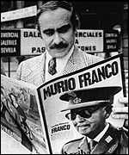
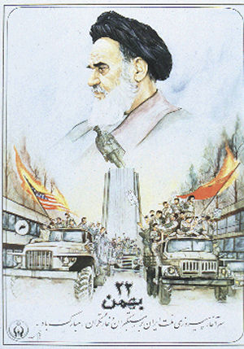
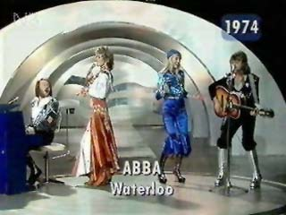
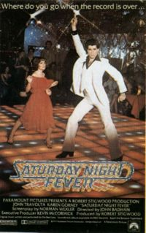
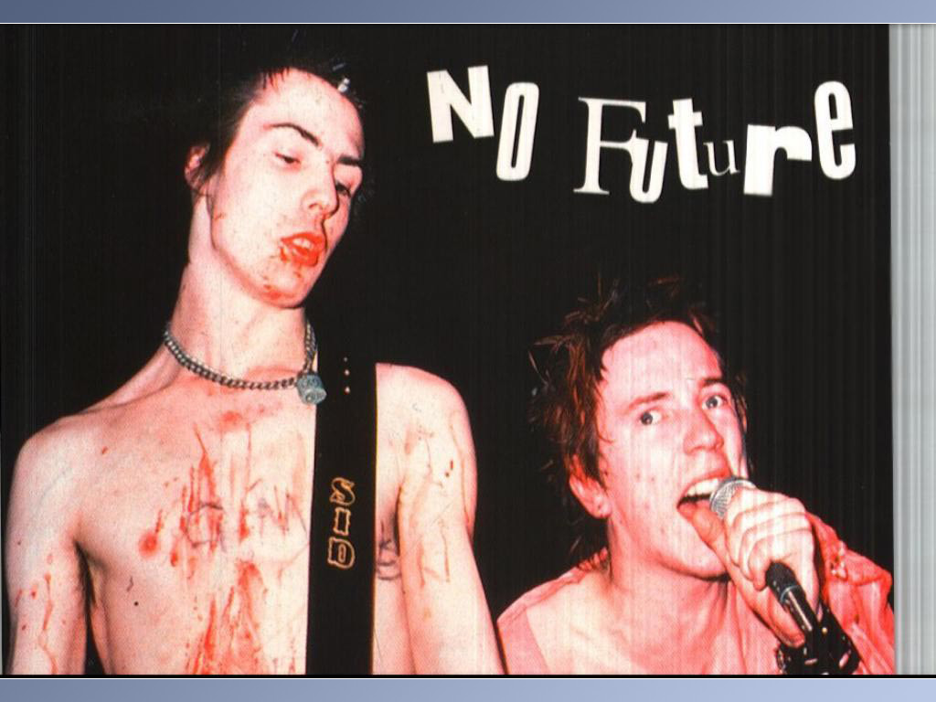

I WILL SURVIVE (GLORIA GAYNOR)
First I was afraid, I was petrified
Kept thinking I could never live without you by my side
But I spent so many nights thinking how you did me wrong
I grew strong, I learned how to carry on
and so you're back from outer space
I just walked in to find you here with that sad look upon your face
I should have changed my stupid lock,
I should have made you leave your key
If I had known for just one second you'd be back to bother me.
Go on now go walk out the door
just turn around now 'cause you're not welcome anymore
weren't you the one who tried to hurt me with goodbye?
you think I'd crumble, you think I'd lay down and die
Oh no, not I, I will survive
as long as I know how to love, I know I will stay alive
I've got all my life to live, I've got all my love to give
and I'll survive, I will survive.
It took all the strength I had not to fall apart
kept trying hard to mend the pieces of my broken heart
and I spent oh so many nights just feeling sorry for myself
I used to cry, now I hold my head up high
and you see me somebody new
I'm not that chained up little person still in love with you
and so you felt like dropping in and just expect me to be free
now I'm saving all my loving for someone who's loving me...
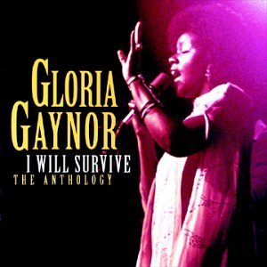

ACROSS THE UNIVERSE (DAVID BOWIE)
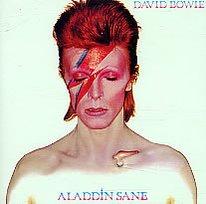
Words are flowing out like endless rain into a paper cup
They slither wildly as they slip away
Across the universe
Pools of sorrow, waves of joy are drifting through my opened
mind
Possessing and caressing me
Nothing's gonna change my world
Nothing's gonna change my world
Nothing's gonna change my world
Nothing's gonna change my world
Images of broken light which dance before me like a million eyes
They call me on and on
Across the universe
Thoughts meander like the restless wind inside a letter box
They tumble blindly as they make their way
Across the universe
Nothing's gonna change my world…
Sounds of laughter, shades of life are ringing through my open
ears
Inciting and inviting me
Limitless undying love, which shines around me like a million
suns
It calls me on and on and on
Across the universe
Nothing's gonna change my world
Nothing's gonna change my world
Nothing's gonna change my world
Nothing's gonna change my world

CONCRETE JUNGLE (BOB MARLEY)
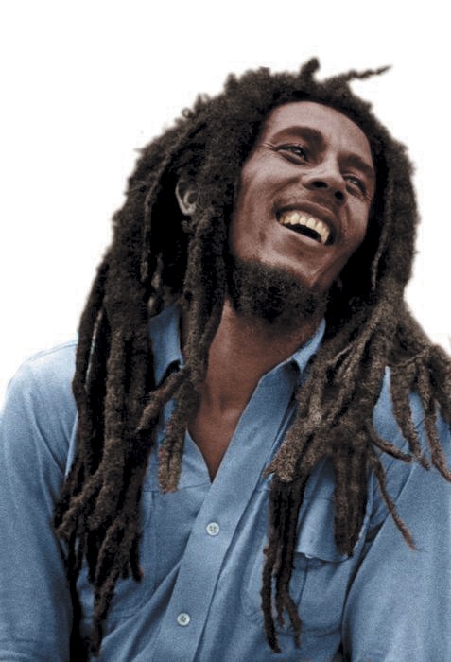
No sun will shine in my day today
(No sun will shine.)
The high yellow moon won't come out to play
(Won't come out to play.)
Darkness has covered my light (and has changed,)
And has changed my day into night
Now where is this love to be found, won't someone tell me?
'Cause life, sweet life, must be somewhere to be found, yeah
Instead of a concrete jungle where the livin' is hardest
Concrete jungle, oh man, you've got to do your best, yeah.
No chains around my feet, but I'm not free
I know I am bound here in captivity
And I've never known happiness, and I've never known sweetcaresses
Still, I be always laughing like a clown
Won't someone help me?
Cause, sweet life, I've, I've got to pick myself from off theground, yeah
In this here concrete jungle,
I say, what do you got for me now?
Concrete jungle, oh, why won't you let me be now?
I said life must be somewhere to be found, yeah
Instead of a concrete jungle, illusion, confusion
Concreate jungle, yeah
Concrete jungle, you name it, we got it, concrete jungle now
Concrete jungle, what do you got for me now

"GOD SAVE THE QUEEN" (SEX PISTOLS)
God save the queen
The fascist regime
They made you a moron
Potential H-bomb
God save the queen
She ain't no human being
There is no future
In England's dreaming
Don't be told what you want
Don't be told what you need
There's no future, no future,
No future for you
God save the queen
We mean it man
We love our queen
God saves
God save the queen
'Cause tourists are money
And our figurehead
Is not what she seems
Oh God save history
God save your mad parade
Oh Lord God have mercy
All crimes are paid
When there's no future
How can there be sin
We're the flowers in the dustbin
We're the poison in your human machine
We're the future, you're future
God save the queen
We mean it man
We love our queen
God saves
God save the queen
We mean it man
And there is no future
In England's dreaming
No future, no future,
No future for you
No future, no future,
No future for me
No future, no future,
No future for you
No future, no future
For you
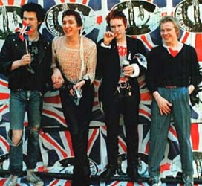

The 1970s decade refers to the years from 1970 to 1979, inclusive.

Social, cultural and political movements
- In the Western world, the focus shifted from the social activism of the sixties to social activities simply for one's own pleasure, save for environmentalism, which continued in a very visible way. The seventies were characterized by the writer Tom Wolfe as the "Me Decade."
- The established institutions of nuclear family, religion and trust in government continued to lose ground during this time. Major developments of the sexual revolution included the awareness of the impact of contraceptive pills on relationships, and an increase in divorce rates, single parent households, and pre-marital sex. By the end of the decade the feminist movement had helped improve women's working conditions. The Gay Rights movement gained prominence and the hippie culture started in the 1960s peaked and carried on through the end of the decade.
- The United States' withdrew from Vietnam and in economis while the United States experienced recession, the economy of Japan rose. The economies of many third world countries continued to make steady progress in the early 1970s. They might have thrived and become stable in the way that Europe recovered after the war; however, the economic growth was slowed by the oil crisis.
Music
- The seventies were a time when a new generation of young people were exposed to new media and hence newer ideas in almost every field. TV and motion picture brought to varied audiences images, lifestyles and music from diverse regions and peoples. This led to the emergence of a new vocabulary and experimentation in music. and later influenced both art rock and progressive rock as well as the punk rock and new wave genres. The main exponents of progressive rock include Genesis, Yes, Emerson, Lake & Palmer and Pink Floyd.
- The seventies were also when many legendary rock bands started, or hit their peak, including Led Zeppeling, Queen, The Who, The Rolling Stones, The Doors…
- Another experimentation in European classical music was brought about by composer Philip Glass and Michael Nyman, with what was to be called Minimalist music.
- The Seventies will be also remembered for the rise in disco music. Singers like Donna Summer, Gloria Gaynor, Dalida and Anita Ward popularized the genre and were described in subsequent decades as the "disco divas." The Village People scored a Top Ten hit with "Y.M.C.A." and the Bee Gees had a string of number 1s following their collaboration on the Saturday Night Fever soundtrack.
- The mid-seventies saw the rise of punk music :The Ramones, the Sex Pistols, and The Clash were some of the earliest bands to make it big in both the United Kingdom and the United States. Punk music has also been heavily associated with a certain punk fashion and absurdist humor which exemplified a genuine suspicion of mainstream culture and values
- Towards the end of the decade, Jamaican reggae music, already popular in the Caribbean and Africa since the early 1970s, became very popular in the U.S. and in Europe, mostly because of reggae superstar and legend Bob Marley as well as his band, The Wailers.

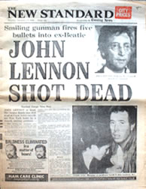
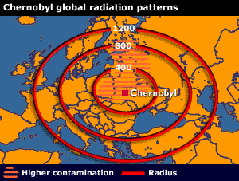
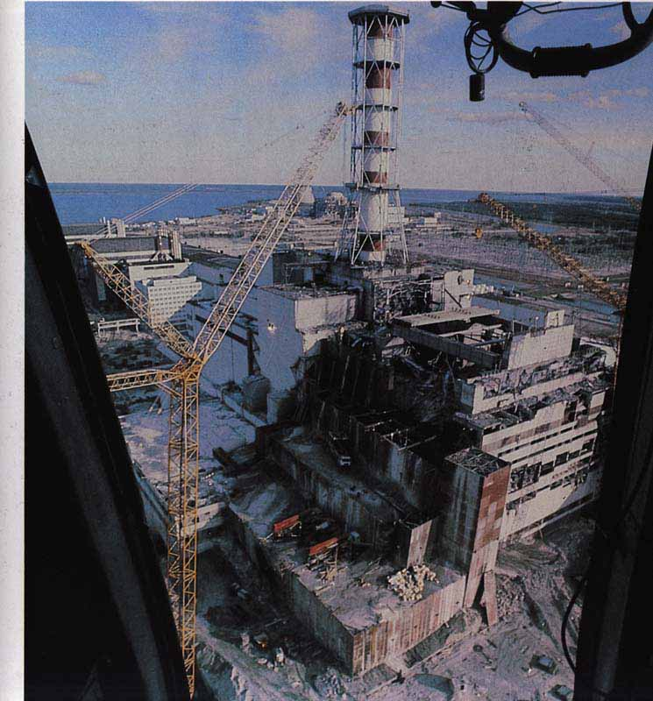

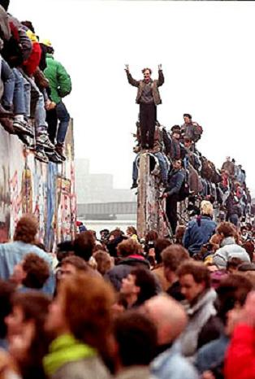
The 80s

EVERY BREATH YOU TAKE (THE POLICE)
Every breath you take, every move you make.
Every bond you break, every step you take, I'll be watching you.
Every single day, every word you say, every game you play, every night you stay...
...Oh! can't you see you belong to me? how my poor heart aches with every breath you take.
Every vow you break, every smile you fake, every claim you stake...
...Since you've gone I been lost without a trace, I dream at night I can only see your face
I look around but it's you I can't replace I feel so cold and I long for your embrace
I keep crying baby, baby, please...

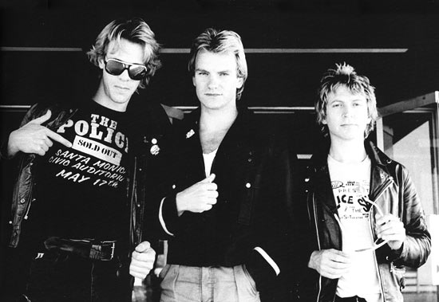

THERE IS A LIGHT THAT NEVER GOES OUT (THE SMITHS)

Take me home tonight
Where there's music and there's people
Who are young and alive
Driving in your car
I never never want to go home
Because I haven't got one anymore
Take me home tonight
Because I want to see people
And I want to see life
Driving in your car
Oh please don't drop me home
Because it's not my home, it's their home
And I'm welcome no more
And if a double-decker bus
Crashes in to us
To die by your side
Is such a heavenly way to die
And if a ten ton truck
Kills the both of us
To die by your side
Well the pleasure, the privilege is mine
Take me home tonight
Take me anywhere, I don't care
I don't care, I don't care
And in the darkened underpass
I thought Oh God, my chance has come at last
But then a strange fear gripped me
And I just couldn't ask
Take me home tonight
Oh take me anywhere, I don't care
I don't care, I don't care
Driving in your car
I never never want to go home
Because I haven't got one
No, I haven't got one
And if a double-decker bus
Crashes in to us
To die by your side
Is such a heavenly way to die
And if a ten ton truck
Kills the both of us
To die by your side
Well the pleasure, the privilege is mine
There is a light that never goes out
There is a light that never goes out
There is a light that never goes out
There is a light that never goes out
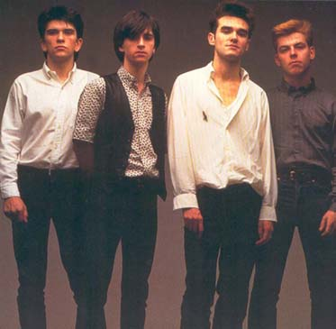

WALK LIKE AN EGYPTIAN (THE BANGLES)
All the old paintings on the tombs
They do the sand dance don't you know
If they move too quick (oh whey oh)
They're falling down like a domino
All the bazaar men by the Nile
They got the money on a bet
Gold crocodiles (oh whey oh)
They snap their teeth on your cigarette
Foreign types with the hookah pipes say
Ay oh whey oh, ay oh whey oh
Walk like an Egyptian
The blonde waitresses take their trays
They spin around and they cross the floor
They've got the moves (oh whey oh)
You drop your drink then they bring you more
All the school kids so sick of books
They like the punk and the metal band
When the buzzer rings (oh whey oh)
They're walking like an Egyptian
All the kids in the marketplace say
Ay oh whey oh, ay oh whey oh
Walk like an Egyptian
Slide your feet up the street bend your back
Shift your arm then you pull it back
Life is hard you know (oh whey oh)
So strike a pose on a Cadillac
If you want to find all the cops
They're hanging out in the donut shop
They sing and dance (oh whey oh)
Spin the clubs cruise down the block
All the Japanese with their yen
The party boys call the Kremlin
And the Chinese know (oh whey oh)
They walk the line like Egyptian
All the cops in the donut shop say
Ay oh whey oh, ay oh whey oh
Walk like an Egyptian
Walk like an Egyptian

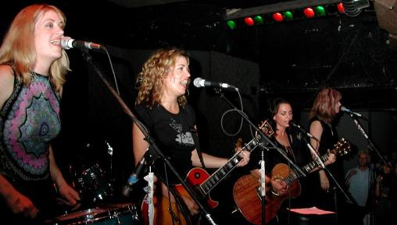

The 1980s officially refers to the years from 1980 to 1989

Social, cultural and political movements
- Like the 1960s, the decade was an era of frantic change, characterised by political and economic decentralisation, especially in Political events of the 1980s culminated in the toppling of military governments and authoritarian regimes, and the downfall of the military juntas of Brazil, Chile, Uruguay and Argentina. In most of the third world, the decade was characterized by debt crisis that began in 1982.
- The end of the decade also saw massive democratic revolutions like the Tiananmen Square protests of 1989 in China, the Czechoslovak velvet revolution, and the overthrow of the dictatorial regime in Romania and other communist Warsaw Pact states in Central and Eastern Europe. These changes continued to be felt in the 1990s and on into the 21st Century.
- The 1980s are also generally considered to be the transition between the industrial and information ages. The 1980s saw rapid developments in numerous sectors of technology which have defined the modern consumer world. Electronics such as personal computers, gaming systems, the first commercially available hand-held mobile phones, and new audio and data storage technologies such as the compact disc, are all still prominent well into the 2000s. On the strength of their high-technology industries, the Japanese economy soared to record highs in the 1980s.
- The decade was one of contrasts. Whilst yuppies reigned over the world's stock exchanges, social consciences were much in evidence: celebrities gathered to record major charity records and perform major charity concerts such as Live Aid; environmental concerns became ever more pressing in the wake of the Chernobyl disaster; and political correctness became common verbal and ideological currency.
Music
- In the United States, MTV is launched and music videos begin to have a huge effect on the record industry. Early eighties groups such as Devo and Haircut 100 are pioneers. Pop artists such as Madonna and Michael Jackson master the format and turn it into big business.
- The sounds of new technology, synthesizers and electronic keyboards, along with drum machines, lend an electronic, distinct sound to most 1980s records.
- Top-charting artists of the 1980s include The Police,Lionel Richie, Dire Straits, Duran Duran, Van Halen, Phil Collins,, Bryan Adams, Queen, U2, Madonna, Cyndi Lauper, Cher, Tina Turner, Bruce Springsteen, Prince, Michael Jackson, Janet Jackson, Whitney Houston, Beastie Boys, and Bon Jovi.
- Music styles such as hip- hop and rap bbecome hugely popular.


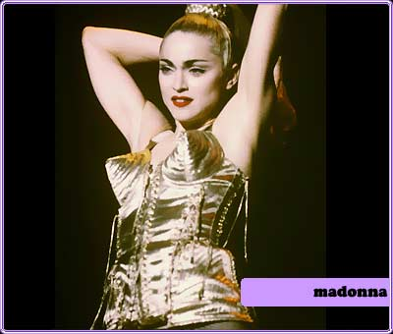
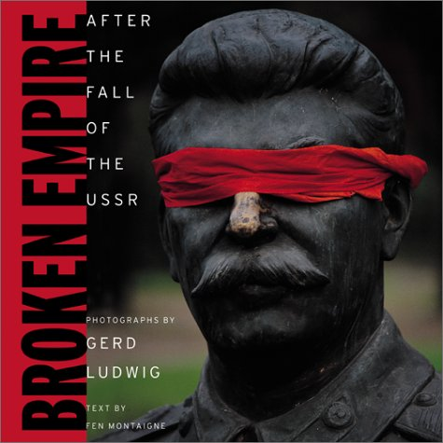
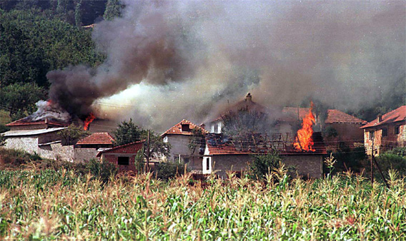
The 90s

War in Bosnia

LOSING M Y RELIGION (R.E.M.)
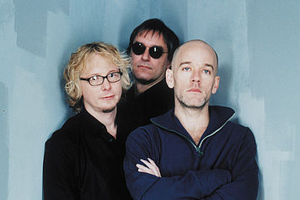
Life is bigger
It's bigger than you
And you are not me
The lengths that I will go to
The distance in your eyes
Oh no I've said too much
I set it up
That's me in the corner
That's me in the spotlight
Losing my religion
Trying to keep up with you
And I don't know if I can do it
Oh no I've said too much
I haven't said enough
I thought that I heard you laughing
I thought that I heard you sing
I think I thought I saw you try
Every whisper
Of every waking hour
I'm choosing my confessions
Trying to keep an eye on you
Like a hurt lost and blinded fool
Oh no I've said too much
I set it up
Consider this
The hint of the century
Consider this
The slip that brought me
To my knees failed
What if all these fantasies
Come flailing around
Now I've said too much
I thought that I heard you laughing
I thought that I heard you sing
I think I thought I saw you try
But that was just a dream
That was just a dream

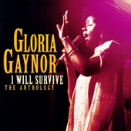
WONDERWALL (OASIS)
Today is gonna be the day that they're gonna throw it back to you
By now you should've somehow realized what you gotta do
I don't believe that anybody feels the way I do about you now
Backbeat the word was on the street that the fire in your heart is out
I'm sure you've heard it all before but you never really had a doubt
I don't believe that anybody feels the way I do about you now
And all the roads we have to walk along are winding
And all the lights that lead us there are blinding
There are many things that I would like to say to you, I don't know how
Because maybe you're gonna be the one who saves me?
And after all, you're my wonderwall
Today was gonna be the day but they'll never throw it back to you
By now you should've somehow realized what you're not to do
I don't believe that anybody feels the way I do about you now
And all the roads that lead to you were winding
And all the lights that light the way are blinding
There are many things that I would like to say to you, I don't know how
I said maybe you're gonna be the one who saves me?
And after all, you're my wonderwall
I said maybe you're gonna be the one who saves me?
And after all you're my wonderwall
Said maybe you're gonna be the one that saves me...
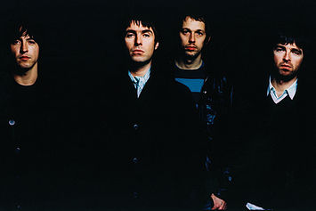

IRONIC (ALANIS MORRISSETTE)
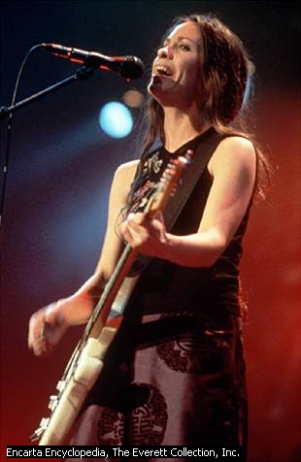
An old man aged 98
He won the lottery and died the next day
It's the black fly in your Chardonnay
It's the death row pardon 2 minutes too late
Isn't it ironic
Don't you think
It's like rain on your wedding day
It's a free ride when you've already paid
It's the good advice that you just can't take
And who would have thought
It figures
Mr Play-It-Safe was afraid to fly
Packed his suitcase and kissed his kids goodbye
He waited his whole damn life to take this flight
And as the plane crashed down he thought 'Well isn't this nice'
And isn't it ironic
Don't you think
It's like rain on your wedding day
It's a free ride when you've already paid
It's the good advice that you just can't take
And who would have thought
It figures
Well life has a funny way of sneaking up on you
When you think everything's ok
And everything's going alright
And life has a funny way of helping you out when
You think everything's gone wrong and everything blows up
In your face
A traffic jam when you're already late
A no-smoking sign on your cigarette break
It's like 10,000 spoons when all you need is a knife
It's meeting the man of my dreams and the meeting his beautiful wife
And isn't it ironic
Don't you think
A little too ironic
And yeah I really do think
It's like rain on your wedding day
It's a free ride when you've already paid
It's the good advice that you just can't take
And who would have thought
It figures
Life has a funny way of sneaking up on you
Life has a funny funny way of helping you out
Helping you out

The 1990s decade refers to the years from 1990 to 1999, inclusive

Social, cultural and political movements

- The 1990s were marked with rapid progression of globalization and global capitalism following the collapse of the Soviet Union and the end of the Cold War. Key forces shaping the decade were the and popularization of personal computers in the early 1990s and the dot-com boom and rise of the Internet in the late 1990s.
- The first terrorist attack on American soil took place in the World Trade Center on February 26, 1993 from two Egyptian suspects to have ties with Al-Qaeda under Osama Bin Laden; later the suspect of twin-bombings of two US embassies in Africa (Nairobi, Kenya and Dar Es Saleem, Tanzania on August 21, 1998 and President Clinton authorized missile attacks on Al-Qaeda training camps in Afghanistan as well bin Laden's factories in Sudan, but this failed to alter the radical Islamic terror campaign.
- Youth culture in the 1990s was characterized by environmentalism, anti-globalization in some parts and entrepreneurship. Fashions were often individualistic, tattoos and body piercing gained popularity and "retro" styles inspired by fashions of the 1960s and 1970s were also prevalent. Some young people became increasingly involved in outdoor activities that combined embracing athletics with the appreciation of nature (such as kayaking, rock climbing and snowboarding).

Music

- Popular styles include grunge (Nirvana, Smashing Pumpkins, Pearl Jam, Alice In Chains); heavy metal and alternative metal (Marilyn Manson, Nine Inch Nails, Metallica), Britpop and British rock (Oasis, Blur, Suede, Pulp, Radiohead) pop-punk and Commercial-Punk (Green Day), Hip-Hop(MC Hammer, Marky Mark) Rap ( Public enemy, de la Soul). Singer-songwriters include Alanis Morissette, Beck, and Jeff Buckley, and the multi platinum success Jewel.
- Latin music becomes popular outside a Spanish-speaking audience with crossover hits by Ricky Martin, Jennifer Lopez, the hit dance song Macarena and others. As Hispanic culture grows in the US, other Latin music genres took root, like Tejano music in the Southwest US is a mixed Mexican conjunto (accordion based)-Texan country-modern pop music.

The 2000s

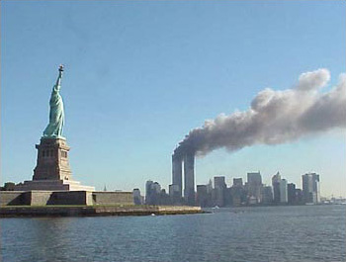


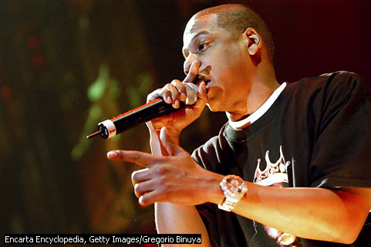

COMPLICATED (AVRIL LAVIGNE)
Uh Huh life's like this uh huh uh huh that's the way it is
Cause life's like this uh huh uh huh that's the way it is
Chill out what you yellin for?
Lay back it's all been done before
And if you could only let it be you will see
I like you the way you are when we're drivin in your car
And you're talkin to me one-on-one but you've become
Somebody else round everyone else
Watchin your back like you can't relax
You tryin to be cool you look like a fool to me, tell me
Why'd you have to go and make things so complicated?
I see the way you're actin like you're somebody else
Gettin' me frustrated life's like this you
You fall and you crawl and you break and you take what you get and you turn it into
Honestly, you promised me I'm never gonna find you fake it no no no.
You come over unannounced dressed up like you're somethin else
Where you are and where it's at you see you're makin me laugh out
When you strike a pose take off all your preppy clothes
You know you're not foolin anyone when you become
Somebody else round everyone else watchin your back like you can't relax
You tryin to be cool you look like a fool to me tell me
Why'd you have to go and make things so complicated?
I see the way you're actin like you're somebody else
Gettin me frustrated life's like this you
You fall and you crawl and you break and you take what you get and you turn it into
Honestly, you promised me I'm never gonna find you fake it
No no no (no no no) No no (no no no) No no (no no no) No no
Chill out what you yellin for?
Lay back it's all been done before and if you could only
let it be you will see
Somebody else round everyone else watchin your back like you can't relax
You tryin to be cool you look like a fool to me, tell me
Why'd you have to go and make things so complicated?
I see the way you're actin like you're somebody else
Gettin me frustrated life's like this you
You fall and you crawl and you break and you take what you get and you turn it into
Honestly, you promised me I'm never gonna find you fake it, no no
Why'd you have to go and make things so complicated? (yeah yeah)
I see the way you're actin like you're somebody else
Gettin me frustrated life's like this you
You fall and you crawl and you break and you take what you get and you turn it into
Honestly, you promised me I'm never gonna find you fake it no no no...
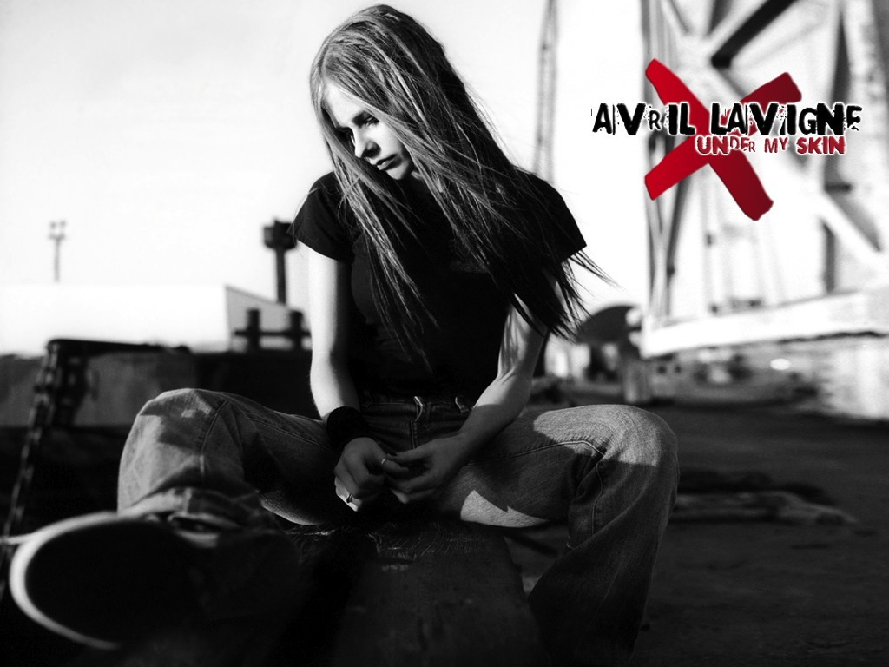

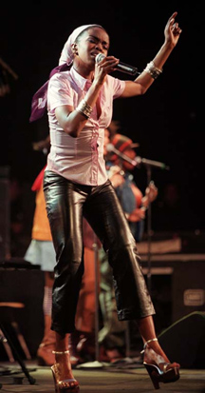
EVERYTHING IS EVERYTHING (LAURYN HILL)
[Lauryn:] Everything is everything, what is meant to be, will be
After winter, must come spring, change, it comes eventually...
...I wrote these words for everyone who struggles in their youth
Who won't accept deception, in-instead of what is truth
It seems we lose the game, before we even start to play
Who made these rules? (Who made these rules?) We're so confused (We're so confused)
Easily led astray, let me tell ya that...
...Everything is everything...after winter, must come spring...
I philosophy, possibly speak tongues, beat drum, Abyssinian, street Baptist
Rap this in fine linen, from the beginning, my practice extending across the atlas
I begat this flipping in the ghetto on a dirty mattress, you can't match this rapper slash actress
More powerful than two Cleopatras, bomb graffiti on the tomb of Nefertiti
MCs ain't ready to take it to the Serengeti
My rhymes is heavy like the mind of sister Betty (Betty Shabazz!)
L-Boogie spars with stars and constellations then came down for a little conversation
Adjacent to the king, fear no human being roll with cherubims to Nassau Coliseum
Now hear this mixture, where Hip Hop meets scripture, develop a negative into a positive picture...
...Now everything is everything, what is meant to be, will be after winter, must come spring
Change, it comes eventually.
Sometimes it seems we'll touch that dream but things come slow or not at all
And the ones on top, won't make it stop so convinced that they might fall
Let's love ourselves and we can't fail to make a better situation
Tomorrow, our seeds will grow all we need is dedication, let me tell ya that...
...What is meant to be, will be after winter, must come spring, change, it comes eventually...

YOU’RE BEAUTIFUL (JAMES BLUNT)
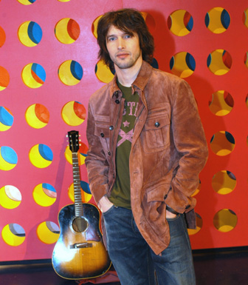
My life is brilliant.
My love is pure.
I saw an angel.
Of that I'm sure.
She smiled at me on the subway.
She was with another man.
But I won't lose no sleep on that,
'Cause I've got a plan.
You're beautiful. You're beautiful.
You're beautiful, it's true.
I saw your face in a crowded place,
And I don't know what to do,
'Cause I'll never be with you.
Yes, she caught my eye,
As I walked on by.
She could see from my face that I was,
Flying high,
And I don't think that I'll see her again,
But we shared a moment that will last till the end.
You're beautiful. You're beautiful.
You're beautiful, it's true.
I saw your face in a crowded place,
And I don't know what to do,
'Cause I'll never be with you.
You're beautiful. You're beautiful.
You're beautiful, it's true.
There must be an angel with a smile on her face,
When she thought up that I should be with you.
But it's time to face the truth,
I will never be with you.
The 2000s decade refers to the years from 2000 to 2009

Social, cultural and political movements

- Thus far, the 2000s has generally been marked with an escalation of the social issues of the 1990s, which included the increasing awareness of terrorism and the rapid expansion of economic globalization. Communications and telecommunications have advanced drastically, with the widespread proliferation of the Internet and mobile phones, among other things.
- Most major political developments in the 2000s revolved around the War on Terrorism, which was triggered by the September 11, 2001 Attacks and the Moscow Theatre Siege, and led to the American war in Iraq. These and other events have dominated the news almost daily, including the many controversies regarding their consequences and justifications. The Iraq War, launched in 2003, has generated extreme controversy around the world, with many questioning its justification or questioning the United States' motives. Tensions have escalated in the Middle East regarding the War in Iraq, the Iranian nuclear crisis, Israel's month-long war against Hezbollah in July 20006, and the election of Hamas in Israeli-occupied Palestine. North Korea has generated a nuclear crisis of its own by withdrawing from the Nuclear Non-Proliferation Treaty and its reporting of a successful nuclear test.
- Economic developments have largely focused on the explosion of Asia's economic and political potential, with China experiencing immense economic growth, moving toward the status of a regional power and billion-consumer market. India, along with many other developing countries, has seen a rapid increase in its economy, accelerated by increased technological integration with the economies of more developed countries.
Music
- Hip-Hop is the most popular musical genre with the youth, replacing rock and roll. Artists such as Kanye West, Outkast, Lil Jon, 50 Cent, Nelly, and Eminem were the dominant hip-hop artists that defined the hip-hop genre in this decade thus far.
- Some styles of the 1990s remain strong and even trendy. The teenager pop genre changed into a more adult-alternative or pop-rock oriented sound early on in the decade. In 2002, a new "teen pop rock" movement began. With singers such as Avril Lavigne and Vanessa Carlton. Circa mid to late 2000s genres are merging more and more and it's the songs that combine hip-hop/pop/r&b (for example Promiscuous , SexyBack, SOS , My Love, ondon Bridge).

