Discovering my talents



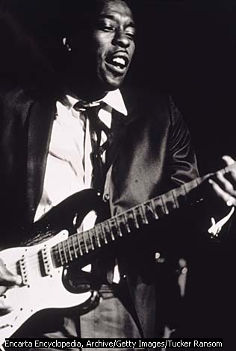
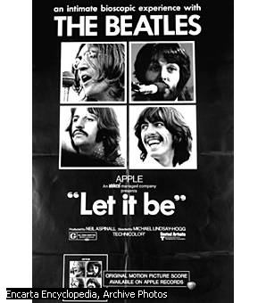
UNIT 3 Become a musician

Evaluation Appendix

Objectives

- To understand that Music is a way of expressing different cultures and part of Art and as such also an expression of human creativity and genius.

- To reflect upon and work on the features of Music and the process of composing.

- To be able to produce different types of texts, such as process descriptions, lyrics for songs, reports, and biographies as well as to be able to use techniques specific to Music as a subject.

- To be able to get information from sources in English, written and audiovisual and/or on-line.

- To be able to carry out classroom interactions in English, leading to the completion of the required tasks.

- To be able to present both orally and in written form the outcomes of the final products assigned.

7. To be able to develop critical judgment about my own and others performance.

Unit 3 Become a musician

SUBJECT, LINGUISTIC & EDUCATIONAL OBJECTIVES
Subject Objectives: Literature | Language Objectives
To understand that Music is a way of expressing different cultures and part of Art and as such also an expression of human creativity and genius.  Activities 1,2,3,4,5,6,8 | To be able to produce different types of texts, such as process descriptions, lyrics for songs, reports, and biographies as well as to be able to use techniques specific to Music as a subject.  Activities 1,2,4,5,6,9
To reflect upon and work on the features of Music and the process of composing.  Activities 1,2,4,5,6,7,8,9 | To be able to get information from sources in English, written and audiovisual and/or on-line.  Activities 2,3,4,5,6,9
To be able to carry out classroom interactions in English, leading to the completion of the required tasks.
Activities 1,2,3,4,5,6,7,8,9
To be able to present both orally and in written form the outcomes of the final products assigned.
Activities 1,2,3,4,5,6,7,8,9
Attitudinal and/or educational objective

To understand that Music is a way of expressing different cultures and part of Art and as such also an expression of human creativity and genius.
Activities 1,2,3,4,5,6,8
To be able to develop critical judgment about my own and others performance.
Activities 7,8

Unit 3 Become a musician

SUBJECT & LINGUISTIC CONTENT
SUBJECT CONTENT | LANGUAGE CONTENT
- Different traditions in World Music  - Musical Instruments: families and description  - Music as a source of enjoyment and culture and as an expression of human creativity  - Features of the composition process  - Listening to music | - Text types: process description, explanatory text, justifying opinions and preferences, reporting, lyrics od songs, CV as a text, review of the biography.  - Punctuation: colon, semicolon, comma, speech marks, question marks…  - Review of present tenses  - Articles  - Causal linkers

SKILLS CONTENT
- Listening to a piece of music and identifying its main features.
- Identifying the main structure of a process description text.
- General interpretation of texts for self-enjoyment.
- Analysing the features of songs’ lyrics as texts.
- Making a critical judgment of others’ works
- Relating oral and written codes by listening and reading at the same time
- Producing a description of a instrument.
- Producing a song and its lyrics.
- Making connections between the different arts in order to write a report on music and lyrics.
- Making connections between music and current events.
- Filling in mind maps to organize actions
- Memorizing and using language formulae

Secondary 3 Discovering my talents Unit 3 :Become a musician
NAME | 1. Follows teacher’s instructions | 2. Gets the gist of oral / written and audiovisual texts | 3. Selects the required information from written and audiovisual texts | 4. Shares the information he/she gets. | 5 Builds texts using the required language | 6.Transfers information from one type of text to another one | 7. Uses the dictionary properly. | 8. - Uses classroom interaction language appropriately. | 9.- Presents orally tasks and conclusions

OBJECTIVE:

ACTIVITIES:

CONTENT:
SUBJECT | LANGUAGE | SKILLS

SS

PERFORMANCE

SUBJECT | LANGUAGE | SKILLS

Objective achieved:
Yes

