Discovering Universal Culture

UNIT 1
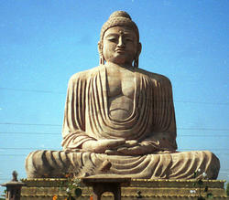
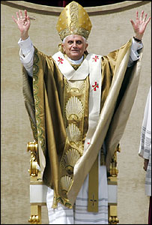

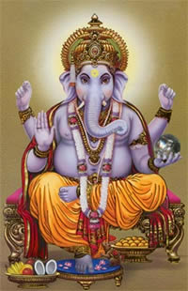
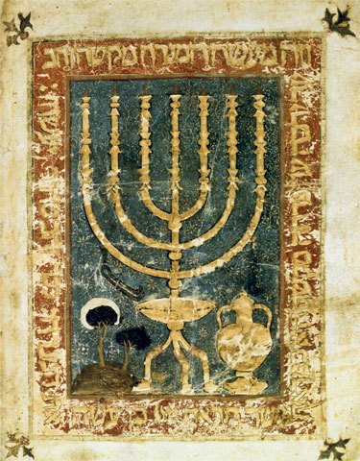
Human Beliefs

Objectives

- To understand that Religion is a cultural trait we all humans share and also a way to express the human spirit.

- To reflect upon the beliefs of the different World Religions with an open and critical view.

- To be able to produce different types of texts, such as argumentative texts expressing and justifying opinions as well as opinion essays.

- To be able to get, process and share information from sources in English, written and audiovisual and/or on-line.

- To be able to carry out classroom interactions in English, leading to the completion of the required tasks.

- To be able to present both orally and in written form the outcomes of the final products assigned.

7. To be able to develop critical judgment and to hold one’s own ideas.

Basic competences

Curricular competences to which this unit is related:

- Linguistic competence
- Competence in ITC
- Citizen ship
- Cultural Competence
- Learning to learn
- Personal autonomy

Unit 1 Human Beliefs

SUBJECT, LINGUISTIC & EDUCATIONAL OBJECTIVES
Subject Objectives: Literature | Language Objectives
To understand that Religion is a cultural trait we all humans share and also a way to express the human spirit.  Activities 1, 2,3,4,5,6 | To be able to produce different types of texts, such as argumentative texts expressing and justifying opinions as well as opinion essays.  Activities 2,4,5,6,7,8,9
To reflect upon the beliefs of the different World Religions with an open and critical view.  Activities 1,3,4,5,6,7,8,9 | To be able to get information from sources in English, written and audiovisual and/or on-line.  Activities 1,2,3,4,5,6,8,9
To be able to carry out classroom interactions in English, leading to the completion of the required tasks.
Activities 1,2,3,4,5,6,7,8,9
To be able to present both orally and in written form the outcomes of the final products assigned.
Activities 2,4,5,7,8
Attitudinal and/or educational objective
To reflect upon the beliefs of the different World Religions with an open and critical view.
Activities 1,2,3,4,5,6
To be able to develop critical judgment and to hold one’s own ideas.
Activities 7 ,8

Unit 1 Human Beliefs

SUBJECT & LINGUISTIC CONTENT
Subject content | Language content
- Concept of religion  - Concept of myth  - Concept of confessionality  - Concept of secularism  - The major world religions: main aspects, beliefs and rites  - Ancient Greek mythology | - Text types: myths, religious texts, debates, opinion essay.  - Punctuation: colon, semicolon, comma, speech marks, question marks…  - Vocabulary: Words from Latin or Greek origin  - Linkers: although, nevertheless, however, on the one hand, on the other hand…  - Tenses: Review of all present and past tenses

SKILLS CONTENT
- General interpretation of texts for self-enjoyment
- Making hypothesis and predicting parts of a story
- Making a critical judgment of others’ works
- Relating oral and written codes by listening and reading at the same time
- Filling in mind maps to organize actions
- Selecting main information
- Filling in fact files
- Drawing conclusions
- Justifying and holding one own’s opinion
- Following the convention of debates

Secondary 4 Discovering Universal Culture Unit 1 : Human Beliefs
NAME | 1. Follows teacher’s instructions | 2. Gets the gist of oral / written and audiovisual texts | 3. Selects the required information from written and audiovisual texts | 4. Shares the information he/she gets. | 5 Builds texts using the required language | 6.Transfers information from one type of text to another one | 7. Uses the dictionary properly. | 8. - Uses classroom interaction language appropriately. | 9.- Presents orally tasks and conclusions

OBJECTIVE:

ACTIVITIES:

CONTENT:
SUBJECT | LANGUAGE | SKILLS

SS

PERFORMANCE

SUBJECT | LANGUAGE | SKILLS

Objective achieved:
Yes Partially(minimum)

