

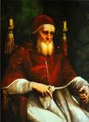
The four Stanze di Raffaello ("Raphael's rooms") in the Palace of the Vatican form a suite of reception rooms, the public part of the papal apartments. They are famous for their frescoes, painted by Raphael and his workshop. Together with Michelangelo's ceiling frescoes in the Sistine Chapel, these are the grand fresco sequences that mark the High Renaissance in Rome.
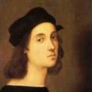
Raphael
and
Pope Julius II

The Stanze, as they are called, were originally intended as apartments for Pope Julius II. He commissioned Raphael, at the time a relatively young artist from Urbino, in 1508 or 1509 to redecorate the existing interiors of the rooms entirely.
The rooms are the Sala di Costantino ("Hall of Constantine"), the Stanza di Eliodoro ("Room of Heliodorus"), the Stanza della Segnatura ("Room of the Signatura") and the Stanza dell'incendio del Borgo ("The Room of the Fire in the Borgo").

After the death of Julius in 1513, with two rooms frescoed, Pope Leo X continued the program. Following Raphael's death in 1520, his assistants Gianfrancesco Penni, Giulio Romano and Raffaellino del Colle finished the project with the frescoes in the Sala di Costantino.
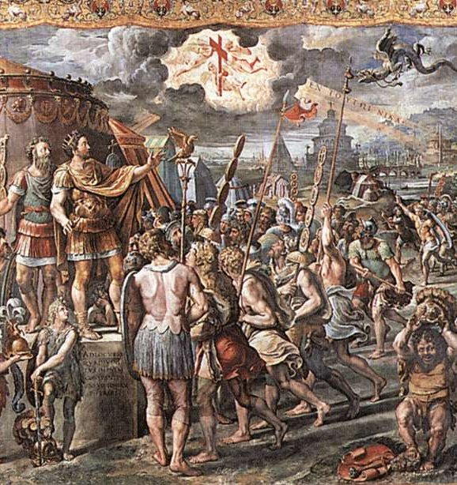

The Stanza della segnatura ("Room of the Signatura") was the first to be decorated by Raphael's frescoes. It was the study housing the library of Julius II, in which the Signatura tribunal was originally located. The artist's concept brings into harmony the spirits of Antiquity and Christianity and reflects the contents of the pope's library with themes of theology, philosophy, jurisprudence, and the poetic arts, represented in tondi above the lunettes of the walls. The theme of this room is worldly and spiritual wisdom and the harmony which Renaissance humanists perceived between Christian teaching and Greek philosophy. The theme of wisdom is appropriate as this room was the council chamber for the Apostolic Signatura, where most of the important papal documents were signed and sealed.
Toward the end of 1509, Raphael began work on the wall opposite the Disputa. This second painting, entitled The School of Athens, represents the truth acquired through reason; it was meant to reside over the philosophical section of Pope Julius II's library. It is perhaps Raphael's most famous fresco.

The School of Athens is one of the most famous paintings by the Italian renaissance artist Raphael. It was painted between 1509 and 1510 as a part of Raphael's commission to decorate with frescoes the rooms that are now known as the Stanze di Raffaello, in the Apostolic Palace in the Vatican. The Stanza della Segnatura was the first of the rooms to be decorated, and The School of Athens the second painting to be finished after La disputa.

The painting
Because it was positioned over the philosophical section of the library of Pope Julius II, The School of Athens shows the greatest philosophers, scientists and mathematicians of classical antiquity. Plato and Aristotle, the Greek philosophers that were considered most important, are standing in the center of the composition at the top of the steps. Plato is holding his Timaeus. Aristotle is carrying a copy of his Nichomachean Ethics. Their gestures correspond to their interests in the philosophical field - Plato is pointing upwards towards Heaven and Aristotle is gesturing towards the earth.
Diogenes is lying carefree on the steps before them to show his philosophical attitude: he despised all material wealth and the lifestyle associated with it. To the left, is a great block of stone the significance of which is sometimes connected with the first epistle of St Peter; it symbolizes Christ, the "cornerstone" which the builders have rejected and which becomes a stumbling block and a "rock of offence" to the unbeliever. The man leaning on the block is Heraclites, meant to be Michelangelo. This figure was an afterthought: it was not in the original cartoon. In 1510, Raphael snuck into the Sistine Chapel to view Michelangelo’s work on the ceiling by candle light. He was so awed by the unfinished work that he added Michelangelo in his own style of painting to show his respect for the artist.

Raphael's self portrait is at the far lower-right of the fresco, the young man with brown hair staring straight out at the audience. On the left of the painting a girl-like figure, dressed in white, is also staring out at the audience. Romantic legend has it that she is Raphael's love, Margherita. Other interpretations, however, claim that it is Hypatia of Alexandria, or a portrait of the young Francesco Maria I della Rovere.

The philosophers

The identity of some of the philosophers in the picture, such as Plato or Aristotle, is uncontroversial, but scholars disagree on many of the other figures. They are usually identified as follows:^{[1]}
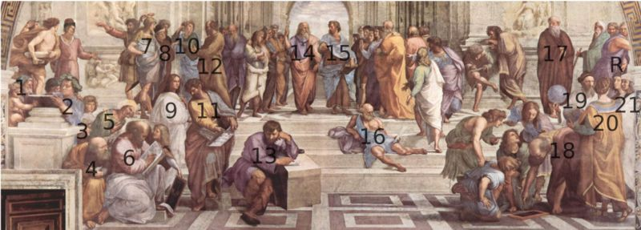

1: Zeno of Citium or Zeno of Elea? – 2: Epicurus – 3: Frederik II of Mantua? – 4: Anicius Manlius Severinus Boethius or Anaximander or Empedocles? – 5: Averroes – 6: Pythagoras – 7: Alcibiades or Alexander the Great? – 8: Antisthenes or Xenophon? – 9: Hypatia or the young Francesco Maria della Rovere? – 10: Aeschines or Xenophon? – 11: Parmenides? – 12: Socrates – 13: Heraclitus (painted as Michelangelo) – 14: Plato holding the Timaeus (painted as Leonardo da Vinci) – 15: Aristotle holding the Ethics – 16: Diogenes of Sinope – 17: Plotinus? – 18: Euclid or Archimedes with students (painted as Bramante)? – 19: Strabo or Zoroaster? – 20: Ptolemy – R: Raphael as Apelles – 21: Il Sodoma as Protogenes

fresco

Pronunciation: 'fres-(")kO
Function: noun
Inflected Form(s): plural frescoes
Etymology: Italian, from fresco fresh, of Germanic origin; akin to Old High German frisc fresh
1 : the art of painting on freshly spread moist lime plaster with water-based pigments
2 : a painting executed in fresco
- fresco transitive verb

Renaissance
Pronunciation: "re-n&-'sän(t)s
Function: noun
Usage: often attributive
Etymology: French, from Middle French, rebirth, from Old French renaistre to be born again, from Latin renasci, from re- + nasci to be born
1 capitalized a : the transitional movement in Europe between medieval and modern times beginning in the 14th century in Italy, lasting into the 17th century, and marked by a humanistic revival of classical influence expressed in a flowering of the arts and literature and by the beginnings of modern science b : the period of the Renaissance c : the neoclassic style of architecture prevailing during the Renaissance
2 often capitalized : a movement or period of vigorous artistic and intellectual activity
3 : REBIRTH, REVIVAL

High Renaissance

High Renaissance art, which flourished for about 35 years, from the early 1490s to 1527, when Rome was sacked by imperial troops, revolved around three towering figures: Leonardo da Vinci (1452–1519), Michelangelo (1475–1564), and Raphael (1483–1520). Each of the three embodied an important aspect of the period: Leonardo was the ultimate Renaissance man, a solitary genius to whom no branch of study was foreign; Michelangelo emanated creative power, conceiving vast projects that drew for inspiration on the human body as the ultimate vehicle for emotional expression; Raphael created works that perfectly expressed the classical spirit—harmonious, beautiful, and serene.

tondo
Pronunciation: 'tän-(")dO
Function: noun
Inflected Form(s): plural ton·di
Etymology: Italian, from tondo round, short for rotondo, from Latin rotundus
1 : a circular painting
2 : a sculptured medallion

lunette

Pronunciation: lü-'net
Function: noun
Etymology: French, from Old French lunete small object shaped like the moon, from lune moon
1 : something that has the shape of a crescent or half-moon: as a : an opening in a vault especially for a window b : the surface at the upper part of a wall that is partly surrounded by a vault which the wall intersects and that is often filled by windows or by mural painting c : a low crescentic mound (as of sand) formed by the wind
2 : the figure or shape of a crescent moon

humanism
Pronunciation: 'hyü-m&-"ni-z&m
Function: noun
1 a : devotion to the humanities : literary culture b : the revival of classical letters, individualistic and critical spirit, and emphasis on secular concerns characteristic of the Renaissance
2 : HUMANITARIANISM
3 : a doctrine, attitude, or way of life centered on human interests or values; especially : a philosophy that usually rejects supernaturalism and stresses an individual's dignity and worth and capacity for self-realization through reason
- hu·man·ist hyü-m&-/-nist/ noun or adjective
- hu·man·is·tic "hyü-m&-'nis-tik, "yü-/ adjective
- hu·man·is·ti·cal·ly hyü-m&-nis -ti-k(&-)lE/ adverb

afterthought
Pronunciation: after-thot
Function: noun
1 : an idea occurring later
2 : something (as a part or feature) not thought of originally : something secondary

awed

Pronunciation: 'od
Function: adjective
: showing awe <awed respect> to inspire with awe <we were awed by the beauty of the mountains>

Language related tasks

1.- Using the glossary have the ss writing sentences using figures 1, 2 and 3 as prompters.

2.- Shadow dictation:

The School of Athens is one of the most famous paintings by the Italian renaissance artist Raphael. It was painted between 1509 and 1510 as a part of Raphael's commission to decorate with frescoes the rooms that are now known as the Stanze di Raffaello, in the Apostolic Palace in the Vatican. The Stanza della Segnatura was the first of the rooms to be decorated, and The School of Athens the second painting to be finished.

3.- Gap filling to review position words:

Raphael's self portrait is at the far lower-right of the fresco, the young man with brown hair staring straight out at the audience. On the left of the painting a girl-like figure, dressed in white, is also staring out at the audience, she is Hypatia of Alexandria.

4.- Write a spatial description of the picture

Subject related tasks

1.- Choosing one of the philosophers on the painting, research and write his/her biography.

2.- Researching ancient philosophical schools and writing a brief glossary of them.

3.- Paint the class as the school of Athens.

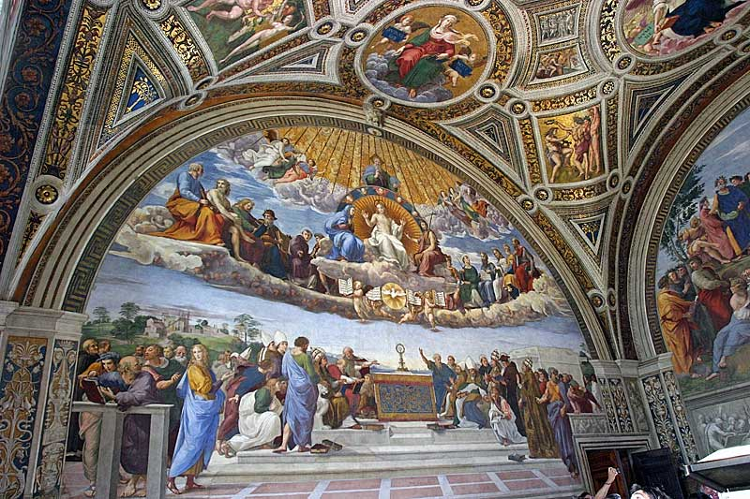
Figure 1
Part of La Stanza della Signatura

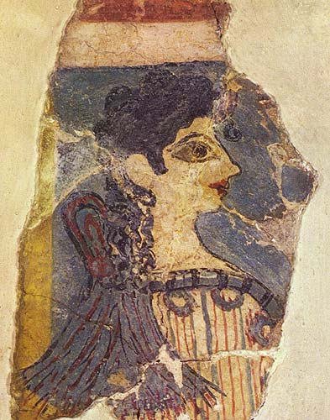
Figura 2: a Greek ancient painting

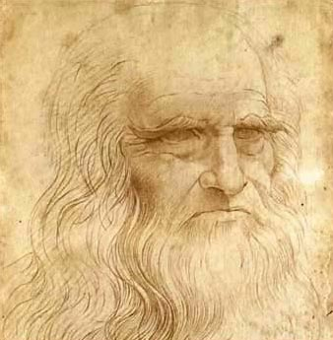
Figura 3: Leonardo da Vinci

