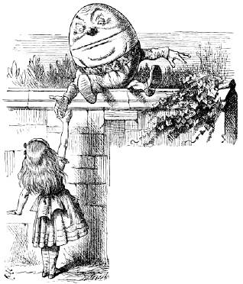
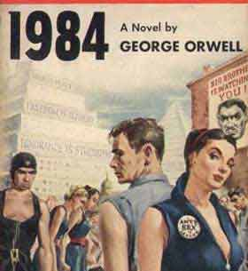

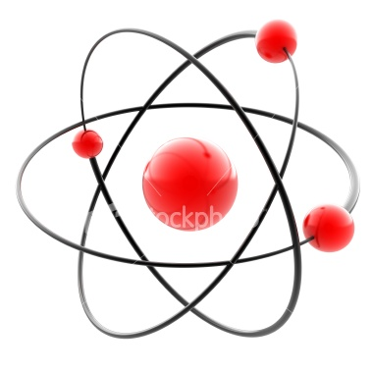

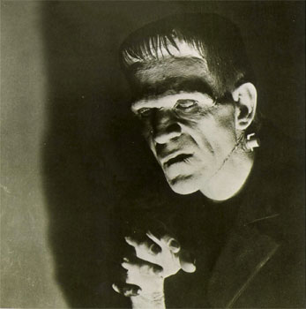

Index of tasks

Activities in this appendix | Link to main activities in the unit
The Needs of the Many  The Captain’s Dilemma  A Prison for the Mind?  When is a door not a door?  Is there a God?  The Scientist’s Child  The best possible world?  The Frontiers of Ethics  Logic in Wonderland  Identity crisis  Fire and Water  Me, Myself and I  The Cave of Shadows  Experiencing Freedom  All’s well that ends well  Bad faith? | Activities 2, 5,6 and 9  Activity 9  Activity 2  Activity 2  Activities 2 and 3  Activity 3  Activity 3  Activities 6 and 9  Activity 5  Activity 6  Activity 3  Activity 2  Activity 2  Activity 6  Activity 2  Activities 2 and 9

Based on Morality and Philosophy for GSCE
Classrooom resources
ISBN 1841066176

Index of readings

Readings in the materials list | Link to main activities in the unit
From The Story of Philosophy in the List of Materials  Achilles and the Tortoise  The Myth of the cave  Can the existence of God be proved?  “God said, let Newton be”!  The beginnings of a Modern outlook  The power of ideas  The philosopher artist  The Einsteinian revolution  The future of Philosophy | Activity 8  Activity 2  Activities 2 and 3  Activity 3  Activity 2 and 3  Activity 8  Activity 2  Activities 3 and 7  Any of the acts but better towards the end of the unit

The Needs of the Many

The Golden Rule appears in Luke’s Gospel. Luke tells Christians they should:

“Treat others as you would like them to treat you”

The Golden Rule is an important principle and is followed by all major world religions. In contrast to this ethical system is utilitarianism.

Utilitarianism states that actions should be performed that create the greatest happiness for the greatest number.

Utilitarianism is different from the Golden Rule because it looks at the results of actions rather that the actions themselves. What this means is that a utilitarian would allow one innocent person to die in order for one hundred people to live.

What do you think?

Tasks:

- Explain in your words what the Golden Rule is
- Compare the Golden Rule to utilitarianism. Which of the two do you prefer and why?
- Why has dropping the atom bomb on the Japanese cities of Hiroshima and Nagasaki at the end of Word War II been called a utilitarian action?
- Think about some of the problems in the world today (poverty, disease and war). Decide how this might be solved if everyone followed the Golden Rule.
- Copy and complete the table below:

Question | Golden Rule answer | Utilitarian answer
A ship of 100 people will sink unless one person fixes the ship’s engine. However, gas leaking from the engine will kill whoever fixes the engine. Should the engine be fixed?
The Captain’s Dilemma
Moral dilemmas: A moral dilemma is a situation in which a person can choose from two courses of action, however, both choices lead to a conclusion that is morally wrong. Below is an example of a moral dilemma.
Read the example and find a solution to it. Remember, there may not be a right answer.

Billy Budd was a sailor. He was strong, brave and kind to everyone around him. He was not a clever man but everyone respected his good nature and hard work.

One of the officers on board hated Billy. His name was Smith. Smith was an evil man who resented Billy because Billy was honest and good.

One day Smith went too far and tried to beat Billy for something he had nor done. Billy turned on the officer and struck him a single blow. The officer fell to the ground dead.

The captain of the ship was left with a moral dilemma. The law told him that any murderer should be hanged, but Billy was such a good man usually.

What was the captain to do? If he hanged Billy for killing an officer he would be killing a man who was usually very good. On the other hand, if he didn’t hang him he would be breaking the law and that would mean that the law could be broken whenever anyone felt like it.

Tasks

- Decide whether or not Billy should be hanged. Explain your answers carefully giving your reasons.
- Rewrite and illustrate the Captain’s Moral dilemma (next handout)

Billy was a good sailor and popular with his mates.
One of the ship’s officers, Smith, hated Billy because of his goodness.

A Prison for the Mind?

How people understand the world is controlled by the five senses (sight, hearing, touch, taste and smell). However, since ach sense can be deceived, can we be sure that our senses are telling us the truth?

This problem has been explored by philosophers for centuries.
In the 17th century a philosopher called Descartes decided that the world around him might be a dream. He said that a round tower sometimes look square when seen from a distance and that a straight stick appears bent when seen through water.

Descartes decided that if his senses could be deceived, how could he prove that the world around him was real and not a dream? Worse still, how could he be sure that he himself existed?

Finally he decided that even if his body was being deceived, he had to have a mind with which he could think about these problems. Once he could be sure of having a mind he could the begin to prove the existence of the world around him..

Tasks

- What are the two examples Descartes gives to show that his senses could be deceived?
- Make a list of the ways in which your senses could be deceived.
- Write a script in which you interview Descartes about his dream theory.
- True or false: Which of the statements below are true or false

The senses can never be deceived
Descartes believed that the senses can be deceived
Descartes was interested in whether or not the world around him existed
There are six senses
A stick in the water remains straight
A round tower at a distance looks square.
- Design a poster advertising Descartes’ doubts about the existence of the world. You should include the various ways in which the senses can be deceived.

When is a door not a door?

In Philosophy there are two kinds of facts. Facts which always stay the same (necessary facts) and facts which change (contingent facts).

Below is an example of each:

- “2+2=4” is a necessary fact. It stays the same no matter who you are, where you are or what time you are living in.
- “My shoes are red” is a contingent fact. It is subject to change. Tomorrow I might be wearing trainers, or black shoes, or no shoes at all.

The importance of necessary or contingent facts becomes obvious when you consider conditioning (also known as brainwashing). Conditioning means people making people believe things they would not normally believe.

In the story 1984 by George Orwell, a man called Winston Smith is conditioned through torture so that he believes he is seeing five fingers held in front of him when in fact there are four.

If a person can be made to believe something like that they can be made to believe anything. This is a very dangerous power.

Tasks

- In your own words explain what conditioning is
- What sort of impact does conditioning have on people’s lives?
- Do you think conditioning is good or bad? Explain your answer giving clear reasons.

- Below is a list of ten facts. Decide which facts are contingent and which are necessary. Then place them into the table in the correct column.

  - A triangle has three sides
  - The sum of the internal angles of a square is 360 degrees
  - The sky is blue
  - The moon is full
  - John is paying cricket
  - Two plus two equals four
  - Peter has a red car
  - Light travels faster than sound
  - It is raining
  - Five is a prime number

Necessary facts | Contingent facts

Is there a God?
Part I

The problem of proving God’s existence depends on what you mean by God.

For Pantheists the problem is simple. They believe God is in everything that exits. Their argument looks likes this:

- God is in everything
- Everything that exists, exists
- Therefore, God exists

Proving God exists is not so easy if you believe that God exists outside the world. One of the main arguments for the existence of God is the ONTOLOGICAL ARGUMENT.

THE ONTOLOGICAL ARGUMENT

This states that if you understand the nature of God, God must exist. Below is a simple way of understanding the argument.
- A real football will always be greater then an imaginary football
- So something is greater if it is real than if it is imaginary
- If God is the greatest thing imaginable, God must be real, because if God was not real, God would not be the greatest thing imaginable.

Tasks:

- What do pantheists believe in ?

- How does believing in God affect the way people live their lives?

- Why do you think people believe in God when they cannot easily prove that God exists?

- Complete the passage below:

There are many different theories about the existence of _______.

Pantheists believe that God is in __________________________ ,

Which means that since everything around exists, God must exist.

Other people think that for God to be God, He must possess every

________________________, therefore he must exist. If he

didn’t exist He wouldn’t possess every possible quality and

_____________________ He would not be God.

MISSING WORDS

therefore everything quality God

- Use the diagram below to list some of God’s qualities

GOD

Is there a God?
Part II

As well as the ONTOLOGICAL ARGUMENT there are two more important arguments for the existence of God.

THE COSMOLOGICAL ARGUMENT

This argument was set out by St Thomas Aquinas. It was also set out as the KALAM ARGUMENT by the Muslim philosophers al-Kindi and al_Ghazali.
The Cosmological Argument states that:

- Everything that moves is moved by something
- There must be something that is unmoved which started everything off
- That something must be God. God is the unmoved mover.

THE ARGUMENT FROM DESIGN

William Paley explained that if you found a watch on a desert island, you would assume that given the design and purpose of the watch it must have been made by someone.

Paley said the same was true of the universe and that since the creator of the universe would have to be all-powerful (omnipotent) and all-knowing (omniscient) that being must be God.

Tasks

- Copy down the COSMOLOGICAL ARGUMENT AND THE ARGUMETN FOR DESIGN on your notebook.
- Choose the argument you think is more likely and explain why.
- Write a newspaper column in which you explain that God exits using the argument you prefer.

- Write the answers to the questions below in the grid.
When you have completed the grid you will find a hidden word in the column indicated by the arrow.

1.- Word meaning very strong
2.- Argument set out by al_Kindi and al _Ghazali
3.- Word meaning all powerful
4.- Something which has no beginning or end, and lives forever
5.- Word meaning sacred
6.- Surname of man who set out the Design Argument
7.- Saint who created the Cosmological Argument
8.- Word meaning all-knowing
9.- The object William Paley found in the desert island

The Scientist’s Child

Christians and Jews believe that life should only be created by God. This has been a problem for those scientists who have tried to ceate life artificially.
In Mary’s Shelley’s book Frankenstein, a medical student creates a human being from the remains of dead bodies. This newly created person is brought to life using a spark of electricity. However, it is treated as a freak by both its creator and the rest of the world and becomes hateful as a result.

For many years people have thought of this story as mere fantasy. However, advances in medical science mean that this may no longer be the case.

Some peole think that scientists are trying to act like God by creating new life and that this is wrong. Other people think that this work will save lives by improving medical treatment.

Tasks:

- Why do Christians and Jews think that making people artificially is wrong?
- Do you think making humans artificially is right ot wrong? Explain your answer giving clear reasons.

The best possible world?

What is the problem of evil?
If there is an all-good and all-powerful God, why do evil things happen in the world? Evil and suffering can be caused by natural disasters or people. Religion and philosophy have both explored this problem:

- In the Book of Job, in the bible, a man suffers as a test of his faith in God. He remains faithful in the face of great suffering and is finally rewarded by God.
- In the book Candide by Voltaire, a 18th century French thinker, a man faces endless disasters and suffering, but after every problem claims that “…everything is necessary in the best of all possible worlds”.

Some people have argued that in order to have freedom there must be evil in the world. This is because in order to make a free choice there must be always be a good choice and a bad choice. If the bad choice was taken away there would no longer be a totally free course of action.

Other people claim since evil exists it must indicate that there is not an omnipotent God, since an omnipotent God would not allow evil to exist.

Tasks:

- Make two lists showing the suffering caused by nature and by people
- Explain why some people think that freedom and evil are linked
- Explain the pros and the cons of people being forced to be good by God
- Below is a list of evil actions or events
Decide whether each one is a natural evil or human evil by placing them in the correct column of the table.
Earthquake murder flood landslide
drought robbery assault blackmail

Natural evil | Human evil
The Frontiers of Ethics

Advances in science often mean improvements in medicine. This means that peole live longer and healthier lives. However, with every new advance comes the need to examine the ethical issues that are raised by it.
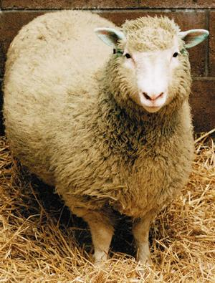
CLONING

Cloning is a way of growing a perfect
Copy of an animal or vegetable. By cloning a person it would be possible to replace damaged limbs or organs by using their clone as a source os spare body parts. A company called ClonaidTM has begun to market the idea of cloning as a way to achieving immortality. Below is an extract of their beliefs:

“Cloning will enable mankind to reach eternal life. The next step…will be to… clone an adult person without having to go through the growth process and transfer memory and personality into this person. Then, we
Dolly, the first cloned sheep.
wake up after death in a brand new
body just like after a good night sleep!.”

There are also plans by a Christian group to clone Jesus using DNA taken from holy relics containing his blood. The DNA would be inserted into a human egg and then implanted into a virgin. She would then give birth to a baby with the same genetic composition as Jesus.

What do you think?

Tasks:
- What is cloning? Explain your answer clearly.
- List the advantages and disadvantages of cloning
- Do you think using clones for transplant surgery is moral? Explain your answer giving clear reasons.
- Copy and complete the passage below:

As medical technology continues to ___________________ ,
the way people view their lives is changing. Some people think that through advanced technology it will be possible to extend the _________________________ life span.

One possible technique of increasing life expectancy involves
_______________________ . Cloning is a way of growing a
________________________copy of a living being. If a clone was made of a person it could be used as a source of spare ____________________parts, or even as a complete body replacement.

One group intends to clone Jesus Christ by using __________
Taken from holy __________________________ which it claims contain Christ’s blood.
MISSING WORDS
Human DNA relics improve
perfect body

- Write a letter explaining either the dangers or the benefits of cloning technology.

Logic in Wonderland

Using language is very important. However, the words we use can change their meaning depending on what it is we are trying to say. The part of philosophy that deals with language is called logic.

THE TOWER OF BABEL
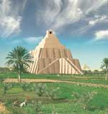
The people of Babel began to build a tower in order to reach heaven. When God saw this he punished them for their pride by making they speak many languages instead of one. As they could not understand each other, confusion began. Soon the people started to fight, eventually destroying their own tower.

LEWIS CARROLL

The writer Lewis Carroll looked at the problem of meaning in his children’s books. Below are two examples from Alice through the Looking Glass.
- “I see nobody on the road”, said Alice.
“I only wish I had such eyes”, the King remarked in a fretful tone.
“To be able to see Nobody! And at that distance too! Why, it’s as much as I can do to see real people, by this light!”

- “When I use a word,” Humpty Dumpty said in a rather scornful
tone, “it means just what I choose it to mean-neither more or less.
“The question is,”said Alice, “whether you can make words mean different things”.
“The question is”, said Humpty
Dumpty, “which is to be master-that’s all”.

Tasks:
- Make a list of words that have two or more meanings.
- Write a story in which someone gets into trouble because they misunderstand something they are told.

Identity Crisis

What makes you, you? Is it your personality? Your appearance? Or the way you behave? Below are two examples of how confusing the nature of identity can be.

THE SHIP
A ship is caught in a storm. Its mast is ripped off and is replaced with an identical mast. Later the hull is found to be rotten and so it too is replaced by a new, identical hull. Eventually, every part of the ship is replaced, by new, but identical parts. Is the same ship?

SPARE PART SURGERY
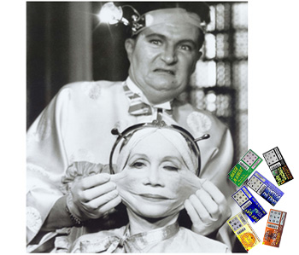
Transplant technology allows organs like the heart, lungs and kidneys to be replaced. However, do these new organs compromise the identity of the recipient? Furthermore, if future technology allows people to replace their whole body with a perfect copy, would they still be the same person?

To answer to either of these questions is necessary to define what part or parts of a person are vital to their identity. Only then, it is possible to decide at what point identity has changed because something is missing.

Tasks:
- Make a list of the things which you think make a person unique.
- Do you think identity changes when something or someone has been given new parts? Explain your answer.
- “Identity is based solely on appearance” Do you agree with this statement?. Explain your answer clearly, giving reasons.
- Complete the diagram below by listing the things that make you unique.
- Now make a list of those things you think are essential to your identity.

Fire and Water

Science is too often seen as the opposite of religion. Whereas religion does not offer proof or evidence of the claims it makes, science is driven by the need to find clear and complete answers to the questions it encounters.

Scientists experiment and examine the physical world to find answers. Religion attempts to offer answers to questions for which science has yet to find solutions.

Some people argue that faith and belief go beyond rational thought and that concepts such as God cannot be understood by science alone.

Other people think that science can offer real answers to real problems and that ideas about faith and belief do not feed the hungry or cure the sick.

Whether you think that religion and science are opponents or allies, both explore important questions which affect people’s daily lives.

Tasks:
- How do scientists try to find answers?
- What argument do people to support faith and belief?
- In what ways can science improve people’s lives?
- “Science and religion are opposed toe ach other”. Do you agree with this statement? Give reasons fro your answer.
- List keywords linked to either religion or science. Two have been done for you.
RELIGION | SCIENCE
Faith | Observation

- Make a list of questions which religion and science both attempt to answer:
Example:
How was the Earth created?

Me, Myself and I

How can we be certain that the world around us is real? Or that people possess minds of their own? In philosophy there are three theories which try to answer this question.

1.- Dualism claims that there is both mind and matter. However, how they are linked is difficult to prove. The philosopher Descartes was a dualist. He concluded that the one thing people can be certain of is the mind. As a result of this he made the famous statement “cogito ergo sum” which means “I think therefore I am”. Descartes used the absolute certainty of the mind to begin proving the existence of the physical world.

2.- Idealism states that there is only mind. Idealists believe the physical world is a creation of the mind. When critics of idealism asked what happens to the world when people sleep, a famous idealist, Bishop Berkeley pointed out that God maintains the world when we are asleep.

3.- Materialism argues that the only thing that is real is matter. According to this theory the mind is a myth and so thoughts, emotions and actions are merely the results of electrical impulses in the brain, whicj scientists can measure and study.

What do you think?

Tasks:
- In your own words, explain what a dualist believes about mind and matter.
- “The mind cannot be seen, heard or touched, therefore it does not exist”. Do you agree with this statement? Giver reasons for your answer.
- Write a conversation between an idealist and a materialist in which they explain to each other what they think about mind and matter.

The Cave of Shadows

There are many ways of exploring reality. Some people think that reality is a dream. Other people think that the physical world is all that there is, and that ideas about the human mind are just fantasy.
In his book The republic, the Greek philosopher Plato used the metaphor of a cave to explain how he thought people understand reality.

THE CAVE

There is a cave in which a group of people have been kept all their lives. They are chained so that they can only see the cave wall
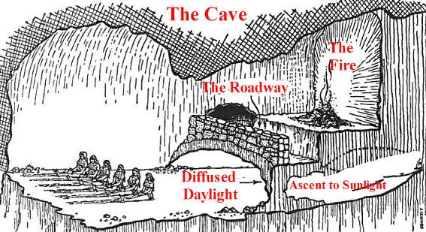
Behind them is a fire, throwing shadows onto the cave wall. The shadows show people walking through the cave. Eventually one of the prisoners breaks free and escapes. When he leaves the cave his eyes slowly adjust to the daylight outside. Finally, he begins to see the world around him for the first time, and realizes that the images he had known all his life were merely shadows of the real world. When he returns to the cave he tries to explain to the other prisoners what it is he has seen, but the other prisoners do not believe him. They cannot understand that their reality is just a shadow of the real thing. Plato argued that the world is a reflection of the real thing, and that only through examining the world can we begin to break free of the cave.

Tasks:
- What does Plato think about the world around us?
- What do the prisoners in the cave think they are seeing? What are they really seeing?
- “Plato’s cave is nonsense-the world is real”. Do you agree with this statement? Give reasons for your answer.
- Use the pictureboard below to illustrate Plato’s cave metaphor.

The prisoner’s are kept in the cave

Experiencing freedom

If you decide you want to eat a piece of chocolate, is it because you like chocolate, or because you were always going to like chocolate? In other words, whenever you make a choice, is it a free choice or one determined by influences beyond your control?

The problem of deciding whether or not people have free will is particularly difficult if you accept there is an all-knowing God, because an all-knowing God would be able to predict our future actions. Therefore, if the decisions we make during our lives are already known to God, surely we do not possess free will?

Those thinkers who accept there is an all-knowing God have employed a variety of ways to prove that people still have a free will.

- Imagine playing a game of chess against an opponent who is so good he/she can predict which move you will make, and when you will make it. You cannot tell that your moves have been predicted, but for your opponent the game has already been played out.
- A similar example involves a football match against the ultimate football team. They can predict when their goals will be scored and what the result will be, but you will still feel as if your team has free will during the match.

Tasks:
- Give an example of someone making a choice
- Make a list of the things which may influence people’s decisions.
- “If God is all-knowing, free will cannot exist.” Do you agree with this statement? Giver clear reasons for your answer.
- Read the story below and then list the various ways in which John was persuaded to buy the black trainers.
John didn’t like black trainers. He said that he would never buy a pair. Then one day he watched a TV programme in which the hero wore black trainers. When John went to school the next day all his friends were wearing black trainers and were telling each other all the great things about black trainers. Later, John saw and advert in a newspaper for black trainers being worn by a famous footballer. All this went on for several weeks. Finally, John decided he did like black trainers after all. In fact, he liked them so much, he went out to buy himself a pair!.

- Do you think John bought the trainers out of his one free will? Explain your answer giving clear reasons.
- Write a story in which someone’s free will is influenced by the world around them.

All’s well that ends well

Is it right to carry out an action which is immoral, if the result of the action is moral? This question sums up the difference between utilitarian and Kantian ethics.

Utilitarianism bases its view of right and wrong on how much happiness an action will create. This means that an immoral action could be performed, such as killing an innocent person, if it led to a greater good, saving one hundred.

Kantian ethics states that moral actions are moral in themselves and are separate from their consequences.

In the Book of Exodus (Bible), God sends ten plagues to Egypt in order to force the Pharaoh to release his Israelite slaves. The plagues caused suffering and death on a massive scale. However, if God is all-good. How can he justify the deaths of the Egyptian people, for the sake of the Israelites’ freedom?

An utilitarian would state that the happiness generated outweighed the suffering, so God’s action was moral. A Kantian would claim that sending the plagues is not moral in itself, so the action is immoral.

Tasks:
- Explain how Kantian and Utilitarians view ethical decisions.
- Give an example of how an immoral action can lead to a greater good.
- “The end always justifies the means”. Do you agree with this statement? Give clear reasons for your answer.

Bad faith?

Rights and responsibilities are like two faces of the same coin. They are linked in a way that means that if you disregard one, you disregard the other.

Most people understand what it means to have a right. In European countries, people have the right to vote when they reach the age of eighteen. However, what people tend to forget is that each right has a corresponding responsibility.

Those who hold a driving licence have the right to drive a car on the road, but they also have the responsibility to follow the traffic code.

- The philosopher Jean Paul Sartre created a concept known as
bad faith. Sartre claimed that when a person refuses to acknowledge the freedom they have they are not taking responsibility for their actions. Each time a person does this they are committing bad faith.


When people fail to accept their responsibilities they take away other people’s rights. For example, if a motorist decided to drive on the pavements whenever she/he felt like it, she/he would be denying pedestrians the right to walk safely on the pavements.

Tasks:
- Make a list of ten rights with their corresponding responsibilities.
- In your own words explain Sartre’s theory of bad faith
- Match up the rights and responsibilities on the cards below (next handout)

RIGHT

TO HOLD A DRIVING LICENCE FROM THE AGE OF EIGHTEEN
RESPONSIBILITY

TO MAKE A SENSIBLE AND INFORMED CHOICE

RIGHT

TO USE PUBLIC TRANSPORT
RESPONSIBILITY

TO FOLLOW THE TRAFFIC CODE

RIGHT

TO VOTE IN AN ELECTION FROM THE AGE OF EIGHTEEN
RESPONSIBILITY

TO PAY THE CORRECT FARE

RIGHT

TO WATCH TELEVISION
RESPONSIBILITY

TO PAY FOR A TELEVISIÓN LICENCE EACH YEAR

RIGHT

TO DRINK ALCOHOL FROM THE AGE OF EIGHTEEN
RESPONSIBILITY

TO BEHAVE SENSIBLY AND PROPERLY IN A PUBLIC PLACE

RIGHT

RESPONSIBILITY

RIGHT

RESPONSIBILITY

RIGHT

RESPONSIBILITY

RIGHT

RESPONSIBILITY

