Discovering Universal Culture

UNIT 2

Human Thoughts

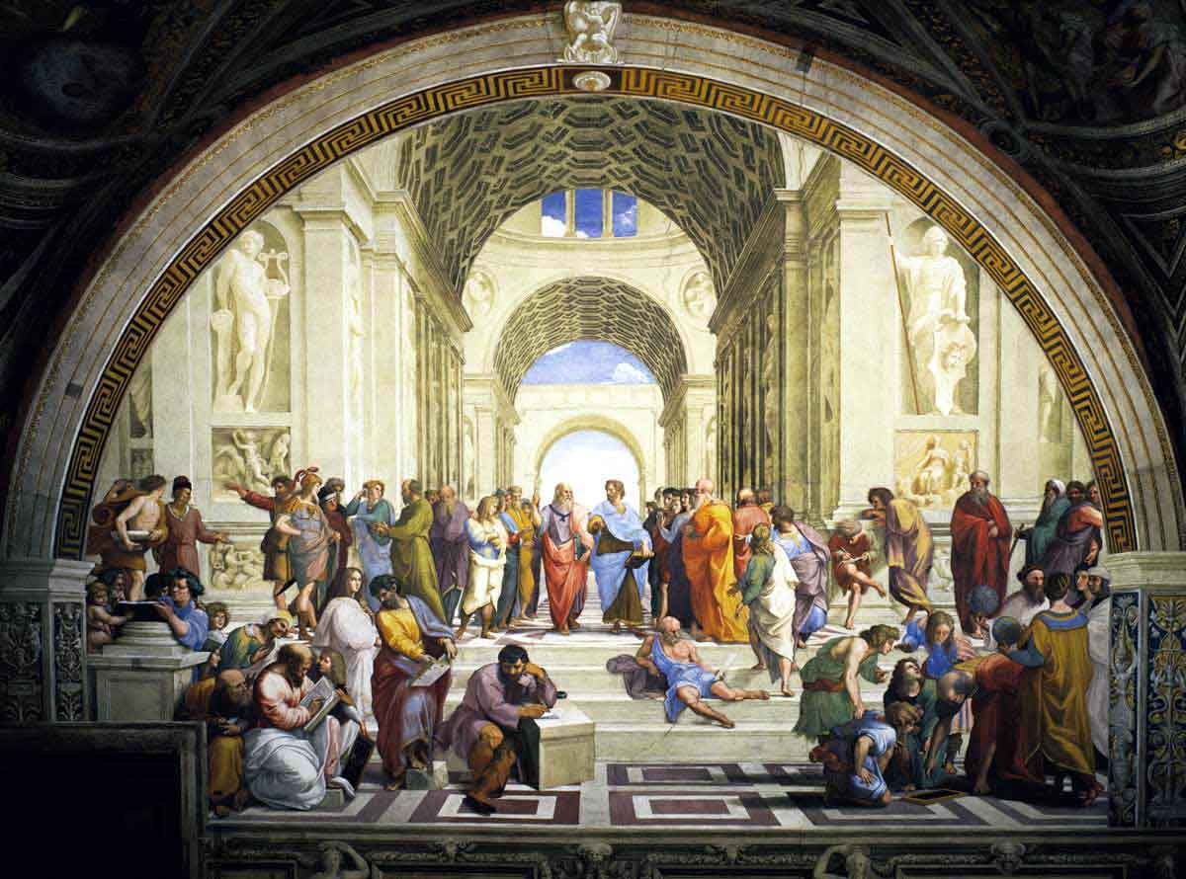
The School of Athens
by Rafaello de Sanzio, (1508 / 1511)

INDEX

Introduction to Unit 2

Page
About this Unit 3
General Aims and Final Products 3
Objectives & Competences 4
Map of Activities 5
List of Handouts 6
List of Appendices 7
Description of the activities 8-16

Sequence of Activities
Page
Act 1: Eternal philosophical questions 8
Act 2: Philosophical Superpowers 9
Act 3: Philosophy and Religion 10
Act 4: Sophie’s world 11
Act 5: Researching on philosophical schools 12
Act 6: What does philosophy have to do
with my life? 13
Act 7: Music and Philosophy 14
Act 8: The philosophical puzzle 15
Act 9; A moral stand 16

Introduction

About this unit

Human beliefs is a unit of sequenced activities intended to last for one term.
This unit consists of 9 separate activities, representing different stages and functions of the general learning process:
- Finding out previous knowledge about the topic
- Fostering learner motivation
- Exposing learners to new knowledge
- Researching information
- Integrating learning
Every activity comprises a series of tasks or sub-activities. These tasks and sub-tasks are not equal in depth and length and are designed to deal with the proposed subject content and language skills.
These activities are linked in a progressive sequence towards the completion of a final product, which is shared by the whole group, cooperatively accomplished and rich enough to incorporate the work and learning developed through a given period of time.
The last activity is always an individual assessment proposal where learners have to show the progress made in both subject and language content.

General Aims

- To motivate students to learn in English.
- To understand that Philosophy is an attempt to answer the universal questions that humanity has posed itself since very early times.
- To reflect on issues with regard to Philosophy and Ethics:
- identifying the major thinkers of the western philosophical tradition
- address the relationship between philosophy, religion, and science
- identify ways in which philosophy is relevant to every-day life
- To prepare students to approach research and learning in English, and to help them realise that English can be their main tool of communication in a global and multicultural world.
- To develop students’ attitudes so that they become active and autonomous towards their own school learning, both of content and language.
- To help students feel the connection and value of this learning for their own lives.

Final Products

Collective final product:
- A philosophical puzzle
Writing philosophical dilemmas and having learners answering tot hem to later give a prize to the best answer.
Individual final product:

- A moral stand : Stating a philosophical or moral stand on a particular issue and justifying it.

Objectives

- To understand that Philosophy tries to answer the fundamental questions, which every person reflecting about the world and his or her place in it has been asking throughout the ages.

- To reflect upon world and everyday life issues with an open and critical view, researching and holding our own stand from an ethical point of view.

- To establish similarities and differences between religion, philosophy and science.

- To be able to produce different types of texts, such as argumentative texts expressing and justifying opinions as well as opinion essays.

- To be able to get, process and share information from sources in English, written and audiovisual and/or on-line.

- To be able to carry out classroom interactions in English, leading to the completion of the required tasks.

- To be able to present both orally and in written form the outcomes of the final products assigned.

- To be able to develop critical judgment and to hold one’s own ideas.

Key competences in the curriculum:

Curricular competences to which this unit is related:

- Linguistic competence
- Scientific competence
- Competence in ITC
- Citizen ship
- Cultural Competence
- Learning to learn
- Personal autonomy

Map of UNIT 2

This map makes reference to the stages within the general learning process:

Engagement to topic. (Previous knowledge; cognitive challenge;)

Exposure to new content. (Language & Content)
  - Research: getting and organizing information.
  - Integration of learning: outcomes, assessment and application in new contexts.

2.1  “Eternal philosophical questions”  - Engagement on the topic  - Exposure to new content | 2.2  “Philosophical Superpowers”  - Exposure to new content | 2.3  “Philosophy and Religion”  - Exposure to new content
2.4  “Sophie’s world”  - Exposure to new content | 2.5  “Researching on philosophical schools”  - Exposure to new content  - Research: getting and organizing information. | 2.6  “What does philosophy have to do  with my life?”  - Exposure to new content  - Research: getting and organizing information.
2.7  “Music and Philosophy”  - Exposure to new content  - Integration of learning: using it in new situations | 2.8  “A philosophical puzzle”  - Integration of learning: using it in new situations | 2.9  “A moral stand”  - Application of learning  - Assessment

Description of the activities
Each of the following 9 activities is described in one page, following a basic frame, which includes a brief account of the contents and the procedure. When we use the following abbreviation S4 U2 we mean Secondary 4th year unit 2. Activities have been numbered 2.1, 2.2, … 2.9, in reference to the number of the unit (2) and to the order of the activity within the proposed sequence:

Title
Description: A very brief account of the activity
Aim: In terms of general learning, integrating linguistic contents and Geology and Earth Sciences content as well as attitudinal development.
Procedure: A series of suggested steps and tasks to carry out the activity
Materials: The basic materials needed to carry out the activity as well as some references to optional materials relevant to the topics and tasks proposed in the activity.
Linguistic skills: the skill or skills mostly targeted in the activity.
Approximate timing of the activity considering the current timetable of English (3 sessions per week).

Handouts

Handouts are materials for the students. They are crucial to carry out the activity although they can be replaced by similar materials. They are provided in easy printable and photocopiable format.
The handouts are linked to the activity they belong to, so that they are easy to identify and find. When two or more handouts are necessary to one activity, they are numbered a, b, c, etc. For example: Handout 2.1

List of Handouts for the activities in Unit 2

h.2.1.a Don’t panic!. It’s only Philosophy
h.2.1.b Eternal philosophical questions
h.2.2.a Philosophical Superpowers
h.2.2.b Philosophers’ trading cards
h.2.3 Philosophy and Religion
h.2.4.a Sophie’s World
h.2.4.b Who are you?
h.2.5.a The fields of Philosophy
h.2.5.b Dossier on Philosophy
h.2.5.c Researching on Philosophy and philosophers
h.2.6.a Where do I stand on different issues?
h.2.6.b Survey data analysis
h.2.7.a Philosophy and Music
h.2.7.b Listening notes
h.2.7.c Vocabulary building
h.2.7.d Philosophy Talk on Music
h.2.8 A philosophical puzzle
h.2.9 A moral stand

Appendices

Appendices are directed to teachers. They provide complementary explanations regarding general procedure or some methodological aspects. Sometimes they can also contain extra materials and organizational tips. They are presented alongside the sequence in relation to concrete activities, but they will be referred to in other similar activities in the rest of the units. Consequently, they are numbered with no specific reference to any unit or activity, for example: Appendix 1, 2 etc.

List of Appendices in Unit 2

Appendix 1 Evaluation Appendix
Appendix 2 The School of Athens
Appendix 3 Useful language
Appendix 4 Answer keys and scripts
Appendix 5 Morality and Philosophy Extra Tasks (link to main activities in the unit provided)

Activity 2.1: Eternal philosophical questions

Description

Students listen to some philosophical quotes and try to establish the basic universal questions behind them.

General aim
To understand that Philosophy tries to answer the fundamental questions, which every person reflecting about the world and his or her place in it has been asking throughout the ages.
To be able to get, process and share information from sources in English, written and audiovisual and/or on-line.

Procedure
- Step 1:Distribute and work on the handout (h.2.1.a)
- Step 2: Read the paragraph on the handout(h.2.1.b) to them and let them answer the questions and then hold a collective session to share their task.
- Step 3: Explain to the ss the aim of the activity: listening to some texts from an American TV program called “No dogs and philosophers allowed” and trying to establish the questions they are referring to.
You can mention that the person talking is British actor John Cleese (Monty Python) and that they’ll be seeing more of him in the next activity.
- Step 4: Play the tracks, one by one,(you can download them from the webpage or play them directly from the web) and let them time to answer, play more than once if necessary and help them to interpret them.
Be flexible with the outcomes, if they get the general meaning and if the question is well formulated is enough.
- Step 5: Possible questions: What is what philosophers do?/Shall we live the moment or think of the tomorrow?/What’s the meaning of life?/What do we owe future generations?/Why is interesting to have information about the lives of others?/Quantity or quality of life?/What is courage?/Are youths right, Do values change?/Have we to fear death?/Do we have to be happy with what we’ve got?

Materials

Hand outs | Classroom reference/School library |  | On-line
Hand outs | Books | Multimedia | On-line
h.2.1.a  h.2.1.b |  |  | http://www.nodogs.org/cleese.html

Language skills focused
Speaking, listening and writing
Timing:
1 session

Activity 2.2: Philosophical Superpowers

Description

Students identify main philosophers and philosophical schools and research on them.

General aim

To be able to get, process and share information from sources in English, written and audiovisual and/or on-line.
To be able to carry out classroom interactions in English, leading to the completion of the required tasks.

Procedure
- Step 1: Download Monty Python’s sketch “International footballers” from You Tube or play it directly from the web.
- Step 2: While watching it learners have to write down the names of the philosophers they hear ( h.2.2.a) and then check if they are included in the trading cards (h.2.2.b )
- Step 3: Now they have to choose one of the philosophers in the trading cards and another one not included there, and research and make a trading card like the ones in h.2.2.b
Materials

Hand outs | Classroom reference/School library |  | On-line
Hand outs | Books | Multimedia | On-line
h.2.2.a  h.2.2.b  Appendix 5 |  |  | http://www.youtube.com/watch?v=xrShK-NVMIU

Language skills focused
Speaking, listening, reading and writing
Timing:
4 sessions

Activity 2.3: Philosophy & Religion

Description

Students watch a short documentary on Philosophy, Religion and Science and try to establish relationships between the three.

General aim

To establish similarities and differences between Religion, Philosophy and Science.
To be able to produce different types of texts, such as argumentative texts expressing and justifying opinions as well as opinion essays.
To be able to get, process and share information from sources in English, written and audiovisual and/or on-line.

Procedure
- Step 1: You are going to watch the last chapter in disc 4 of Religions of the World: Skepticism and Religious Relativism
- Step 2: Have the ss completing the first task “Before watching the documentary” and then make it possible for them to share their ideas.
- Step 3: While they watch the documentary they have an identifying and ordering exercise first and then a vocabulary activity.
- Step 4: Finally as a post-task activity they are going to look up for new words or expressions in the dictionary or in other sources; and then write definitions, match opposites and finally describe themselves in philosophical terms.
Materials

Hand outs | Classroom reference/School library |  | On-line
Hand outs | Books | Multimedia | On-line
h.2.2.a
h.2.2.b

Language skills focused
Speaking, listening, reading and writing
Timing:
2 sessions

Activity 2.4 Sophie’s World (Who are you?)

Description:

Ss will read the first chapter of this novel (Sophie’s world, by Jostein Gaarder) and they will work on it. They will discover, analyze the thoughts, feelings,…which are behind the origins of philosophy as something that can be very close to them also.

General aim:
To understand that Philosophy tries to answer the fundamental questions, which every person reflecting about the world and his or her place in it has been asking throughout the ages.
To reflect upon world and everyday life issues with an open and critical view, researching and holding our own stand from an ethical point of view.

Procedure
- Step 1: Ss read and at the same time listen to the first chapter of the book. (h.2.4.a) The aim is not understand the whole chapter but only to be able to get the main ideas and be able to carry out the tasks in the activity.
- Step 2: They will carry out some after reading activities (h.2.4.b) individually and in pairs.
- Step 3: They might continue reading the book. It could be a collective reading homework: different groups reading different chapters, and each group report the main ideas at the beginning of the class as a warmer.

Materials

Hand outs | Classroom reference/School library |  | On-line
Hand outs | Books | Multimedia | On-line
h 2.4.a  h.2.4.b | Sophie’s world, by Jostein Gaarder  978-1-85799-291-5 | Audio CD | - El mundo de Sofía (1999) de Erik Gustavson basado en el libro de Jostein Gaarder  -El mundo de Sofía, de Jostein Gaarder

Language skills focused: Reading, writing, speaking

Timing: 2 sessions

Activity 2.5 Researching on philosophical schools

Description:
Students learn about the different fields of Philosophy as a science, so later they can research on the field and philosopher that most interests them.

General aim:
To reflect upon world and everyday life issues with an open and critical view, researching and holding our own stand from an ethical point of view.
To be able to get, process and share information from sources in English, written and audiovisual and/or on-line.
To be able to carry out classroom interactions in English, leading to the completion of the required tasks.
To be able to present both orally and in written form the outcomes of the final products assigned.

Procedure
- Step 1: Learners are going to listen to a short explanation of Philosophy as a science and fill in some gaps in the texts. (h.2.5.a).
- Step 2: Dossier on Philosophy (h.2.5.b) . The dossier’s contents are: Brief History, Main schools, Ethics in the West, Applied Philosophy and Eastern and African traditions.
- Step 3: now, the idea is that they personalize their research choosing a field of study in Philosophy, a school and a philosopher they might be interested in. (h.2.5.c)

Materials

Hand outs | Classroom reference/School library |  | On-line
Hand outs | Books | Multimedia | On-line
h 2.5.a.  h.2.5.b  h.2.5.c |  | Encarta  Audio CD | http://www.wikipedia.org/

Language skills focused:
Listening, reading, writing, speaking

Timing: 5 sessions

Activity 2.6 What does Philosophy have to do with my life?

Description:

Learners have to start thinking not only in the practical aspects of philosophy but also in its personal dimension.

General aim:

To be able to get, process and share information from sources in English, written and audiovisual and/or on-line.
To be able to carry out classroom interactions in English, leading to the completion of the required tasks.
To be able to present both orally and in written form the outcomes of the final products assigned.
To be able to develop critical judgment and to hold one’s own ideas.

Procedure
- Step 1: h.2.6.a On this handout learners are going to start expressing their own worries and to think of controversial everyday topics.
- Step 2: In pairs let them choose or assign them a topic or two and then from the 2 books in the materials table photocopy the practice sheets related to them and let them go through the activities proposed on them.
- Step 3: Learners are going to conduct a survey on the topics, try to make them understand that this a serious task and not something to go about lightly or even to forge the answers.
- Step 4: h.2.6.b Let them read the assignment carefully and make sure they understand what they have to do.
Materials

Hand outs | Classroom reference/School library |  | On-line
Hand outs | Books | Multimedia | On-line
h.2.6.a  h.2.6.b | Taboos and issues  Instant discussions

Language skills focused:
Listening, reading, writing, speaking

Timing: 5 sessions

Activity 2.7 The Philosophy of Music

Description:

Students start by listening to some music excerpts that can be brought by the teacher or by themselves or from the music classroom to later rebuild a TV program on Philosophy and Music from a set of listening notes.

General aim:

To be able to get, process and share information from sources in English, written and audiovisual and/or on-line.
To be able to carry out classroom interactions in English, leading to the completion of the required tasks.
To be able to present both orally and in written form the outcomes of the final products assigned.
To be able to develop critical judgment and to hold one’s own ideas.

Procedure
- Step 1: h.2.7.a Learners listen to the excerpts and try to convey feelings, moods, places , facts, etc; in fact whatever comes to their minds while listening to the music. Suggestions: Also spoke Zarathustra( Richard Strauss); Canon in D (Pachebel); Vivaldi’s Piccolo Concerto; Anton bruck’s Violin Concerto nº1; The Picnic by Satie; Mozart Piano Concerto; Vaughn Williams Symphonya Antarctica.
- Step 2. h.2.7.b It is a pre-task activity on new vocabulary to be able to deal later in the task with a text. So let them do it in an autonomous way but don’t forget to check the outcome.
- Step 3: h.2.7.c From a set of listening notes taken from the program Philosophy Talk they are going to reconstruct the program’s dialogue and role play it. To listen to the actual show in the net can be of help.

Materials

Hand outs | Classroom reference/School library |  | On-line
Hand outs | Books | Multimedia | On-line
h.2.7.a  h.2.7.b  h.2.7.c |  |  | http://www.philosophytalk.org/notesPastShows.htm

Language skills focused:
Listening, reading, writing, speaking

Timing: 5 sessions

Activity 2.8 A Philosophical puzzle

Description:

Holding a contest to determine which one is the cleverest answer to philosophical real cases and questions.

General aim:

To reflect upon world and everyday life issues with an open and critical view, researching and holding our own stand from an ethical point of view.
To be able to produce different types of texts, such as argumentative texts expressing and justifying opinions as well as opinion essays.
To be able to develop critical judgment and to hold one’s own ideas.

Procedure
- Step 1: Group them in threes and distribute handout 2.8 . Let learners read it. Help them with any problem they may have with the text or with the procedure of the activity.
- Step 2: Work on the criteria to decide the best answer and then let them make a superpower card from activity 2 for the winners to be given as a diploma.
Materials

Hand outs | Classroom reference/School library |  | On-line
Hand outs | Books | Multimedia | On-line
h.2.8.a
h.2.8.b
h.2.2.b

Language skills focused:
Listening, reading, writing, speaking

Timing: 5 sessions

Activity 2.9 A moral stand

Description:

Individual assessment task in which they have to write an argumentative text on one of the proposed issues and finally take a personal and ethic stand or point of view on it.

General aim:

To reflect upon world and everyday life issues with an open and critical view, researching and holding our own stand from an ethical point of view.
To be able to produce different types of texts, such as argumentative texts expressing and justifying opinions as well as opinion essays.
To be able to develop critical judgment and to hold one’s own ideas.

Procedure
- Step 1: Review the features of an opinion essay like the one they wrote at the end of the previous unit.
- Step 2: Have a look at the list of issues and encourage them to choose one from the list. Allow for diversity so but if someone wants to write about something else is OK.
- Step 3: Work on the proposal of text lay out on the handout with them and let them write a draft to be checked against it.
- Step 4:Once you have negotiated with each of the learners the final outcome they proceed to do it.
Materials

Hand outs | Classroom reference/School library |  | On-line
Hand outs | Books | Multimedia | On-line
h.2.8.a  h.2.8.b  h.2.2.b |  |  | http://www.writefix.com/argument/

Language skills focused:
Reading, writing, speaking

Timing: 3 sessions

