VERBS IN ENGLISH



In English, there are three basic tenses: present, past, and future. Each has a perfect (past) form, indicating completed action; each has a progressive(continous) form, indicating ongoing action; and each has a perfect progressive form, indicating ongoing action that will be completed at some definite time. Here is a list of examples of these tenses and their definitions:
 | Simple Forms | Progressive Forms | Perfect Forms | Perfect Progressive Forms
Present | take/s | am/is/are taking | have/has taken | have/has been taking
Past | took | was/were taking | had taken | had been taking
Future | will/shall take | will be taking | will have taken | will have been taking

Simple Forms

Present Tense

Present tense expresses an unchanging, repeated, or reoccurring action or situation that exists only now. It can also represent a widespread truth.

Example | Meaning
The mountains are tall and white. | Unchanging action
Every year, the school council elects new members. | Recurring action
Pb is the chemical symbol for lead. | Widespread truth

Past Tense

Past tense expresses an action or situation that was started and finished in the past. Most past tense verbs end in -ed. The irregular verbs have special past tense forms which must be memorized.

Example | Form
W.W.II ended in 1945. | Regular -ed past
Ernest Hemmingway wrote "The Old Man and the Sea." | Irregular form

Future Tense

Future tense expresses an action or situation that will occur in the future. This tense is formed by using will/shall with the simple form of the verb.

Example: The speaker of the House will finish her term in May of 1998.

The future tense can also be expressed by using am, is, or are with going to.
Example: The surgeon is going to perform the first bypass in Minnesota.

We can also use the present tense form with an adverb or adverbial phrase to show future time.

Example: The president speaks tomorrow. (Tomorrow is a future time adverb.)

Progressive Forms

Present Progressive Tense

Present progressive tense describes an ongoing action that is happening at the same time the statement is written or said . This tense is formed by using am/is/are with the verb form ending in -ing.

Example: The sociologist is examining the effects that racial discrimination has on society.

Past Progressive Tense

Past progressive tense describes a past action which was happening when another action occurred. This tense is formed by using was/were with the verb form ending in -ing.

Example: The explorer was explaining the latest discovery in Egypt when protests began on the streets.

Future Progressive Tense

Future progressive tense describes an ongoing or continuous action that will take place in the future. This tense is formed by using will be or shall be with the verb form ending in -ing.

Example: Dr. Jones will be presenting ongoing research on sexist language next week.

Perfect Forms

Present Perfect Tense

Present perfect tense describes an action that happened at an indefinite time in the past or that began in the past and continues in the present.This tense is formed by using has/have with the past participle of the verb. Most past participles end in -ed. Irregular verbs have special past participles that must be memorized.

Example | Meaning
The researchers have traveled to many countries in order to collect more significant data. | At an indefinite time
Women have voted in presidential elections since 1921. | Continues in the present

Past Perfect Tense

Past perfect tense describes an action that took place in the past before another past action. This tense is formed by using had with the past participle of the verb.

Example: By the time the troops arrived, the war had ended.

Future Perfect Tense
Future perfect tense describes an action that will occur in the future before some other action. This tense is formed by using will have with the past participle of the verb.

Example: By the time the troops arrive, the combat group will have spent several weeks waiting.

Perfect Progressive Forms

Present Perfect Progressive

Present perfect progressive tense describes an action that began in the past, continues in the present, and may continue into the future. This tense is formed by using has/have been and the present participle of the verb (the verb form ending in -ing).

Example: The CEO has been considering a transfer to the state of Texas where profits would be larger.

Past Perfect Progressive

Past perfect progressive tense describes a past, ongoing action that was completed before some other past action. This tense is formed by using had been and the present perfect of the verb (the verb form ending in -ing).

Example: Before the budget cuts, the students had been participating in many extracurricular activities.

Future Perfect Progressive

Future perfect progressive tense describes a future, ongoing action that will occur before some specified future time. This tense is formed by using will have been and the present participle of the verb (the verb form ending in -ing).

Example: By the year 2020, linguists will have been studying and defining the Indo-European language family for more than 200 years.

possibilility
invitations
permission
advice

request
instructions

obligation

MODAL VERBS

Modal verbs are verbs which behave differently from “normal” verbs.

These are some of the differences:

- They don’t usually take “-s” in the 3rd person.
- We use “not” after the modal verb to make the negative.
- Modals go before the subject in questions.
- Most modal verbs can’t be used in the past or future.

In this unit you are going to read, listen, speak and write about issues expressing:

- Advice
- Obligation
- Possibility
- Necessity
- Probability
- Suggestions
- Requests
- Instructions, also used for advice, instructions and request

ADVICE/INSTRUCTIONS

When you give an advice you tell people what is good for them. SHOULD is the modal verb used to give advice.

Ex:
- A healthy balanced diet should include a variety of different foods from each of the groups.
- Eating should be an enjoyable experience.
- Young people should know that the younger you start smoking, the more dangerous it is.
- Why should we exercise?
- Children between the age of 5 and 18 should take part at least in one hour of moderate physical activity each day.

OBLIGATION

An obligation is something people do because it’s their duty. HAVE TO and MUST is used to express obligation.

Ex:
- We have to choose between choosing healthy foods and the ones we like.
- The skeleton, which is built up during puberty, has to last them for the rest of their lives
- When we have finished an exercise session, we must cool down by jogging, stretching and bending again.

POSSIBILITY

To express that something is likely to happen *, we use CAN, COULD, MAY, MIGHT.

Ex:
- Smoking in teenagers can cause permanent genetic changes.
- Adults can’t help us. They don’t know anything about the way we feel.
- The link between smoking and fatal diseases such as various types of cancer, heart disease and strokes can’t be denied.
- Drugs can take you to delinquency quite easily.
- You might be surprised!
- Bullies may appear confident and strong but is not always the case.
Likely to happen*: can happen, it’s possible

- Eating only certain food types or not eating particular nutrients can be very bad for us.
- Too much of some foods and soft drinks can be a problem

NECESSITY

A necessity is something which has to happen and you cannot avoid or prevent. It is expressed with HAVE TO, NEED TO

Ex:
- I have to worry if my body has not started to change yet.
- We need to talk to parents and other adults about what is happening to us.
- All animals have to eat to survive
- Your parents need to feel that they can trust you to act responsibly

PROBABILITY

When something is certain to happen in the future, we use WILL, MUST (When we are fairly true that something is the case)

Ex:
- Parents and teachers, the adults around us will listen to our problems and try to help.
- I must have been 13 or so.

SUGGESTIONS

Recommendations we make. We use COULD to express suggestion.

Ex:
- We could say that the average daily requirements could vary from 1,600 to 2,800 calories.
- We could say that smoking causes bad breath, bad skin and a lingering smell in your hair and clothes.

REQUEST

When you request something you ask very politely for it. We use CAN, COULD, WILL, WOULD

Ex:
- Can we talk about it?
- Teacher, sir, could you define exercise for us?
- To finish the interview, teacher could you give us some fitness tips or advice?
- Dr Ann, could you explain for us why we feel so confused and strange at times?
- Can you describe their behaviour?

IMPERATIVES

When we tell people to do something we use IMPERATIVES

Ex:
- Then, put on some warm clothes, so that the body cools down slowly.
- My advice is: walk and /or cycle from and to school everyday if possible. Try to be active in the playground. Help at home, housework is exercising. Eat healthy

Active and Passive Voice

Active Voice

In sentences written in active voice, the subject performs the action expressed in the verb; the subject acts.

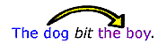
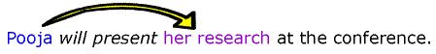
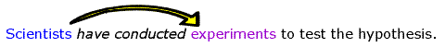
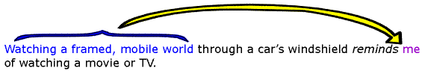
In each example above, the subject of the sentence performs the action expressed in the verb.

Passive Voice

In sentences written in passive voice, the subject receives the action expressed in the verb; the subject is acted upon. The agent performing the action may appear in a "by the . . ." phrase or may be omitted.

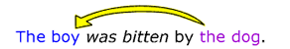
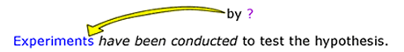
(agent performing action has been omitted.)
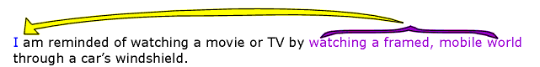

Using the passive voice
Sometimes the use of passive voice can create awkward sentences, as in the last example above. Also, overuse of passive voice in an essay can cause your writing to seem flat and uninteresting. In scientific writing, however, passive voice is more readily accepted since using it allows one to write without using personal pronouns or the names of particular researchers as the subjects of sentences (see the third example above). This practice helps to create the appearance of an objective, fact-based discourse because writers can present research and conclusions without attributing them to particular agents. Instead, the writing appears to convey information that is not limited or biased by individual perspectives or personal interests.
You can recognize passive-voice expressions because the verb phrase will always include a form of be, such as am, is, was, were, are, or been. The presence of a be-verb, however, does not necessarily mean that the sentence is in passive voice. Another way to recognize passive-voice sentences is that they may include a "by the..." phrase after the verb; the agent performing the action, if named, is the object of the preposition in this phrase.

In most non scientific writing situations, active voice is preferable to passive for the majority of your sentences. Even in scientific writing, overuse of passive voice or use of passive voice in long and complicated sentences can cause readers to lose interest or to become confused. Sentences in active voice are generally--though not always-- clearer and more direct than those in passive voice.

Passive (indirect) | active (direct):
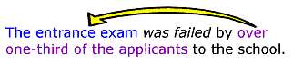 | 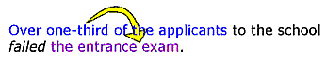
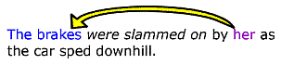 | 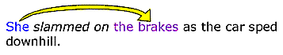
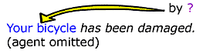 | 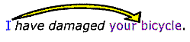

Sentences in active voice are also more concise than those in passive voice because fewer words are required to express action in active voice than in passive.

passive (more wordy) | active (more concise)
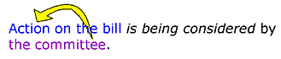 | 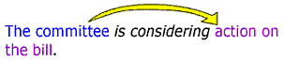
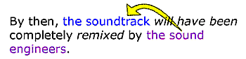 | 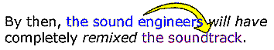

Changing passive to active

If you want to change a passive-voice sentence to active voice, find the agent in a "by the..." phrase, or consider carefully who or what is performing the action expressed in the verb. Make that agent the subject of the sentence, and change the verb accordingly. Sometimes you will need to infer the agent from the surrounding sentences which provide context.

Passive Voice | Agent | Changed to Active Voice
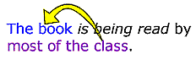 | most of the class | 
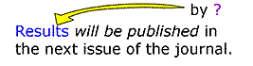 | agent not specified; most likely agents such as "the researchers" | 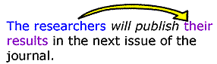
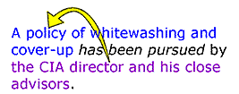 | the CIA director and his close advisors | 
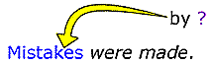 | agent not specified; most likely agents such as "we" | 
Choosing Passive voice

While active voice helps to create clear and direct sentences, sometimes writers find that using an indirect expression is rhetorically effective in a given situation, so they choose passive voice. Also, as mentioned above, writers in the sciences conventionally use passive voice more often than writers in other discourses. Passive voice makes sense when the agent performing the action is obvious, unimportant, or unknown or when a writer wishes to postpone mentioning the agent until the last part of the sentence or to avoid mentioning the agent at all. The passive voice is effective in such circumstances because it highlights the action and what is acted upon rather than the agent performing the action.

active | passive
The dispatcher is notifying police that three prisoners have escaped. | Police are being notified that three prisoners have escaped.
Surgeons successfully performed a new experimental liver-transplant operation yesterday. | A new experimental liver-transplant operation was performed successfully yesterday.
"Authorities make rules to be broken," he said defiantly. | "Rules are made to be broken," he said defiantly.

In each of these examples, the passive voice makes sense because the agent is relatively unimportant compared to the action itself and what is acted upon.

Changing active to passive

If you want to change an active-voice sentence to passive voice, consider carefully who or what is performing the action expressed in the verb, and then make that agent the object of a "by the..." phrase. Make what is acted upon the subject of the sentence, and change the verb to a form of be + past participle. Including an explicit "by the..." phrase is optional.

Active Voice | Agent | Changed to Passive Voice
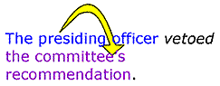 | The presiding officer | 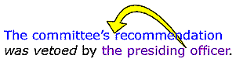
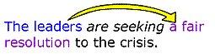 | The leaders | 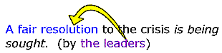
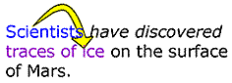 | The scientists | 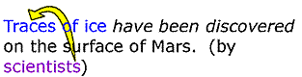

In each of these examples, the passive voice is useful for highlighting the action and what is acted upon instead of the agent.

